# 

**THE NATIONAL REGIONAL GOVERNMENT OF OROMIYA**

**OROMIYA PLANNING AND DEVELOPMENT COMMISSION**

**PHYSICAL AND SOCIO-ECONOMIC PROFILE OF WEST ARSI ZONE**

**April, 2022**

**Finfinne**

**THE NATIONAL REGIONAL GOVERNMENT OF OROMIYA**

**OROMIYA PLANNING AND DEVELOPMENT COMMISSION**

**PHYSICAL AND SOCIO-ECONOMIC PROFILE OF WEST ARSI ZONE**

# Chapter One.

# 1.1 Introduction

A socio economic profile is a key element of a social and economic  assessment. A socio  economic assessment or profile is used by line officers, planning staff, scientists, and others to inform both planning activities and decision making. It is a tool that provides a 'birds-eye view' of a group of communities. It can assist in identifying unique and shared characteristics for the purpose of implementing growth strategies, development planning, and supporting and growing local services.

It is evident that we haven’t enough and reliable information and data about the natural resource, cultural, land escapes and socio-economic conditions to prepare a meaningful developmental plan without the concept of Socio-Economic Profile.

For proper, consistent and meaningful development planning, for conducting development oriented research and for evidence based planning data must be collected, analyzed, organized, interpreted, processed and summarized to serve as tools for the decision-makers and researchers. They provide opportunities to see or investigate the performances of government to assess the impact of public policies and actions.

The commitments to implement development programs and combat poverty should be based on clear evidences that require a robust statistical data system which provides reliable, comprehensive and harmonized statistical information. The statistical information is vital for decision-making by all components of the society, particularly policy makers as well as economic and social players. Therefore, it is essential for integration and sustainable development.

But in our zone planning is largely interpreted as data collection, processing, evaluation, analysis and description of the present situation. In depth analysis and evaluation of these data are rare to be found and applied. Most of the time, planning becomes the wishing of the individuals. To minimize these Problems by improving the data collection, management and the uses of information, West Arsi Zone Planning and Economic Development office have been collected and organized information to present compiled document concerning physical and socio-economic condition of the Zone and its development constraints.

# 1.1 Back Ground of the Zone

West Arsi is one of Oromiya Regional state territory founded/formed in1998E.C of same Districts which was included underArsi, Bale and East Shewa zones and named after a subgroup of the Oromo, who inhabit it. Currently West Arsi Zone has 13 districts, 2 town admiration ,totally, it has structured by **15** adiminestratins, 324 PAs ,and **44** small towns.

The Astronomical location of West Arsi zone lies between 60 17’ 00’’ N to 70 42’ 35’’N Latitude and 380 3’ 42’’ E to 390 45’ 58’ E Longitude.It shares boundery line with East Shewa zone to the north, SNNPRS to the west and south, Arsizoe to the northeast, Guji to the south east and Bale zone to the east.. Shashemene town which is located in the Rift Valley region at **250km** from Finfine the Regional and National Capital, to the South is the administrative center of the zone

The total area of Zone is **12767km2**.Survey show that about 76.19% of the zone are flat plain, while about 23.81% are ragged or un utilized terrain which including valley, gorges, hills and dissected plateaus .Most parts of the zone have elevations of ranging from 1500 to over 3300m.

Based on the 2007/1999 Census conducted by the  CSA , Projected population of zone as of 2012 is 2,976,960, of whom 1,471,651 are men and 1,505,309 women. Rural population accounts 86% (basically rely on agriculture for its livelihood) and 14% of population are urban inhabitants.

Generally, West Arsi Zone is divided into three agro-climate zone mainly due to variation in altitude which is dominantly characterized by the alpine (baddaa), temperate (badda-dare) and Desert ( Gammoojjii)agro – climatic zone.

The mean annual temperature of the zone is found between 20-250c in the low land and 10-160c in the high land area. However, there is a slight variation of temperature from month to months. October to May is the hottest months while June to September is the coldest months.

For most of the areas, the rainy season starts in March and extends to November with the highest concentration in June, July and August.

Out of about 18 major soil associations identified in the Country by FAO 8 soil associations Luvisols. 40%,Vertisols 17%, Cambisols 14%, Nitosols 6%, Andosols 13%, Lithosols, 4.5% and Fluvisols 0.7%cover the land area of West Arsi Zone.

The Majority of population of the zone is engaged in farming and animal raring. The major Crop produced are

Cereals,Teff, Wheat ,Barley ,Oat ,Maize ,Millet

Pulses,Faba beans/ horse beans ,Field peas ,Haricot bean ,Cheack pea

Oil Seeds,Nug ,Sesame ,Linseed ,Rape seed ,Grount nut

The total Land areas occupied by peasant holdings is 350,538.85 hect/3505.4 km2.

West Arsi Zone is characterized by Diversified Agro-climatic zones, Topography, attractive forest sites in which forest camps are constructed for the arrival of Tourists and many lakes that can serve as tourist attraction sites.

Map 1.1 Zone Map with its Administrative divisions.

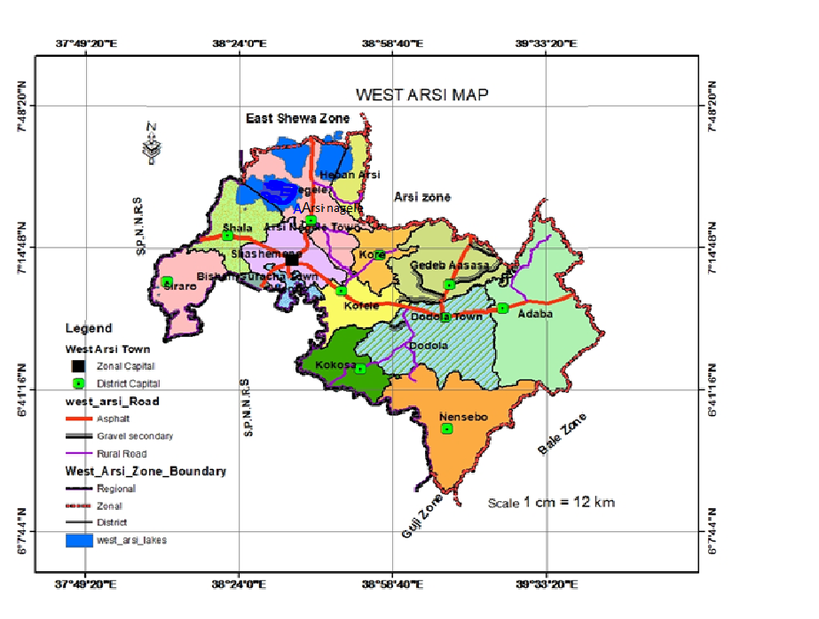

Source GIS Data

# 1.2 Objective of the Document

One of the basic tasks of Oromia Planning and Economic Development Bureau and zone Planning and Economic Development Offices is the Collection compilation , analysis, synthesis, and dissemination of Regional, Zonal and District data on natural resources and socio economic issues that could serve as bases for development planning and several other related activities in the region .

Hence this Socio-Economic Profile of our Zone is prepared in the form of Compiled Document by collecting and analyzing Primary and secondary data through different method at Zonal and District level on natural and socio-economic conditions for the following General objectives

1. Planners and decision makers to:-
2. Identify major differences in resource endowment and socio-economic activities in

various districts of the region in order to help them formulate appropriat Regional

development polices and strategies.

1. formulate short, medium, and long-term Rural Centered development Plans for the Region, Zone, and district .
2. Developing a Geographic Information System (GIS), Establishing Modern Information system and reliable data base at all Level.
3. Providing basic Information for those who want to invest, wish to Participate in different development activities and other related purpose in our Zone.
4. To provide the ecological, social, economic and Other information necessary for the natural resources utilization tosustain the economic development, diversity, and productivity of the regional resource to meet the needs ofpresentandfuturegenerations.

1.3 Data Source and Methodology

Primary and Secondary data source has used to gather relevant information to prepare this Bio-Physical and Socio-Economic Profile Document of our Zone.

The Primary data are obtainedby conventional methods, namely,

1. Physical Observation

The Geographical Location of Rural/Urban Facilities like Health, Educational, and administrative, etc Institutions is taken by GPS through field survey. Photographing, drawing or sketching was also used while Collecting data in the area understudy.

1. Focus Group Discussion.

Discussion with focal person and concerned expert of concerned sectors and interviewing or asking other target groups and note taking to obtaining the required data was made.

The main sources of Secondary data used for the preparation of the document are

* Different documents in different Sectors like Agriculture, Health, Education, Water and Energy Resource office, Finance and Economic Development offices, as well as the documents available in our office.
* The document covers almost the data and activities of the two consecutive years of 2011 and 2012E.C.

The data has been analyzed using Percentage, tables, Maps Graphs and figures.

# 1.4. Significance of the Document

In general, this Document of Socio-Economic Profile of our zone is highly required to create awareness in the mind of policy makers, Development Planers and concerned bodies about the Conditions of the Zone with the specific purpose of the following

* It helps us toknow the short, medium and long interests of the people that coincide with population growth rate,
* It helps us to know the amounts and types of the available natural recourses, human resources, capital, etc and scientifically identify and implement,
* It is required in order to identify the existingproblems and development needs, which form the basis for setting objectives and hypotheses, goals, issues, strategies and formulating alternative policies as well asplans for future development,
* It is required in order to identify and evaluate alternative policies and courses ofactions/results,
* It is required for monitoring and evaluating outputs or results in order to progress toward the targeted goals and /or danger signs calling for correction and
* It is required to provide feedback about the impact of the courses of action during or after their implementation.

# 1.5. Limitation of this profile

* Most of the sectors found at Zone levels do not respond to the data collection formats distributed to them. Because there is low awareness of the significance of data and information, and accordingly the attention given for data collection, organization, compilation, storage and management is very low.
* Inconsistency._ data which are collected from Some Sectors are unreasonably decreasing or increasing. No logical consistency in the data collected when compared with the previous ones.
* Shortage of basic skill of the Data and Information Officers and Focal Persons who engaged in the data collection, analysis, organization, storage and management is also another problem. In other ward capacity of workers to analyze, summarize, manage and make accessible information for planning and decision-making purposes is not yet well developed in the Zone.

# 1.6 . Organization of the document

This socio-economic profile Document contains four chapters.

The first chapter deals with the introduction that traces the concept of data and information, Objectives, Data Source and Methodology and Significance of the document.

The second chapter tries to cover the physical setting of the Zone which comprises location, physiographic Division of the Zone, Geological structure, Mineral resource relief, Water resource, climate, vegetation, wild life and land use of Zone..

The Third chapter deals about socio – economic condition that includes population, agriculture, mining & industry and infrastructure & social facilities in the Zone.

The last chapter focuses on the potentialities and constraints for the development comprehensively

# Chapter two

# Physical Setting

Setting Physical Condition of our Environment is very important to study the distribution of the natural features, such as Climate, Land form, Soil, Vegetation, drainage system. It considers distribution, arrangement and interaction of these natural features and human features and their causes and effects.

In general all Life that has survived must have adapted to these conditions of its environment, all influence any species, within any environment. However life in turn modifies its condition in various forms. The major natural features that can affect human features in the Zoe are discussed as follows.

## Location

The terms location and place in [geography](https://en.wikipedia.org/wiki/Geography) are used to identify a [point](https://en.wikipedia.org/wiki/Point_(spatial)) or an area on the [Earth](https://en.wikipedia.org/wiki/Earth)'s surface or elsewhere. The term location generally implies a higher degree of certainty than place, which often indicates an entity with an ambiguous boundary, relying more on human /social attributes of [place identity](https://en.wikipedia.org/wiki/Place_identity) and [sense of place](https://en.wikipedia.org/wiki/Sense_of_place) than on [geometry](https://en.wikipedia.org/wiki/Geometry).

A location is therefore, the place where a particular point or area , Human Settlement, City, Town or object exists. It gives information of many different spots of interests for Visitors and locals. A location of the place or an area can be identified through two methods, Relative Location and Astronomical /Absolute Location.

* + 1. **Relative Location of West Arsi Zone**

Relative location can help to analyze how two places are connected, whether by distance, Culture or even technology. Direction like north, south, east and west helpto describe where one place is in relation to another.

Accordingly West ArsiZoneis one of Oromiya National Regional state territory dominantly situated in the South Westpart of the region and it shares bounder line with

* East Shewa zone to the north,
* SNNPRS to the west and south,
* Arsi zone to the Northeast,
* Guji to the south east and
* Bale zone to the east..

### Astronomical Location

Coordinate of longitude and latitude help to pinpoint theabsolute Location of place or things. Coordinates simply give a places position relative to the equator (latitude) and Prime meridian (longitude.)

In the case of absolute location, according to the data obtained from GIS Data, the Astronomical Location of West Arsi Zone lies between 60 17’ 00’’ N Which is the most Southern point located in Nensebo District to 70 42’ 35’’N Latitude the most northern point of the Zone found in HebanArsi District.. Longitudinally the Zoeneis located between 380 3’ 42’’ E the most Western point of Zone located in Siraro to 390 45’ 58’ E Longitude, eastern Most point of the West Arsi Zone located in Adaba District.

Map 2.1 West ArsiZone Relative and Astronomical Location of West Arsi Zone.

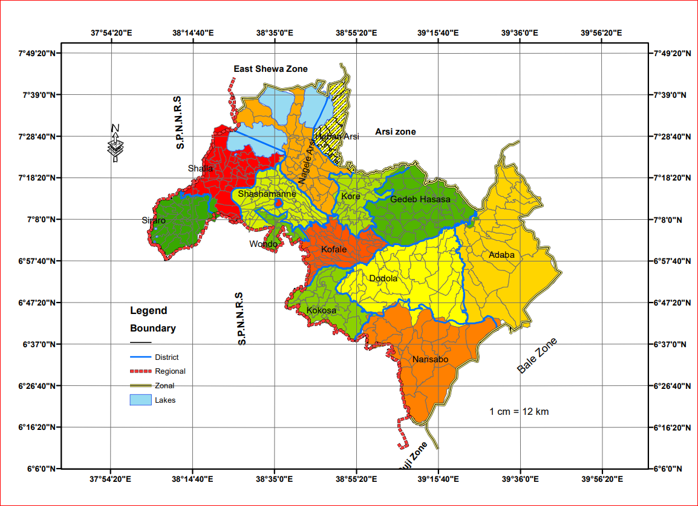

Source Geographic Information System Data

## Area .

The total area of Zone is **12767km2 .**Survey show that about **76.19%** of the zone are flat plain, while about **23.81%** are ragged or unutilized terrain which including valley, gorges, hills and dissected plateaus.

## Geological Structure

Geologic structures are usually the result of the powerful tectonic forces that occur within the earth. These forces fold and break rocks, form deep faults, and build mountains. Repeated applications of force the folding of already folded rocks or the faulting and offsetting of already faulted rocks can create a very complex geologic picture that is difficult to interpret. Most of these forces are related to plate tectonic activity. Some of the natural resources we depend on, such as metallic ores and petroleum, often form along or near geologic structures. Thus, understanding the origin of these structures is critical to discovering more reserves of our nonrenewable resources.

According to the information obtained from Geographic Information System (GIS) data of Oromia Geology, the Geologic Structurecovers West Arsi Zone is

Predominantly andesite flows and flow breccia; includes basalt flows, minor rhyolitic rocks, and some sedimentary rocks. Sedimentary  Clastic Conglomerate (Bed, Tuffaceous)Tuffaceous and feldspathic

Quaternary alkaline basalts and trachytes (Chilalo Formation /Lower and upper part ) which were erupted along preexisting structure on Several plateaus of the Zone, Nazarth series a thick succession of welded ignimbrites with fiamne , pumice, ash and rhyolity flow and domes with rare interrelation of basalt flow which occur in the plateaus, Arsi and Bale Basalts,Makonnen basalts and Basalt flows are categorized under these rock types .,

* **Chilalo Formation**

Chilalo Formation (Lower part): are commonly Trachyyte, trachy basalt, peralkaline, rhyolite with subordinate alkaline basalt. It covers about 11.8% of areas of the Zone and covers the Southern and Central Mountainous part of Dodola District and Northern part of GedebHasasaandKorewhich consists number of well known peaks like Kaka Mountain mostly covered by natural forest. Chromic Luvisolswhich occur in areas of dense mixed high forest and dense coniferous high forest overlay most of this portion of West Arsi Zone.

Chilalo Formation (Upper part):Characterized by Alkaline basalt peralkaline rhyolite with subordinate alkaline basalt. It covers (2%) total area of the zoneoverhigh dense coniferous high forest areas of South _ Central portion of Dodola and Adaba Districts.

**Nazareth Series**

Nazareth series is a thick succession of welded ignimbrites with fiamne , pumice, ash and rhyolity flow and domes with rare interrelation of basalt flow which occur in the plateaus. Such basalts occur in the Northern and Central Portion of Dodola District over areas of intensively cultivated by peasant and state and wood landed areas,Southern,Easten and central portion of GedebHasasaDistrict,almost all parts of Kofale and Southern and Eastrenparta of kore District, Easten , Southern and central parts of Nasaboo,someSouthernand Northern parts of Adaba,some parts of **Southrn Arsi Nagele** and Shashamanne Districts, Western, Central and Northern parts ofkokosa District and it covers about **42.1%** of the Zone. Much of it occurs in those agro-ecological zones thatpermit their intense cultivation for extensive crop and livestock production .

* **Makonnen Basalts:** -

The Makonnen basalts mostly overlie on the crystalline basement in the type area and yielded an absolute age range of Oligocene to Miocent. Such basalts are not wide spread over several areas of the zone. It covers only about 1.1% around the border of KokosaandNensaboDistricts. The Makonnen basalts are physically separated and readily distinguishable on the basis of similar basal elevation columnar form, Thickness of flow and the fact that they have a basal pale soil rather than residual sandstone .

**Arsi and Bale basalt;_**

Arsiand Bale basalt are commonly felsics on the upper parts. It was given to the flooded basalt succession of the plateaus of the zone where the flood basalt activity culminated by the formation of larger volicanic edified, which formed some of the highest peaks of the zone It is only found in Northeastern portion ofAdaba District and Overlaid 3.4% total area of West Arsi Zone. The age of these basalts ranges from late Oligocene to early Miocene geologic period of time.

**Basalt flowes,spatter cones and hyaloloclastites /Transitional type between alkaline and tholeiti**

Rocks in the tholeiitic magma series are classified as subalkaline (they contain less sodium than some other basalts) and are distinguished from rocks in the [calc-alkaline](https://en.wikipedia.org/wiki/Calc-alkaline) magma series by the [redox](https://en.wikipedia.org/wiki/Redox) state of the magma they crystallized from (tholeiitic magmas are reduced; calc-alkaline magmas are oxidized . When the parent magmas of basalts crystallize, they preferentially crystallize the more magnesium-rich and iron-poor forms of the silicate minerals [olivine](https://en.wikipedia.org/wiki/Olivine) and [pyroxene](https://en.wikipedia.org/wiki/Pyroxene), causing the iron content of tholeiitic magmas to increase as the melt is depleted of iron-poor crystals. However, a calc-alkaline magma is oxidized enough to precipitate significant amounts of the iron oxide [magnetite](https://en.wikipedia.org/wiki/Magnetite), causing the iron content of the magma to remain more steady as it cools than with a tholeiitic magma.

It covers about 10% of the total areas of Zoneand distributed over Central and Eastern border of Adaba, ­some North Eastern and Central portion of Siraroandcentral part of Shalla District around the southern border of shalla Lake.

* **Alluvial and lacustrine deposites:sandsilt,clay,diatomite limestone and beach sand.**

This category is also used for lake or marine deposit (non-glacial) and Lake sediments. Middle Pleistocene lava-dammed Snake Plain lake beds of silt, clay and diatomite. Silt, clay, sand, and gravel; Quaternary-Tertiary alluvial and lacustrine .ALLUVIAL DEPOSITS-Locally includes beach and sand dune deposits. These categories cover 6.6% of the areas in Wondo ,SouthernShshamanne, central Siraro and ArsiNagele in between Langeno , Abijata and Shalla lakes.

* .**Dino Formation:Ignimbrite,tuff,coarsepumice,waterlain pyroclastic rocks with rare Intercalations of lacustrine sediments**

Ignimbrite is a variety of hardened [tuff](https://en.wikipedia.org/wiki/Tuff).Ignimbrites are [igneous rocks](https://en.wikipedia.org/wiki/Igneous_rock) made up of crystal and rock fragments in a glass-shard [groundmass](https://en.wikipedia.org/wiki/Matrix_(geology)), albeit the original [texture](https://en.wikipedia.org/wiki/Texture_(geology)) of the groundmass might be obliterated due to high degrees of [welding](https://en.wiktionary.org/wiki/weld). Ignimbrite is the deposit of a pyroclastic density current, or [pyroclastic flow](https://en.wikipedia.org/wiki/Pyroclastic_flow), which is a hot suspension of particles and gases flowing rapidly from a [volcano](https://en.wikipedia.org/wiki/Volcano) and driven by being denser than the surrounding atmosphere. Ignimbrites form as the result of immense explosions of pyroclastic ash, [lapilli](https://en.wikipedia.org/wiki/Lapilli) and blocks flowing down the sides of volcanoes.

Ignimbrites are made of a very poorly sorted mixture of [volcanic ash](https://en.wikipedia.org/wiki/Volcanic_ash) (or [tuff](https://en.wikipedia.org/wiki/Tuff) when [lithified](https://en.wikipedia.org/wiki/Lithification)) and [pumice](https://en.wikipedia.org/wiki/Pumice) lapilli, commonly with scattered lithic fragments. The ash is composed of glass shards and crystal fragments. Ignimbrites may be loose and unconsolidated, or lithified (solidified) rock called lapilli-tuff. Near the volcanic source, ignimbrites commonly contain thick accumulations of lithic blocks, and distally, many show meter-thick accumulations of rounded cobbles of pumice.

Ignimbrites may be white, grey, pink, beige, brown or black - depending on their composition and density. Many pale ignimbrites are [dacitic](https://en.wikipedia.org/wiki/Dacite) or [rhyolitic](https://en.wikipedia.org/wiki/Rhyolite). Darker-coloured ignimbrites may be densely welded [volcanic glass](https://en.wikipedia.org/wiki/Volcanic_glass) or, less commonly, [mafic](https://en.wikipedia.org/wiki/Mafic) incomposition.Such rocks cover about 14.2% of the area of the District and distributed over central ArsiNagele and Shashamanne eastern part of HebanArsi, south western and Central Shalla Districts.

* **Rhyolitic volcanic centers,obsidianpitchstone,pumice,ignimbrite,tuff,. subordinate trachytic flows (predominantly peralkaline in composition).**

Eventually, the additional heat leads to the development of silica-rich magma bodies and eruption of silicic lavas (e.g. rhyolite). Volcanism in volcanic centers ...

Although dacitic-to-rhyolitic lavas typically erupt from stratovolcanoes, they are not as abundant as andesite lava. Instead, felsic eruptions from stratovolcanoes are more commonly explosive and associated with the generation of tephra and pyroclastic flows. It covers only about 1% of the totoal area of a Zone at the border of Shashamane and Shala.

**Map_2.2 Geologic Structure of West Arsi Zone**

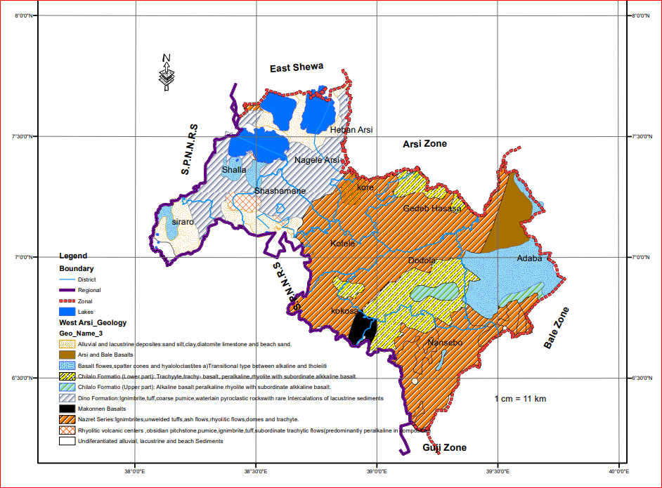

Source Geographic Information System Data

## 2.4. Relief Drainage and Climate

### 2.4.1.Relief

Relief is the features of lands which differentiated by its altitude. These features are mountain, hills, plateaus, plain and others. The land form of any places have its own advantage and disadvantage for human settlement and other activities. Thus, the Zone is characterized by large mountainous topography, hills and dissected plateaus, valley, gorgesand plains.

Geological survey indicated that the zone is fallen under the tertiary volcanic of the trap series that makes its conducive for farming activities and extraction of constriction materials. Besides, there are also sedimentary formations (lacustrine Sediments within the basin) Geological Survey show that about **76.19%** of the zone are flat plain, while about **23.81%** are ragged or unutilized terrain which including valley, gorges, hills and dissected plateaus.

The **Kaka Mountain West Arsi** zone and **Arsi zone** boundary is one of the highest mountains in Oromiya next to Tulu Demtu and Chilalowhicharise to high altitude plateaus of mount around **4215masl**.Amountain has formed from lava outpourings in ancient geological periods. The flow of lava forms larger outstanding rocks. These rocks of the volcanic outpouring are predominantly igneous rocks. The Central and Southern part of Adaba and Dodola districts is Mountainous with Maximum elevation 3800m above sea level. This area is mostly covered by natural forest and serves as a water shade between Wabeshbele and Genale River basins consists number of well known peaks Simbo, Waka Beta and Somkeru

These Mountainous regions are the best ecosystem of afro alpine vegetation and source of larger rivers, habitat of an endemic and endangered mountain Nyala, Ethiopian wolf, Mineliks Bush buck and geologically outpouring igneous rocks. Erica Arboreavegetations dominated the area~~.~~

**Map2.3 Relief features of West Arsi Zone**

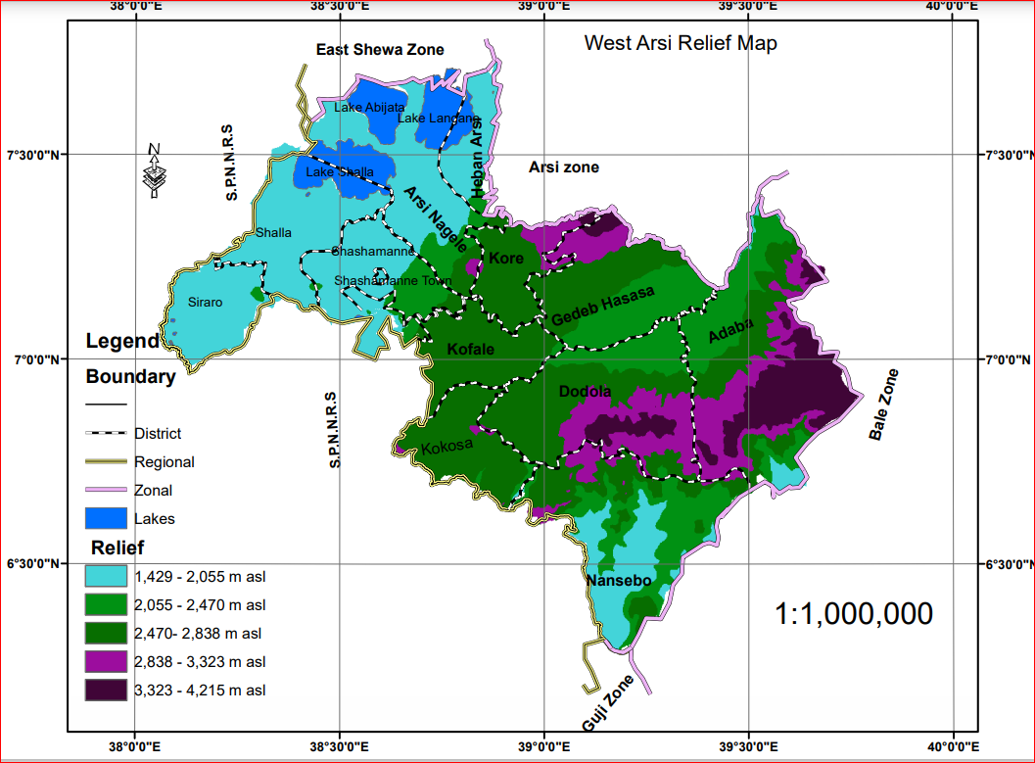

### 2.4.2 Drainage Pattern

**Rivers**

West Arsi is naturally endowed with many rivers and streams. It has high network or density of permanent rivers and streams

There are several perennial water courses originated from the high mountain ranges of Adaba and Dodolawhich are the water shade for WabeShebele and Genele river basins. Many of these water courses flow north wards to the upper part of Wabeshebele river and Some flow South ward to the Genele river basins.

Over 20 streams arise with in Kaka Mountains these joints to form larger rivers such as lagaGurcha, layea, DabaraKatarWorga, Burbura Hersha, Qaqawa, Tankaro,Sudani and the Others. These Rivers and springs are the only source of water for the low land areas.Example, lagaGuracha and layeaforNageleArsi human consumption, live stock irrigation and serve as ecotourism area For example Lephis water fall from lagaGuracha in Koreworeda

**Lakes:** -

West Arsi zone is rich in natural lakes too. The major rift valley lakes of Abijata, Langano, and Shalla are partly in West Arsi zone. Manmade LakeMelkaWekena Lake which has been used for generating hydroelectric power is also belongs to West Arsi zone. Moreover, they are the home of different type of birds, important sources for fish production and recreational purpose.

**Table 2.1. Number of major Rivers in West Arsi Zone**

|  |  |  |  |  |
| --- | --- | --- | --- | --- |
| All Weather River | Wet Season River | All Weather River | Wet Season River | |
| Shashemene | | Siraro | | |
| Dedeba, Tina, MelkaOda and Laftu | Gogeti | - | | Budameda, Tilo and Mechefera. |
| Adaba | | ArsiNegele | | |
| Maribo, Nanesho, Wachekore, Furuna and Arba |  | HaroKali’oGogessa,  GedamsoAwedeJitu,  AwedeGudo and DabaGudo |  | |
| GedebHasasa | | Kofale | | |
| Wektetra, Gerdela, Uruba, Ubolto, Debara, and Aware | - |  |  | |
|  | - | Kore | | |
|  | -- | AnjeleloXika, AnjeleloGuda, LegaGuracha, Kerenesa and Leya |  | |
| Kokosa | | Shala | | |
| wabe, Logita, Maganamo and Hafursa | - | Shares Lake Shala and Hawasa within ArsiNegele and Hawasa | - | |
|  | - | Dodola | | |
|  | - | Logita,WabeUkuma, Maribo | Koro,Lenisho and Heraro | |
| Nansabo | |  |  | |
| Belecho, Bedesa,Hodema, Katimera, Halila and Hamile | - |  |  | |

**Map2.4 Major Rivers of west Arsi Zone**

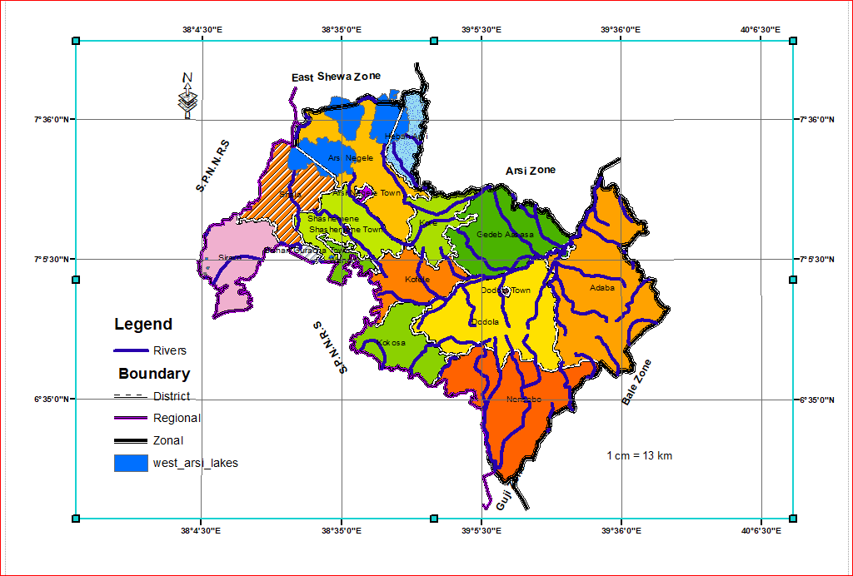

### 2.4.3. Main Seasons

There are four Main Seasons per year in the Zone; Namely Sumer, Autumn, Winter and Spring.

Table_2. 2.__ Main Seasons in the Zone

|  |  |  |  |
| --- | --- | --- | --- |
| Months | **English Name** | **Afan Oromo Name** | **Amharic Name** |
| June, July, August | Summer | Ganna | Keremt |
| September,October,November | Autumn | Birraa | Tsedey |
| December, January, February, | Winter | Bona | Bona |
| March, April, May | Spring | Arfaasaa | Belg |

SourceZone Agricultural Development Office

Rain fall in the Zone is seasonal over time. There is long and heavy summer rain which is normally referred to as the heavy rain. There is also short and moderate rain in Autumn and Spring. Winter is characterized by little or no moisture in a Zone.

### 2.4.4. Climate Characteristic

Climate is a major component of physical environment which has dominating influence on other natural elements like soil and vegetation. The Climatic differences and processes that determine other natural elements and economic activities that should be carried out are controlled by condition of temperature, humidity, wind and rain fall.

The Zone is divided into 4(four) agro-climate zone mainly due to variation in altitude which is dominantly characterized by the Cool (baddaadiilallaa’aa),Cool temperate (baddaa), temperate (badda-dare) and Warm Temperate (Gammoojji)agro – climatic zonealthough there is no clear distinction of their boundary limits.This variation of temperature provides wide opportunities for the production of different types of crops range from moderately cool to cool thermal districts

Table 2.3.Agro climatic zone of west Arsi zone

|  |  |  |  |  |  |  |
| --- | --- | --- | --- | --- | --- | --- |
| Altitude | Annual mean temp | Description | | Area | | |
| Agro Climatic Zones | Afan Oromo | | Km2 | (%) |
| 500 – 1500/1700 | 19-250c | Warm Temperate | Gammoojji | | 651 | 5.1 |
| 1500/1700- 2500m | 14-190c | Temperate | BaddaDaree | | 7422 | 58.3 |
| 2500 – 3500m | 9-140c | Cool temperate | Baddaa | | 4653 | 36.3 |
| >3500m | < 90c | Cool | Dilela | | 44 | 0.3 |
| Total |  |  |  | | 12767 | 100 |

Source calculated from Climatic map

**Map 2.5 Agro climatic zone of west Arsizone**

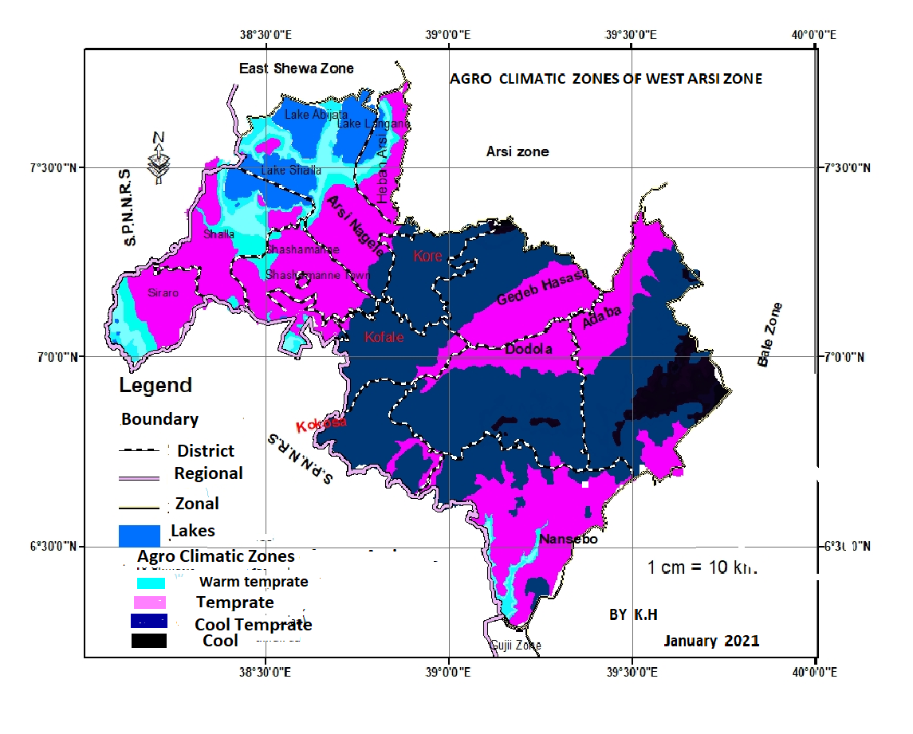

Source Geographic Information System Data

#### 2.4.4.1 Temprature

Temperature as an element of climate plays a fundamental role on Bio-physical and socio-economic Conditions. Hence, there is a most obvious link between Temperature and these conditions.

The mean annual temperature of the zone is found between 20-250c in the low land and 10-160c in the high land area. However, there is a slight variation of temperature from month to months. October to May is the hottest months while June to September is the coldest months.

#### 2.4.4.2.Rain Fall.

The amount and seasonal variation in distribution of rain usually determine the type of economic activities and contribute to the type of vegetation which prevail in the Zone. However the distribution of rain is influenced by topography of the land that makes it uneven. For most of the areas, the main rainy season Summer (Ganna) starts in June and extends to September and the spring (Arfaasaa) season starts in March and extends to May and it is distributed unevenly throughout the year.

Rain fall that comes at summer season is significantly more important for crop production and animal husbandry which are important for the livelihood of the society of theZone. For most of the areas, the rainy season starts in March and extends to November with the highest concentration in June, July and August. The number of rainy days varies from Cool /Dega to Cool temperate /WeinaDega and this number slightly decreases as one goes down to the Warm Temperate /kolla areas.

Based on the climate data available in our office, the mean annual rainfall varies from District to District. Generally, WestArsi zone receives abundant and well-distributed rainfall both in amount and season, which is conducive for different types of vegetation growth and agricultural activities. On average, the zone gets annual mean rainfall of 1300mm.

## 2.5. Soils

Soil is a complex mixture of inorganic minerals, decaying organic matter, water and living organisms. It is a unique and vitally important part of the terrestrial ecosystem. It is fundamental to continue human existence ; without soil we can’t grow the food we need. The earth’s thin layer provides nutrients for plants which directly or in directly provide the food all animals need to stay alive and healthy.

The following are the major uses of soil.

* Soil is used in agriculture where it serves as the primary nutrient base for plants. The types of soil used in agriculture vary with respect to the species of plants that are cultivated.
* Soil resources are critical to the environment and food production. Soil provides minerals and water to plant. Soil absorbs rainwater and releases it later, thus preventing floods and drought.
* Soil is the habitat for many organisms.

Accordingly the information obtained from Geographic Information System /GIS data of Soil, out of about 18 major soil associations identified on the basis of predominant chemical and physical properties derived from parent materials, in the Country by FAO, 8 of the soil associations which cover West Arsi are classified intoLuvisoils,Vertisoils, Cambisoils,Nitosoils, Andosls, Lithosoils, Fluvisoilsandsolonchackswith the rest being composed of swamps and marshes rocks, stones and sand. The definitions and explanations of the sub-units and major soil groups are as follows.

1. **Luvisols.**

These soils cover about 1638 km2 (38.7% ) of the land area of the zone. They developed in areas where pronounced wet and dry season occur. Where leaching is not very high they are found in association with nitosols.

In the zone understudy, Luvisols are subdivided into Chromic Luvisols(29.7%) and OrthicLuvisols (9%).

Chromic Luvisolslargelyoccur in areas of dense mixed high forest and dense coniferous high forest inNorthern, Western and North eastern parts of Nensebo; Southern portions of Dodola and Adaba; Northern Gedeb Hasasa and Eastern Kore on and around Kaka Mt.; some parts of Western and Eastern Kokosa, around border of small parts of North western and South EasternArsiNageledisteicts.

OrthicLuvisols cover central highland of theDodola and Adabadistricts,some parts of GedebHasasa south of Kaka mt., some parts of Dodola and it stretched from Nn parts of Kokossa through Western Kofale up to Southern Shashamanne around border of Kofale and South western Negele Arsi adjacent to Shashamanne District.

**ll. Vertisoils**

About **2157.3 km2 (16.9%** ) of the land area of the zone is covered by this major soil type. Two of its sub-types found with in a zone are PelicVertisols and chromic vertisols.

PelicVertisols (black basaltic soil): the sub-unit ofVertisols cover about 11.8% of the land area of the Zone and mostly occur on broad nearly flat to undulating topography, which often lack integrated natural drainage networks.. For the reason such soils have high clay content and sticky it is difficult for farming purpose..

Much of it occurs in those agro-ecological zones that permit their intense cultivation for extensive crop and livestock production . It stretches from most Eastern part of Adaba by covering small central portions of the district through central Dodola and distributed over central portion of Kokossa , South eastern Kofale , Centraland western Gedeb Hasasa .

chromicvertisols ; chromic vertisols covers only about 5% of land surface of the zone.Unlike the PelicVertisols, which are found in humid areas ,chromic vertisols mostly occur in moderate climatic portion and gently sloping ground of the zone and distributed over central Shashamanne and Arsinagelle, Southern and eastern Heban Arsi Districts.)

**lll. Cambisoils**

Such soils are developed from the recent lava deposits of quaternary period and they are young and shallow. Camisoles occurred on slopes, are often shallow or have many stones or rock outcrops have little agricultural value. However Camisoles that are deep and not stony are good for agriculture.

Camisoles Soil type cover about 13.7 % of the total land of the zone. Two sub-units of Cambisoles Calcic Cambisoles(9.8%) and Eutric Camisoles (3.9%) are found in the Zone.

Calcic Cambisoles are mainly occurring in limestone areas of Northern part of the of Dodola and Adabadistrictswhere share boundary with Hasasa district and in large areas of southern, Eastern and central GedebHasasaintensively cultivated areas.

Eutric Camisoles arelocated in Northern Arsinagelle between the Lake Shalla, Langano and Abijatawhre covered by Alluvial and lacustrine deposit, sand and silt deposite. Some Eutric Camisoles are also located by encircling with Chromic luvisolsin South western of Nensebo and South eastern Adeba

**lv. Nithosoils**

Nitosols Covers about 719 km2(5.6%)of the district. They are reddish brown to red clay soils of tropical regions and show features of strong weathering. They are basically associated with high rainfall, and were probably formed originally on forest cover areas. On the whole, unless on steep slopes and/or eroded, the soils are deep and are very porous. They have a high moisture storage capacity and a deep rooting volume. In the zone understudy, EutricNitosolssub-units ofNitosolscover larger portions of Kor and Kofele districts of the zone.

**V. Andosols**

About 12.8% of areas of West Arsi Zone is covered by Andosols. These Major soils occur on young, vitric pyroclastic materials with largest extent in the rift valley mainly with sodicphase. The two subclasses of Andosolsfouned in the Zone are MolicAndosols and Vitric Andosols.

Vl. OrthicSolonchaks (0.5%): They occur only in drier climate, generally on alluvial plains. They are highly saline soils, containing soluble salts that influence plant growth and found northwestern ArsiNegele between Lake Langano ,Abijata and Shallaaswelas to the western part of Shalla Lake in Northern Shalla District.

Vll.Fluvisols (0.71%): Fluvisols are young soils developed in recent alluvial deposits of river plains, deltas, former lakes and coastal areas. Soil conditions are highly variable, i.e., in arid areas many soils are saline. EutricFluvisols occur in smaller portions of Shashemene and Shalla districts of West Arsi zone.

**Vll. Lithosols** _

Lithosols is a thin soil consisting mainly of particularly weathered rock fragments and lacking infertility and moisture. About 4.4% of areas of West Arsi Zone is covered by Lithosols and it is located at some portion of western Shashamanne, Eastern Shalla, Southern Siraro and central and western parts Nensebo District.

**Map_2.6 Soil distribution of West Arsi Zone**

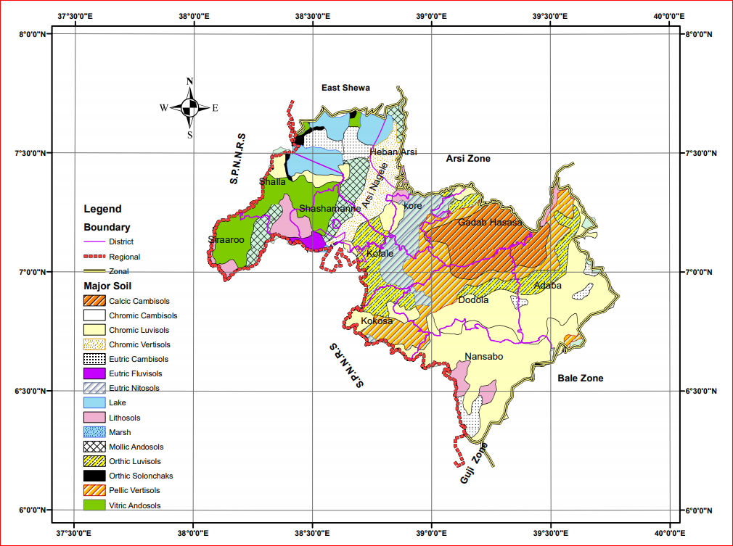**Source Geographic Information System Data**

## 2.6. Vegetation and Wildlife

Forests provide many social, economic, and environmental benefits. In addition to timber and paper products, forests provide wildlife habitat and recreational opportunities, prevent soil erosion and flooding, help provide clean air and water, and contain tremendous biodiversity. Forests are also an important defense against global climate change. Through the process of photosynthesis, forests produce life-giving oxygen and consume huge amounts of carbon dioxide, the atmospheric chemical most responsible for global warming. By decreasing the amount of carbon dioxide in the atmosphere, forests may reduce the effects of global warming.

The natural vegetation cover of an area is determined mainly by the altitude, temperature, amount of rainfall and parent material from which the soil has been derived and type of human interference. Its coverage and composition also changes over time due human activities.

According to some literatures and oral tells hundred years ago most parts of the West Arsi zone was covered with dense and endogenous natural forest. However, due to an increase of demands for cropland, woods for construction and firewood as a result of population growth, this type of forests almost have been lost in many areas of the zone..

Different varieties of forest species are found in all the climate conditions of the zone. The land closer to the mountains is loosely scattered with indigenous trees such as Acacia, Junipers, Olea Africana, and with increasing altitude and decreasing farming activities, the forest cover of the Mountains slopes become thicker and gradually transpires to dense alpine (high altitude) forest. The forest in the areafound up an elevation of 3000masl is dominated by Junipers and Podocarpus trees. In the higher altitude greater than 3000m Erica shrubs, Giant lobelia and giant thistles are common.

At Present though the actual area covered by the natural vegetation does not exactly known it is estimated that Only about 18% of the zone was covered by forest that included from wooded grass land to Afro – Alpine.

T**able_ 2.4.Major Type of climatic- climax vegetation in the Zone**

|  |  |
| --- | --- |
| Name of district | Type of climatic- climax vegetation |
| Adaba | Afro- alpine region, Junipers forest, podocarpus forest and sub-afro alpine |
| A/Negele | podocarpus forest, |
| Dodola | Junipers forest, sub-afro alpine |
| G/Hasasa | Junipers forest and sub-afro alpine |
| Kofale | Aningeria forest and Junipers forest |
| Kokosa | Aningeria forest and arundinaria forest |
| Kore | Aningeria forest, arundinaria forest and Junipers forest |
| Nansabo | Aningeria forest, olea forest, arundinaria forest and sub-afro alpine |
| Shalla | Junipers wood land |
| Shashemene | Junipers wood land |
| Siraro | Junipers wood land and podocarpus forest, |
| Wondo | Junipers wood land and podocarpus forest, |
| HebaArsii | Junipers wood land and podocarpus forest, |

Source: - data available in West Arsi Planning and development office.

**Map_2.7 West Arsi zone Climatic climax Vegetation**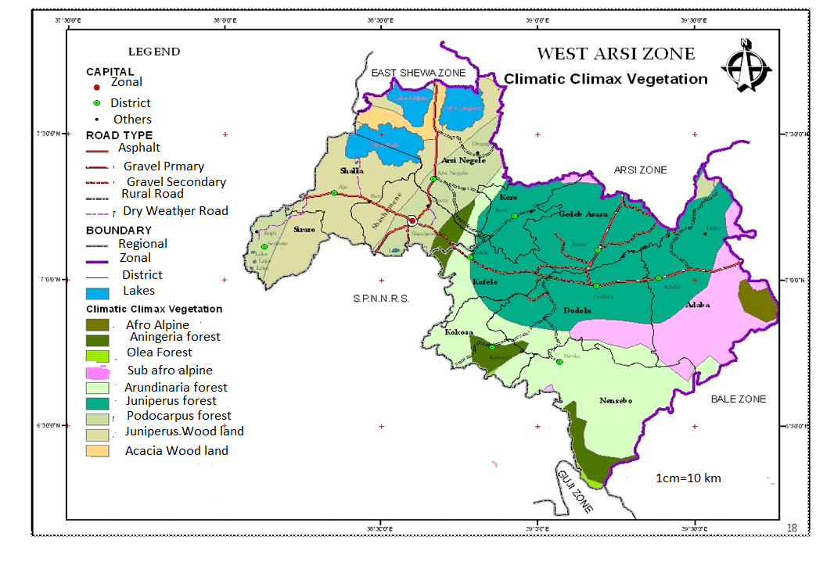2.6.2 Wild life

Wild life includes all wild living creature large or small mammals, brides, fishs, reptiles amphibians and others are regarded as wild life.

The diverse climate and topographic phenomenon have provided a wide range of natural environments, which form favorable habitat for a formation of wide variety of fauna and flora in West Arsi zone. Wild animals like bushbucks, warthogs, or monkeys occur especially in dense forest. Nyalas, wolfs, klipspringers, hares or hyraxes are also found in the alpine Erica moorlands of Dodola and Adaba Districts.

However, due to uncontrolled hunting and destruction of their natural habitat as a result of rapid population growth and related human activities, there is rapid decrease of wildlife in size, species and distribution. Nyalas and bushbucks have been most affected, but they can still be seen in the early morning or late afternoon. The purpose of hunting is to get social prestige or recognition, however, which is reduced to some extent today. Some of the wild animals are hunted because they are harm to domestic animals, crops and sometimes men.

Numerous bird species like White-cheeked turako (Tauracoleucotis), black kite (Milvusmigrans), augurbuzzard (Buteorufofuscus), harrier hawk (Polyboroidesradiatus), Abyssinian ground hornbill (Bucorvusabyssinicus) and speckled pigeon (Columba guinea) belong to the different parts the Zone ..

**Wild Animals conservation:-**In general west Arsi zone has one National park and (Shalla –Abijata), two Sanctuaries area (SinkeleSwaye) and Langano. Shalla – Abijata National park which could be considered as reserved area for wild life particular for bird of species suppose these parks largely constitute the water bodies of Shalla and Abijata

# Chapter three

# 3.Socio-Economic Conditions

## 3.1 Population

Human Population is the number of people living in definite area. The study of human population is also necessary for development and socio-economic activities. For example, population is the major source of the labor force for the productive and non-productive economic sectors such as agriculture, manufacturing , teaching, health service ,etc.

Human population is also the main productive force and creator of material wealth. This makes the study of population extremely important for the overall socio-economic development of a country. population studies yield knowledge that is important for planning, particularly by government ,in fields such as health ,education ,housing ,social security ,employment ,environment preservation. Such studies also provide information needed to formulate government population policies, which seek to modify demographic trends in order to achieve economic and social objectives.

According to projection made from the Census of 2007 /1999 E.C by CSA, the Population West Arsi Zone increase from 2893784 of whom 1430445 are men and 1463339 in 2011to about2976960, male 1471651 and female 1505309 in 2012. Rural population accounts 81% (basically rely on agriculture for its livelihood) and 19% of population are urban inhabitants.

The population growth rate of the Zone during the two consecutive years was about 2.9% Which is 2.6% for Rural and 4.1% for Urban ~~.~~This shows that the size of population is growing rapidly from time to time in the zone in general and in Urban Centers in particular because of migration from rural to urban .

Table 3.1.Population of West Arsi Zone by sex and place of residence

|  |  |  |  |  |  |  |  |  |  |
| --- | --- | --- | --- | --- | --- | --- | --- | --- | --- |
| Year | Rural | | | Urban | | | Total | | |
|  | Male | Female | Total | Male | Female | Total | Male | Female | Total |
| 2011 | 1,148,954 | 1,185,536 | 2,334,490 | 284,649 | 281,894 | 566,543 | 1,433,603 | 1,467,429 | 2,901,033 |
| 2012 | 1,174,880 | 1,212,697 | 2,387,577 | 294,331 | 291,408 | 585,739 | 1,469,211 | 1,504,105 | 2,973,316 |

Source:-CSA population projection in 2019/2011 2020/2012

### 3.1.1. Age Sex structure

* **Dependency Ratio** - Dependency ratio is the dependent population 0-14+65 and above years per economically active section of the population (age 15-64 years).

This structure is among the most important item needed for demographic inquiries which can have considerable impacts on its demographic and socio economic situation, both at present and future.

According to projection made from the Census of 2007 /1999 E.C by CSA In West Arsi Zone the age group 0-14, 15-64 and 65 and above years during the year 2012E.C were 1354517 (45.5%), 1518250 (50%) and 104194(3.5%) of the total population of the Zone respectively

Mathematically 1354517+104194*100 = 95% which means 95 people are dependant

1518250 on 100 people.

In general there is high, Dependency ratio in the Zone that needs the intervention of policy makers

This has caused the population of West Arsi Zone to have very broad base and narrow apex, indicating high fertility, decaling mortality and a rapid population growth rate.

1. **Sex Ratio –** The overall sex ratio sex structure of the Zone which is the proportion of male to female population in is about 97 percent which means 97 males per 100 females that shows female population is higher than male population during both years.

**3.1.2. Average Family Size –**

According to the 1999 population and housing census of Ethiopia, the average household size of the zone is 5.5 person per household for the zone, which is 5 for urban and 6 for rural per household

### 3.1.3. School age Population

School age Population is the total population of official School age group for a given level of education . Accordingly the official School age group for Primary School First and second Cycle is 7_10 and 11-14 years old respectively. Similarly 15 – 16 and 17 - 18 years are the official School age group belonging for Secondary School First and second Cycle respectively.

According to the information obtained from Population projection of CSA the School age population of West Arsi Zone during the year 2011 and 2012E.C was as shown in the following table.

Table3.2. School age Population of the Zone Gov’t and Non-Gov’tduring 2011/2012 E.C

|  |  |  |  |  |  |  |  |  |
| --- | --- | --- | --- | --- | --- | --- | --- | --- |
|  | Primary School (1-8) | | | | Secondary School (9-12) | | | |
| First Cycle | | Second Cycle | | First Cycle | | Second Cycle | |
| 7-10 | | 11-14 | | 15 - 16 | | 17 – 18 | |
| M | F | M | F | M | F | M | F |
| 2011 | 173754 | 155858 | 66528 | 55675 | 8040 | 6409 | 2136 | 1386 |
| 2012 | 178720 | 163717 | 72962 | 62318 | 7915 | 6676 | 5187 | 3301 |

Source _ population Projection of CSA

### 3.1.2 Population density.

Population density which is also termed as the spread of Population over Space, is measured in various ways. But in our case we use the density that relate numbers of in habitants to the area of lands in habituated.

#### 3.1.2.1 Crude density

Crude density _ is a measure of numbers of inhabitants per unit area which is also known as human _ land ratio is calculated by

**Crude density= total population of the area**

**total area, in km2 ,of the area**

So total population of the Zone in year 2011= **2,901,033**

Total area of the Zone = **12767km2**

Therefore Crude density during the 2011 E.C**= 2,901,033 /12767km2 = 227P/km2**

Total population of the Zone in year 2012 = **2,973,316**

Total area of the Zone= 12767km2

therefore Crude density = **2,973,316** /12767= 233 p/km2

As Shown above the crude density of the district population which was 227/km2 in the year 2011 was increased to 233p/km2during 2012 due to the natural increase in human population.

#### 3.1.2.2.Agricultural density/Rural density

Agricultural density/Rural density is the ratio of agricultural (rural) population to cultivated land. Agricultural density considers only Agricultural population and land occupied by all rural population. Agricultural population density is a more meaningful measures than crude population density for developing countries where agriculture is a dominant activity.

Agricultural density =rural population

cultivated land

therefore Agricultural density during the was 2011 **was 2,334,490/3427 =681p/ km2.** This Means 681 people live in one sq.km.

**Rural population of Zone during 2012 = 2,387,577**

cultivated land of the district = 3503 km2

therefore Agricultural density during the year 2012 E.C was **2,387,577** /3503 = 682 p/km2

This Means 681 people live in one sq.km.

**West Arsi Zonal and Districts with their area, capital town's Number of PA'S towns and urban kebeles**

|  |  |  |  |  |  |  |  |  |  |
| --- | --- | --- | --- | --- | --- | --- | --- | --- | --- |
| No | Woreda /Town | Area in km 2 | Capital Town | No of PA'S | Number of Town | Number urban kebeles | Population | Finfine in km | From West Arsi Capital in km |
| 1 | Siraro | 719 | Loke | 28 | 4 | 4 | 206,278 | 353 | 54 |
| 2 | Shala | 915.7 | Aje | 37 | 2 | 2 | 212,882 | 279 | 30 |
| 3 | Wondo | 166.9 | Intaye | 9 | 2 | 2 | 121,537 | 268 | 18 |
| 4 | Shashemene | 665 | Sh/nne | 37 | 1 | 1 | 279,775 | 250 | - |
| 5 | Nagele Arsi | 1425.1 | Arsi Negle | 36 | 6 | 7 | 215,876 | 220 | 30 |
| 6 | Kofale | 663 | Kofale | 38 | 2 | 3 | 244,618 | 270 | 25 |
| 7 | Kore | 533 | Qore | 20 | 2 | 2 | 147,436 | 360 | 105 |
| 8 | Gadab Hasasa | 1135 | G/Hasasa | 25 | 6 | 7 | 268,989 | 285 | 85 |
| 9 | Dodola | 1595 | Dodola | 23 | 4 | 4 | 230,686 | 320 | 75 |
| 10 | Nansabo | 1692 | Warqa | 19 | 2 | 2 | 162,856 | 389 | 139 |
| 11 | Kokosa | 649.3 | Kokosa | 22 | 4 | 4 | 204,138 | 360 | 105 |
| 12 | Adaba | 2170 | Adaba | 22 | 4 | 5 | 198,648 | 320 | 75 |
| 13 | Shashamane Town | 11 | Shashamanne | - | 1 | 8 | 171,813 | 250 | - |
| 14 | B/ Guracha Town | 10 | Bishan Gur. | - | 1 | 2 | 50,771 | 266 | 16 |
| 15 | Negele Arsi Town | 5.8 | Arsii Negele | - | 1 | 3 | 143,690 | 220 | 30 |
| 16 | Dodola Town | 8 | Dodolaa | - | 1 | 2 | 35,627 | 320 | 75 |
| 17 | Heban Arsii | 403.2 | Goljota | 8 | 1 | 1 | 77,696 | 229 | 61 |
| 18 | West Arsi zone | 12767 | shashamene | 324 | 44 | 59 | 2,973,316 | 250 | - |

Source; west Arsi zone finance & economic Dev’t **office**

Source: District Agriculture and Natural Resource office and population Projection of CSA

## 3.2.Agriculture *.*

The agricultural Sector plays primary role in a country political, economic and social stability makes measures of agricultural production extremely sensitive. Being it is the primary activity in the district where above 95% of the population engaged in various agricultural activities and generate their income for house hold consumption to sustain their livelihood . Above all the sector is Believed as the main source to accumulate capital for the process of establishing the future industrialized Oromia.

Accordingly the Zone agriculture have been suffered for a years from the use of traditional farm implements and subsistence farming system as well as Limited use of modern inputs that resulted to the sector’s poor performance (i.e. low productivity of the sector . Private agricultural holding includes fragmented privately owned agricultural holding on which all types of agricultural activities such as crop production, livestock’s rearing—etc are performed by the operator/ holder to obtain agricultural Production for the self-reliance was the main activity .

However the Surplus production along with productivity increments that have been registered during the last Ten years indicated that the agricultural system as a whole the crop production sub sector in particular is showing improvement.

### 3.2.1 .Cooperatives

 The cooperative movement in the Zone has been strongest in rural areas. Farmers have formed cooperatives for many purposes, including marketing of produce, purchasing of production, Purchasing` of Agricultural input and provision of credit. Farm marketing associations are the most important type of agricultural cooperative. The modern farmer-member, who depends increasingly on off-farm products, can realize maximum savings by ordering goods through cooperatives.

**Table 3.3. Type, Number, Members of cooperatives and their capital in 2012**

|  |  |  |  |  |  |  |  |  |
| --- | --- | --- | --- | --- | --- | --- | --- | --- |
| **Lakk** | **Types** | **No** | **Members** | | | **Capital** | | |
|
| **Female** | **Total** | **Female** | **Oprational** | **Fixed** | **Total** |
|  | **Union** | **474** | **77,030** | **26,514** | **103,544** | **71,776,714** | **34,666,232** | **106,442,946** |
| **1** | General Agr. | 216 | 55,326.00 | 14,056.0 | 69,382.00 | 47,032,500. | 29,641,300.0 | 76,673,800.0 |
| **2** | Saving and credit | 154 | 4,012.00 | 9,411.00 | 13,423.00 | 21,987,713.58 | 649,932.12 | 22,637,645.7 |
| **3** | Forest | 88 | 16,712.00 | 2,880.00 | 19,592.00 | 2,756,500.0 | 4,375,000.00 | 7,131,500.00 |
| **4** | Vegetables | 16 | 980.00 | 167.00 | 1,147.00 |  |  | **-** |
|  | Coopratives | 593 | 130,182 | 43,707 | 454,203 | 225,195,199 | 56,832,984 | 282,028,182 |
| 1 | General agriculture | 263 | 98,035 | 19,617 | 117,652 | 170,572,333 | 33,799,541 | 204,371,874 |
| 2 | saving and credit | 186 | 7,601 | 16,721 | 23,942 | 36,271,084 | 8,533,354 | 44,804,439 |
| 3 | MI/Qo/sumsuma | 1 | 2 | 10 | 12 | 107,392 | - | 107,392 |
| 4 | EekoTruzim | 1 | 17 | - | 17 | 18,740 | 62,087 | 80,827 |
| 5 | consumer |  | 4,625 | 2,151 | 287,406 | 11,712,382 | 1,605,531 | 13,317,913 |
| 6 | forest | 62 | 14202 | 3051 | 17263 | 1024901.56 | 4018744.9 | 5,043,646 |
| 7 | Irrigation | 27 | 2,863 | 867 | 3,730 | 1,447,282 | 1,931,866 | 3,379,148 |
| 8 | seed production | 22 | 1,408 | 346 | 1,766 | 1,165,707 | 5,554,641 | 6,720,348 |
| 9 | Animal fattening | 12 | 723 | 540 | 1,353 | 1,948,557 | 341,634 | 2,290,191 |
| 10 | Milk production | 6 | 292.0 | 166.0 | 458.0 | 455,027.9 | 269,366.2 | 724,394 |
| 11 | Fishes | 5 | 313.0 | 30.0 | 343.0 | 234,341.3 | 327,102.3 | 561,444 |
| 12 | Honney | 4 |  | 150.0 | 102.0 | 25,200.0 | 138,968.0 | 164,168 |
| 13 | Coffee | 1 | 90 | 5 | 95 | 187,856 | 187,856 | 375,712 |
| 14 | Baso and kinche | 3 | 11 | 53 | 64 | 24,395 | 62,292 | 86,686 |

Source Zone Cooperative Office

#### Major types of services delivered by cooperatives.

* Supplying improved seeds to the community in general and their members in particular.
* Providing loan service to the poor.
* Supplying basic materials used for home consumption.
* Supplying the production of their members to the local market
* Multiplying better improve seeds and distributes to the community at large.
* Providing a loan for few months with interest which is payable which in turn increases their capital.

Table _House Holds and total members of that were affected by drought

|  |  |  |  |  |  |  |  |  |  |
| --- | --- | --- | --- | --- | --- | --- | --- | --- | --- |
| Year | House Hold | | | Family Members | | | Total | | |
| Male | Female | Total | Male | Female | Total | Male | Female | Total |
| 2011 | 39828 | 41454 | 83293 | 202290 | 210546 | 412836 | 242118 | 252000 | 494118 |
| 2012 | 18348 | 37446 | 57806 | 93193 | 96997 | 190190 | 111541 | 134443 | 245984 |

To survive those people the type and amount of reliefs indicated in the following table were distributed to them.

**Table .Amount Reliefs Distributed to affected people for the year 2011/2012 E.C**

|  |  |  |  |
| --- | --- | --- | --- |
| Zone | Types of reliefs | Amount t of reliefs distributed | |
|  | 2011 | 2012 |
| West Arsi Zone | Maize /Wheat | 289065 kun | 167,893 kun |
| CSB | 13408.4 | 14761 kun |
| pulse | 21189.5 kun | 4561 kun |
| Cooking oil | 8813.4 Lit | 5019li |

Source:- Zone Food security , Disaster prevention and preparedness Office.

3.2.5 Land Use and Land Covers

#### 3.2.5 .1 Land Use;-

Land use refers to human activitieswhich are directly related to land, making the use its resource, or having an impact on it.

The term land use has both rural and urban aspect. It involves the concept of optimizing land use potential and land use planning. Land use may vary in nature and intensity according to both the purpose it serves and the biophysical characteristics of the land itself.

Land use change can move in to two direction

* Negatively, leading to land degradation and loss of potential.
* Positively , resulting in higher value or potential.

The best allocation of land for its best alternatives use in the Zone is the land occupied by crop cultivation/intensively cultivated and Moderately cultivated land:

1. The intensively cultivated land; -

Includes areas of intensively cultivated by state (large scale farm ) located in flat areas of highland of the zone located in Adaba (Hunte)and Dodola (Serefot&Heraroas well rain feed peasant cultivation are confined to parts of kofale, Dodola, GedebHasasa, Adaba, Siraro, A/Negelle,Shalla,Shashemene and kore.

1. **Moderately cultivated land: -**

This includes cultivated land under rain fed peasant cultivation of grains, Livestock’s grazing and browning land.. In several parts of the Zone open woodland is interspersed with moderately Cultivated rain fed peasant mixed farming areas.

#### 3.2.5 .2 Land cover-;

The major type of land covers including forest, Afro alpine health vegetation, woodland, shrubs, grass, water flat land and rocks

**Forest: -**

It includes the dense mixed high forest, distributed and high dense coniferous high forest areas. Forest areas are confined to highlands of the Zone around. The high population pressure in the Zone tend to higher rates of clearing for agriculture while the accessible forest has been already removed

**Afro alpine health vegetation**

**Wood land;** -

It includes wooded grassland, open and dense woodland. The woodland is characterized by discontinuous canopy and smaller trees than the high forest area. This kind of land cover is most common in areas of south central Nensebo, central portions of Dodola, Adaba and ArsiNagelle Districts.

**Shrub/Bush Land: -**

Shrubs are a multi- stemmed woody plant in which most of steam very close to the ground, in general, less than 5m high but can be founded much higher in favorable environments. They are often intermixed with the grasses and in the moderately cultivated land areas. The main activities of these areas are pastoral livestock grazing and browning. It is distributed over some parts of Western Shashamanne, Eastern Siraro and Northern parts of HebanArsi.

**Grass land:-**

Grass land is very often mixed with trees, bushes and shrubs and the areas of grass land is dependent to a large degree on crown covers of trees and shrubs .It covers Central parts of Shalla and Siraro District.

Table 3.4 Land use/cover of West Arsi zone

|  |  |  |  |
| --- | --- | --- | --- |
| No | Type of land use | Area in km2 | Percent |
| 1 | Afro-alpine heath vegetation | 182.5 | 1.4 |
| 2 | Bushed shrubbed grassland | 175.8 | 1.4 |
| 3 | Dense coniferous high forest | 1039.9 | 8.1 |
| 4 | Dense mixed high forest | 2093.5 | 16.4 |
| 5 | Dense shurubed land | 54.48 | 0.4 |
| 6 | Dense wood land | 92.3 | 0.7 |
| 7 | Disturbed high forest | 884.1 | 6.9 |
| 8 | Exposed sand soil surface | 47.2 | 0.4 |
| 9 | Intensively cultivated | 3237.8 | 25.4 |
| 10 | Moderately cultivated | 830.8 | 6.5 |
| 11 | Open bush land | 58 | 0.5 |
| 12 | Open grassland | 855 | 6.7 |
| 13 | Open shrubland | 492.1 | 3.9 |
| 14 | Open woodland | 1012.05 | 7.9 |
| 15 | Perennial crop cultivation | 161.5 | 1.3 |
| 16 | Pernnial swamp | 35.9 | 0.3 |
| 17 | Riparian woodland or bushland | 53.2 | 0.4 |
| 18 | State farm | 695.6 | 5.4 |
| 19 | Water body | 483.17 | 3.8 |
| 20 | Wooded grassland | 282.1 | 2.2 |
|  | Total | 12767 | 100.0 |

Map 3.1 Land use Land cover

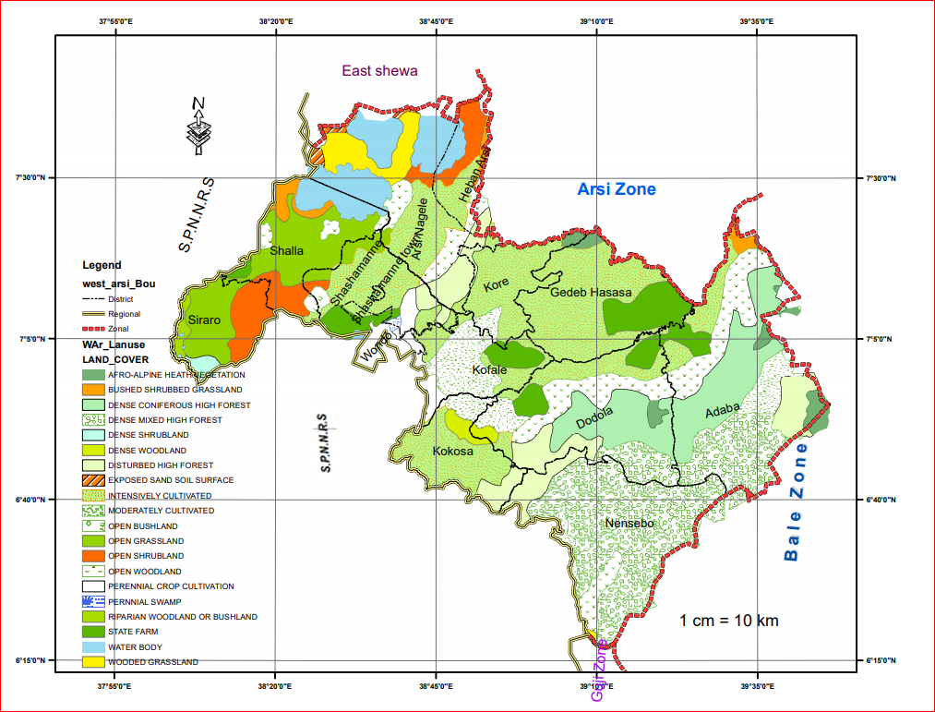

Source Geographic Information System Data

### Crop production

#### 3.2.6.1 Private agricultural Holding

This sub-sector includes fragmented privately owned agricultural holding on which all types of crop production are performed by the operator/ holder to obtain agricultural Production for the self reliance

Climatic factors of the Zone is suitable for the production of crops such as Wheat, Barely, Sorghum, Oats, Chickpeas, Linseed, Millet and other crops.

Cereals are the major food crops both in terms of the area they are planted and volume of production obtained. They are produced in larger volume compared with other crops because they are the principal staple crops. Cereals are grown in all portions of the Zone with varying quantity.

Oilseeds are also grown to flavor the food consumed at home and earn some cash for peasant holders in the Zone.

The total Land areas occupied by peasant holdings in 2010/2011 and 2011/2012 were 342,730.45 hect and 350,538.85 respectively .Similarly11,959,367.49 and11,576,155.70 quintals of various crops were obtained from agriculture in the year mentioned above respectively. Rain fed agriculture is the dominants crops production system of the zone.

Table 3.5 Estimates of area cultivated and production of major crops for peasant holdings

|  |  |  |  |  |  |
| --- | --- | --- | --- | --- | --- |
| S/N | Major Crops | Meher | | | |
| Year 2009/2010 | | Year 2011/2012 | |
| Area cultivated (ha.) | Production yield (Kunt.) | Area cultivated (ha.) | Production yield (Kunt.) |
| A | Cereals |  |  |  |  |
|  | Teff | 20047.2 | 288630.5 | 20538 | 189499.2 |
|  | Bread Wheat | 105777 | 4290408 | 109445 | 4427993.1 |
|  | Barley |  |  |  |  |
|  | Food barley | 47206.2 | 1468274 | 39755.5 | 1251914.4 |
|  | Beer barley | 40119.9 | 1570906 | 49577.8 | 1912151.7 |
|  | Finger millet | 3747.5 | 82780.2 | 4873.5 | 100737.7 |
|  | Oat | 473 | 10839.5 | 434 | 10703 |
|  | Stok cereals |  |  |  |  |
|  | Maize | 84,294.50 | 3306604 | 81742.8 | 2972680.5 |
|  | Millet | 2565.5 | 59364.6 | 1670.25 | 28031.2 |
| B | Pulses |  |  |  |  |
|  | Faba beans/ horse beans | 4838.65 | 92624.29 | 5476.75 | 93444.9 |
|  | Field peas | 2236.05 | 42400.95 | 2391.5 | 47421.2 |
|  | Lantiles | 201.25 | 2812.25 | 197.25 | 2537 |
|  | Haricot bean | 24224.2 | 539511.7 | 27392 | 452274.3 |
|  | Cheack pea | 590 | 111620 | 440 | 8353.5 |
|  | Vetch | 0 | 0 | 0 | 0 |
|  | Soya bean | 0 | 0 | 0 | 0 |
| C | Oil Seeds |  |  |  |  |
|  | Nug | 90 | 920 | 121 | 1331 |
|  | Sesame | 0 | 0 | 0 | 0 |
|  | Linseed | 6159.9 | 89435 | 6333 | 75628.5 |
|  | Rape seed | 159.6 | 2236.5 | 150.5 | 1454.5 |
|  | Grount nut | 0 | 0 | 0 | 0 |
|  | Total | 342,730.45 | 11,959,367.49 | 350,538.85 | 11,576,155.70 |

Source Zone Agriculture and Natural resource Office.

From the above table, we can see that, the land cultivated in the cropping year 2012 has increased by7858 hectare from the previous cropping period of 2011 and the amount of production for the cropping year of 2012 has decreased by 383212 quintal from the previous production year .

The reduction in agricultural productivity is generally considered to be the results of a more un favorable climatic condition occurred at mentioned production years.

#### 3.2.6.2 Fertilizer, Improved seed Pesticides distributed to Farmers

Productivity of land may be raised by applying input packages consisting of improved seeds, fertilizers, agro-chemicals and labour intensive methods.

**Improved seed**_ Is defined as crop variety, which gives significantly higher yield, better quality and/or better benefit compared to traditional varieties of seeds, and usually produced by the Ethiopian Seed Enterprise (ESE) .

**Fertilizer** _Refers to anything added to the soil intended to increase the amount of plant nutrients available for crop growth. Usually fertilizer are divided into two parts, Natural and commercial Examples of natural fertilizers are farmyard manure and wood ashes while commercial fertilizer are DAP(Di–Ammonium phosphate) and UREA(Ammonium Nitrate

**Pesticides**_Pesticides are chemicals useful for the mitigation, control or elimination of pests which are troublesome or harmful to crop. Insecticides and fungicides are all considered as pesticides

The data of fertilizer, pesticides and herbicides presented in the following table do not reflect the actual amount utilized by the farmers of the Zone because some farmers might buy from private traders. The given data represents only amount distributed by cooperative and agricultural office

Table- 3.6 Fertilizers, Improved Seeds, Horticultural seeds and pesticides distributed to farmers.

|  |  |  |  |
| --- | --- | --- | --- |
| Input distributed | Qun | Number of inputs distributed | |
| 20009/2010 | 2011/2012 |
|
| Fertilizers | Quintals |  |  |
| * Dap | Quintals | 8145 | 955 |
| * Urea | Quintals | 1032.5 | 1680 |
| **Improved seeds** | Quintals | 606,048 | 475,797 |
| Pesticides |  |  |  |
| Liquid (liter) | Lit/kg | 93,425 | 70,262 |
| Herbicide (liter) | Lit/kg |  |  |
| Liquid (liter) | Lit/kg | 722,584 | 1,261,887 |

Source Zone Agriculture and Natural resource Office.

#### 3.2.6.3. Method of maintaining soil fertility

There are indigenous techniques of maintaining Soil fertility by local farmers. Among the techniques Using plant residues, manure, crop rotation , and fallowing land are traditional way of maintaining soil fertility while the modern techniques of Soils conservation are contour plough and making upper plot running water aversion ditch but Soil bund making, planting trees, terracing and planting grass Strips in Supply plots are categorizing to modern method of Soil Conservation techniques while Fertilizer is common way to maintaining Soil fertility in the Zone.

#### 3.2.6.4 Soil Conservation

Organic Farming, system of agriculture that uses environmentally sound techniques for raising crops and livestock that are free from most synthetic pesticides, growth hormones, and antibiotics Organic farmers typically rely on pesticides and fertilizers derived from plants, animal wastes, and minerals. They incorporate biological methods, such as the use of one organism to suppress another, to help control pests. The methods used in organic farming seek to increase soil fertility, and reduce air, soil, and water pollution. The main maintaining of Soil and Water Conservation in the Zone are Soil bund construction, seedling plantation, Terrace construction and Check dam construction

#### 3.2.6.5 Agricultural Activities and Calendar of the Zone

A major characteristic of Ethiopian agricultural is the existence of two well- known crop production seasons referred to as the meher (or main) and Belg (short rain). The generally accepted definition of the meher season is that of the long rainy seasons, which normally occurs from June to September. The Belg season most often refers to small but timely rainy season, which normally occurs from February to May but in limited areas of the zone.

Generally, the meher season rainy period provides ideal growing conditions for the longer maturing crops. Harvest of meher crops can extend to December or January in some areas. Most of the time holders rely on short maturing crops for planting during the Belg rainy period and harvest of the crops is in June or July .Belg cropping practices are heterogeneous across different portions of the Zone . The nature of the sawing period also overlaps with some of the meher season crops. Consequently, the report on Belg season crops in the past faced a problem of a clearly defined growing period

In the Zone there are so many crops under cultivation having different cropping sequences and calendar. The time of performing agricultural activities such as land preparation, planting, weeding and harvesting vary depending on the type of crop. On average it takes about four to five months from land preparation to harvesting dates Mehar in highland areas depending on variety, duration of rain and wind status.

Table 3.7..Time and round of land preparation for Major Crops

|  |  |  |  |
| --- | --- | --- | --- |
| No | Types of activities | Meher Season | Belg Season |
| 1 | Land preparation | February _March | Jan-Feb |
| 2 | Planting (Sowing) | Apr –July | Jan-Apr |
| 3 | Weeding | May-Sep | March-July |
| 4 | Harvesting | Sep-January |  |

Source Zone Agriculture and Natural resource Office and personal experience

#### 3.2.6.6 Land Holding Size of House Holds in Hectare

A household is considered an agricultural household when at least one member of the household is engaged in growing crops and /or breeding and raising livestock in private or in partnership with others.

A holder is a person who exercises management control over theoperations of the agricultural holding and takes the major decision regarding the utilization of the available resources. He/ She also has technical and economic responsibility for the holding.

Holding: A holding is all the land and/or livestock kept which is used wholly orpartly for agricultural production and is operated as one technical unit by one person alone, or with others, without regard to title, legal form, size or location.

According to the data obtained from Zone Agriculture and Natural resourceOffice average land holding size of the Peasant is 1.8% hectare . But this does not show equal distribution of land for there is considerable differences among the households as to the share of the land . Hence 7.1% of households have insignificant land less than or equal to 0.5 hec .47% of them have between 1 hectare and 2.5% hectare . 32.8%have between 3.5% and 4.5 %hectare. Finally only 12.8% house holds have greater than 4.5% hectare. Generally Shortage of Agricultural land seems a serious problem in the Zone.

#### 3.2.6.7 Major Crop Diseases and pest

There are a number of pre harvest and post harvest Agricultural losses due to diseases and pests. There are a diseases (fungal) which are extremely harming the productivity of the Zone crops. The most prevalent crops diseases harming the productivity of crops in the Zone includes corn head and loose smut, Wheat and Barley Yellow rust, stem rust and brown rust and Maize ear rots.

#### 3.2.6.8 Number of Development Agents

Rural development is often discussed together with agricultural development and agricultural extension. It combines educational methodologies, communication and group techniques in promoting agricultural and rural development. It includes technology transfer, facilitation, and advisory services as well as information services and adult education.

When systematically and effectively provided, extension is known to enhance social and economic development. To attain this, at present Development Agents trained in agronomy and livestock development have already been commandeered to take on tasks involving construction of postharvest on-farm infrastructure, marketing and processing, farm management and the organization of farmers into special agricultural interest groups. Preparation in these areas requires in-depth knowledge, positive attitudes and special skills training, and selectivity as to which agents are likely to respond well to such training.

Table 3.8 Number of Development Agents in the Zone are elaborated as follows

|  |  |  |  |
| --- | --- | --- | --- |
| Year | Male | Female | Total |
| 2011 | 721 | 162 | 883 |
| 2012 | 744 | 136 | 880 |

Source:-Agricultural And Natural Resources Office

#### 3.2.6.9 Major Agricultural Constraints.

There are a number of agricultural Production losses at different operational times such as pre-harvest, harvest and post-harvest. Agricultural losses are due to weeds, diseases and pests.

**Diseases**_ Plant Diseases caused by biotic (living) agents like fungi, bacteria, viruses, nematodes and parasitic plants and a biotic (nonliving) factors such as nutrient deficien­cies, lack of water, temperature stress and combinations of these problems as they relate to specific types of plants or a combination of the two.

**Weeds**_ Weeds are undesirable plants growing out of place. Weeds can be sometimes harmful both to human and animals. There two types of weeds based on their morphological structures, namely broad leaves and grass weeds.

* **Broad Leaved Weeds**_ The Most common Broad Leaved Weeds in many Districts under the zone are Galiumspurium, Amaranthushybridus, Argemoneochroleuca, Rumexspp, Rumexcrispus, Rumexobtusilolius, Chrysantemumsegatum, etc.

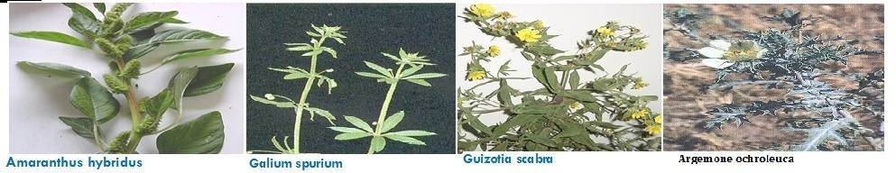

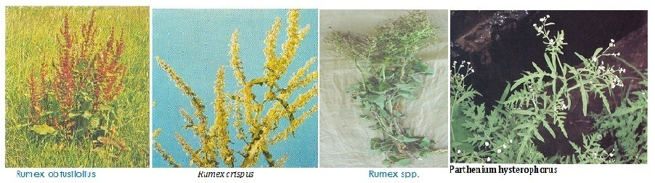

* **Grass type Weeds**_Some Grass type Weeds are Snow deniapoly stachya, Avenafatua, Setariaspp, Loliumtemulentum, etc.

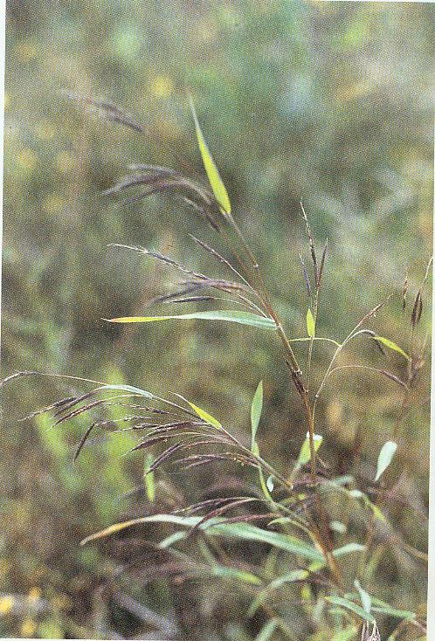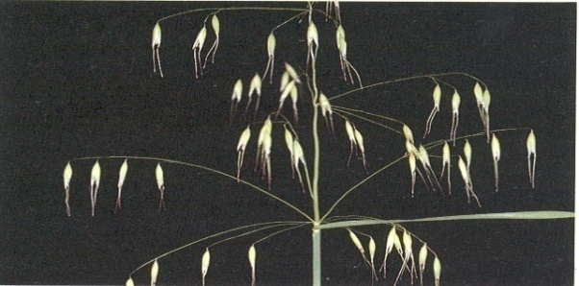

Snow deniapoly stachya Avenafatua

In addition to the culture of utilizing complete agricultural inputs like improved seeds, recommended ratio of fertilizer to specific agro-ecology, proper agronomic practice and pre-harvest, harvest and post-harvest handling technology is not developed to the desirable standard in the Zone to enhance production and productivity of agriculture.

Shortage of agricultural input, Shortage of oxen, shortage of farm land due to high agricultural density of population and lack of Soil fertility due to erosion are also another agricultural Constrains.

**Distribution of FTC /Total Coverage FTC in West Arsi Zone**

|  |  |  |  |  |
| --- | --- | --- | --- | --- |
| **S/N** | **Zone Name** | **Number PA’s** | **Number of FTC in the Zone** | **Remark** |
|  | **West Arsi** | **324** | **221** |  |
|  |  |  |  |  |

Map 3.2 Distribution of FTC

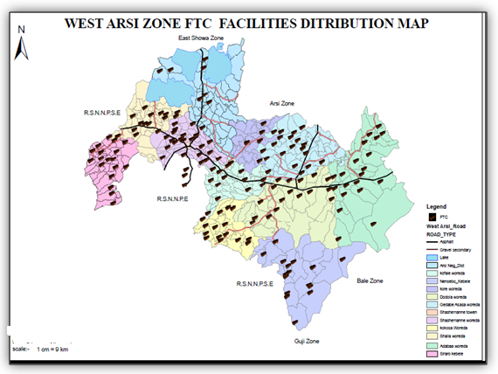

### 3.2.7 .Livestock and Bee keeping

#### 3.2.7.1 Livestock

Livestock plays an important role in providing export commodities, such as live animals, hides, and skins to earn foreign exchanges to the country. On the other hand, draught animals provide power for the cultivation of the smallholdings and for crop threshing virtually all over the country and are also essential modes of transport to take holders and their families long-distances, to convey their agricultural products to the market places and bring back their domestic necessities.

The rural lively hold is highly depends on animal husbandry and crop production mostly interrelated or (Supports to each other) most farming activities (Plowing, crashing and transporting) are done by means of livestock in the district. The Zone has different livestock population but, livestock extension package of dairy and beef farms development were not well adapted in the . The major livestock’s feeds in the Zone are grazing land, crop residual, and bush browning. There is gradual declining of pastureland and currently reaching to the maximum level particularly due to the expansion of farm land.

#### 3.2.7.2. Beekeeping

Bee-keeping farming is another source of income for farmer family. However, rapid deforestation rate and lack of enough moisture, herbicides and insecticides sprayed for weeds are the main problems in bee farming.

**Table-3.9.- Number of Livestock and poultry (for private holdings) in the Zone**

|  |  |  |  |
| --- | --- | --- | --- |
|  | Types of livestock’s | 2011 | 2012 |
| 1 | Cattle | 3,352,768 | 3,338123 |
| 2 | Goats | 411,752 | 413,969 |
| 3 | Sheep | 891,024 | 291,140 |
| 4 | Horse | 293,342 | 291,140 |
| 5 | Mules | 6799 | 6325 |
| 6 | Donkeys | 197,368 | 196,359 |
| 7 | Camels | 134 | 134 |
| 8 | Poultry | 1,134,292 | 1,156,258 |
| 9 | Beehives | **251,620** | **260,492** |
|  | * Traditional | 213,875 | 214,120 |
|  | * Transitional | 23493 | 31212 |
|  | * Modern | 14,252 | 15,160 |

Source: West Arsi Zone Livestock & fishery resource Dev't and Office

### .Livestock Diseases

Animal Diseases have numerous negative impacts on productivity of herds i.e. death of animals, loss of weights, slow down growth, poor fertility performance, decrease in physical power and the likes.

According to the information of Zone Livestock development agency the major animal diseases in the Zone according to their occurrence and distribution from the most frequent to the least includes

1. Lumpy skin disease
2. Anthrax
3. Pasteurellosis (Bovine and ovine)
4. Sheep & goat pox
5. African horse sickness
6. Newcastle disease
7. PPR
8. internal parasites ,
9. External parasites
10. Mastitis

As to the same source there have been many ways of fighting against diseases and among these, vaccinations (preventive measures) and treatments (curative measures) are the major ones.To reduce the prevalence of such diseases different vaccination and treatments have been given at different parts ofthe Zone.

Table__3.10. Availability of animal health institutions by type

|  |  |  |  |  |  |  |  |  |  |
| --- | --- | --- | --- | --- | --- | --- | --- | --- | --- |
|  | *Name of districts* | *Number of clinic and Type* | | | | | *Number of veterinary* | | |
| *"A''* | *"B’* | *"C'’* | *"D'’* | *Non Standared* | *DVM* | *Health  Assistant* | *Health  Technician* |
| *1* | *Adaba* | *0* | *1* | *1* | *7* | *0* | *6* | *15* | *2* |
| *2* | *ArsiNegelle* | *0* | *1* | *1* | *8* | *11* | *3* | *24* | *0* |
| *3* | *Dodola* | *0* | *1* | *1* | *7* | *3* | *0* | *17* |  |
| *4* | *GedebHasasa* | *0* | *1* | *1* | *5* | *4* | *4* | *15* | *1* |
| *5* | *Kofale* | *0* | *1* | *0* | *4* | *9* | *4* | *16* | *2* |
| *6* | *Kokossa* | *0* | *1* | *0* | *11* | *0* | *3* | *14* | *2* |
| *7* | *Nansabo* | *0* | *0* | *1* | *10* | *3* | *2* | *15* | *0* |
| *8* | *Kore* | *0* | *0* | *1* | *3* | *6* | *4* | *13* | *5* |
| *9* | *Shalla* | *0* | *0* | *1* | *5* | *7* | *3* | *20* | *1* |
| *10* | *Shashemene* | *0* | *0* | *1* | *9* | *5* | *5* | *19* | *0* |
| *11* | *Siraro* | *0* | *0* | *1* | *5* | *2* | *3* | *7* | *0* |
| *12* | *Wondo* | *0* | *0* | *1* | *2* | *4* | *4* | *12* |  |
| *13* | *HeebanArsii* | *0* | *0* | *0* | *2* | *3* | *3* | *5* | *0* |
|  | *Total( Zone)* | *0* | *6* | *10* | *78* | *57* | *44* | *192* | *7* |

Source: West Arsi Zone Livestock & fishery resource Dev't and Office

## 3.3.Mining and Industry

### 3.3.1.Mining

Mining involves the extraction of mineral bearing substance from the crust of the earth. Minerals are naturally occurring organic and inorganic substance which forms an important part of natural resources

At present the mineral resources of West Arsi Zone is not identified well and surveyed. These are because at zonal level mineral prospecting and mapping requiring a huge capital and skilled human power. But currently several type of minerals( metallic , Non metallic , Construction and Energy mineral ) are identified by local and other people in different parts of the zone .

Among such mineral Gold , spring Mineral, lime stone and lignite are widely available in the zone

**3.11 Some common mineral and Rock that found in West Arsi Zone**

|  |
| --- |
| *Woreda*Mineral*Kebele*Specific name of place  *A/Negalle*………Pumice &Ignimbrite *………BasakaIlala………*MalkaShayi&MadaraBasaku  *Kore…………* Pumice &Ignimbrite *……………. Bole Hilensa…………Chabi*  Shashemene……… Ignimbrite ……. AwashoAnko…………Burka Shumbulo  Nansabo…………… Gold & spring Mineral……… Bedesa&Bulga…… Bedesa  *Shalla …………………… Sand ………………………….Bunge…………*  *A/Nagelle…………………….Sand*  *G/Hasasa……………………….Sand* |

Source: Zone and districts water office

### 3.3.2.Industry-

The development of the industrial sector can play a great contribution in creating job opportunity, income generation, utilizing the locally available raw materials and improving the technological inputs for different economic sector as well as for import substitution. Basically, there are three types of industrial classification based on the level of activities. Namely; large scale industry, small and medium scale industry, and cottage and hand craft industry. Out of these classifications, those which are found in the study ZoneareMedium&Small scale industries type of Oil refinery,Coffee purple machine , Flour Manufacturing Blocket Manufacturing grain mill, Furniture and equipment

***Tale 3.12.Number of Medium & Small Scale Establishments by Type of Factory***

|  |  |  |  |  |  |
| --- | --- | --- | --- | --- | --- |
| Type of factory | Number of establishment | | | Type of ownership | |
|
| Private | Public | Total | Foreign | Domestic |
| Blocket Manufacturing | 7 | 0 | 7 | 0 | 7 |
| Flour Manufacturing | 8 | 0 | 8 | 0 | 8 |
| Furniture and equipment | 5 | 0 | 5 | 0 | 5 |
| Coffee purple machine | 30 | 0 | 30 | 0 | 30 |
| Oil refinery | 0 | 0 | 0 | 0 | 0 |

Source: West Arsi Zone IndustryPromotion& Development office

**3.4.Infrastructure and Social facilities**

Infrastructure is economic and social underpinnings of a community or nation .Elements of infrastructure include systems of transportation, power generation, communications, banking, education, and health.

### 3.4.1.Transport and Communication

#### 3.4.1.1. Transportaion _

Transportation is movement of people and goods from one location to another. Transportation systems and the routes they use have greatly influenced both how and where people live. Reliable transportation allows a population to expand throughout a country’s territory and to live comfortably in remote areas far from factories and farms.

When come to the specific Zone regarding the availability of the transport there is no sufficient Vehicles which can transport passengers from place to place within the Districts under the Zone especially to transport to different Peasant Associations connected by intra roads. . However, there are a lot of horse drawn carts and few bajajs which transport people from place to place within the Districts. Carts also transport goods and passengers from market to home within towns and from Town to Rural kebles across the intra gravel roads and they are the main means of transportation .

#### 3.4.1.2. Road

Road is Path established over land for the movement of vehicles, people, and animals. Roads provide dependable pathways for moving people and goods from one place to another.

The increment of road and transportation is the main factors that facilitate the growth and the development of one area. Accordingly, at the moment, the government has facilitated the construction of new roads and has improved the existing road throughout the country to increases the proximity of urban to urban, urban to rural and rural to rural.

Regarding the Road of West Arsi Zone there is the national asphalted highway that crosses the Zone (about 351.59 km length).The gravel surface intra Rural roads constructed to connect urban to rural and rural to rural administrative divisions of the Zone accounts about **1805.7**km.

However many intra local /feeder roads/ connecting administrative divisions/ areas of the Zone are not properly made. As a result, roads are muddy and hold water at rainy season, which affects free movement of the residents. For this reason, motorized traffic movement is limited especially during rainy seasons..

**Table 3.12. Length of West Arsi Zone Roads by Types**

|  |  |  |  |  |  |  |
| --- | --- | --- | --- | --- | --- | --- |
| S/N | Name of District | Asphalt | Gravel | Cobol Stone | All weather weather Road | Dry Weather Road |
| 1 | Adaba | 40 | 141.6 | 0 | 181.6 | 148.9 |
| 2 | NageleArsi | 47 | 150.7 | 0 | 197.7 | 108.5 |
| 3 | NageleArsi Town | 0.6 | 26.0 | 3 | 29.6 | 0 |
| 4 | Dodola | 45 | 133.2 | 0 | 178.2 | 197.4 |
| 5 | Dodola Town | 3.5 | 11.0 | 2.8 | 17.3 | 0 |
| 6 | G.Hasasa | 35 | 177.9 | 0 | 212.9 | 176.5 |
| 7 | Kofale | 28 | 135.6 | 0 | 163.6 | 164.8 |
| 8 | Kokosa | 0 | 90.7 | 0 | 90.7 | 146 |
| 9 | Nansabo | 0 | 111.6 | 0 | 111.6 | 132.31 |
| 10 | Qore | 0 | 160.0 | 0 | 160 | 98.92 |
| 11 | Shalla | 16 | 150.1 | 0 | 166.1 | 180.6 |
| 12 | Shashamane | 86 | 207.4 | 0 | 293.4 | 201 |
| 13 | BishaanGurach Town | 2 | 20.0 | 3 | 25 | 0 |
| 14 | Siraro | 0 | 115.7 | 0 | 115.7 | 165 |
| 15 | Wondo | 17 | 107.5 | 0 | 124.5 | 95.8 |
| 16 | HebanArsi | 0 | 58.2 | 0 | 58.2 | 68.77 |
| 17 | Sheshamane Town | 31.49 | 8.5 | 103.9 | 143.89 | 0 |
|  | Total | 351.59 | 1805.7 | 112.7 | 2269.99 | 1884.5 |

*Source: West Arsi Zone Road Autority.*

#### 3.4.1.2_Communication:

Communication is the process of sharing ideas, information, and messages with others in a particular time and place. The developments of communication service enhance the people as to have update information about their day to day life.

So, When come to under study District, the following are the major type of communication.

**Telephone** _ telephone is a telecommunication device that transmit and receives sound most commonly human voice ~~.~~Example fixed automatic telephone and Mobile phone.

In case of fixed telephone service, only few towns get fixed automatic telephone lines service and other many towns and all peasant Associations do not get the service. Therefore, for the fact that the pace of provision of fixed telephone lines could not cope with the fast growth rate of the Zone, the Corporation has to expand its fixed automatic telephone lines service in the Zone.

Concerning mobilenetwork coverage, even though Data for the mobile Telephone service in a Zone, is not fully available, it is the most Communication tool for many people almost in all administrative divisions of the Zone. However, a mobile telephone service is associated with poor network and insufficient mobile network coverage especially in the remotest Districts of Peasant Associations

Therefore, to go with ever increasing development at the area, the concerned bodies need to give due attention to improve communication of Mobile network and expand fixed telephone lines that help to strength rural-urban linkage and would provide an opportunity to accessible market information for agricultural products and thus strengthen rural economies.

**Postal service** _ Postal service the cheapest means of communication, is not available in many Districts under the the Zone. Therefore, to go with ever increasing development at the area, the concerned bodies need to give due attention on providing service as soon as possible.

Table 3.14.Number and Type of post Offices and Post Boxes

|  |  |  |  |  |
| --- | --- | --- | --- | --- |
| West Arsi Zone | Type of Post Offices | | | |
|  | Permanent Agent | Regular Agent | Post Office | Total |
| 2011 |  | 3 | 3 | 3 |
| 2012 |  | 3 | 3 | 3 |

Source

### 3.4.2.Water and Energy Supply

#### 3.4.2.1.Water

As the demand for pure water increase in our country; particularly in our region the government strives to supply adequate potable water to the community to have strong, healthy,productive, and generally to maintain the well being of a population***.***

Some years ago people of the Zone found complaining that the production and supply of pure water was so small to cover the demand. Thus, it is possible to say that the provision of pure water was hardly enough for home consumption;

However, at present the problem of potable and clean water in the Zone is improving step by step. Water Supply coverage of the Zone which was 45.06% in the town and 52.78% in the rural areas during the year 2011 increased to 47.71% in the town and 64.99% in the rural areas during the year 2012 E.C. Percentage of Average Total population /Rural+ Urban supplied with potable water which was 50.99% during the year 2011 also increased to 60.92% in the year 2012E.C.The major sources of drinking water are unprotected spring, pond, rivers, well, lakes and tap water in their order of importance.

|  |  |  |  |  |
| --- | --- | --- | --- | --- |
| **Potable water coverage of west Arsi Zone District , Rural, Urban and Total by 2011/2012** | | | | |
| **No** | **Name of District/Towns** | **Rural %** | **Urban %** | **Total %** |
| 1 | Adaaba | 73.07 | 36.70 | 68.18 |
| 2 | Ar/Nag | 96.05 | 55.70 | 92.01 |
| 3 | Mag/Ar/Na | 0.00 | 38.19 | 38.19 |
| 4 | Dodola | 68.37 | 79.20 | 69.35 |
| 5 | Mag/Dodola | 0.00 | 37.36 | 37.36 |
| 6 | Gadab | 52.19 | 58.89 | 53.55 |
| 7 | Heban Arsi | 64.19 | 40.81 | 58.92 |
| 8 | Kofale | 58.05 | 60.66 | 58.32 |
| 9 | Kokosa | 63.50 | 64.85 | 63.65 |
| 10 | Nansabo | 58.01 | 52.88 | 57.59 |
| 11 | Kore | 89.75 | 66.84 | 87.33 |
| 12 | Shalla | 39.05 | 33.37 | 38.45 |
| 13 | Sh/nne | 73.63 | 0.00 | 73.63 |
| 14 | Mag/Sha/ne | 0.00 | 44.86 | 44.86 |
| 15 | Siraro | 35.95 | 17.52 | 34.25 |
| 16 | Wondo | 84.25 | 64.17 | 81.92 |
| 17 | Mag/Bish/Gu | 0.00 | 60.19 | 60.19 |
|  | **Total Zonal** | **64.99** | **47.71** | **60.92** |

**Table -3.15_Urban + Rural Supplied with Potable water in the Zone**

|  |  |  |  |  |  |  |  |
| --- | --- | --- | --- | --- | --- | --- | --- |
|  | **Year** | **population size of the Zonre** | | | **Population access to potable water in percent** | | |
|  |
|  | **Rural** | **Urban** | **Total** | **Rural %** | **Urban%** | **Total %** |
|  | 2011 | 2,104,579 | 634,200 | 2,738,779 | 52.78 | 45.06 | 50.99 |
|  | 2012 | 2,243,987 | 692,404 | 2,936,391 | 64.99 | 47.71 | 60.92 |
| Source- West Arsi Zone and District water and Energy Resource Development Office | | | | | | | |

According to the information obtained from the Zone water, Mineral and Energy office in 2012E.C. there were 76 deep wells, 103 Shallow wells fitted with hand pump 1307 hand dug fitted with hand pump,605 spring on spot are existed and functional Schemes at present in the Zone

Table.3.15 Functional Water schemes by 2011/2012

|  |  |  |  |  |  |  |  |  |
| --- | --- | --- | --- | --- | --- | --- | --- | --- |
|  | | | | | | | | |
| lakk | Name of District/Towns | Total | Iskimoota Bishaan tajaajila kennaa jiran | | | | | |
| Deep wells | Shallow well | Hand dug well fitted with hand pump | Motorized and gravity spring | spring on spot | River diversion |
| 1 | Adaba | 218 | 7 | 5 | 129 | 6 | 71 |  |
| 2 | Negelle Arsii | 119 | 10 | 12 | 54 | 2 | 41 |  |
| 3 | Dodola | 274 | 9 | 15 | 178 | 1 | 71 |  |
| 4 | Gadab Hasasa | 272 | 4 | 58 | 197 | 7 | 6 |  |
| 5 | Kofele | 276 | 7 | 6 | 247 | 0 | 16 |  |
| 6 | Kokosa | 328 | 2 | 0 | 196 | 3 | 127 |  |
| 7 | Qore | 257 | 1 | 0 | 187 | 1 | 68 |  |
| 8 | Nensebo | 163 | 0 | 0 | 0 | 23 | 140 |  |
| 9 | Shashemene | 131 | 6 | 7 | 88 | 1 | 29 |  |
| 10 | Shalla | 4 | 4 | 0 | 0 | 0 | 0 |  |
| 11 | Siraro | 16 | 16 | 0 | 0 | 0 | 0 |  |
| 12 | Heban Arsi | 7 | 0 | 0 | 0 | 4 | 3 |  |
| 13 | Wondo | 65 | 0 | 0 | 31 | 1 | 33 |  |
| 14 | Mag/Shashemene | 5 | 4 | 0 | 0 | 0 | 0 | 1 |
| 15 | Mag/Arsi Nagelle | 6 | 6 | 0 | 0 | 0 | 0 |  |
| 16 | Mag/Dodola | 1 |  | 0 | 0 | 1 | 0 |  |
| 17 | Mag/Bishan Guracha Town | 1 |  | 0 | 0 | 1 | 0 |  |
|  |  | **2143** | **76** | **103** | **1307** | **51** | **605** | **1** |

Source- West Arsi Zone and District water and Energy Resource Development Office

Generally, even though currently the problem of potable have already showed some improvement, the problem is however, the people found complaining that the production and supply of pure water was so small to cover the demand. Thus, it is possible to say that the provision of pure water was hardly enough for home consumption. Therefore , the starts need much more attentions from every perspective on providing adequate potable water to the community of the Zoneas soon as possible***.***

#### 3.4.2.2.Energy Supply

Energy sources can be traditional or modern. The major local energy sources are firewood, animal dung charcoal and farm residue both in rural and urban areas of the zone, according to their order of importance, which consequently intensifies deforestation rate and minimize the role of manures as natural fertilizer in the zone. The modern energy sources are electricity, biogas, fossil fuel and solar energy.

|  |  |  |  |  |  |
| --- | --- | --- | --- | --- | --- |
| Table 3.17. Rural PA's supplied with electricity in the zone | | | | | |
| **No** | **Year** | Number of PA's and Towns in the Zone | Number of PA's and towns supplied with electricity | Coverage of the Zone | Source of power |
| 1 | 2011 | 371 | 159 | 42.9 | hydro power |
| 2 | 2012 | 371 | 163 | 43.9 | hydro power |
| Source- West Arsi Zone and District water and Energy Resource Development Office | | | | | |

Data gained from the Zone water, Mineral and Energy office indicates that about43.9Percent of rural population supplied with electricity, ~~50%~~ of total population uses kerosene for house light and 100% uses wood as a source of energy for cooking purposes. As to the same source abut**62**Percent of urban population supplied with electricity at the moment. Many households haven’t gotten a “chance” to have their own power meter; suddenly, many are still waiting till they “win the chance even in the Towns. Hence, the dwellers are not benefiting from the service; thus, suffers from the lack of lighting and power that were needed for home consumption as well. Consequently, they were forced to use local energy like charcoal, firewood, animal dung, farm residue , and petroleum as a source of energy both in rural and urban areas of the Districts under a Zone.

|  |  |  |  |
| --- | --- | --- | --- |
| Table3.18 Domestic energy supply of West Arsi zone | | | |
| No | Domestic energy supply | Rank | |
| Rural | Urban |
| 1 | Fire wood | 1 | 4 |
| 2 | Crop residue | 3 | 5 |
| 3 | Dung | 2 | 6 |
| 4 | Charcoal | 6 | 2 |
| 5 | Electric | 5 | 1 |
| 6 | Diesel | 4 | 3 |
| Source- West Arsi Zone and District water and Energy Resource Development Office | | | | |

Fuel Station and their Capacity by Types of Fuels by Wereda/Zone

|  |  |  |  |  |
| --- | --- | --- | --- | --- |
| West Arsi Zone | Name Fuel Station | Litter | | |
| Benzene | Kerosene | Gas oil |
| Adaba | mobil | 10000 | 450000 | 10000 |
| Ar/Nagelle | Total | 50000 | 300000 | 100000 |
| mobil | 22000 | 20000 | 80000 |
| Shashemene | mobil | 50000 | 450000 | 150000 |
| Total | 50000 | 500000 | 150000 |
| Dodola Town | Nock | 22000 | 32000 | 110000 |
| yetababarut | 100000 | 100000 | 180000 |
| Total | 304000 | 1852000 | 49000 |

Source: West Arsi Zone and districts water, energy & mineral office

Therefore for sustainable development is to be maintained within the Zone , the starts need much more attentions from every concerned bodies.

### 3.4.3. Education

Education plays a key roles in ability of developing country to absorb modern technology and to develop the capacity of self-sustaining growth and development. It has played appositive role in the development of society by creativity and innovation. . But In developing countries schools face a lot of problems in carrying out their duties and responsibilities. The Education System in Ethiopia also suffering from quality and Relevance efficiency. The problem cause dissatisfaction and critics from stake holders.

It is for this reason that the whole developing countries that are lagging much behind than developed countries are striving to provide basic education for all of their citizens;

To attain this goal, the Ethiopian government already has set strategies like increasing public awareness and participation towards this sector, constructing additional schools, having appropriate teaching materials and qualified teachers, minimizing the distance travelled to arrive at schools and creating better relationship among the beneficiaries and the schools are among the identified decisive factors.

When we come to the specific Zone under study, there are a number of efforts that have been made to realize the mentioned international and national goal; “education for all. Some of the education jobs associated to the pointed out objectives like additional number of sections constructed so far by community participation, were helpful for achieving this goal.

#### 3.4.3.1 School distribution

Provision of primary education and improving secondary education is the focal area of educational goals of Oromia region. This can be achieved through expansion of schools and reduce local disparities of schools as a key strategy.

Quality , Equity and access are also one of the objectives of the strategy is re-arranging the Management and organization of the education system so as to make de -centralized and Co-ordinate ,participatory and efficient.

This requires the effectiveness and Commitment of all the Stake holders Particularly of the teachers , the School Leader ship and Management aiming at helping and improving all students to raise their broad out comes through School improvement

Table_3.9_Number of kindergarten, primary schools, senior secondary schools

|  |  |  |  |  |  |  |  |
| --- | --- | --- | --- | --- | --- | --- | --- |
| No | level of school | 2011 | | | 2012 | | |
|  |  | Gov | NGO | Privet | Gov | NGO | Privet |
|  | Kindergarten | 6 | 23 | 45 | 4 | 29 | 48 |
|  | Primary (1-4) | 150 | 9 | 14 | 144 | 10 | 17 |
|  | Primary (1-8) | 565 | 16 | 21 | 577 | 15 | 21 |
|  | Secundary (9-12) | 58 | 3 | 6 | 55 | 2 | 4 |
|  | *Technical/Vocational* |  |  |  |  |  |  |
|  |  |  |  |  |  |  |  |

*Source:-ZoneEducation Office*

|  |  |  |  |  |  |  |  |  |
| --- | --- | --- | --- | --- | --- | --- | --- | --- |
| **Government & Non-Government** | | | |  |  |  |  |  |
| **West Arsi Zone** | **Primary School (1-8)** | | | | **Secondary School (9-12)** | | | |
| **First Cycle** | | **Second Cycle** | | **First Cycle** | | **Second Cycle** | |
| 7-10) | | 11-14) | | 15 - 16 | | 17 - 18 | |
| **M** | **F** | **M** | **F** | M | **F** | **M** | **F** |
| 2011 | 173754 | 155858 | 66528 | 55675 | 8040 | 6409 | 2136 | 1386 |
| 2012 | 178720 | 163717 | 72962 | 62318 | 7915 | 6676 | 5187 | 3301 |

*Source:-ZoneEducation Office*

#### 3.4.3.2. Students Enrollment

Previously West Arsi Zone had low enrollment rate Persistent disparity between sex, High rate of drop out, Wastage of resource and efficiency of system, However, based on activities done by government intervention , strong participation of Community and private organizations in last few years a lot of changes achieved regarding creating access to education, improving quality education, improving equity, and enhancing internal efficiency in our zone.This show that the attitude of society changes to wards education.

According to the information obtained from Zone Educational Office, in the Academic year of 2011 and 2012 EC, the total number of students who were attending the regular class in the Zone were 551054 (_298864M and252190F) in 2011EC, 595290(320788M and 274502F) in 2012 EC.

Table_3.20-Number of enrolled students by levels of schools and sex

|  |  |  |  |  |  |  |  |
| --- | --- | --- | --- | --- | --- | --- | --- |
| NO | School level | 2011 | | | 2012 | | |
| Male | Female | Total | male | Female | Total |
| 1 | Kindergarten | 6716 | 6184 | 12900 |  |  |  |
| 2 | Primary (1-4 | 194703 | 172312 | 367015 | 197739 | 179643 | 377382 |
| 3 | Primary (5-8 | 77353 | 62930 | 140283 | 86155 | 71427 | 157582 |
| 4 | Primary (1-8 | 272056 | 235242 | 507298 | 283894 | 251070 | 534964 |
| 5 | Secundary (9-12 | 26808 | 16948 | 43756 | 36894 | 23432 | 60326 |
| 6 | Total | 298864 | 252190 | 551054 | 320788 | 274502 | 595290 |

*Source:-Zone Education Office*

As One can observe from the above table in the Academic year of 2011 and 2012 EC, the number of students who were attended the regular class in all School level has been increasing in the past two respective years and even expected to increase in the future as a result of natural rate of population increase and attitudinal change of the Society towards education

|  |  |  |  |  |  |  |  |  |  |  |  |  |  |  |  |  |  |  |
| --- | --- | --- | --- | --- | --- | --- | --- | --- | --- | --- | --- | --- | --- | --- | --- | --- | --- | --- |
| **A.  Government & Non Government** | | | | | | | | |  | |  | |  | |  | |  | |
| School Level | **2011** | | | | | | | | | | | | | | | | | |
| Number of enrolled students | | | | | | | Number of dropped out students (All Government &Non Government) | | | | | | Number of detained students | | | | |
| (All Government &Non Government) | | | | |
| M | | | F | | T | | M | | F | | T | | M | | F | | T |
| (1-4) | 194703 | | | 172312 | | 367015 | | 16044 | | 12981 | | 29025 | | 178659 | | 159331 | | 337990 |
| (5-8) | 77353 | | | 62930 | | 140283 | | 4467 | | 2647 | | 7114 | | 72886 | | 60283 | | 133169 |
| (1-8) | 272056 | | | 235242 | | 507298 | | 20511 | | 15628 | | 36139 | | 251545 | | 219614 | | 471159 |
| (9-10 | 21467 | | | 13983 | | 3550 | | 1091 | | 700 | | 1791 | | 20376 | | 13283 | | 33659 |
| (11-12) | 5341 | | | 2965 | | 8306 | | 176 | | 56 | | 232 | | 5165 | | 2909 | | 8074 |
| **B  .Government & Non Government** | | | | | | | | |  | |  | |  | |  | |  |
| School Level | | 2012 | | | | | | | | | | | | | | | |
| Number of enrolled students | | | | | Number of dropped out students (All Government &Non Government) | | | | | | Number of detained students | | | | |
| (All Government &Non Government) | | | | |
| M | F | | T | | M | | F | | T | | M | | F | | T |
| (1-4) | | 197739 | 179643 | | 377382 | | 13609 | | 9522 | | 23131 | | 184130 | | 170121 | | 354251 |
| (5-8) | | 86155 | 71427 | | 157582 | | 6356 | | 5015 | | 11371 | | 79799 | | 66412 | | 146211 |
| (1-8) | | 283894 | 251070 | | 534964 | | 19965 | | 14537 | | 34502 | | 263929 | | 236533 | | 500462 |
| (9-12) | | 36894 | 23432 | | 60326 | | 6092 | | 2255 | | 8347 | |  | |  | |  |

**Table 3.21.StudentsParticipation Rate**

|  |  |  |  |  |  |  |  |  |  |  |  |  |  |  |  |  |  |  |  |  |  |  |  |  |  |  |  |
| --- | --- | --- | --- | --- | --- | --- | --- | --- | --- | --- | --- | --- | --- | --- | --- | --- | --- | --- | --- | --- | --- | --- | --- | --- | --- | --- | --- |
| School level | 2011 | | | | | | | | | | | | | | 2012 | | | | | | | | | | | | |
| GER | | | | | | NER | | | | | | | | GER | | | | | | | | | NER | | | |
| M | | F | | T | | M | | F | | T | | | | M | | | F | | | | T | | M | | F | T |
| (1-4) | 120.0 | | 108.2 | | 114.1 | | 107.6 | | 98.2 | | 102.9 | | | | 117.7 | | | 109 | | | | 113.4 | | 103.3 | | 96.8 | 103.3 |
| (5-8) | 56.7 | | 46.4 | | 51.6 | | 48.8 | | 41.0 | | 44.9 | | | | 61.2 | | | 51.2 | | | | 56.2 | | 51.8 | | 44.7 | 48.3 |
| (1-8) | 91.5 | | 80.2 | | 85.9 | | 87.6 | | 77.7 | | 82.7 | | | | 90.0 | | | 80.8 | | | | 85.4 | | 85.3 | | 77.5 | 81.4 |
| (9-10 | 36.2 | | 23.3 | | 29.7 | | 13.6 | | 10.7 | | 12.1 | | | | 36.3 | | | 25.1 | | | | 30.7 | | 12.9 | | 10.8 | 11.9 |
| (11-12) | 9.9 | | 5.4 | | 7.6 | | 4.0 | | 2.5 | | 3.2 | | | | 25.4 | | | 13.6 | | | | 19.5 | | 9.0 | | 5.6 | 7.3 |
| **A.      Literacy Class (ABE)** | | | | | | | | | |  | | |  | | | |  | | | |  | |  | |
| **Phase** | | **2011** | | | | | | | | | | | **2012** | | | | | | | | | | | |
| **Enrollment** | | | | | | | | **Number of ABECs** | | | Enrollment | | | | | | | | | | Number of ABECs | |
| **M** | | **F** | | **T** | | | | **M** | | | | **F** | | | | **T** | |
| 1 | | 4796 | | 3557 | | 8353 | | | | 96 | | | 3844 | | | | 2968 | | | | 6812 | | 81 | |
| 2 | | 1780 | | 1535 | | 3315 | | | | 1456 | | | | 1201 | | | | 2657 | |
| 3 | | 735 | | 603 | | 1338 | | | | 747 | | | | 658 | | | | 1405 | |
| **B.  Integrated Adult Functional Literacy (IFAL)** | | | | | | | | | | | | | | | | |
|  | |  | | | | | |  | |  | |  | | | | | | |  |
| **Year** | | **Number of Adult education centers** | | | | | | **Enrollment** | | | | | | | |  |
| **M** | | **F** | | | | **T** | |  | | | |
| 2011 | | 173 | | | | | | 14362 | | 8022 | | | | 22384 | |  | | | |
| 2012 | | 179 | | | | | | 9331 | | 8832 | | | | 18163 | |  | | | |

##### **3.4.3.2.1 -Gross enrolment rate of the Zone**

Gross enrolment which is a measure of participation the total enrolment in specific level of education , regardless of age expressed as a percentage of the official school age population corresponding to the same level of education in a given school. Since it includes under aged and over aged pupils, GER can be greater than 100%

GER is calculated as

GER = Total enrolment in specific level of education , regardless of age x100

Official school agepopu.corresponding to the same level of education

As shown in table above

* Gross enrolment rate of Primary Education {1_8) which indicate the percentage of total enrolment in Primary schools irrespective of age out of the corresponding Primary school age **(7-14)** population has shown a little increment during the two consecutive years of **2011and 2012**. Accordingly, in **2011** it was **85.4% (M=90.5F=80.2)** and then by showing increment it rose to **85.9% (M=90.7 F=80.7) by 2012 EC**.
* Gross enrolment rate of general secondary Education Grade **(9_12)** that comparers the total number of students in the secondary School with the school age population of this level (**15_18** years old which was **18.7% (M=23%, F=14.4)** in the academic year of **2011** increased to **25.1%** (**M=30.85%,** **F=19.35)** in the academic year of **2012 E.C**

**3.4.3.2.2.Net Enrolment Rate of the Zone**.

NER is the best way of measuring organized timely school participation and is a more refined indicator of school and enrolment coverage in terms of explaining the proportion of pupils enrolled from the official age group. Unlike Gross enrolment rate, it is the rate of the official age group for a given level of education expressed as a percentage of the corresponding school age population . NER is usually lower than the GER since it excludes over-aged and under-aged pupils.

Net enrolment rate is calculated as

NER= Total enrolment in specific level of education with official age group x100

official school age population corresponding to the same level of education

As one can observe from table above

* Net Enrolment Rate in Primary school (1-8) which indicate the percentage of students who enrolled in Primary school, whose age is 7_14, compared to the School age population of this level that is total population of 7_14 years old was **82.7**(**M=87.6 ,F=77.7in 2011** EC decreased to **81.4% in (M=85.3 F=77.5 ) in 2012**.

Thus the reason for the declining of NER in this School level should be identified through research to mitigate the probl

* Net Enrolment Rate in Secondary School (**9_12**) that indicate students enrolled in Secondary Schools whose age is 15_18 and compare it to the total number of population belonging to the mentioned age group which was **7.65%** in **2011** academic year increased to **9.6%in 2012** academic year. However the NER in Secondary is still very low.

**C.Students National Examination & University Entrance Examination Results**

1. **National Examination (EGSCE) 2011**

|  |  |  |  |  |  |  |  |
| --- | --- | --- | --- | --- | --- | --- | --- |
| **Ownership** | 2011 | | | | | | % Promotion |
| **Students registered for exam.** | | | **Promoted to PP** | | |
| **M** | **F** | **T** | **M** | **F** | **T** |
| Government | 8223 | 5238 | 13462 | 7318 | 4551 | 12643 | 93 |
| Non Government | 866 | 866 | 1732 | 819 | 774 | 1593 | 91 |
| Total |  |  |  |  |  |  |  |

1. **National Examination (EGSCE) 2012**

|  |  |  |  |  |  |  |  |
| --- | --- | --- | --- | --- | --- | --- | --- |
| **Ownership** | 2012 | | | | | | **% Promotion** |
| **Students registered for exam.** | | | **Promoted to PP** | | |
| **M** | **F** | **T** | **M** | **F** | **T** |
| Government | 2619 | 1562 | 4181 | 420 | 133 | 553 | 14.29 |
| Non Government | 520 | 319 | 839 | 254 | 152 | 406 | 48.39 |
| Total | 3139 | 1881 | 5020 | 674 | 285 | 959 | 31.34 |

**D.University Entrance**

1. **2011 entrants**

|  |  |  |  |  |  |  |  |
| --- | --- | --- | --- | --- | --- | --- | --- |
| **Ownership** | **2011** | | | | | | **% Promotion** |
| **Students registered for exam.** | | | **Students joined university** | | |
| **M** | **F** | **T** | **M** | **F** | **T** |
| Government | 8223 | 5238 | 13462 | 7318 | 4551 | 12643 | 93 |
| Non Government | 866 | 866 | 1732 | 819 | 774 | 1593 | 91 |
| Total | 8223 | 5238 | 13462 | 7318 | 4551 | 12643 | 93 |

ii. 2012 entrants

|  |  |  |  |  |  |  |  |
| --- | --- | --- | --- | --- | --- | --- | --- |
| **Ownership** | **2012** | | | | | | **% Promotion** |
| **Students registered for exam.** | | | **Students joined university** | | |
| **M** | **F** | **T** | **M** | **F** | **T** |
| Government | 2619 | 1562 | 4181 | 420 | 133 | 553 | 14.29 |
| Non Government | 520 | 319 | 839 | 254 | 152 | 406 | 48.39 |
| Total | 3139 | 1881 | 5020 | 674 | 285 | 959 | 31.34 |

Map_3.3 Distribution of Schools

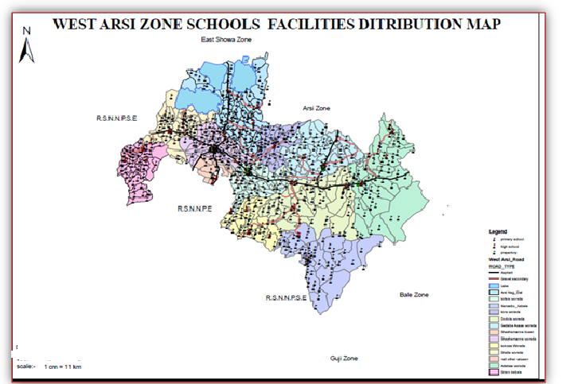

Source:- Zone Education Office and GIS data

#### 3.4.3.3. Teachers’ distribution

Teachers’ are the main or vital teaching and learning media. The teaching and learning process is possible only if there are appropriate teachers. Through these process students are nearest only to the teachers, that they may or may not provide them an appropriate level of knowledge.

Table 3.23..Number of teachers(1-12) by educational level and sex /Gov’t/

|  |  |  |  |  |  |  |  |  |  |
| --- | --- | --- | --- | --- | --- | --- | --- | --- | --- |
| Level | Year | 2011 | | | | 2012 | | | |
| Sex | TTI | Diploma | Degree | Mas | TTI | Diploma | Degree | Mas |
| (1-8) | Male | 452 | 3745 | 817 |  | 605 | 3996 | 885 | 1 |
| Female | 103 | 2188 | 296 |  | 158 | 2188 | 348 | 0 |
| Total | 555 | 5933 | 1113 |  | 763 | 6184 | 1233 | 1 |
| 9_12 | Male |  | 44 | 1091 | 81 | 0 | 38 | 1003 | 101 |
| Female |  | 4 | 139 | 4 | 0 | 6 | 131 | 5 |
| Total |  | 48 | 1230 | 85 | 0 | 44 | 1134 | 106 |

Table 3.24..Number of teachers(1-12) by educational level and sex / NGO

|  |  |  |  |  |  |  |  |  |  |
| --- | --- | --- | --- | --- | --- | --- | --- | --- | --- |
| Level | Year | 2011 | | | | 2012 | | | |
| Sex | TTI | Diploma | Degre | Mas | TTI | Diploma | Degree | Mas |
| (1-8) | Male | 18 | 235 | 77 | 1 | 56 | 206 | 80 | 0 |
| Female | 20 | 79 | 11 | 0 | 17 | 73 | 11 | 0 |
| Total | 38 | 341 | 88 | 1 | 73 | 279 | 91 | 0 |
| (9-12) | Male |  | 3 | 69 | 1 | 0 | 2 | 66 | 1 |
| Female |  | 0 | 9 | 0 | 0 | 0 | 9 | 0 |
| Total |  | 3 | 78 | 1 | 0 | 2 | 75 | 1 |

Source:- Zone Education Office

**3.4.4. Health safety facilities**

People in the zone of districts face different difficult problem which either directly or in directly harms in their health. In such condition they must get enough health safety facilities like Health centers, malaria C.C Clinics, health Posts and drug vender.

The right to adequate health care has been enshrined in the constitution, but provision represents a major challenge. Private health facilities can meet the demands of those who can afford to pay, although the cost of hospitalization, treatment, and medical aid subscriptions is soaring. For the majority who cannot afford to pay, current government plans emphasize primary health care that provides a comprehensive package of health-care services.

Accordingly, there are 5 Hospitals, 85 health center and 324 health posts that owned by the government and 2 Hospitals, 90 drug venders, 222 clinics and 1 pharmacythat could give medication service to the communities of the Zone at present.

|  |  |  |  |  |  |  |  |  |  |  |  |  |  |  |  |  |  |  |  |  |  |  |  |  |  |  |  |  |  |  |  |  |  |  |  |  |  |  |
| --- | --- | --- | --- | --- | --- | --- | --- | --- | --- | --- | --- | --- | --- | --- | --- | --- | --- | --- | --- | --- | --- | --- | --- | --- | --- | --- | --- | --- | --- | --- | --- | --- | --- | --- | --- | --- | --- | --- |
| Health sector Man power 2011 E.C | | | | | | | | | | | | |  | | | | | | | | | Health sector Man power 2012 E.C | | | | | | | | | | | | | | | |  |
|  |  | | GOV | | | | | | | | | | NGO | | | | | | | | | GOV | | | | | | | NGO | | | | | | | | |
|  | **Districts** | | Doc  tors’ | | Nurses | | | HA | | HO | Sanit  Arians | | Doctors’ | | Nurses | | HA | | HO | | Sanitarian | Doc  tors’ | Nurses | HA | | HO | | Sanit  Arians | Doc  tors’ | | Nurses | | HA | | HO | | Sanit  arian |  |
| 1 | AdabaWoreda  Health Office | |  | | 66 | | |  | | 16 | 2 | |  | |  | |  | |  | |  |  | 58 |  | | 18 | | 3 |  | |  | |  | |  | |  |
| 2 | Negele Arsi Woreda  Health Office | |  | |  | | |  | | 14 | 2 | |  | |  | |  | |  | |  |  | 59 |  | | 23 | | 1 |  | |  | |  | |  | |  |
| 3 | Negelle Arsi Town  Woreda Health Office | |  | | 19 | | |  | | 3 | 2 | |  | |  | |  | |  | |  |  | 30 |  | | 5 | | 2 |  | |  | |  | |  | |  |
| 4 | BishanGuracha  Town Woreda Health Office | |  | |  | | |  | |  |  | |  | |  | |  | |  | |  |  |  |  | |  | |  |  | |  | |  | |  | |  |
| **5** | Dodola Rural Woreda  Health Office | |  | | 45 | | |  | | 16 | 3 | |  | |  | |  | |  | |  |  | 39 |  | | 13 | | 4 |  | |  | |  | |  | |  |
| **6** | Dodola Town  Health Office | |  | | 7 | | |  | | 4 | 4 | |  | |  | |  | |  | |  |  | 17 |  | | 7 | | 1 |  | |  | |  | |  | |  |
| **7** | Gedeb AsasaWoreda  Health Office | |  | | 55 | | |  | | 14 | 1 | |  | |  | |  | |  | |  |  | 42 |  | | 18 | | 3 |  | |  | |  | |  | |  |
| **8** | KofeleWoreda  Health Office | |  | | 50 | | |  | | 20 | 3 | |  | |  | |  | |  | |  |  | 46 |  | | 17 | | 3 |  | |  | |  | |  | |  |
| **9** | KokosaWoreda  Health Office | |  | | 47 | | |  | | 13 | 4 | |  | |  | |  | |  | |  |  | 49 |  | | 17 | | 3 |  | |  | |  | |  | |  |
| **10** | NenseboWoreda  Health Office | |  | | 29 | | |  | | 12 | 1 | |  | |  | |  | |  | |  |  | 30 |  | | 10 | | 1 |  | |  | |  | |  | |  |
| **11** | Qore Woreda  Health Office | |  | | 28 | | |  | | 9 | 0 | |  | |  | |  | |  | |  |  | 31 |  | | 10 | | 1 |  | |  | |  | |  | |  |
| **12** | ShalaWoreda Health Office | |  | | 69 | | |  | | 23 | 3 | |  | |  | |  | |  | |  |  | 63 |  | | 25 | | 3 |  | |  | |  | |  | |  |  |
| Health sector Man power 2011 E.C Health sector Man power 2012 E.C | | | | | | | | | | | | | | | | | | | | | | | | | | | | | | | | | | | | | |  |
|  |  | GOV | | | | | | | | | | NGO | | | | | | | | | | GOV | | | | | NGO | | | | | | | | | | |
|  | **Districts** | Doc  tors’ | | Nurses | | HA | HO | | Sanit  Arians | | | Doctors’ | | Nurses | | HA | | HO | | Sanitarian | | Doc  tors’ | Nurses | HA | HO | | Sanit  Arians | | | Doc  tors’ | | Nurses | | HA | | HO | Sanit  arians |  |
| 13 | ShashemeneZuriaWoreda Health Office |  | | 43 | |  | 21 | | 4 | | | DNA | | DNA | | DNA | | DNA | | DNA | |  | 44 |  | 31 | | 6 | | |  | |  | |  | |  |  |
| 14 | SiraroWoreda Health Office |  | | 64 | |  | 14 | | 2 | | | DNA | | DNA | | DNA | | DNA | | DNA | | DNA | 59 |  | 20 | | 1 | | |  | |  | |  | |  |  |
| 15 | WondoWoreda Health Office |  | | 35 | |  | 14 | | 2 | | | DNA | | DNA | | DNA | | DNA | | DNA | | DNA | 33 |  | 13 | | 1 | | |  | |  | |  | |  |  |
| 16 | Heban Arsi |  | | 29 | |  | 16 | | 1 | | | DNA | | DNA | | DNA | | DNA | | DNA | | DNA | 24 |  | 10 | | 1 | | |  | |  | |  | |  |  |
| 17 | West Arsi Zonal Health Department |  | |  | |  |  | |  | | |  | |  | |  | |  | |  | |  | 3 |  | 8 | | 2 | | |  | |  | |  | |  |  |

Table_3.5_Number of health Institutions Administrated under health office

|  |  |  |  |  |  |  |  |  |
| --- | --- | --- | --- | --- | --- | --- | --- | --- |
| Number of Health Institutions administrated Under Health Office | | | | | | | | |
| MaqaaAanaa | 2011 Eth. C | | | | 2012 Eth. C | | | |
| Gov | NGO | Private | Total | Gov | NGO | Private | Total |
| Health Center | 85 | 0 | 0 | 85 | 85 | 0 | 0 | 85 |
| Clinic | 0 | 2 | 222 | 224 | 0 | 2 | 222 | 224 |
| Health Post | 324 | 0 | 0 | 324 | 324 | 0 | 0 | 324 |
| Drug Vender | 0 | 0 | 90 | 90 | 0 | 0 | 90 | 90 |
| Hospital | 5 | 0 | 2 | 7 | 5 | 0 | 2 | 7 |
| Pharmacy | 0 | 0 | 1 | 1 | 0 | 0 | 1 | 1 |
|  |  |  |  |  |  |  |  |  |
| Health coverage | 88 | | | | 88 | | | |

Number of health Institutions Administrated under health office

|  |  |  |  |  |  |  |  |  |  |  |  |  |  |  |
| --- | --- | --- | --- | --- | --- | --- | --- | --- | --- | --- | --- | --- | --- | --- |
| Districts | 2011 Eth. C | | | | | | | 2012 Eth. C | | | | | | |
| Health Center | Clinic | Health Post | Drug Vender | Hospital | Pharmacy | Health Coverage | Health Center | Clinic | Health Post | Drug Vender | Hospital | Pharmacy | Health Coverage |
| Adaba | 9 | 19 | 24 | 9 |  | 1 | 85 | 9 | 19 | 24 | 9 |  | 1 | 85 |
| Negele Arsi Rural | 8 | 10 | 37 |  |  |  | 90 | 8 | 10 | 37 |  |  |  | 90 |
| Negelle ArsiTown Woreda | 1 | 22 |  | 15 | 1 | 1 | 85 | 1 | 22 |  | 15 | 1 | 1 | 85 |
| BishanGuracha Town |  |  |  |  |  |  |  |  |  |  |  |  |  |  |
| Dodola Rural Woreda | 6 | 17 | 20 | 6 | 1 |  | 90 | 6 | 17 | 20 | 6 | 1 |  | 90 |
| Dodola Town Health Office | 1 | 20 |  | 13 | 1 |  | 100 | 1 | 20 |  | 13 | 1 |  | 100 |
| GedebAsasa | 7 | 34 | 37 | 16 |  | 1 | 100 | 7 | 34 | 37 | 16 |  | 1 | 100 |
| Kofele | 8 | 23 | 37 | 13 |  | 1 | 70 | 8 | 23 | 37 | 13 |  | 1 | 70 |
| Kokosa | 7 | 14 | 24 | 3 | 1 | 1 | 71 | 7 | 14 | 24 | 3 | 1 | 1 | 71 |
| NenseboWor | 5 | 20 | 24 | 3 |  | 4 | 80 | 5 | 20 | 24 | 3 |  | 4 | 80 |
| QoreWoreda | 6 | 12 | 20 | 5 | 1 | 1 | 100 | 6 | 12 | 20 | 5 | 1 | 1 | 100 |
| ShalaWoreda | 8 | 15 | 38 | 2 |  |  | 80 | 8 | 15 | 38 | 2 |  |  | 80 |
| ShashemeneZuria | 7 | 12 | 38 | 1 |  |  | 80 | 7 | 12 | 38 | 1 |  |  | 80 |
| SiraroWoreda | 7 | 12 | 27 | 4 | 1 |  | 100 | 7 | 12 | 27 | 4 | 1 |  | 100 |
| WondoWoreda | 3 | 5 | 11 | 1 |  | 2 | 100 | 3 | 5 | 11 | 1 |  | 2 | 100 |
| Heban Arsi | 3 | 7 | 8 | 1 |  |  | 100 | 3 | 7 | 8 | 1 |  |  | 100 |
| West Arsi Zonal Health Department | 86 | 242 | 345 | 92 | 6 | 12 | 88 | 86 | 242 | 345 | 92 | 6 | 12 | 88 |

|  |  |  |  |  |  |  |  |  |
| --- | --- | --- | --- | --- | --- | --- | --- | --- |
| Number of Health Institutions administrated Under Health Office | | | | | | | | |
| Maqaa Aanaa | 2011 Eth. C | | | | 2012 Eth. C | | | |
| Gov | NGO | Private | Total | Gov | NGO | Private | Total |
| Health Center | 85 | 0 | 0 | 85 | 85 | 0 | 0 | 85 |
| Clinic | 0 | 2 | 222 | 224 | 0 | 2 | 222 | 224 |
| Health Post | 324 | 0 | 0 | 324 | 324 | 0 | 0 | 324 |
| Drug Vender | 0 | 0 | 90 | 90 | 0 | 0 | 90 | 90 |
| Hospital | 5 | 0 | 2 | 7 | 5 | 0 | 2 | 7 |
| Pharmacy | 0 | 0 | 1 | 1 | 0 | 0 | 1 | 1 |
| Others (Drug Store) | 0 | 0 | 0 | 0 | 0 | 0 | 0 | 0 |

***Table_3.26_Number of medical person who providing services in the Zone***

|  |  |  |  |  |  |  |  |  |
| --- | --- | --- | --- | --- | --- | --- | --- | --- |
| ***Medical personnel*** | 2011 Eth. C | | | | 2012 Eth. C | | | |
| Gov | NGO | Private | Total | Gov | NGO | Private | Total |
| Doctors | 46 | 0 | 26 | 72 | 51 | 0 | 24 | 75 |
| Health officers | *209* | 0 | 0 | 0 | 247 | 0 | 0 |  |
| Pharmacists | 130 | 0 | 0 | 0 | 135 | 0 | 0 |  |
| Lab. Technician | 158 | 0 | 0 | 0 | 187 | 0 | 0 |  |
| Sanitarians | 34 | 0 | 0 | 0 | 36 | 0 | 0 |  |
| Health assistants |  | 0 | 0 | 0 |  | 0 | 0 |  |
|  |  | 0 | 0 | 0 |  | 0 | 0 |  |
| Nurses(Degree and Dip. | 586 | 0 | 0 | 0 | 627 | 0 | 0 |  |
| Extant ion worker | 846 | 0 | 0 | 0 | 843 | 0 | 0 |  |
| Total | 1432 | 0 | 0 | 0 | 1470 | 0 | 0 |  |
|  |  |  |  |  |  |  |  |  |

*Source:- Zone Health Office*

#### 3.4.4.1 Ten top diseases in the zone

|  |  |
| --- | --- |
| No | Major Types of Diseases |
| 1 | Pneumonia |
| 2 | Functional intestinal disorders |
| 3 | Acute upper respiratory infections |
| 4 | Typhoid and paratyphoid |
| 5 | Dyspepsia |
| 6 | Disorders of urinary system |
| 7 | Helminthiases |
| 8 | Shigellosis |
| 9 | Acute tonsillitis |
| 10 | Typhus fever |

Source: Zonal and districts health office

***Map..3.7 Distrubtion of Health Institutions.***

***~~~~***

### 3.4.5. Children and Women Socio- Economic Indicators

Mothers and children under the age of 18 years are estimated to constitute large proportion of zonalpopulation. poverty, malnutrition, poor environmental sanitation and ,personal hygiene,incomplete coverage of immunization and inadequate health care facilities are major factors responsible for morbidity and mortality of mothers and children in the zone. The regional government of Oromia prioritize mother and child health issue, expand health services at each PA Like the establishment of Health post at each PA, Assignments of Health extension workers at each PA, provision all Planned Health Packages services for mothers and children able the improvement of mother and children health services and subsequently decreasing mortality and morbidity of mother and children when compare to the previous women health status.

#### 3.4.5.1. Women Issue Indicators

Maternal mortality ratio (MMR): the ratio of the number of maternal deaths during a given time period per 100,000 live births during the same time-period. The MMR is used as a measure of the quality of a health care system. A Maternal death refers to female death from an aggravated by pregnancy or its management excluding accidental or incidental causes during pregnancy and childbirth within 42 days of termination of pregnancy, irrespective of the duration and the site of the pregnancy.

The maternal mortality ratio (MMR can be calculated by dividing number of Maternal death by total recorded number of live births in the same period and multiplying 100,000

Women health indicators remain at or near the bottom of world ranking with one of the highest maternal mortality ratios, currently estimated to be 401 deaths per 100,000 Lives birth (EDHS, 2017), and a high female morbidity women’s economic dependence on men deprives them of their right to decision making including on Family planning and their right to protect themselves from HIV infection. In the case of West Arsi Zone, data on maternal mortality Ratio (MMR) is not different fromNational data as it’s reported both from zonal and zonal Districts Health Offices;

**PPH,Sepsis, Unsafe abortion,Eclipse and ObstructedLab our a**re the major causes for maternal death in the zone.

Women heavy work Load, Combined with poverty and Lack of economic Security makes more difficult for women to access health information and services. The time taking activities, that promote gender disparity and carried out by women in the zone are cooking food,childcare,fetchingwater,fire wood collection, and washing clothes

#### Prevention of Mother to child Transmission of HIV/AIDS_

Prevention of Mother to child Transmission of HIV/AIDS refers to the services that counsel pregnant woman about HIV status and offer HIV test and provide prevention services to those who are positive.

Table 3.27.Prevention of mother to child transmission of HIV AIDs

|  |  |  |
| --- | --- | --- |
| No | PMTCT related indicators | Number of persons |
| 1 | Number of mothers tested for HIV/AIDS | 74,612 |
| 2 | Number of pregnant &Lactating women receiving ART | 68 |
| 3 | Number of children exposed to riskof HIV Infection | 49 |

*Source:- Zone Health Office*

#### Number of women used family planning services

Currently the service has been provided to Urban and rural communities at house hold level through the health extension programme. Accesses to this services has been almost universal for all urban and rural communities, so that every woman can get any contraceptive method of her choice free of charge.

According to the information obtained from Zone Health office number of women used family planning services (Contraceptive Prevalence) in the Zone during the year 2011 and 2012E.C were as follows.

Table .3.28.Number of Women Used Family Planning Services (Contraceptive prevalence)

|  |  |  |
| --- | --- | --- |
| No | Type of Services | Number of women served |
| 1 | Oral pills | 63262 |
| 2 | Implant | 82238 |
| 3 | IUCD | 569 |
| 4 | Injectable | 174783 |

*Source:- Zone Health Office*

Considerable Number youth before Age of 18Many Young girls in the zone are Vulnerable to Unwanted pregnancy, due to various reasons. About 31 young girls gave birth before age 18 in the zone.

Access to safe delivery (mid wife) for non-complicated delivery

According to the information obtained from Zone health expert during the past ten years most births take place at home particularly in rural areas, being not attended by skilled birth attendant because of

* Educational level of mothers
* Most of the time the final decision to the place of delivery is made by husbands or relatives.
* There is a stigma attached to the woman who delivers at health care, she will be considered as weak and having a child at home is considered as a sign of strength.

At present due to the introduction of health Extension workers who can assist delivery at health post level and the expansion of the health facilities compared to the past previous years Institutional delivery shows improvement . The Health service coverage indicators, Antenatal care (ANC), Skilled birth attendance (SBA), Postnatal care (PNC), Contraceptive prevalence rate (CPR), Expanded Program for Immunization coverage (EPI), showed increasing trend during the study period 2011/2012 E.C.

As to the same Source access to safe delivery (mid wife) for non-complicated delivery during the year 2011and 2012 for the Zone was as shown in the following table.

Table .3.29Women access to Safe delivery (mid wife ) for non complicated delivers

|  |  |  |
| --- | --- | --- |
| No | Type of Services | No of women got services |
| 1 | Delivery Service | 53468 |
| 2 | ANC 4th follow up Service | 47079 |
| 3 | Syphilis Screening | 61287 |
| 4 | Malnutrition Screening and Management for PLW | 59151 |
| 5 | Iron &Folic acid supplementation | 84837 |

*Source:- Zone Health Office*

#### Total Fertility Rate (TFR)

Total Fertility Rate is the average number live birth in a year per of 1000 women of reproductive age (15-49). TFR is one of the most useful and the best possible estimates of how many children women are having currently,

According District Health office TFR for the district during the year 2011 and 2012 E.C, was 5.6 both in Rural and Urban

Early marriage, polygamy, and age at First Sexual intercourse are Contributing to high rate of Fertility in the zone.

Table 3.30.Health Facilities access to improved water supply and sanitation Facilities at zonal Level**.**

|  |  |  |  |
| --- | --- | --- | --- |
| No | Type of Health Facilities | Access to Improved water Supply | Accessed to Improved sanitation Facilities |
| 1 | Hospitals | 5 | 5 |
| 2 | Health Centers | 49 | 77 |
| 3 | Clinics(Gov and private) | DNA | DNA |
| 4 | Health post | 36 | 99 |

*Source:- Zone Health Office*

3.4.5.6. Women equal Responsibilities in Local political bodies***.***

The government of the country is promoting women Leadership and decision making power of women at different government administrative level including at member of council and cabinet member ( the highest political assignment).

There are 13 Districts and 4 urban administrations in the zone. At both 13 Districts and 4 urban administrations, women participation in both districts &peasants Association level councils are 40,413 ( 39.7 % . At 13 Districts and 4 urban administrations of the zone, there are 733 cabinet members ofwhich 140 ( 20%) are women

#### 3.4.5.2. Children Issue Indicators

##### **Infant and** [**Child mortality**](https://en.wikipedia.org/wiki/Child_mortality)

Infant mortality rate /Under 1 years old / neonatal mortality rate/ is the death of a child less than one year of age. It is measured as infant mortality rate (IMR), which is the number of deaths of children under one year of age per 1000 live births. The rate for a given region is the number of children dying under one year of age, divided by number of live births during the year, multiplied by 1,000.

According to information obtained from Zone Health office IMR of the Zone during the two consecutive year of 2011 and 2012 E.C was 40 per thousand Live births.

[Childmortality](https://en.wikipedia.org/wiki/Child_mortality), also known as Under 5 mortality is the death of a child before the child's fifth birthday, measures as the Under-5 Child Mortality Rate (U5MR). National statistics sometimes group these two mortality rates together. Child mortality rate is considered as good indicator of the health status / socio – economic development / of a given country, region and zone. The Data taken from Zone Health office show that theUnder 5 Years old deathper1000 Live birth was 59 in both year of 2011 and 2012E.C

,ARIP ,neumonia,Intestinal Parasite, Skin Infection, and Diarrheaareare top reasons forthe infant mortality in the zone.

##### **3.4.5.2.2. Disabled Children in the Zone**

Disability is a consequence of an impairment that may be physical, mental, sensory, emotional, developmental or some contribution of these that result in restriction in an individual’s ability to participate in what is considered normal in their every day society. A disability may be present from birth or occur during a person’s life time.

Disability covering

* Impairment_ a problem in body function or structure
* Activity limitation_ difficulty encountered by an individual in executing a task or action.
* Participation restriction_ problem experienced by an individual in involvement in life situation

Accordingly types of Disability identified in the Zonebyworkers and Social affair Office is divided in to a number of broad sub categories which include

* Mobility and physical imparity
* Spinal cord disability
* Brain disability
* Vision disability
* Hearing disability

There is about 1155 disabled Children of which (598 M and 557F) in the zone. The age distribution of disabled children is described in the following table.

Table 3.31.Disabled Children in the Zone /2012 E.C

|  |  |  |
| --- | --- | --- |
| Age | Sex | Number of Disabled children |
| 0-7 | M | 128 |
| F | 112 |
| Total | 230 |
| 8-12 | M | 247 |
| F | 236 |
| Total | 483 |
| 13-18 | M | 223 |
| F | 219 |
| Total | 442 |
| Total 0-18 | M | 598 |
| F | 557 |
| Total | 1,155 |

Source :zone health office

**Malnourished children**

Malnutrition is the major problems in the zone specially in the rift valley districts like shala ,siraro ,&etc .malnourished children data in the zone was 2336 for reporting period.

**SCHOOL ACCES TO IMPROVED WATER SUPPLY &SANITATION FACILITIES**

|  |  |  |
| --- | --- | --- |
| **Schools** | **Access to improved**  **water supply** |  |
|  | **Access to improved sanitation** |
|  |  |
| Kindergartens | 22 | 20 |
| Primary schools | 63 | 61 |
| Secondary schools | 17 | 17 |

Source :zone health office

**3.4.5.2.3. Health problems of the zone :**

-The major health problems are uneven distribution of health services, shortage of trained man-power, low coverage of clean water and health services, lack of self hygiene and environmental sanitation which result intern resulted into high prevalence of communicable diseases, prevalence of sexual transmitted diseases such as HIV, etc.

### 3.4.6. Social Security.

Social Security, public programs designed to provide income and services to individuals in the event of retirement, sickness, disability, death, or unemployment. In particular, it refers to the social insurance portion of that act, which uses contributions made by workers and employers to provide income to people and their families during retirement or in the case of involuntary unemployment, disability, or death.

Unemployment is one of the indicators of social security in a country. In West Arsi zone, as in the country in general, unemployment is mainly urban problem, which is caused by rapid rural-urban migration. It is motivated mainly by the migrants’ expectation to get better economic opportunity in urban area due to lack of information regarding the real situation exists in urban area of the country in general and zone in particular. Therefore, the number of unemployed labor force increases in urban areas of the zone, which in turn increases social in securities and problem.

According to West Arsi zone social and workers affair department, very few unemployed people are registered in the zone. These registered people, however, cannot represent all unemployed people in the zone.

**Number of Criminal and Civil Cases lodged in all court (supreme, high courts, woreda courts)**

|  |  |  |  |  |  |  |
| --- | --- | --- | --- | --- | --- | --- |
| year | Number of cases  lodged during the year | | Decided cases | | Pending cases | |
| Woreda | Zonal level | woreda | Zonal level | woreda | Zonal level |
| 2011 | 1600 | DNA | 1500 | DNA | 171 | DNA |
| 2012 | 2300 | DNA | 1452 | DNA | 371 | DNA |

**Table 3.32.Number of Unemployed Registered Persons in the zone.**

|  |  |  |  |  |  |  |  |  |  |  |  |  |
| --- | --- | --- | --- | --- | --- | --- | --- | --- | --- | --- | --- | --- |
| Year | Illiterate | | Grade 1-8 | | Grade 9-12 | | Certificate | | Diploma | | Degree | |
| Male | Female | Male | Female | Male | Female | Male | Female | M | F | M | F |
| 2011 | 2443 | 1254 | 12635 | 4570 | 11605 | 4147 | 1265 | 392 | 1265 | 392 | 754 | 177 |
| 2012 | 2027 | 955 | 15800 | 7223 | 22788 | 10451 | 3672 | 2098 | 3672 | 2098 | 2685 | 893 |

Table 3.33.Number of Unemployed Registered and Employed Workers by Sex in the zone

|  |  |  |  |  |  |  |  |  |  |  |  |  |
| --- | --- | --- | --- | --- | --- | --- | --- | --- | --- | --- | --- | --- |
| Year | Illiterate | | Grade 1-8 | | Grade 9-12 | | Certificate | | Diploma | | Degree | |
| Male | Female | Male | Female | Male | Female | Male | Female | M | F | M | F |
| 2011 | 540 | 1879 | 8399 | 2932 | 12000 | 4991 | 1121 | 598 | 1121 | 598 | 933 | 472 |
| 2012 | 637 | 2002 | 10220 | 3790 | 12738 | 5061 | 1584 | 702 | 1584 | 702 | 1173 | 503 |

***Zone workers and Social affair Office***

Number of Permanent & Temporary Employees by Sex in the Zone

|  |  |  |  |  |  |  |
| --- | --- | --- | --- | --- | --- | --- |
| Year | Permanent employees | | | Temporary employees | | |
| Male | Female | Total | Male | Female | Total |
| 2011 | 17468 | 7337 | 24804 | 4320 | 1607 | 5927 |
| 2012 | 23535 | 25796 | 49331 | 1550 | 883 | 2433 |

Number of Permanent Employees by Level of Education, Sex in the zone.

|  |  |  |  |  |  |  |  |  |  |  |
| --- | --- | --- | --- | --- | --- | --- | --- | --- | --- | --- |
| year | Level of Education | | | | | | | | | |
| < 10/12 grade | | Certificate | | Diploma | | BA/BSC | | MA/MSc | |
|  | Male | Female | Male | Female | Male | Female | Male | Female | Male | Female |
| 2011 | 1124 | 471 | 752 | 408 | 6443 | 3243 | 6584 | 1563 | 191 | 22 |
| 2012 | **1544** | **681** | 751 | 406 | 6413 | 2906 | 6224 | 1418 | 126 | 9 |

### 3.4.7.Finance and Financial Institutions

Credit, or the use of a promise to pay in the future, is an invaluable supplement to money today. Most of the business transactions in the Zone use currency credit. Bank deposits are commonly included in the monetary structure of a country; the term money supply, in its most narrow definition, denotes currency in circulation plus bank deposits. In The real value of money is determined by its purchasing power, which in turn depends on the level of commodity prices. Experience has shown, however, that equally important in determining the price level are the speed of turnover of money and the volume of production of goods and services. The volume and speed of turnover of bank deposits are also significant.

***Budget of ZoneBy Sources of Revenue and Expenditure***

**Total Reveneus Collected by West Arsi Zone and Districts (2011 and 2012**) ***Idilee***

|  |  |  |  |  |
| --- | --- | --- | --- | --- |
| T/L | District | year | | |
| 2011 | 2012 | Total |
| 1 | Qoree | 15,503,965.51 | 18,572,256.92 | 34,076,222.43 |
| 2 | Kofalee | 23,248,026.59 | 27,707,488.57 | 50,955,515.16 |
| 3 | G/ Asaasaa | 36,926,150.23 | 46,632,808.75 | 83,558,958.98 |
| 4 | A/Dodolaa | 23,933,296.71 | 28,607,546.29 | 52,540,843.00 |
| 5 | M/ Dodolaa | 22,875,329.17 | 27,087,772.86 | 49,963,102.03 |
| 6 | Nansabo | 16,495,981.07 | 18,457,991.84 | 34,953,972.91 |
| 7 | Adaabbaa | 28,990,720.99 | 34,177,602.38 | 63,168,323.37 |
| 8 | Kokosaa | 18,428,128.12 | 19,271,868.64 | 37,699,996.76 |
| 9 | Arsii Nagalle | 24,556,418.87 | 35,787,662.44 | 60,344,081.31 |
| 10 | M/Arsii Nageellee | 36,857,130.00 | 39,215,263.05 | 76,072,393.05 |
| 11 | Shaa/nnee | 95,008,163.38 | 156,735,257.54 | 251,743,420.92 |
| 12 | Siraaroo | 14,598,772.27 | 17,843,958.29 | 32,442,730.56 |
| 13 | Shaallaa | 16,650,196.23 | 20,804,639.37 | 37,454,835.60 |
| 14 | Wandoo | 11,453,428.51 | 12,915,356.37 | 24,368,784.88 |
| 15 | Heban Arsii | 8,848,507.53 | 10,800,517.87 | 19,649,025.40 |
| 16 | ATG Godina | 129,549,787.28 | 168,501,818.45 | 298,051,605.73 |
|  | **Total** | **523,926,013.46** | **683,121,821.63** | **1,207,043,812.09** |
| 1 |  |  |  |  |
| 2 |  |  |  |  |

**Total Reveneus Collected by *By Manicipalities* West Arsi Zone and Districts (2011and 2012)**

|  |  |  |  |  |
| --- | --- | --- | --- | --- |
| T/L | District | years | | |
| 2011 | 2012 | Total |
| 1 | Qoree | 3,831,355.66 | 4,230,010.56 | 8,061,366.22 |
| 2 | Kofalee | 7,503,021.00 | 10,062,018.49 | 17,565,039.49 |
| 3 | G/ Asaasaa | 13,966,619.03 | 12,478,652.28 | 26,445,271.31 |
| 4 | A/Dodolaa | 5,047,367.00 | 5,875,233.14 | 10,922,600.14 |
| 5 | M/ Dodolaa | 16,553,825.07 | 13,280,045.24 | 29,833,870.31 |
| 6 | Nansabo | 2,983,196.00 | 3,676,971.00 | 6,660,167.00 |
| 7 | Adaabbaa | 8,621,516.43 | 10,038,388.75 | 18,659,905.18 |
| 8 | Kokosaa | 3,679,582.15 | 4,426,297.91 | 8,105,880.06 |
| 9 | Arsii Nagalle | 1,573,844.32 | 2,223,989.53 | 3,797,833.85 |
| 10 | M/Arsii Nageellee | 29,905,763.53 | 34,631,653.52 | 64,537,417.05 |
| 11 | Siraaroo | 6,142,936.18 | 7,314,701.73 | 13,457,637.91 |
| 12 | Shaallaa | 2,082,936.97 | 2,299,246.52 | 4,382,183.49 |
| 13 | Wandoo | 392,332.98 | 796,858.40 | 1,189,191.38 |
| 14 | Heban Arsii | 2,907,502.71 | 2,913,301.92 | 5,820,804.63 |
| 15 | ATG Godina | 0 | 0 | 0.00 |
|  | **Total** | **105,193,810.03** | **114,249,380.99** | **219,439,168.02** |

**Source of Revenues in 2012**

|  |  |  |  |  |
| --- | --- | --- | --- | --- |
| T/L | West Arsi Zone | Years 2012 | | |
| Tax Revenues | Non tax Revenues | Total |
| 1 | Qoree | 14,871,241.76 | 1,234,687.64 | 16,105,929.40 |
| 2 | Kofalee | 23,504,109.19 | 1,507,853.38 | 25,011,962.57 |
| 3 | G/ Asaasaa | 36,016,308.23 | 5,672,851.12 | 41,689,159.35 |
| 4 | A/Dodolaa | 23,802,452.27 | 2,018,229.94 | 25,820,682.21 |
| 5 | M/ Dodolaa | 22,959,756.03 | 1,887,219.12 | 24,846,975.15 |
| 6 | Nansabo | 13,925,200.91 | 2,392,733.03 | 16,317,933.94 |
| 7 | Adaabbaa | 30,535,340.61 | 2,249,160.93 | 32,784,501.54 |
| 8 | Kokosaa | 16,151,615.54 | 965,304.40 | 17,116,919.94 |
| 9 | Arsii Nagalle | 30,740,304.71 | 2,525,491.16 | 33,265,795.87 |
| 10 | M/Arsii Nageellee | 33,511,499.85 | 2,884,986.82 | 36,396,486.67 |
| 11 | Shaa/nnee | 149,277,264.79 | 2,714,078.57 | 151,991,343.36 |
| 12 | Siraaroo | 13,876,004.91 | 1,559,720.32 | 15,435,725.23 |
| 13 | Shaallaa | 15,424,785.26 | 2,774,144.93 | 18,198,930.19 |
| 14 | Wandoo | 10,753,325.21 | 816,383.49 | 11,569,708.70 |
| 15 | Heban Arsii | 8,600,177.96 | 733,090.31 | 9,333,268.27 |
| 16 | ATG Godina | 156,008,159.24 | 3,041,875.53 | 159,050,034.77 |
|  | **Total** | **599,957,546.47** | **34,977,810.69** | **634,935,357.16** |

Revenue and Budget of districts By Sources of Revenue and Expenditure in 2012

|  |  |  |  |  |  |  |
| --- | --- | --- | --- | --- | --- | --- |
| ***West Arsi Zone*** | Tax  revenue | Non Tax  Re venues | Total | Block subsidry from MOFD | | Total |
| Kore | 15,503,965.51 | 18,572,256.92 | 34,076,222.43 |  | |  |
| Kofale | 23,248,026.59 | 27,707,488.57 | 50,955,515.16 |  | |  |
| G/ Asasa | 36,926,150.23 | 46,632,808.75 | 83,558,958.98 |  | |  |
| Dodol | 23,933,296.71 | 28,607,546.29 | 52,540,843.00 |  | |  |
| M/ Dodolaa | 22,875,329.17 | 27,087,772.86 | 49,963,102.03 |  | |  |
| Nansabo | 16,495,981.07 | 18,457,991.84 | 34,953,972.91 |  | |  |
| Adaabbaa | 28,990,720.99 | 34,177,602.38 | 63,168,323.37 |  | |  |
| Kokosaa | 18,428,128.12 | 19,271,868.64 | 37,699,996.76 |  | |  |
| ArsiiNagalle | 24,556,418.87 | 35,787,662.44 | 60,344,081.31 |  | |  |
| M/ArsiiNageellee | 36,857,130.00 | 39,215,263.05 | 76,072,393.05 |  | |  |
| Shaa/nnee | 95,008,163.38 | 156,735,257.54 | 251,743,420.92 |  | |  |
| Siraaroo | 14,598,772.27 | 17,843,958.29 | 32,442,730.56 |  | |  |
| Shaallaa | 16,650,196.23 | 20,804,639.37 | 37,454,835.60 |  | |  |
| Wandoo | 11,453,428.51 | 12,915,356.37 | 24,368,784.88 | |  |  |
| HebanArsii | 8,848,507.53 | 10,800,517.87 | 19,649,025.40 | |  |  |
| ATG Godina | 129,549,787.28 | 168,501,818.45 | 298,051,605.73 | |  |  |
| **Total** | **523,926,013.46** | **683,121,821.63** | **1,207,043,812.09** | |  |  |

Capital Expenditure by types of expenditure and Wereda/Zone 2012

|  |  |  |  |
| --- | --- | --- | --- |
| **West Arsi Zone** | Adm. &General Services | Economic services | Social services |
| Adaabbaa | 311132.48 | 7925274.70 | 145885.40 |
| ArsiiNagalee | - | 2299999.96 | - |
| Bul/M/ArsiiNagallee | - | - | 2534133.37 |
| M/BishaanGurraachaa | 2251038.42 | 1742433.54 | 1363656.43 |
| Bul/ MagaalaDodolaa | 4783078.47 | 623840.45 | 317301.58 |
| Bul/Magaalashashenmanne | 19004838.50 | - | 274028.49 |
| Dodolaa | 2,318,302.63 | 580,362.89 | - |
| Gadab | 1,332,865..72 | 994,5165.32 | - |
| Kofalee | 2390,590.80 | 2393337.01 | - |
| Kokkossaa | 2315574.50 | 775999.12 | 1180707.39 |
| Nansaboo | 4208653.27 | 6717294.84 | 3538637.31 |
| Qoree | 4565288.36 | 235670.97 | - |
| Shaallaa | 1284193.87 | 3779082.69 | - |
| Shaashamannee | 10,000 | 3214611.58 | 2321253.14 |
| Siraaroo | 4487198 | 5518779.49 | 768894.32 |
| Wondoo | 1256250.98 | 1852716.55 | 1719991.81 |
| HeebanArsii | 3648465.11 | 4657866.13 | 432885.84 |
| Zonal Level | 52869218.87 | 331046926.61 | 36771336.33 |
| Total | **107,036,689.98** | **383,309,361.85** | **51368711.41** |

Government and Non-Government Financial Institutions by types in the zone 2011/12

|  |  |  |  |  |  |  |  |  |  |
| --- | --- | --- | --- | --- | --- | --- | --- | --- | --- |
| **Year** | Commercial | Construction & Business | Development | Oromia international | Oromia cooperative | NIB | Awash | Dashen | Bu |
| **Bank** |  |  |  |  |  |  |  |
| **2012** | 20 | 18 | 2 | 6 | 13 | 8 | 14 | 5 | 3 |

Number of Micro Financing Institutions in the Zone by Names

|  |  |  |  |  |  |  |  |
| --- | --- | --- | --- | --- | --- | --- | --- |
| West Arsi | Names and number of Micro Financial Institutions | | | | | | |
| BusaGonofa MFI | Walqo (OCSSCO) | SIYMFI | Wisdom MFI | Metemamen MFI | PEASE MFI | RURAL BANK (Busa Gonofa) |
| Adaba | 0 | 1 | 0 | 0 | 0 | 1 | 0 |
| Arsi Negelle | 1 | 1 | 0 | 0 | 1 | 0 | 0 |
| Dodola | 1 | 1 | 0 | 0 | 0 | 1 | 0 |
| Gedeb Hasasa | 1 | 1 | 0 | 0 | .0 | 1 | 0 |
| Kofale | 0 | 1 | 0 | 0 | 0 | 0 | 0 |
| Kokossa | 0 | 1 | 0 | 0 | 0 | 0 | 0 |
| Dodola town | 1 |  | 0 | 0 | 0 | 1 | 0 |
| Shashemene town | 1 | 1 | 0 | 0 | 1 | 1 |  |
| Nansabo | 0 | 1 | 0 | 0 | 0 | 0 | 0 |
| Kore | 0 | 1 | 0 | 0 | 0 | 0 | 0 |
| Shalla | 0 | 1 | 0 | 0 | 0 | 0 | 0 |
| Shashemene(Zuria) | 0 |  | 0 | 0 | 0 | 0 | 0 |
| Siraro | 0 | 1 | 0 | 0 | 0 | 0 | 0 |
| Wando | 0 | 1 | 0 | 0 |  |  |  |
| Heban arsi | 0 |  |  |  |  |  |  |
| Ida’ama | 5 | 5 |  |  | 2 | 4 | 0 |

Non-Governmental Organizations (NGOs) 2012

* Total NGO’s operating in the zone:……..66
  + Local: - ………………………….36
  + International ‘-…..……………...30
* Number of projects :………………………109
* Local:-………………………..63
* International :……………..…46

Total NGO’s projects budget :……….3,135,612,752.33

* Local :-…………………………………...1,443,493,673.33
* International :-………………………..1,692,119,097
* Local NGO =1443493673.33

International =1692119079

So number of NGO and their project show in the table.

|  |  |  |  |  |
| --- | --- | --- | --- | --- |
| No | District | Number of NGO In the District | Number of proct | Remark |
| 1 | Adaba | 17 | 7 |  |
| 2 | Dodola | 10 | 10 |  |
| 3 | G/Hasasa | 6 | 6 |  |
| 4 | Heban Arsi | 7 | 9 |  |
| 5 | Kofale | 14 | 15 |  |
| 6 | Kokkossa | 5 | 5 |  |
| 7 | Bishan Guracha Town | 0 | 0 |  |
| 8 | Dodola Town | 5 | 5 |  |
| 9 | Negele Arsi Town | 7 | 7 |  |
| 10 | Sheshemane Town | 0 | 0 |  |
| 11 | Nage/Arsi | 18 | 29 |  |
| 12 | Nansebo | 6 | 7 |  |
| 13 | Kore | 7 | 9 |  |
| 14 | Shashamane | 18 | 29 |  |
| 15 | Shalla | 9 | 14 |  |
| 16 | Siraro | 10 | 17 |  |
| 17 | Wondo | 9 | 13 |  |
| 18 | Total /Zone/ | 148 | 182 |  |

*Source:- West Arsi Zone Finance and Eco. coop. office*

**Cash Crop**

Most of the people of west Arsi zone depend on subsistence agriculture; the main cash crop is coffee especially in Nansabo districts,chat in Wondo District. Food crops include banana,avocado, sweet potatoes, sorghum, and beans. Cattle and goats are the main livestock raised. Overgrazing and soil erosion are serious difficulties that affect the entire zone. Coffee was once West Arsi zone major Exportable crop in the year 2011 band 2012 coffee supplied to central markets for

### 3.4.8 Trade, Tourism and Sport

#### 3.4. 8.1 Trade

Trade the Phenomena of transaction and exchanging of goods and services are a basic component of human activities throughout the world. Even in most remote villages people regularity meet in village market to exchange goods and services .

Trade activities are the main factors to urban foundation and development. In any case trade activity divided in to two mean categories, such as formal and informal trade.

Formal trade activities mainly categories in the form of retailer, wholesale, service and industry related with legal licensed from concerned office while informal trade activities are working illegal ways. Off farm activities like trade, carpentry, handcrafts, etc are not yet developed especially in the rural areas of the district. Trading activity is mostly carried out in urban areas. Hence trading is an economic activity for the majority of urban population of towns which are under administration of the Zone.

Table 3.34Number of Private Trades and their Capital

|  |  |  |  |  |  |  |  |  |  |  |
| --- | --- | --- | --- | --- | --- | --- | --- | --- | --- | --- |
| Year | Wholesale | | Retail | | Service | | Industry | | Others | |
| Number | Capital | Number | Capital | Number | Capital | Number | Capital | Number | Capital |
| 2011 | 313 | 76,291,724 | 3672 | 42,483,488 | 1806 | 102,650,451 | 282 | 212,763,491 | 1172 | 23,181,768 |
| 2012 | 523 | 108,404,471 | 4275 | 43,140,488 | 2326 | 175,050,451 | 801 | 212,784,491 | 1410 | 23,431,768 |

Source Zone Trade Development Office

#### 3.4.8.2 Tourism

Tourism is smokeless industry comprising a number of tangible and intangible components. The tangible elements include transport systems such as air rail, water and new space, hospitality services accommodation foods and beverages, tours souvenir related services such as banking, insurance and safety and security. The intangible elements include rest, relaxation and different experience.

There are three elements of tourism:-

* Transport
* Locate
* Accommodation,

West Arsi zone has better opportunities for the development of tourism economy. However, due to lack of promotion and tourist amenities like standard hotels and other social infrastructures, tourism economy is not yet developed in the zone. Similarly, meaningful survey and study are not conducted to assess tourist attraction sites potential of the zone.

. West Arsi zone are many attraction Location Such as ShalaAbiyat National park, Bale Mountain National park, Sinkel National Park and Lake Shala National Park which could be considered as reserved area for wildlife. Those parks largely constitute variety of wildlife ranging from small sized different birds to big mammals. Among variety of wildlife in the districts Duiker, warthog, Hyena, man goose, Nyala, monkey, swains, hartebeests, greater kudu, Cheetah, and Ape.

The major’srestaurants that had given available serve in the zone Africa vacation club, suban beach result, langano lodge, Bishangari lodge, weni lodge, karkaro lodge and Motel of Adaba and Dodola and wabishable hotel. Almost 90% of those restaurants are found in ArsiNegelle districts

Benefits of tourism

The following lists are most benefits of tourism.

* New Employment opportunity.
* Diversity and stability of local economy.
* A source of additional revenue.
* Improvement of local living standard.
* Conservation of natural and cultural heritage.

Table3.35 Tourist attraction centers of West Arsizone by type

|  |  |  |  |  |  |
| --- | --- | --- | --- | --- | --- |
| Name of the Attraction site | Wereda | Its distance/km/ from | | Type of the site* | It’s situation** |
| Finfinne | Capital of the zone |
| Bale Mountain National park | Adaba | 225 | 25 | Natural forest | Underdeveloped |
| ShalaAbiyat National park,Laphisfall,Langanno,QilxuuRe,ee,BishaanGaarii | ArsiNagele | 225 | 25 | Lake and different types of brides | Underdeveloped |
| Kaka Mountain,  Asabi Cave,Water fall | G/Asasa | 290-315 | 115 |  | Underdeveloped |
| Gamo- Abbaa Ambo, Silancho | Kokosa | 367 | 117 | Historical and Water fall | Underdeveloped |
| Millennium park,ShasheMountain,Botanical Garden and DidaBoke Recreation center | Shashemene  town | 245 | 1 | Historical, cultural , manmade eco- museum and youth recreation center | Excellent, at intialstage |
| Stone Caves | Nansabo,Dodola | 389 | 139 | Natural Built Cave | Good |
| Kaka park,Kumbi park and duro park | kore | 310 | 60 | Wild Life | Good |
| Lake Shala National Park | Shala | 281 | 250 | Lake and different types of brides | Underdeveloped |
| Sinkel National Park | Siraro | 302 | 52 | swains | Underdeveloped |

Source

#### 3.4.8.3 Sport

Sport and recreation center played a great role for the well being of physical fitness of the citizens especially, for younger. So, the presence of enough and proper Sport and recreation center use as to have well being and positive thinkers’ citizens; this means it is the base for the progression of one community.

Football and Athletics are types of sport activities in the Zone. However, there are no well-organized sport facilities in the Zone Therefore, construction of recreational center and spots field are the serious issues that should be given due attention by concerned bodiesProblems and Potentialities

## Problems

### 4.1.1. Problems Associated with Environmental- conditions-

* **Deforestation ,**

One of the vital evidence for the prevailing environmental degradation in West Arsi Zone is the growing of deforestation. This is a problem caused by multitude of factors. Among these factors the major are the demand for fuel wood expansion of agricultural land, settlement, burning etc are prime causes. At present the forest resource of the Zonehave been declining significantly over time. This is mainly caused by rapid population growth and the increasing population’s needs for forest resources such as wood and land.

With rapid population growths which subsequently increase the demand for forest products, the percentage will go down further by multitude of two factors, Human factors and Animal factors.

* . Human factors

Among these factors the major are the demand for fuel wood expansion of agricultural land, settlement, burning etc are prime causes. With rapid population growths which subsequently increase the demand for forest products, the percentage will go down further. Rapid population growth is important factor facilitate land degradation . Thus the population size of the Zone which is increasing over time has exerted a lot of pressure on the limited land and forest. Establishment of legal and illegal wood workshops are facilitating the over exploitation of the forest resource of the Zone

* **Live stock factors**

The community in the Zone depend on the live stock in addition to crop production there is shortage of pasture land as the land is occupied by farm so the peasants are obliged to send their live stock to the forest . In some areas peasants are cutting some short trees to feed their browsers on leaves of these trees .

The influence of live stock on foresee resource is more intensive during summer season in the months of June ,July and August . Because at this time, farm lands are occupied by crop. Thus almost all animals are sent to the forest and these animals destruct the forest by breaking tree branches and stepping on regenerating seedlings.

Finally, the deforestation process is causing land degradation and Soil erosion which intern resulted in low agricultural productivity and loss of bio-diversity.

**Soil Erosion**

Soil erosion generally refers to detachment and transports of soil material by water, wind are the major factors of erosion. Natural erosion is not detrimental to man’s well being and is wholly beyond his control. Contrary to this , continued deforestation and the disturbance of nature has resulted in land degradation depletion and top soil and loss of invaluable wildlife which endangers the very insistence of the population by decreasing the production of the land , the availability of the fuel wood, loss of bio – diversity , change of the micro climate etc.

The lack of soil conservation has also aggravation and depletion of soil resource through soil erosion by water and wind. Recent climatic changes and the resultant drought are mainly a result of years of degradation of natural resources particularly soil. The degradation of soils is the results of the manifested in the highland areas where areas where high population densities and land cultivation is intense.

The major variable affecting soil erosion are climatic, soil property, topography vegetation and other related factors from climate, variable rainfall (procreation) is the most forceful factor causing erosion through splash and surface runoff. Rainfall can be explained in terms of intensity. Duration and distribution under high intensity and clay nature of soil rainfall cannot infiltrate the soil and flows hydraulic force of its flow land which carries soil material away through the hydraulic force of its flow sheet and gullies erosions are the major types of water erosion. In arid and semi arid climatic wind erosion is more severe than in humid ones

Soil erodibilty is largely dependent upon texture structure and organic matter. Nature of clay and amount and kinds of salts present generally fine textured and alkali soils are more erodible. Soils of high detachability and high transportability are highly erodible

Regarding topography, slopes accelerate erosion as it increase the velocity of the flowing water. Unidirectional general slope of the field results intone sheet erosion. While an undulating field with local slopes in more than one direction results in to rill or galley erosion in addition to imperceptible sheet erosion . Soil erosion is most all affected by different characteristics of slope much as steepness of slope, length of slope, variations in steepness, micro- topography and aspects of slope. Sheet erosion occurs on gentle slope and bare land while gully erosion are localized and occurred due to heavy rainfall rushing down steep slopes, cutting deep grooves into the land erosion is particularly intense in mountainous area where area steep slope and bare land offer land ready access to running water or erosion agents.

The removal of vegetative cover through land clears, overgrazing and bad farm practice have induced rapid soil erosion particularly by water. Then it erosion becomes severe when the nature balance is distributed by human activities heavy destruction of natural proactive cover like trees aggresses accelerate soil erosion in hilly areas. Intensive tillage, combined with monoculture and short rotations in rich in organic matter valuable soil components, soil erosion and other forms of soil degradation make the agricultural soil less fertile. Some of the lands that are severely eroded are lost from production.

The plugging of steep slopes and marginal lands through improper farming practices is exposed the area to sever erosion.

On the other hand shifting cultivation aggravates the clearing of forest area. After some years, this area is abandoned and new clearing is made. So the abandoned in the zone has impact on natural resources. Thus the farmed has been increased which leads to deforestation and exposes the surface of the land particularly the high lands to the sub- region and initiate soil erosion. On the other hand soil erosion (creeping deaths of the soil) is a great problems of the zone it affects the land from which soil is washed damages the area of downstream by flood and sediments and is detrimental to the economy because it lowers the overall production of the farm.The present severity of the soil erosion in the zone is ranging from negligible to very sever. The classification of the present severityranges from Very slight to Very severe soil erosion

As mentioned above soil erosion is the most serious one of the mountainous area of the zone due to steep slope. Cultivation of steep and unprotected slopes overgrazing and indiscriminative felling of forest trees are major reasons of soil loss in the highland areas of the zone

Generally The following are some of the way in which Human activities accelerate soil erosion that is caused by natural factors.

* Deforestation_Atpresent deforestation is progressing at a rapid rate and has become one of the main causes for the accelerated soil erosion.
* Bad cultivation _ Bad cultivation practice also speed up erosion by making soil vulnerable to the natural forces that we have previously mention.
  + Over Cropping – In order to keep up with increasing food requirements, people over cultivate their lands. This too frequent tillage remove nutrents from the soil faster than natural process can replenish them and destroy the land’s fertility.
* Overgrazing­_ Since too many animals are kept in areas used for pastoral activities, most of these areas are over grazed. The livestock destroys the vegetation faster than it can be replenish itself. When the vegetation is destroyed the land is laid bore and is therefore vulnerable to erosion.

The removal of vegetative cover through land clearing overgrazing and bad farm practice have induced rapid soil erosion particularly by water. The plugging of steep slopes and marginal lands through improper farming practices is exposed the area to sever erosion. Intensive tillage, combined with monoculture and short rotations, soil erosion and other forms of soil degradation make the agricultural soil less fertile.

### 4.1.2. Problems associated with Economic conditions

#### 4.1.2.1 Shortage of Farm Land

The major economic problems of the Zone is associated with shortage of farm land With rapid and continuously increase in number of population which subsequently increase the demand for arable land, the farm land availability for the crop Production is decreasing from time to time. Thus the population size of the Zone which is increasing over time has exerted a lot of pressure on the limited land that can be cultivated. Due to the combined effects of these factors, the presentaverage land holding size of the District Peasant is only about 1 hectare. Generally Shortage of Agricultural land seems a serious problem in our Zone.

#### Shortage of grazing land

The community in the Zone depend on the live stock in addition to crop production. How ever, due to increase in demand of farm land, the availability of land used for grazing purpose is decreasing from time to time. The gradual declining of pastureland is currently reaching to the maximum level particularly in intensively and moderately cultivated parts of a zone due to expansion of farm land. As a result during summer season when farm lands are occupied by crops, almost all animals are sent to the forest and these animals destruct the forest by breaking tree branches and stepping on regenerating seedlings especially in Districts of high land areas.

### 4.1.3. Problems associated with Social Conditions

Even though, there is a progress in social condition as compared to the previous years, there are many constraints that have impacts on socio-economic developments of the society.

Some of the problems are;-

#### Education

* The dropoutin all School level of Zone During the year under study was too large and indicates the discouragements in teaching learning process. So, these call for the serious attention of education officials found at different level to reduce dropout so as to meet the millennium development goal.
* A number of students who completed Grade 10 and Grade 12 every year, However, the majority of them left Unemployed.

#### Health Problems

The major health problems are uneven distribution of health services, shortage of trained man-power, low coverage of clean water and health services, lack of self hygiene and environmental sanitation, which result into high prevalence of communicable diseases,

#### Unemployment Problems

Unemployment is one of the serious problem in the in the region in general, unemployment is mainly urban problem, which is caused by rapid rural-urban migration. Therefore, the number of unemployed labor force increases in urban areas of Arsi zone, which in turn increases social in securities and illegal migration of youth population to Arab countries.

#### Communication Problems

**.Telephone Problems**

Fixed automatic telephone is not well developed in the Zone. Only few town gets fixed automatic telephone lines service and other towns and all peasant Associations do not get the service. Concerning mobile network coverage, a mobile telephone service is associated with poor network and insufficient mobile network coverage especially in the remotestDistrictsofPeasant Associations.

**Road**

Low coverage, closed and poor quality of internal roads are the main problems associated with the Road of theZone.

The intra local gravel Rural roads constructed to connect urban to rural and rural to rural administrative divisions of the Districtof the Zone are not properly made. As a result, roads are muddy and hold water at rainy season, which affects free movement of the residents.

### 4.1.4.Drought Problem

Drought is lack of rainfall over along period of time. Drought occurs in many parts of the zone in the areas rain has become very poor and peoples are frequently affected by drought . West Arsi zone is one of the drought prone areas of oromoia regional State

Unless drought reversing mechanisms are used to over come the impact of drought. it consequences could displace human beings Generally, the following could be taken as the consequences of drought in west Arsi Zone these are Climate change, drying up surface water such as ponds, river and swamps, decline in water table, loss of soil moisture, damage to agriculture crops and pasture, starvation and famine, death and migration of people, desertification, decrease in biodiversity

In west Arsi Zone, some parts have fallen under the treat of drought. The drought probabilities of the zone can divided as

* Drought probability area; - these area include some parts of Shalla, Siraro, Shashemene and NegelleArsidistricts
* Moderate degree of desertification: - this includes medium plateaus of the zone like part of shalla, Siraro some part of ArsiNegelle and shashemene districts
* Desertification free Zone: - these areas are confined to high plateaus of the zone such as KofaleDodola, Kokossa and GedebHasasa districts

### 4.1.5 Waste Disposal Problem in TownsUnder the Zone

There is no waste disposal site, public toilet in the towns administered under the Zone . Especially, the absence of waste disposal site may result in the aggravation of communicable health related diseases particularly for acute watery diarrhea and cholera. In addition to this the waste disposal may pollute both surface and underground water

As information gathered from the people and health professionals, the major types of wasters were household waste, commercial waste, animal dung and festal. From the mentioned types of wastes household wastes were found to be bulkier than others. During the field observation, we saw that wastes were dumped widely along the roads.

Consequently, it is worthwhile that the municipal offices of the towns need to prepare to manage waste disposal through:

## 4.2 Potentialities

### Land Use Potential

Temperature, altitude, length of growing period, moisture availability, flood hazard, degradation hazard, toxicity, rooting condition and workability, and pests and diseases are some of the major ones that determine the potentiality of the land for any crop production. Climatic change leads to annual or seasonal changes in water availability, which directly should change agricultural productivity.

Moisture available is determined factor that determine the potentiality of land for rain fed agriculture and it is measured by the length of growing period. Length of growing period is directly related to altitude. The length of growing period is the outcome of precipitation and evapo- transpiration. The highlands of the zone have more precipitation and low evapo – transpiration and accordingly have longer length of growing period. The lowlands of the zone have high evapo- transpiration and relatively low precipitation, therefore, precipitation tends to be low in lowlands, which causes short length of growing period

Changes in the ration of precipitation to potential evapo – transpirations could also affect the amount of water discharge. The intensity of rain fall causes more floods and greater erosion hazards. Water logging affects plant growing in both agriculture and natural environmental by limiting diffusion of oxygen to plant roots. Excessive soil wetness considerably hinders agriculture be impeding tillage. On the other hand, areas in the lower slope classes(less than 20% of slope) are extensively used for arable cropping generally without risk or problems of erosion.

Soil are formed through several interaction among many variables like parent materials, climate , organisms relief and time The strength and interaction among these variables differ from place , which gradually resulted in the formation of different soil erosion profile , which reduces the capacity to store soil moisture. The extent, Nature and important of land degradation are not uniform through out the zone, and accordingly the productivity of the soil differs from place to place

On the other hand, in land suitability assessment levels of inputs are categorized in to low, medium and high levels, which are equivocate to peasant, cooperative and state farm levels, respectively

Land use potential of zone can be categorized into crops (rain fed agriculture) livestock husbandry forestry, irrigation schemes and parks

**Land Use potential for Rain fed agricultural:** There are some major groups of land use potentials of crops in West Arsi Zone, i.e. highland perennial highland annual, lowland perennial, lowland annual. Larger portion of zone understudy has rainfall limitation and short growing periods. Food shortage largely revels in the zone

As mentioned earlier, land use potential for highland annual (temporary) crops accounts for about 12.5% of the total area of the zone. The most important annual crops are maize, sorghum, wheat, barley and teff. Pulses and oil seeds are of little significance with small area being used for growing them. Smaller portion of Shalla, Siraro, Kofale, Shashemene, Dodola, Adaba and GedebHasasa district.

**Land Use potential for Livestock:** - High potential area for livestock husbandry accounts for 25% of the total area of the zone. In general, land use potential for livestock is mainly confined to low plateaus and plains of Kokossa, Adaba, Nansabo,Kore,Kofale and others districts

Low potential area for livestock husbandry: - it is confined to localized area of **ShallaSiraro, Shashemene, Dodolaand NegelleArsi**

**Potential area for forestry**: - land use potential for protective forest account for about 8 %, while existing natural forest are confide to localized area of the zone (including parts of Adaba, Kofale, Dodola, ArsiNegelle and Kokossa districts protective forest including highland and plateau peripheries forming areas of high slop gradients subject to land degradation hazards.

**Potential Irrigation:** - Potential irrigation area is located in Shalla, DodolaNegelleArsi, ShashemeneAdaba districts

**Land use potential for parks:** land us potential for national parks and wildlife sanctuaries and reserves accounts for about 5% of the total land area of the zone. Land use potential for national is located in lowland area of the zone (including Lanago Lake, Shalla Lake Sinkel Park) a potential area of wild life sanctuaries and reserves.