


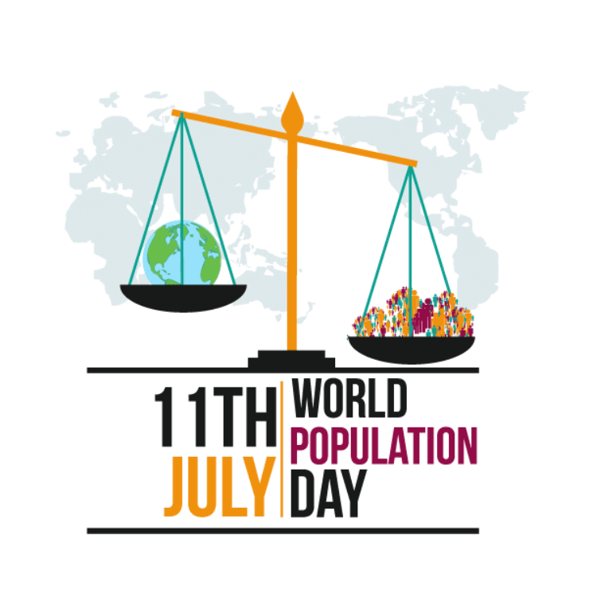
Jildi 1 Lakk. 1 Vol.1 No. 1
Barruulee Ummataa fi Misooma

Population and Development Bulletin
Oromia Planning and Economic Development Commission

Onkololeessa, 2013
Finfinnee

Barruulee Dhimmoota Uummataa fi Misoomaa bara 2012
Komishinii Karooraa fi Misooma Dinagdee Oromiyaa
Daareektoreetii Qorannoo Imaammata Misomaa
Bara Maxxansaa: Fulbaana 2013

Qopheessitoota:
Tasammaa Baqqalaa(MSc)
Fiqaaduu Abdisaa(MA)
Mogas Amaara (BA)

Kan Maxxanfame:
Komishinii Karooraa fi Misooma Dinagdee Oromiyaa
Daareektoreetii Qorannoo Imaammata Misomaa
Bilbilaa: 251-115-152-005/0115-510015
Lakk. San. Postaa -669 Code 2675/1250
Faaksii: 251-551-0429/515-2328
E-mail:-Oromiaplanning@gmail.com
Finfinnee
Jildii.1 , Lakk. 1
Onkololeessa, 2013

Baafata
Fuula
Acronyms iv
Dhaamsa Komishinaraa v
1.Micro and Small Enterprise Performances and Challenges: The Case of Selected Urban Centers in Oromia Region 1
2.Why Reproductive Health and Rights is Key to Sustainable Development Goals? 20
3.Population Analysis and Planning Concept 23
4.Population and Development Related Awareness Creation and Collaboration with Development Partners in 2019/2020 26
5.Cee’umsa gara industirii taasifamuuf IMX’n gahee bal’aa taphachuu danda’a: Yaada Ka’umsaa…………… 31

Acronyms

CCRDA Consortium of Christian Relief and Development Association
CSA Central Statistical Agency
DSW Deutsche Stiftung Weltbevoelkerung
FGD Focus Group Discussion
IMX Intrapiraayizii Maakiroo fi Xixiqqaa
KGT Karoora Guddinaa fi Tiransformeeshinii
LDCs Least Developed Countries
MSEs Micro and Small Enterprises
OCSSCO Oromia Credit and Saving Share Company
OPEDC Oromia Planning and Economic Development
PPS Probability proportional to size sampling
RH Reproductive Health
SDGs Sustainable Development Goals
SPSS Statistical Package for Social Science
UN United Nations
WALQO Waldaa Aksiyoona Liqii fi Qusannoo Oromiyaa

Dhaamsa Komishinaraa

Guddina ariifachiisaa fi itti fufiinsa qabu mirkanneessuuf baayyinni ummataa fi guddinni diinagdee biyya tokkoo keessatti walsimee adeemuu akka qabu amanamaadha. Diinagdeen biyya tokkoo Uummata isaatiif tajaajiloota hawaasummaa fi bu’uura diinagdee dhiyeessuu danda’u qaba.Uummata oomishuu danda’uuf carraa hojii uumuu danda’uu qaba.Kana ta’uu baannaan biyyi tokko ummata baayyee qabaachuun ishee qofti misooma biyya tokkoo mirkanneessuu keessattti faayidaarraa miidhaansaa caaluu danda’a.
Guddinni baay’inna ummataa guddina diinagdee biyya tokkoo wajjiin yoo wal simuu baate, dhiibbaan inni gama diinagdee fi qabeenya uummamaa irratti geessisu guddaa dha. Akkaataa barbaadamuun, guddinni diinagdee saffisuu hin danda’u.Qabeenyi uummamaa keessattuu bosonni akka manca’u gochuun biyyeen isaa akka dhiqamuu fi oomishitummaan akka xiqqaatu godha.Akkasumas,tajaajilawwan hawaasummaa kanneen akka tajaajila fayyaa, barnootaa, dhiyeessa manneen jireenyaa,bishaan qulqulluu fi bu’uraalee misoomaa waliin gahuu irratti dhiibbaa guddaa qaba.
Naannoo Oromiyaatti walitti dhuufeenya guddina diinagdee fi guddina baay’ina uummataa yammuu ilaalamuuu rakkoolee heddu hubachuun nidanda’ama.Kunis akkaataa lakkoofsa ummataa fi manneenii bara 1987tti gaggeeffameen baayinni uummata naannichaa mil. 18.7 kan ture bara 1999tti mil.26.9 fi bara 2012tti immoo mil. 38.8 irra gahee jira.Baay’inni ummata naannichaa bara 1987 irraa eegalee hanga 2012tti %2.6 guddachaa jira. Mootummaan biyyaalessaa Itoophiyaa dhimmi ummata irratti xiyyeeffannoo kennuun bara 1985tti Imaammata ummataa baasuun sochiin guddaa taasifamaa tureera.Imaammata bahee kanarratti hundaa’uudhaan Naannoo Oromiyaatti waggoottan 25 darban hojiiwwan dhimmoota uummataa fi misoomaa walqabataan hedduun hojjatama turaniiruu. Akka Naannoo Oromiyaatti ittifayydama karoora maatii naannichaa dabalaa kan dhufe yoo ta’u, sababa kanaan baayyina ijoollee dubartiin tokko deessu bara 1992tti 6.4, 1997 6.2 ,2011tti 5.6 fi bara 2008tti 5.4tti hir’achuu isaa bu’aalee tattaaffii gama kanaan godhaman keessaa isa muraasadha.
Mootummaan Naannoo Oromiyaa guddina diinagdee ariifataa, ittifufiinsa qabuu fi haqa qabeessa ta’e mirkanneessuuf Karoora Guddinaa fi Traansfoormeeshinii (KGT-I fi II keessatti dhimmi ummataa fi misoomaa dameewwan heddu(Cross-cutting issues) jechuun karoora keessatti haammachuun hojirra oolchaa turee jira. Kunis kaayyoon waliigalaa guddina baayyina ummataa fi guddina diinagdee naannoo Oromiyaa walmadaalee akka deemuun gochuun hiyyumaa balleessuu fi misooma ittifufiinsa qabu fiduuf carraaqqii godhamu keessatti gahee guddaa taphatee jira.
Karoora waggaa kudhanii naannichaa (2013-2022) keessatti karoorri ummataa fi misoomaa Naannichaa akka hojiirra ooluu hirmaannaa uummata bal’aa qindoomina caasalee mootummaa, qaamoolee dhuunfaa,waldaalee uummataa fi deeggartoota misoomaa adda addaat waliin uumuun raawwachuuf akka haammatamu ta’eera. Qaamoleen kun keessattuu caasaaleen mootummaa sadarkaa adda addaa irra jiran fuldurattis qindoominaa fi kutannoodhaan karoora bahe hojiirra oolchuuf gahee guddaatu isaan irraa eeggama.

Dr. Tashomaa Addunyaa(PhD),
Komishinara

Micro and Small Enterprise Performances and Challenges: The Case of Selected Urban Centers in Oromia Region
(By Tesemma Bekele)

  - Introduction
Many development researchers and governments around the globe agree on the fact that micro and small enterprises play a vital role in employment generation and economic growth. According to Tambunan T. (2006), the World Bank rationalizes its support for MSEs for the following reasons. First, since the size of the domestic markets of most LDCs are limited due to their small geographical size and the low purchasing power of their population, small-scale industries would be appropriate to exploit economies of scale. Secondly, since capital required per job created in small industries is relatively small, they can assist in coping with the growing unemployment problems. Thirdly, since small-scale industries do not require much capital, particularly foreign currency, it is easier to set up many industries in many regions with relatively smaller investment. Fourthly, small-scale industries would be seedling grounds for the growth of entrepreneurship in LDCs. For these and other reasons, the arguments in favor of small-scale industries have been accepted both by governments of LDCs and international organizations like the United Nations and the World Bank.
The government of Ethiopia also recognized the strategic importance of MSEs and institutionalized it in its MSE development policy and strategy document that MSEs hold a strategic place within the country’s industrial development and they are also the key instruments of job creation in urban centers, whilst job creation is the center piece of the country’s development plan. As part of the industrial sector, MSEs are increasingly becoming popular and important in the Ethiopian economy as they would play a decisive role in contributing to employment generation, poverty reduction and fair distribution of wealth.
Thus, this assessment is to give highlights for all stakeholders on the situations and challenges of the MSEs and possible actions for resolving fundamental problems. It is to provide policy makers with pragmatic, action-oriented recommendations for addressing an issue, questions, or problems. Thus, it is expected to provide some insights for more informed interventions as feasibly designed in the sector development strategies. Accordingly, it could pave ways for further studies to use existing, abundant human resources for employment creations, entrepreneurial ignitions, income generations, and socioeconomic development.
  - Objectives
1.2.1 General Objective
The very purpose of this asseement is to shade light on the performances and challenges in the implementation of MSE policy and strategy in the selected urban areas of Oromia Regional State.
1.2.2. Specific Objectives
The specific objectives are as follows:
- To assess the types of supports being given by the government and attitude of the MSEs beneficiaries towards the supports,
- To show the overall performances and success of the MSEs,
- To identify challenges encountered MSEs, and
- To recommend the way forwards based on the findings.
  - Significance of the study
It is to help the government bodies and other stakeholders, who directly or indirectly, involved and have linkages and want to know the gaps in the implementations of these supports. It helps a scientific and continuous way of understanding and learning process based on experience and good practices which this assessment is trying to deal with.
  - The Scope of the study
This assessment covered only five towns:Nekemte, Jimma, Burayu, Shashemenne, Bishoftu from the 19 towns of the Region. In terms of the topic coverage, it dealt with the performances and challenges in implementing MSE policy in terms of supports like production and sales premises, finance and technical support, support and supervision and market linkages which are pledged by the government for MSEs. Finally, this assessment focused on the government supported micro and small enterprises in the selected towns.
1.5. Methodology of Study
Both primary and secondary sources of data were used for this assessment. The research team gathered primary data from MSEs through semi structured questionnaire and in-depth interview with local MSEs officials and experts. Moreover, Focus Group Discussions (FGD) was organized with the members of MSEs Council of the selected towns.

The study was conducted in five towns of the Region:Nekemte, Jimma, Burayu, Shashemene, and Bishoftu, which are purposively selected among the 19 major urban towns and 20 zonal towns of Oromia. The unit of analysis for this study is Micro and Small Enterprises (MSEs) who are currently operating in these above named towns.
About 514 samples were identified from the total population of MSEs in the towns; and then MSEs were stratified into six stratum based on the sector they are operating: Manufacturing, Construction, urban agriculture, Trade, Service, and mining. Then by using simple random sampling technique MSEs were chosen. They were taken from each stratum with probability proportional to size sampling (PPS).

The data were edited, coded and entered into computer software called statistical package for social science (SPSS). Then, descriptive statistics such as percentage, mean, cross tabulation and frequency distributions were used to analyze the data obtained through questionnaires. Qualitative data obtained from MSEs officials and experts were analyzed through narration and interpret.
1.6. Data Analysis and Interpretations
i. Demographic Characteristics of the Respondents
The assessment was undertaken on 514 MSEs through their representatives who were designated by their heads or members; and finally only 498 samples were found complete for this analysis. It was found that among 498 representatives 34.7 % were females.
Age wise, the representatives of the selected MSEs were ranged in between 15-64 years and more than three –fourth of them were concentrated in between 20-34 years.
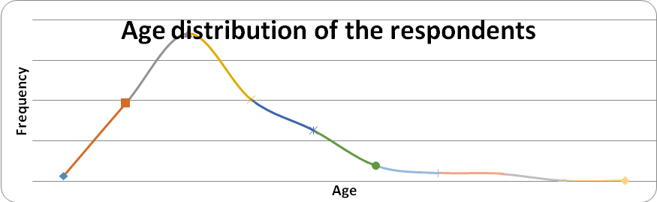
Figure 1: Age Distribution of the respondents, 2018
As per the Ethiopian Youth Policy definition, about 58 % of the respondents were youth population (15-29 years’ age category). This implies that the majority of the respondents were youth though there was gender disparity in participation. Almost 70.3 % of the respondents had the role of managerial/vice managerial placements while the remaining were secretaries, accountants or members in their MSEs during the assessment. In their marital status 59.2% and 37 % of the respondents were married and single during the assessment.
In terms of educational status, 52 % of the respondents were University and TVET graduates while those who completed secondary and primary schools accounted for 31.1 % and 12.8% respectively. These data indicate that many graduates from different higher institutions were joining the MSEs in line with the government’s strategy of availing jobs through MSEs.
It was also seen from the assessment that 85.5 % of the MSEs were organized having two to five members while 10.2% of the MSEs were organized in 6-10 members. These MSEs held 2056 members, of whom 57% were males. This gives a clue that there was high male involvement in MSEs than females despite of high unemployment of females in urban areas of the Region, which was 26.1% for females in 2018(CSA, 2018).
ii. Experience in Businesses and MSEs
Regarding experience of MSEs business, out of 455 respondents 91.4 % of them had nearly less than five years of experience in business while 58.2 percent had two to three years since their establishment. The MSEs policy dictates that all the MSEs, irrespective of their business performance and activities, are supposed to be promoted to medium level MSEs at end of the fifth year. However, all the MSEs were not promoted to higher level. For instance, about 8.4 percent of the MSEs stayed in MSEs for more than five years. As a reference, one of the respondents reported that their MSEs stayed in MSEs for 12 years while four of them stayed for 10 to 11 years long. There is no reason given to stay longer beyond the cut point [five years], otherwise reasons must be given for transparency and equity. On the other hand, there are suggestions from the discussants that the graduation of MSEs to medium enterprises need revisiting either based on the sectors they are running and/or based on the performances of the MSEs.
Regarding the business doing experience before joining MSEs, about 76.5 percent of the 498 respondents underscored that they did not have any business experiences before they joined the MSEs. Also, out of 115 who had reported of having business experience before joining MSEs, 29.5 percent of them had one to seventeen years.
iii. Levels and Sectoral Distribution of the MSEs
a) Levels of the MSEs
Out of the 498 MSEs covered in this assessment, those found at micro level constituted 60.6% and followed by the small enterprises (27.5%) while 11.8 percent were medium level enterprises. It can be observed from the survey report that there was promotion of MSEs from one level to the next higher level: from micro level to small and from small to medium enterprises as though they piled up at micro level. Also, it was noted from the discussants and interviewees that many MSEs drop out/quit the business at initial level.

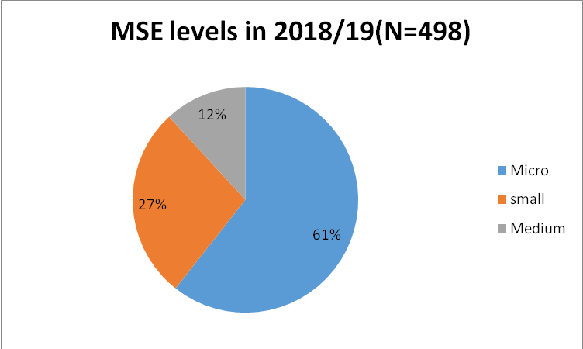
Figure 2: MSEs level in ,2018/2019
b) Sectoral Distribution of the MSEs
MSEs are taken as a base and entry to the development of manufacturing sector, provision of employment and poverty reduction. The most important features observed from the survey that sectoral distributions of the MSEs were disproportion. The survey result showed that more than half (55.2%) of the MSEs were engaged in trade and services while the manufacturing and construction sectors constituted 19.7% and 14.5%, respectively. These data indicated the proportion of production sectors like agriculture and industry, which have major contributions to economic growth, regulate market instability; increase export volume and domestic consumptions were minimal.
Table 1: Sectoral Distribution of the MSEs
S.No | Sectors | Frequency | Percent (%)
1 | Manufacturing | 99 | 19.7
2 | Urban agriculture | 46 | 9.2
3 | Trade and services | 275 | 55.2
4 | Construction | 72 | 14.5
5 | Mining | 7 | 1.4
 | Total | 498 | 100.0

Source: Computed based on the data gathered for this study, 2018

iv. Attitudes towards the Government Supports
- Provision of Production and Sales’ Premises
In line with the current MSEs Development Strategy of Ethiopia, the government has formulated a cluster development strategy in January 2011. The main objective of the cluster development strategy of Ethiopia is to alleviate problems of working and selling premises often faced by MSEs. This strategy was to be implemented through the construction of standard working and selling premises (cluster) where number of enterprises that work on similar and closely related goods can enter and operate. The sites chosen for production and sales’ Premises must be appropriate locations and fulfill needs of the MSEs. Moreover, a transparent system should be created for allocation of MSE production and sales premises, involving regular and on time payment of rents as well as appropriate measures for non-compliance. The building and renting of MSE production and sales premises is a top priority and it should be executed in accordance with the policy and strategy designed for the development of the sector effectively with commitments for continuous improvement based on experience and good practices.
In this regard, following the MSEs policy and strategies, supports were given in the last couple of years for the MSES in provision of production and market premises in the towns selected for this study. Likewise, the Oromia Regional Government was striving to support MSEs though all MSEs in the Region were not equally supported by this provision. It is reported by the MSE Agency that the demand for premises could not match the supply and consequently many were still waiting for this support from the government.
Table 2: Utilizations of Premises per functions

S.No | Purpose of the premises | Frequency | Percent
1 | Production | 83 | 17
2 | Sales | 161 | 32
3 | Production and sales | 164 | 33
4 | Service delivery | 76 | 15
5 | others | 14 | 3
 | Total | 498 | 100
Source: Computed based on the data gathered for this study,2018
Regarding the functions of the premises, as it indicated in table 2, about 33 % of the MSEs were using for the production and sales while17% and 32 % were used for production and sales, respectively during the survey.
From the 498 MSEs, about 75.7% obtained working and sales premises from government while the remaining 24.3% were using premises obtained from other MSEs and private owners in rental-form(see table 3). It was also reported by the discussants of the focus group discussions that government could not provide production and sales premises to large number of MSEs in the towns. Contrarily, some of the MSEs who obtained premises from the government rent out to others particularly when their businesses have gone ill. Another point raised by the discussants was that though the “grown up” MSEs are supposed to transfer the shades to newly organized MSEs, many of them were reluctant to leave production and sales shades standing against the government strategy for the MSEs. This is mainly due to lack of continuous follow up on status of MSEs by government bodies and lack of awareness of the MSEs members on the issue. Besides to this, it was observed and checked from group discussants that some MSEs premises were not in hands of the MSEs due to different reasons mentioned above, and/or others were not functioning for some time before the assessment.
Table 3: Provision of Working Premises
S.No | How did you get the premises | Frequency | %
1 | Government provision | 377 | 75.7
2 | Rental from Other MSEs | 19 | 3.8
3 | Rental from private owners | 87 | 17.5
4 | Others (families…) | 15 | 3.0
 | Total | 498 | 100.0

Source: Computed based on the data gathered for this study, 2018
Besides the provision of premise, it is obvious that those premises given for the MSEs should be convenient for production and markets. In this regard, it is observed during the survey that some of the premises in the surveyed towns are located at outskirts of the towns where potential marketers could not accessible them easily. The survey result indicated that 51.9 % of the MSEs premises were convenient for the production and rendering of services while 37.5% were against this assertion. Therefore, as written in the policy direction of the MSEs, the location of the premise must be at suitable areas for productions and markets though what obtained from the survey were against the envisaged in policy direction.
- Provision of Infrastructures and facilities
It was noted in the policy document of the MSEs that Provision of infrastructure and facilities for the MSEs are pre-requisite to be competent and successful in businesses. However, existing situation did not show the reality at ground. Nearly one-fourth of the MSEs reported that basic infrastructures like water, electricity, roads… were not fully availed by the government as prescribed in the policy document in order that they are to be effective and profitable in their businesses, which are taken as the government obligation/duty. Therefore, about 18.1 percent of the MSEs had at least one facility only; that is, either water, electricity or road access. Those MSEs, which had two facilities in combination from water, electricity and road, accounted 50.6 percent. Only 30.8 percent of the MSEs had more than three facilities.
Other points raised by the group discussants were that the fluctuations and total absences of water and electric supplies have created serious challenges for proper functioning of the MSEs. Absence of toilet facilities in and/or around the work premises have become very serious challenges to the MSEs, especially for females. Many MSEs did not own sewerage facilities to discharges liquid wastes.

- Financial support and its policy implications
One of the supporting packages that the government has decided to provide for MSEs is financial support through a loan to be paid on fixed interest in a fixed period of time as per the rules and regulations of micro-finance institutions of the country to promote MSEs for multidimensional purposes.
In this regard, inaccessibility to finance was reported by 62.5% of the MSEs members; and, inadequacy of the amount of loan given for the MSEs was reported by 62.1% of the respondents during the survey. Besides the insufficiency of the loan to start businesses, 50.6% of the respondents have underlined that loan repayment period was not suitable. Another important thing is that 50.4% of the respondents reported the interest rates being paid were also very high.
It was reported by the respondents that accessibility in general and the amount of loan for both start up and working capitals could not be found easily by the MSEs. The respondents have listed down the following challenges related to MSE financing system: tight loan procedures, high initial saving up of 20% of the startup capital, tight collateral system, and high interest rates on the loan repayment (19%), bureaucracy hurdles at the OCCSCOs( no one-stop shopping) and inadequate financial supply.
It was noted in the discussions made with the group discussants that the loan being provided by the OCCSCO for the MSEs [based on dependable collateral system and savings of 20% of the startup capital needed for the business] has been a big challenge for the poor and unemployed persons to fulfill the minimal requirement to get loan. This is totally meant to help those who had business experiences and some sort of income earlier or sufficient income to support their lives. This call for flexible lending modalities for loan takers for this is a point of complain that being heard from poor youth.
From the OCCSCO side, it was reported that the loans taken by MSEs were not paid back properly as per the schedules set for repayment. There were still outstanding loans on the hands of the MSE members. This led the institution not to provide sufficient amount of money for newly organized MSEs as well as for those who requested additional loans for business expansions.
- Managerial and Technical Skills of MSEs and Attitude of the respondents
The Ethiopian government has set many strategies to support the MSEs operators to build their competencies in business management and entrepreneurship through provision of trainings and continuous support and supervision in works. In the Information technology era, knowledge based business management is important to be competitive and to uphold business in the dynamic business world. Here, having managerial and technical skills required to run business are advantageous. Regarding the managerial skills of the MSE operators of the selected towns of this study, the respondents were asked a few key questions like whether they had work plans; monitor and evaluate their activities and got training on the managerial and technical skills, which indicate directly or indirectly their capacity in this area. Accordingly, about 56.45 % of the MSE operators had trainings on the managerial and technical skills, which were given by the Regional Government; nevertheless, substantial numbers of the operators (nearly to 30 %) have reported their managerial and technical skill had gaps to run business.
- Monitoring and Evaluation and Support for MSEs and the attitude of the Respondents
As indicted in MSEs policy and strategy document for the development and sustainability of the MSE needs continuous support and follow up from all the pertinent bodies established for these purposes to solve pop-up challenges in their day to day activities. Equally, their performances must be monitored and evaluated based on the policy and strategy direction for MSEs and employment. In this regard, the MSEs found in the selected towns for this study were not getting sufficient institutional supports from the concerned bodies in the towns and elsewhere. It was reported by respondents that more than half (53%) of the MSEs operators had work plans in commissioning their businesses though nearly 30 % of them did not have work plans at all, yet. Regarding scheduled monitoring and evaluation of the MSEs, only about 55.24 percent of respondents reported that their performances were monitored and evaluated sporadically. On the other hand, there was also only about 46.1% of the respondents reported the absence of consistent monitoring of government bodies on the activities of MSEs.
Another very important point is that supports being by government bodies to MSEs in their respective towns were measured by the respondents. The result showed that, nearly 39 percent of the respondents favored the adequacy of the government supports being given for MSE while almost half (50 percent) of the respondents reported an inadequacy of the supports obtained from public bodies. As the supports given for MSEs have big impact on better performances and sustainability of the MSEs, this data showed the government bodies attention to rectify the situation of their around.
Experience sharing among the MSEs is an important strategy to acquire knowledge and skills and, share good working practices. Hence, the respondents from the selected towns did not get experience sharing chances among the MSEs of their respective towns and beyond.
- Market Access and Linkages
The availability of markets is very important to generate income having markets to sell products and services. In this regard, one of the duties of public bodies is searching markets for MSEs products and services and establishing market linkages permanently for them. Of course, many MSEs have been benefited in preferential and special support given by government to MSEs from the public procurements. If it is genuinely seen, it is to make MSEs competent in business by availing market opportunities in order to achieve the policy goals and strategies; though, these supports are perversely led many MSEs to development of dependency syndromes. Many discussants and key informant interviewees have raised this challenge as big traits since it constrains the growth and sustainability of the MSEs in the long term.

Any business entity is supposed to have business plan that includes marketing plan for clear path and doing business. In this regard, Micro and Small Enterprises policy and strategy give emphasis to help MSEs in business plan development. However, though business plan is one of mandatory requirements to enter in a business, the survey result indicated that nearly 30% of the MSE operators did not own short and long term marketing plan for their business. The other important observation was that significant numbers of the MSEs (33%) did not have target markets that clearly defined their market potential and customers. Regarding the availability of market linkages for products and services about 59.5% operators involved in the survey reported that they did not have market linkages; and substantial numbers of them (49%) also reported that an entry to markets had full of challenges and inconveniences. It is also noted from the survey that 54% of the MSEs premises built for productions and markets were at inconvenient sites for markets and business expansion.

It is also observed from group discussants that collaboration and market linkages among the MSEs were weak; and bazaars/exhibitions which have high potentials in creating markets and used to promote the MSEs were hardly organized. In line with this, it was noted from the operators who participated in this assessment, 75 percent of the MSEs have never had chances of presenting their products and services on bazaars. The objective of establishing clusters by availing production and sells premises for MSE is to create market linkages and at same time to form cooperation among them. This is an area of attention that must be solved in hitting the policy objectives of the MSEs.

The MSE Policy and Strategy document of the 2011 restated that that market information system shall be established for existing and new MSEs. However, the survey indicated that there were gaps in assessing, organizing and transmitting market information to MSEs in the towns under the study. It was reported by the respondents that only 40 % them (or their MSEs) were receiving market information from the government body assigned to support the MSES in these towns.
- Registration and licensing of MSEs
The Ethiopian Government in its policy document on MSEs stated to facilitate MSES’s registration and licensing in one stop shopping and/or implementing bureaucratic reforms easing and shortening lengthy bureaucratic chains. However, the MSEs in the survey towns were doing their businesses passing through the existing unsolved and recurring bureaucratic hurdles during registration and licensing though the government vowed to shorten the processes therein. It was reported by the respondents and the discussants involved in this study.
Hence, many MSEs facilitators have reported bureaucratic challenges in registrations and licensing of the MSES during starting their businesses, though, these challenges have not unsolved yet. It was reported by 56 percent of the respondents; because the government has been reporting the service deliveries of the public institutions still remains unchanged.
- Production inputs supply
The availability and adequacy of raw materials and other production inputs supply are seriously matter for running business of any kinds. In this regard, the inadequacy of raw materials was reported by 50% of the MSE facilitators during the assessment. Moreover, linkages with productions inputs were not strong. About 57 % of the MSEs reported that they did not have supply linkages on productions as a whole. These indicate that many are working in under capacity.
v. Performances of MSEs
The performances of the MSEs were analyzed based on the capital growth and income improvement. Here, it was observed from the data that the representatives of the MSEs that the initial capitals of 95 percent of the MSEs were grown substantially since joining their MSEs. However, 5% of the MSEs reported either declining or no change in capital growth.
Regarding the monthly income of the MSEs, most of them earn average monthly income of <5,000 birr (82.3%); of which, 35.5% earned below 1,000-birr month. Those who could earn above 5,000 birr per month constituted only 17.7 percent.
Regarding the importance and benefits obtained from MSEs, 80.2 % of 494 respondents reported they have started supporting their families in economy or covering of their own expenses, or started saving and while 12.1% reported gaining nothing from the MSEs businesses they run.
Likewise, 59.4 % of the respondents also reported that they started getting some profits from their business though still substantial numbers of the respondents [25.1%] reported no gains from the MSE businesses. The remaining 15.5 % reported “I did not know” about the profitability of their business. Paradoxically, despite the fact that many of the MSEs reported the gaining of profits and utilization of the income obtained for supporting families, covering of personal expenses and starting savings; about 66.3 % of them reported the insufficiency of the income for their livelihoods after paying expenses like taxes and rents regardless of the sectors they engaged in. In relation to the policy of the MSEs, sufficiency of income for livelihood is a critical element for sustenance of the development of MSEs that need the attention of the policy makers.
Moreover, depending on the supports given and other factors, there were differences in success/achievements of the MSEs. For instance, those who had some business background before joining the MSEs were more successful than those did not. Those MSEs had access to market through exhibition and others are more successful than those could not get the chance. Another scenario was that the longer they stayed in MSEs, their likelihood of having sufficient livelihood was high. Based on the sectors in which the MSEs engaged in, those MSEs engaged in production sectors (urban agriculture, construction and manufacturing sectors) relatively have sufficient livelihood than those joined service and trade sectors. The another point seen in relation to sufficiency of livelihood was those MSES had working premises from the government reported the sufficiency of income for their livelihood than those who were working in rental houses and other forms.

vi. Challenges to MSEs Development
The main challenges impeding the MSEs Business development in the towns were identified through survey, group discussions and interview.
a)Recruitments and Management of MSEs
The selection of unemployed youth for MSEs was reported had challenges due to high migrations: within the Region and/or across Regions in Ethiopa. It has hindered the recruitment of right persons from eligible persons who try to get benefit from government schemes. It was reported that many youths have different identification cards from different towns so that they could easily register and get benefit from all places. This was merely happened as the towns lack organized and up to dated data on unemployment and MSEs

b)Provision of work premises

Many shades constructed for MSEs in the study towns have many problems. Some were constructed without detail study, breaking the plans of the town, not as per the design and at inaccessible sites where basic infrastructures like power, water, roads, and toilets were not fulfilled. Some of the shades constructed at places, where not suitable for markets and market linkages. As result, many MSEs abandon the business while others transferred in rental and/or sales to others.

The transfers of shades were reported not transparent because of the criteria set for the transfer of shades was not observed by the organizers of the MSEs. Many shades were transferred to MSEs based on the “closeness” and kinship lines to the organizers; and by direct orders of the local authorities in these towns. In areas, where temporary shades were built by the MSEs themselves on the lands provided by the urban administrations, shades were changed to residences while others were used for other purposes against the MSEs Policy and strategy.

Some shades were illegally held off the knowledge of urban administrations and made the source of conflicts and raised the issue of equity. It was observed by the researchers and also reported by the discussants that many shades were not clustered yet in these towns so that the government could not to provide infrastructures and support and create market linkages for the MSEs.

c) Supports and supervisions
The supports given for the MSEs are expected to be holistic in as per the policy document of the country, nonetheless, the organizers of the MSEs failed to understand and implement as stated in the MSE policy and strategies documents in these towns. The supports given for the MSEs so far in terms of supervisions and trainings were insufficient.

d)Graduation of MSEs
Regarding the promotion of /graduation from MSES to Medium, it was noted from the Focus Group discussants that because of different reasons/ factors many MSEs did not want promotion to the next higher level. Because those promoted to the medium level did not get sufficient support in getting working place, trainings, market linkages, basic infrastructures; therefore, many conceal their capitals to be known fear of losing established market linkages and conduciveness of working environment.
It was reported that many MSEs were promoted to medium level before developing necessary capacity; and complains on the promotion criteria and lack of transparence.

From the side of those MSEs promoted to the medium level, many of them transferred or sold out the land they obtained for production and sales to the third persons in disguise of private Limited company(PLC). The case of Burayu administration town was an exemplary. From 18 MSEs graduated and applied for land before 2018, 99% of them sold out or transferred the land.

e)Financial Support linked challenges

It was being observed that the amount of loans provided by the towns was increasing from year to year though many MSEs could not get it at all or get insufficient amount of startup capital after waiting for a long time. It was also observed that substantial amount of loans was not paid back or not paid as per the schedule to give loans for the new MSEs. Absence of interest free loans for Muslims is creating challenge in some towns like Shshamane fi Jimma towns nevertheless; the OCSSCO has initiated interest free loans, through the provision of materials needed by the MSEs though most of them demand the money to be given in cash. The MSEs formation and loans provision system and procedures involve long and tiresome processes so that some could not tolerate the challenges and gave up joining the MSEs businesses. Some MSEs join the MSEs till they secure the loans and they would break up by dividing the loan money. Another point that it was reported, not all members of the MSEs had equal awareness business they run and commitment to be successful in their businesses.
Lack of market linkages and inputs for produce: In terms of creating market linkages, many MSEs failed to get access to market linkages in and/or out of their towns as it was proposed to be at the beginning. Another challenge is the lack of sufficient inputs like raw materials to run their business.

Lack of infrastructures: Almost in all the towns under survey, most of the MSEs were located in place where they could not get services and amenities to run their business. From infrastructure and amenities: power and water supply and access to main roads are the most reported challenges the MSEs are facing to run business and lack of toilet privately or in common in their working areas.
  - Conclusion and Recommendations
Conclusion
It was noted from the reports that females’ participation in MSEs was low as compare to males. Some MSEs have shown improvement in generating income and supporting their families and themselves. Earlier business experiences had effect on successfulness of the MSEs in businesses. MSEs, which stayed longer in business, were more fruitful in business than newly joined. The supports being given were not equally perceived by the MSEs members. There were also many challenges that the MSEs were facing including lack of having sufficient loan, bureaucratic hurdles, lack of infrastructures, lack of market linkages and inputs for produce and improper recruitment of The MSEs members.
Recommendations
Region wide Registration of MSEs and Unemployed persons: It was noted from the towns included in the survey that these towns did not know number of unemployment and the residences of their MSEs. Hence, the Region must undertake census on all MSEs and unemployment to get up to date information on the status of the MSEs and unemployment. Additionally, establish ID and data base for MSEs in the Region.
Facilitating Access to Startup Capital: Micro and Financial Institution should have special working procedures for the poor and Muslims to enhance access to startup capital (loan). Those who can provide required “dawn savings” shall be given priority to access loans from other financial institutions besides to MFIs.
Promotion Criteria: The promotion criteria set for MSEs from small to medium level needs some sorts of flexibility and variation, at least, based on the performance of the MSEs and the sectors they are engaged in.
Organization and facilitations: The formation of MSEs should be in competition and feasibility of the business projects. This may initiate individuals who have common vision, capacities, experiences and initiations to come together and to establish MSEs than in campaign form.
Support in work premises and Market Linkage: Many MSEs were challenged by lack of working remises and market linkages/ access. Therefore, working premises must be constructed in clusters for MSEs holding all necessary infrastructures to form market linkages both forward and back ward linkages must be established.
Continuous support and experience sharing and collaboration among the MSEs are very, at least, to learn from each other; and the system of monitoring and evaluation and supporting for MSEs should be revised.
REFERENCES
CoPED, Growth and Transformation Plan-I Final Evaluation, Finfinne, Oromia
Creswell,JW(2003), Research Design, Qualitative, Quantitative and Mixed Approaches, Sage Publications
CSA (2018), 2018 Urban Un Employment Survey in Ethiopia, Addis Ababa, Ethiopia
MoTI, (1997), MSEs Development Strategy , Addis Ababa, Ethiopia
________(2011), Micro and Small Enterprises Strategy , Addis Ababa, Ethiopia
Tambunan, T. (2006), Development of Small & Medium Enterprises in Indonesia from the Asia-Pacific Perspective, LPFE-Usak

Why Reproductive Health and Rights is Key to Sustainable Development Goals?
(By Fekadu Abdsa)

In 2015, 193 Member States of the United Nations agreed to a remarkable consensus of 17 shared goals to drive global progress for a more equal world and a healthier planet. Two of these goals are dedicated to good health and wealth-being and to achieving gender equality, both of which include an explicit focus on sexual and reproductive health and reproductive rights.
But in truth, sexual and reproductive health and rights are critical to progress on all 17 of the goals, from ending extreme poverty and hunger to climate action. Indeed, every dollar invested in family planning and reproductive health services can save up to $31 on spending for education, food, health, housing, and sanitation. Women who can plan if and when they become mothers are more likely to have healthy, well-educated children, leading to more resilient, prosperous families; thriving societies; and growing economies.

As world leaders gather in New York for the 2018 annual UN General Assembly, they explore how sexual and reproductive health and rights underlie all of the Sustainable Development Goals as given below:
1: No Poverty: Girls and women who can plan for and space their children are better able to pursue their education and become economically empowered, lifting themselves and their families out of poverty. As Melinda Gates said: “No country in the last 50 years has emerged from poverty without expanding access to contraceptives.”
2: Zero Hunger: Almost half of all pregnancies worldwide are unplanned. With family planning, women can choose to have only the number of children they want and can support, enabling them to better provide food for themselves and their families, and breaking the cycle of chronic malnutrition.
3: Good Health & Well-Being: Access to family planning and quality reproductive health care sparks a myriad of health outcomes for individuals — reducing unintended pregnancies, unsafe abortions, and maternal and child death. In fact, if we met the needs of the more than 200 million women who want to avoid pregnancy but are not using an effective form of contraception, we would reduce maternal deaths by 73 percent and newborn deaths by 80 percent. It also benefits health for the world — reducing the impact of infectious diseases like HIV/AIDS, tuberculosis, and malaria.
4: Quality Education: Girls who can avoid unintended pregnancy can stay in school to learn and gain the skills they need to be healthy, productive, and empowered adults. Each additional year of education improves a girl’s employment prospects, increasing her future income potential by 10 to20 percent.
5: Gender Equality: Health, rights, and equality are closely interwoven: Women and girls with full access to sexual and reproductive health and rights can more equally contribute economically, socially, and politically to their communities, helping create a more equitable world.
6: Clean Water & Sanitation: Access to clean water and adequate facilities helps girls manage their menstruation and stay in school, and is essential for the safety of expecting women and newborns, helping reduce maternal and newborn illness and death.
7: Affordable & Clean Energy: Electricity is a critical piece of health service delivery, including reproductive health services like safe childbirth. Tens of thousands of health centers across low- and middle-income countries lack electricity, contributing to preventable maternal deaths due to poor lighting or lack of other electricity-dependent services.
8: Decent Work & Economic Growth: If women participated in the economy at the same level as men, $28 trillion — or 26 percent — could be added to the global annual GDP by 2025. That’s the annual GDP of the U.S. and China combined. But to realize this full participation, women need to be healthy and empowered — and that starts with the basic right and ability to plan a family and protect sexual and reproductive health.
9: Industry, Innovation, & Infrastructure: Women are entering the formal workforce at unprecedented rates, especially in manufacturing sectors like textiles, clothing, and footwear. Ensuring this significant portion of the global workforce is healthy, well, and empowered — and their rights are fulfilled — increases productivity and helps drive thriving industries.
10: Reduced Inequalities: Inequality in sexual and reproductive health and rights underlie all other forms of inequality. A woman or girl whose health and rights are not fulfilled is more likely to face inequalities in education, economic stability, and health outcomes; and, a woman or girl in poverty is likely to have less access to reproductive health information and services that can help her break the pattern.
11: Sustainable Cities & Communities: A key component of a sustainable community is its resilience when disaster strikes. Girls and women around the world are disproportionately impacted by crisis and natural disaster, and in the midst of instability, their sexual and reproductive health and rights are often reprioritized. But women are also key agents of change: when healthy and empowered, they are critical to the fabric of recovery for their families, communities, and countries.
12: Responsible Consumption & Production: Healthy, empowered women can better manage natural resources such as firewood, water, and homegrown food for their families.
13–15: Climate Action; Life below Water; Life on Land: Female empowerment is one of the most effective ways to combat climate change. Voluntary family planning combined with girls’ education — two powerful interventions on their own, but which, when taken together, put women in control of their families and futures — can reduce greenhouses gases more than on- and offshore wind combined.
16: Peace, Justice, and Strong Institutions: When healthy, empowered women have a voice at the table in decisions about war and peace, peace agreements are 20 percent more likely to last at least two years and 35 percent more likely to last 15 years.
17: Partnerships for the Goals: No one country or organization can achieve the Sustainable Development Goals alone; global partners, including the U.S., are key in making progress.

Source
https://universalaccessproject.medium.com/17-reasons-why-reproductive-rights-are-key-to-sustainable-development

Population Analysis and Planning Concept
(By Moges Amare)

Develop skills to use population information to develop and revise plans
Planners are able to successfully implement plans if they can develop programs that meet the present and future needs of different segments of the population. Populations are never static; they grow or decline through the interplay of three demographic processes: Fertility, Mortality and Migration. The number of people in a given area can grow or decline as a result of the number of births that take place, the number of deaths that occur and/or by the number of people moving in or out of a locale. Migration can drastically change the size and composition of a population in a brief period of time, especially in small geographic locations.
Planners need to study changes in the composition of the population to plan for education, health care services, and economic development projects. The age of residents, gender, and occupation, level of education, marital status, and living arrangements provide planners with the type of information needed to plan for the residents' diverse needs.
Knowing age ranges is of critical importance to planners since it is closely related to the demand for different types of services. A population composition that has a large percentage of residents under age 15 implies the need for schools, primary health services, and recreational needs. Gender is another key factor. For example, women, especially in their early reproductive years, 20–35, may need specialized health services
Ways Population Analysis is used in the Private and Public Sectors
Private Sector Planning: In the private sector (e.g., business) demographic information is equal to consumer information. Businesses use population characteristics, and demographic data to:
- Identify profitable locations for goods and services. Selection of retail sites is usually based on population composition and the expected growth of its segments.
- Perform production analysis. Determine characteristics of potential customers who may buy services or products. This analysis includes how the composition and location of the population are changing over time.
- Develop advertising strategies. Marketing products to different segments of the population such as youth, baby boomers, elderly, high income, etc.
- Perform strategic planning. Tracking the growth or decline of existing markets, finding new markets and determining what new or existing products are most likely to be successful among different population groups.
The private sector is basically concerned about the "demand" and "location" for products and services. The composition or characteristics of the population is used as indicators of purchasing behavior. The business community also uses population information including estimates of population growth to identify the most profitable locations for goods and services in the future.
Public Sector Planning: Planners in the public sector use demographic information and analysis to assist with a number of planning decisions as indicated below.
- Planners use population information to determine the demand of services among different segments of the population. Demand is determined by the composition of the population and how it is changing over time — age-sex distribution, marital status, household types, occupation distribution, spatial distribution of the population, educational levels and income levels.
- Planners also study the present and future composition of the population and its spatial distribution to identify the best locations to provide services to meet local needs.
- Planners also examine population characteristics to determine the feasibility for new programs. A village may ask the government for a new school. Planners assess the age-sex distribution at present and in the future to determine whether or not it’s feasible to construct a new facility.
- Planners are also concerned about the impact of new plans on population change. A new plan to promote rural industries can lead to population growth as new families move into the community for job opportunities. Housing, health and educational plans may need to be revised to meet the needs of new households that may move into the area.
- Planners are also concerned about the impact of population growth on the ability to implement existing plans. Planners are interested in how changes in size, spatial distribution and composition will affect efforts to implement various types of plans — housing, social services, and infrastructure such as roads, water supply and electricity.
Use of Demographic Analysis in the Planning Process
Demographic analysis is needed in all stages of the planning process for both new and revised plans. Population analysis is needed to identify problems and community needs, establish goals and objectives, assess alternative courses of action, allocate resources for plan implementation, and evaluate the ability of the plan to achieve goals and objectives.
References
Dowell Myers and Lee Menifee, "Population Analysis," The Practice of Local Government Planning, ed. Charles J. Hoch (Washington, D.C: International City/County Management Association, 2000) 61–86.
George W. Barclay, "The Nature of Demography," Techniques of Population Analysis (New York: John Wiley and Sons, 1958) 1–15

Population and Development Related Awareness Creation and Collaboration with Development Partners in 2019/2020
(By Fekadu Abdisa -MSc in Demography)

Achieving the SDGs requires major transformations and unprecedented mobilization from all stakeholders. In particular, at continental level Heads of State committed to the SDGs in 2015 at the UN, therefore national and regional governments should be at the forefront in implementing the SDGs. In response to this the Regional government draws attention to regulatory measures that have been put in place to create the necessary enabling environment for integrating population issues in to regional development plans along with coherent coordination
Even though addressing population challenges should be the primary responsibility of Governments, it requires a joint effort of all stakeholders, including the civic societies as well. This is because the issues of population dynamics and reproductive health concerns cannot be tackled by one sector/organization alone, but requires multi sectoral coordination which refers to deliberate collaboration among various stakeholders (e.g., government, civil society, and private sector) and sectors (e.g., health, education, and environment) to jointly achieve a policy outcome. By engaging multiple sectors, partners can leverage knowledge, expertise, reach, and resources, benefiting from their combined and varied strengths as they work toward the shared goal of producing better health outcomes. Therefore, this ensures that public health problems are complex, and in many cases, a single health issue may be influenced by interrelated social, environmental, and economic factors that can best be addressed with a holistic, multi sectoral approach.
In line with this, since March 2019 to date several Policy dialogue, Workshop, training and Policy advocacy on Population Dynamics and RH mainstreaming in to regional development planning has been under taken between CCRDA and Oromia Population and Development Affairs of Planning and Economic Development Commission. In addition, for media engagement Contractual Agreement for Air Time Service has been signed between Oromia Broadcasting Networks and CCRDA to broadcast for 32 weeks / 20 minutes /per week on RH education and awareness creation for the community at large in “Afaan Oromo”.
The main objective of this collaboration is to bring together broad range of government sectors and non–state sectors/NGS/ to exchange views and positions about the role and contribution of the civic societies to realize the attainment of SDGs and GTP –II relevant to health related goals.
Accordingly, the policy advocacy and dialogue was opened by Teshome Adugna (PhD), the Head of the Oromia Region Planning and Economic Development Commission. In his opening remark, he welcomed all the participants drawn from Regional and National decision makers working in the areas of population dynamics and health related sectors; and noted the role reproductive health or population issue could play in the development of a given region/country.
During workshops and policy dialogue held in the region, review of the progress on Population Dynamics and Reproductive Health related indicators and targets were presented by Scholars from Regional, National and Higher institution like Addis Ababa University. An over view of Oromia population situation (past, present and future) and achievements, challenges and way forward in the process of population policy implementation was presented by regional population and development program Coordinator (Mr.Fekadu Abdisa).A panel discussion on the presentation and also on the general views of regional decision makers (Sector representatives and regional councils ) and the civil society’s role in attaining most development goals relevant to mainstreaming /integrating population and reproductive health issues in to regional development planning was also part of the policy advocacy and dialogue.
The collaboration and partnership so far held offers a wonderful opportunity for civil societies to engage with other stakeholders including the government and to express their interest to provide strategic support for the problem of population dynamics and Reproductive Health response efforts at various levels. There were also positive expressions from the government to work together with civil societies. As expressed by Teshome Adugna (PhD), the Head of the Oromia Region Planning and Economic Development Commission, the government wishes to get civil societies support. This support may refers to raise awareness about the role of mainstreaming RH issues into regional development planning in creating ownership and leadership in the areas of Population Dynamics into the Post-2015 Development Agenda
He noted that knowledge is the base for change. RH and population related workshops and trainings help the society, decision makers and development plan implementers to fill their knowledge gaps and promote RH/population mainstreaming in Development Planning.
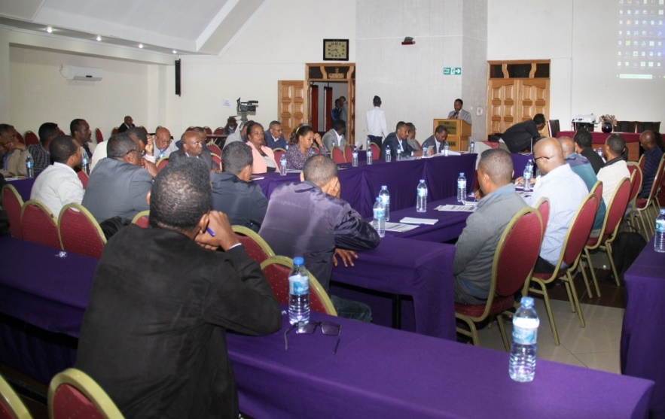
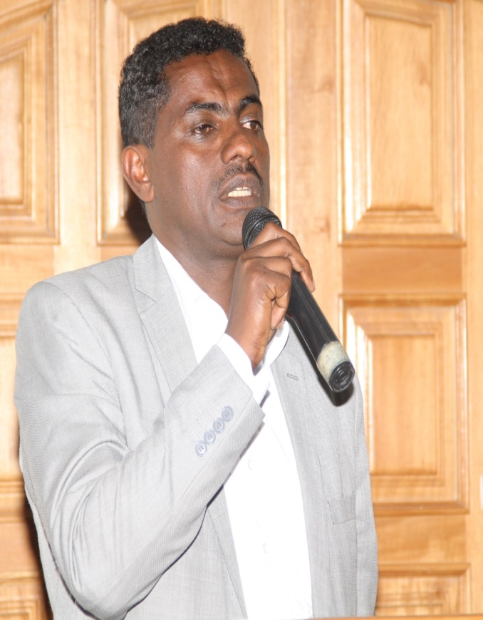
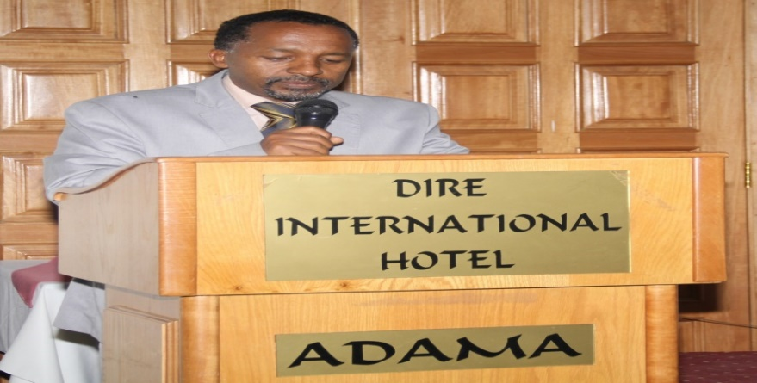
Finally, in his closing remark he noted that the Commission is responsible to coordinate and follow the mainstreaming of the RH/population issues in the preparation of the Region’s ten years perspective plan (2019/20-2030) and the Five years plan (2020/21-2024/25). To make fruitful this, RH Ad-hoc technical Committee for Mainstreaming RH into development planning is established at regional level which includes representatives of CCRDA, DSW Ethiopia and sectoral representatives (health, education women and children’s affairs.
Policy dialogue on Population Dynamics and RH mainstreaming workshops
Welcoming Speech
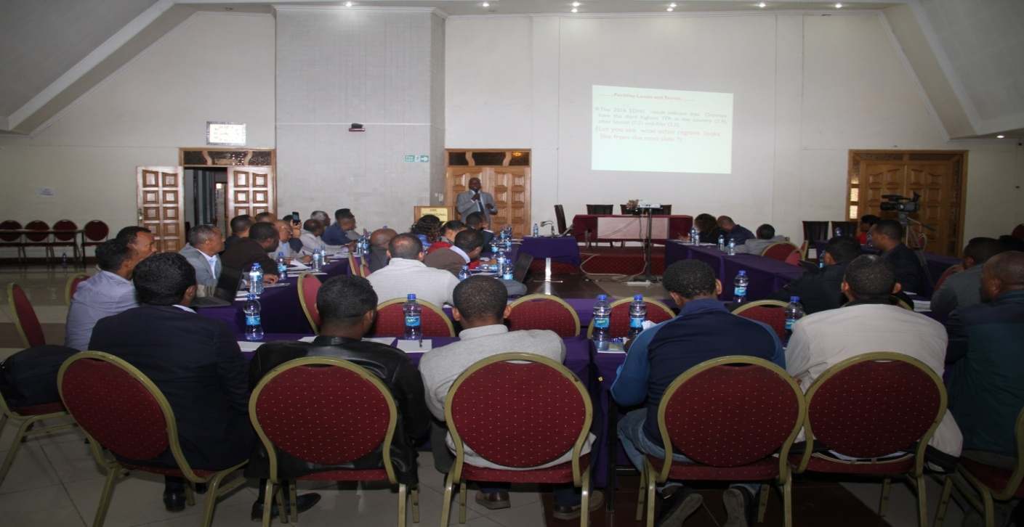
Presentation on RH
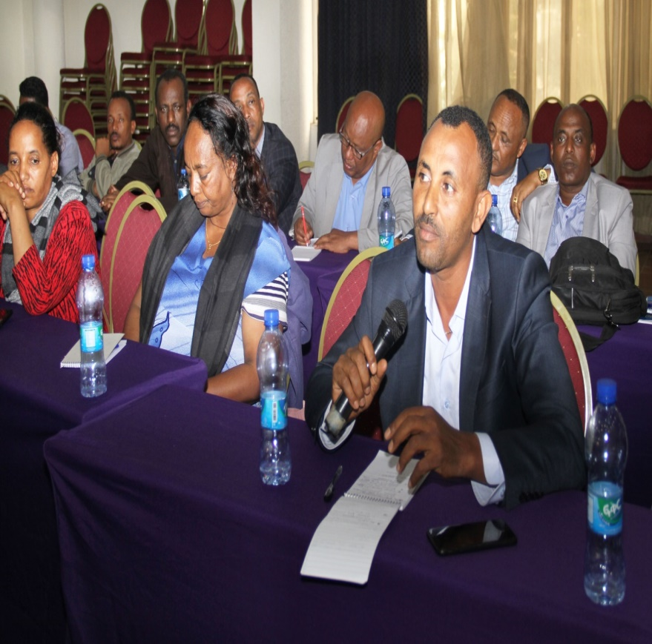
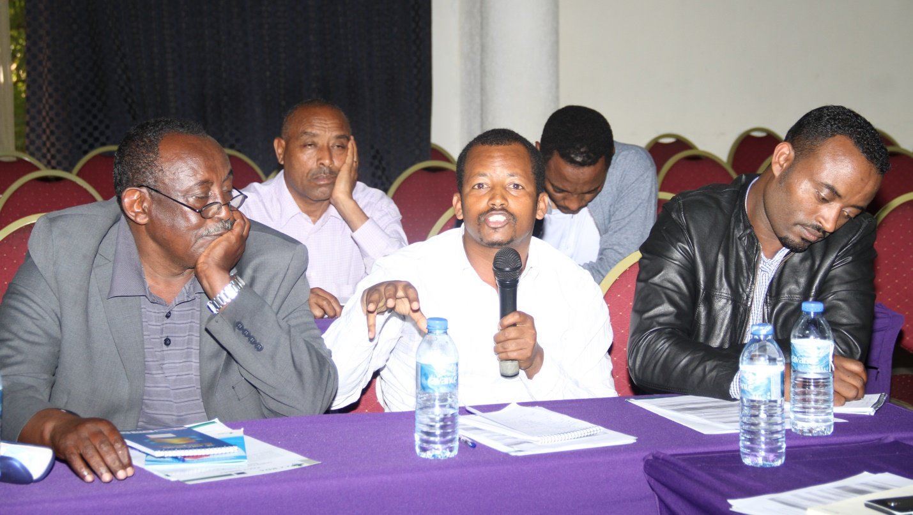
Participation and dialogue on RH by Participant
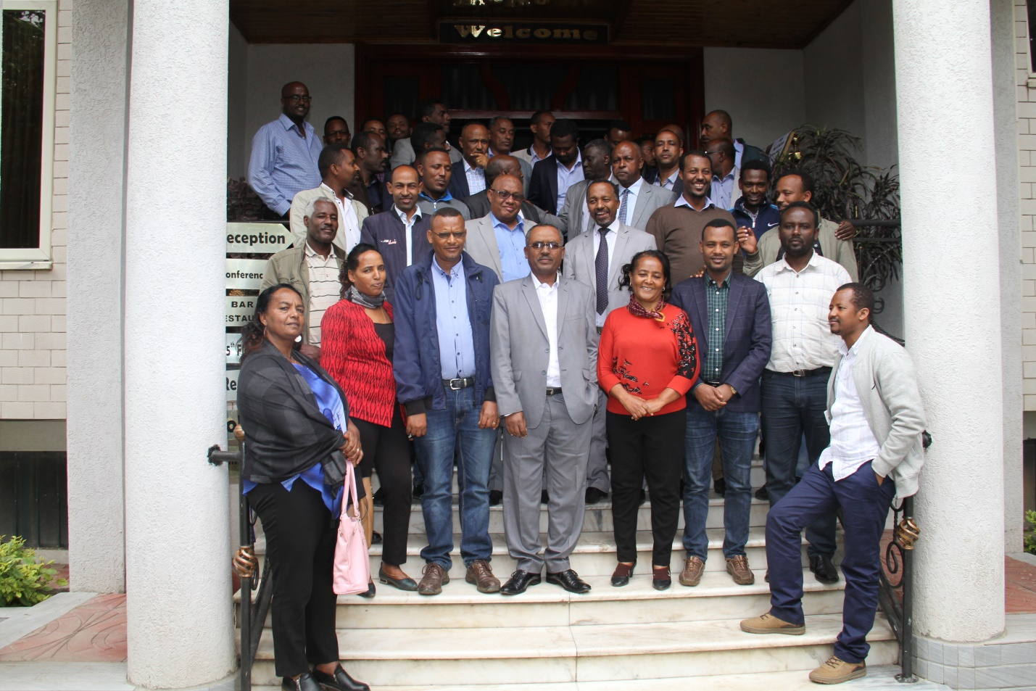
Memorial Photo with participants and coordinator of the Program

Cee’umsa gara industirii taasifamuuf IMX’n gahee bal’aa taphachuu danda’a: Yaada Ka’umsaa
(Abdulaziz Daudiin: I/A Komishinaraa)
Intarpiraayiziiwwan maaykiroo fi xixiqqoon kaappitaala xiqqaa, ogummaa fi teknolojii salphaa, akkasumas lafa xiqqaa irratti hojjechuudhaan carraa hojii bal’aa uumuu danda’u. Invastimantiin dhuunfaa ammo kaappitaala guddaa, teeknolojii fi ogummaa ol’aanaa, fi lafa bal’aa kan barbaadu ta’eetu carraan hojii inni uumu xiqqaadha. Kana malees, sirnaan hooggenemee jennaan invastimantiin dhuunfaa beekumsa haaraa fi gabaa haaraa gara biyyaatti fiduudhaan qaroominaa fi guddina saffisiisa. Haa ta’uu malee sochii hanga ammaatti taasifameen dameewwan oomishaa lamman kun walquba hinqabanu. Kanarraa kanka’e qaawwaa inni tokko qabu inni kaan guutaa diinagdee walittihidhataa (integrated economy) dhugo’oomsuu hindandeenye.
IMXwwan hojii keessa galan keessaa kanneen oomisharratti bobba’an %11 ta’uun isaas quucarummaa damee diinagdee xiqqaa kanaa agarsiisa. Haalli kun yoo hinjijjiiramne humna warshaalee muraasaa qofaan oomisha biyya alaatii galu kan biyya keessaatiin bakka buussuun hindanda’amu; industiriinis hanga barbaadame carraa hojii uumuu hindanda’u. Oomishaa fi oomishtummaa industirii keenyaa hundeerraa jijjiiruuf dhimmoota lama qabannee ka’uu qabna- 1) oomishni industirii keenyaa meeshalee fayyadamtootaa (consumer goods) irratti akka xiyyeeffatu; 2) bal’inaan oomishuufis ta’e humna namaa bal’inaan oomisha industirii irratti bobbaasuuf IMX fi industirii gurguddaa giddutti walitti hidhamiinsa fulla’aa uumuu.
Oomishaa fi oomishtummaa industirii keenyaa hundeerraa jijjiiruuf dhimmoota lama qabannee ka’uu qabna- 1) oomishni industirii keenyaa meeshalee fayyadamtootaa (consumer goods) akka ta’u; 2) bal’inaan oomishuufis ta’e human namaa bal’inaanoomisha industirii irratti bobbaasuuf IMX fi industirii gurguddaa giddutti walittihi dhamiinsa fulla’aauumuu.
Oomish keenya hanga sadarkaa meeshalee fayyadamaa (consumer goods) tti xumuruun maaliif nu barbaachisa?
Yoomiyyu taanaan oomishni xumura irra hinga’in gatiin isaa gadi-aanaadha.Kana malees, akka oomisha xumurarra ga’ee gabaa bal’aa hinqabu. Oomisha keenya hanga xumuraatti yoo geessine gama tokkoon fedhii gabaa biyya keessaa guutuudhaan sharafa biyya alaa meeshalee akkanaatiif ba’u hambisuu nu dandeechisa. Gama biraatiin, gabaa addunyaa keessa galuudhaan sharafa biyya alaa fooyyee qabu akka argannu nu dandeechisa. Fakkeenyaaf, bara 1998 yeroo itti seektarii konistiraakshinii biyyattii sochii hoo’aa keessa galee ture. Haala kana hubachuudhaan warshaan abbootii qabeenya Chaayinaa tokko Awaash irratti hundaa’e.Warshichi akka warshaa simintoo gara biraa adeemsa galteewwan dheedhii lafa keessaa bahan gubuudhaa ofkeessatti hinqabu. Warshichi daaktuu (mills) qofa qaba. “Clinker” biyya Chaayinaa irraa fiduudhaan “pumice” ykn kamichaa Awaashitti argamuun walitti makee daakuudhaan gabaa konistiraakishinii biyya keenyaaf dhiyeessaa ture. Kanaanis hanqina simintoo biyyattii qunname guddaa hiikee jira.Nutis akkuma kana yoo danda’ame hojii gara dhumaa irraa eegaluun xumuruu; yoo kana hintaane garuu jalqabarraa hanga xumuraa walittihidhuudhaan adeemuu qabna. Humna namaa keenya hanga barbaadame gargaaramuus hindanda’u. Hojiiwwan akka kanatti gara xumuraa irraa eegallee xumuruu dandeenyu hojiiwwan salphaa; fkf keemikaalota keessaa kan akka oomisha saamunaa dhangala’aa adda-addaa, barakiinaa, saanitaayizarii, dibata qaamaa fi rifeensaa; akkasumas hojii hodhaa huccuu keessaa kan akka uffata daa’immanii fi ijoollee, boorsaa mana barnootaa, uffata faashina dhiiraa, uffata ispoortii fi tuuttaa adda-addaa, uffata keessaa, kaalsii, fi ashangulliitiiwwan ta’uu danda’u. Kanneen birootis akka kana haala salphaan hojjetamuu danda’an addaa-baasuun ni danda’ama.
Omishoota kana humna warshaalee muraasaatiin fedhii gabaa biyyaa guutuun hindanda’amu.Fedhii gabaa guutuu akka danda’amu warshaalee hojii akkasii irratti bobba’anii fi IMX sirna oomishaatiin walittihidhuu barbaachisa. Abbaan warshaa mirga abbummaa biraandii oomishichaa kanqabaatu ta’ee dizaayinii fi teknolojii, leenjii, fi meeshaa dheedhii IMX’f ni dhiyeessa. IMX’n meeshalee kana gar-tokkee isaa bitachuudhaan, kan hafe duubeedhaan fudahchuudhaan bu’uura dizaayinii fi teeknolojii abbaan warshaa irratti leenjiseen oomishee warshichaaf dhiyeessa. Warshishi qulqullina isaa madaaluudhaan fudhatee maqaa ofii itti maxxansee saamsuudhaan gabaatti baasa. Hanga wal’amantaan guutuun giddu-lamaan IMX fi warshaatti uumamuuf walittidhufeenyi kun wabummaa Bulchiinsa magaalotaatiin kan gaggeeffamu ta’a. Dabalataanis, bulchiinsi magaalaa IMXdhaaf iddo hojii dhiyeessuu fi tajaajila misooma daldalaa (BDS) kennu isaa ittifufa. WALQO’n dhiyeessii liqii iddoo hojiin amansiisaan jiru kanarratti amantii guutuudhaan dhiyeessa. Walumaagala, walittihidhamiinsa kanaan IMX’n hojii (gabaa) amansiisaa kan argatu yemmuu ta’u, industiriin gurguddaan ammo oomisha amansiisaa fi qulqullu bal’inaan oomishee gabaa keessatti dorgomaa ta’a.
Chaartii: Moodeela walittihidhamiinsa oomishaa IMX fi industirii gurguddaa
Industiriidhuunfaa
Gabaaamansiisaa
WALQO
Bulchiinsamagaalaa
Wabiita’uu
Oomishaamansiisaa
Dhiyeessii iddoo oomishaa fi tajaajila BDS
Dizaayinii fi teknolojii, leenjii, meeshaagalteeoomishaa; too’annoosadarkaaqulqulinaahojii
IMX
Dhaabbileefaayinaansii
Deeggertoottainvastimantii
Gabaa

Addunyaarratti dhaabbilee bebbeekamoon akka “Nike, H&M, Puma, Addidas” osoo warshaa tokkollee hinqabaanne haala kanaan oomishtoota wajjiin walitti hidhamuudhaan gabaa addunyaa too’atan.Nutis bifa kanaan guddina industirii keenya saffisiisuutu nurra jiraata.

