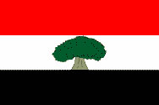

The National Regional Government of Oromia
Planning and Economic Development Commission

Population and Development Relationship:
A Brief Analysis on Oromia Region

October 2020

Finfinne

Population and Development Relationship: A Brief Analysis on Oromia Region

Oromia Planning and Economic Development Commission
Directorate of Development Policy Research
Year of Publication October, 2020

Produced by:
Tesemma Bekele (MSc)
Fikadu Abdisa (MA)
Mogas Amara(BA)

Published by:
Oromia Planning and Economic Development Commission
Directorate of Development Policy Study and Analysis
Telephone 251-115-152-005/0115-510015
P.O.Box-669 Code2675/1250
Fax251-551-0429/515-2328
E-mail:-Oromiaplanning@gmail.com
October, 2020
Finfinnee

Table of Content
Page
Table of Content iii
Lists of Tables v
List of Figures vi
Acronyms vii
1. Introduction 1
1.1. Back Ground 1
1.2. Objective 1
1.3. The Scope of the Study 2
2. Sources of Data and Methods of Analysis 2
3. Basic Concepts of Population and Development 2
4. Analysis on Population and Development Situation 4
4.1. Population Characteristics and Dynamics in Oromia 4
4.1.1. Population Size 4
Table 4.1: Population of Oromia Region by Urban and Rural 5
1,654,097 5
23,712,208 5
4.1.2. Population Structure 5
Table 4.2: Population of Oromia Region by age structure 5
4.1.3. Population Dependency Ratio 6
4.1.4 Population Distribution 7
4.1.5. Population Dynamics 8
Figure 1: Trends of Total Fertility Rate in Oromia 8
Figure 2. Trends in Neonatal, infant and Child mortality in Oromia 10
Figure 3: Trends in Maternal Mortality Ratio in Oromia 10
4.1.6. Population Growth 11
4.2. Implication of Population on Development 12
4.2.1. Population Implication on Economic Development 12
Table 4.3: Comparisons of population and GDP Growth rates 13
Table 4.4: Economic Status of Urban Population of Oromia 14
4.2.2. Population Implication on Social Services 16
Table4. 5: School Age population of Oromia Region 17
Table 4.8: Women’s in different population age groups (Millions) 20
Table4. 9: Health institution to population 20
Table 4.10 : Percentage of Major Health and population Related Indicators 21
Table 4.11: Share of Health Budgets from total budget in birr (2015-2019) 22
Table 4.12: Trends of degree of Malnutrition in Oromia 22
5. Conclusion and the way forwards 23
5.1. Conclusion 23
5.2. The way forward 23
References 24
Annexes 25

Lists of Tables

Page

Table 4.1: Population of Oromia Region by Urban and Rural 5
Table 4.2: Population of Oromia Region by age structure 5
Table 4.3: Comparisons of population and GDP Growth rates 13
Table 4.4: Economic Status of Urban Population of Oromia 14
Table4. 5: School Age population of Oromia Region 17
Table 4.6: Oromia Region Education sector performances 18
Table 4.7: Share of Education Budget from total budget in birr 18
Table 4.8: Women’s in different population age groups (Millions) 20
Table4. 9: Health institution to population 20
Table 4.10 : Percentage of Major Health and population Related Indicators 21
Table 4.11: Share of Health Budgets from total budget in birr (2015-2019) 22
Table 4.12: Trends of degree of Malnutrition in Oromia 22

List of Figures

Figure 1: Trends of Total Fertility Rate in Oromia 8
Figure 2. Trends in Noenatal, inafant and Child mortality in Oromia 10
Figure 3: Trends in Maternal Mortality Ratio in Oromia 10
Figure 4: Trends of Poverty Reduction, economic Growth and population growth. 14
Figure 5: Urban Unemployment and Eeconomic growth 16

Acronyms

BOFED Bureau of Finance and Economic Development
CDR Crude Death Rate
CSA Central Statistics Authority
EDHS Ethiopian Demographic and Health Survey
GDP Gross Domestic Product
ILO International Labour Organization
MMR Maternal Mortality Ratio
MoPED Ministry of Planning and Economic Development
OPEDC Oromia Planning and Economic Development Commission
WHO World Health Organization

1. Introduction

Back Ground

Without adequate understanding of how the country/region is changing from a demographic perspective, forward-looking, planning and agenda setting will be difficult. Recognizing and planning for such demographic change is an essential pre-requisite for sustainable development. It is critical that decision makers, policy makers and planners understand how demographic factors affect sustainable development, but at the same time realize that social, economic and environmental issues will also shape population dynamics. For this reason, population dynamics was emphasized in the Second Growth and Transformation Plan of the country, in general and Oromia in particular.
In view of this, Oromia Planning and Economic Development Commission, is mandated to guide and coordinate strategic initiatives that address population issues and their roles in social and economic development of the Region has prepared this document to high light the population Development Relationship.
This document is helpful for policy analysts, planners and researchers and others who have some sorts of interest to know how population structures and dynamics interplay with development. It contains in detail different issues that can affect population structure, composition, and dynamics, and provides information on statistical data of the population of the Oromia National Regional State.

Objective

The main objective of this population and development relationship analysis is to give information and enhance the knowledge of planners, decision makers and policy makers interested in population and development of the Region.

The Scope of the Study

This analysis focuses on major population elements and development variables to show their associations, as well as existing and coming challenges using CSA annual surveys and sector reports. Primary data are not incorporated.

Sources of Data and Methods of Analysis

The sources of data used for this analysis include all pertinent secondary sources produced by the Central Statistical Agency through survey reports and inter-censual population projection; Regional sectors’ report produced during GTP-II terminal evaluation; and OPEDC reports on RGDP and published pamphlets.

Descriptive statistical analysis such as percentages and frequencies are widely used and presented in graphs and tables in this analysis. Changes overt time of some indicators are tried to incorporate in the analysis.

Basic Concepts of Population and Development

  - Population
Population is the total number of inhabitants living in a given geographical area during a specific point in time. Population is not only about number but about people, the quality of life that people are living. In addition, it is about the reproductive life and the health of individuals, couples, communities and all of the people living in the country.

The rationales to study population encompass to know about the size, age and sex structure; how many people need provision of basic services; proportion of productive and healthy population; promoting reproductive and sexual health; Getting prepared for a wanted baby and providing for a healthy baby; empowering young women to fulfill their potential; ensuring gender equity and equality; promote integrated socio-economic development plan and provide vivid data for those providing services

Population data are vital as people are the means and ends of plans and activities at the household, community, organization, national and global levels. Measurement and analysis of population information are crucial to any socio-economic development plans and processes. Population information is not only vital for planning the resource requirements of the nation but also for distributing the fruits of development. The users of population data include government and non-government organizations, private sectors and professional in all disciplines (MoPED,1994)
The sources of population data include census, sample survey, vital registration and administrative records. The census is the total count of population size and related attributes over a specific period, usually takes place every ten years. Sample survey is the count of people and their respective attributes living in a specific place and time using scientific procedures and statistically representative samples. It is less costly and highly accurate: often used to collect wide range of data. Vital registration is the information gathered through continuous registration of vital events: births, deaths, marriages and divorces. Not commonly practiced in developing countries mainly due to resource constraints. Finally, population data can be obtained from administrative records, which include population records kept by various agencies/sectors/institutions such as health facilities, school registration, municipal records, taxation list, voting list, etc.

  - Development

Development as a concept is a reflection of time and place. It is a normative concept, which means different things to different people depending on who they are and what they need. Moreover, development involves an assessment of the desirability or undesirability of change which can vary with time and the overall environment (social, cultural, political, ideological and economic condition) of the nation. From this point of view, some scholars, planners and practitioners have observed that development is more a process of moving away from certain undesirable conditions than of moving toward an explicit goal. In general, the concept of development is very complex. Development in a comprehensive manner is the reduction of poverty, economic growth, self reliance, overcoming inequality and empowerment. It is about improving the wellbeing of people through raising living standard, improving education and health care and quality of opportunities, which are all essential components of socio-economic development.

Development is measured in terms of poverty, inequalities, employment and equality in distribution and improvements in the quality of life of the people. Therefore, the key indicators of development may include life expectancy at birth, infant and child mortality, level of literacy of the population, GDP per capita or income and employment rate. (BOFED,2014)

Analysis on Population and Development Situation

4.1. Population Characteristics and Dynamics in Oromia

Population size refers to the total number of people living within a defined area, or it refers to a group of people from a defined area that has similar characteristics. As the establishment of the region is very a recent phenomenon, population data could not be found for consecutive years. The Region has started to get demographic and non-demographic data from the 1994 National Population and Housing census.

4.1.1. Population Size

Based on the medium projection made by CSA the population of the region has increased from 18.7 mill in 1994 to about 37,831,576 in July, 2019, of which, 19,104,050 were males (50.5%) and 18,727,525 were females (49.5%) as projected from the third National Population and Housing Census conducted by CSA in 2007, which put the total population of the Region at 26,993,933; of which 13,595,006 males (50.4%) and 13,398,927 females (49.6%). In the last thirteen years, the population of the region has increased by 11.8 million (43%).In the same period; the population of the region has increase annually by nearly 909,000 people. It is projected that urban population of the region have increased from 3.35 mill (12.3%) to 5.96 million (15.33 %) in between 2007 and 2020. Hence, such changes in population size and growth rate must be seen with their implications on overall development of the economy, social, politics and environment and security of the Region, for ignoring them will have unprecedented consequences.

Table 4.1: Population of Oromia Region by Places of Residences/2015-2020/
Year | Urban + Rural |  |  | Urban Population |  |  | Rural Population
Year | Both sex | Male | Female | Both Sexes | Male | Female | Both Sexes | Male | Female
2007 Census | 27,062,002 | 13,629,299 | 13,432,702 | 3,349,793 | 1,695,696 | 1,654,097 | 23,712,208 | 11,933,603 | 11,778,605
2015 | 33,999,815 | 17,121,986 | 16,877,829 | 4,989,826 | 2,524,856 | 2,464,970 | 29,009,989 | 14,597,129 | 14,412,860
2016 | 34,895,497 | 17,599,416 | 17,296,081 | 5,164,085 | 2,623,764 | 2,540,321 | 29,736,077 | 14,975,915 | 14,760,162
2017 | 35,856,743 | 18,090,160 | 17,766,583 | 5,321,672 | 2,707,411 | 2,614,261 | 30,535,071 | 15,382,750 | 15,152,321
2018 | 36,830,815 | 18,587,246 | 18,243,570 | 5,525,705 | 2,812,827 | 2,712,878 | 31,305,111 | 15,774,420 | 15,530,692
2019 | 37,831,576 | 19,104,050 | 18,727,525 | 5,739,521 | 2,921,963 | 2,817,559 | 32,092,054 | 16,182,087 | 15,909,966
2020 | 38,884,904 | 19,636,877 | 19,248,029 | 5,960,535 | 3,034,743 | 2,925,793 | 32,924,373 | 16,602,134 | 16,322,236
Source: CSA and OPEDC Projection 2015-2020.

4.1.2. Population Structure

Population structure describes the relative numbers of people with similar characteristics within a population. For example, people can be grouped by age, sex, or ethnicity. The data on the structure of a population show that how the sub-groups within it affect its composition and characteristics. The structure of the populations changes over time due to of birth, death, or migration of peoples.
Age structure refers to the relative numbers of people with similar characteristics within a given population classified as child, adolescent, youth age, working age and old population. As of July 2019 the total population of Oromia was estimated at 37,831,576 of which 15,412,078 (40.7%) were child aged 0-14 years, 9,220,811 (24.4%) were adolescents age 10-19 years, 11,405,016(30.1 %) were youth age 15-29 years while 21,349,230 (56.4 %) were working age (economically active) 15 to 64 years old and 1,070,267(2.5 %) were 65 years and above ( economically inactive).
Table 4.2: Population of Oromia Region by age structure (2015-2019)
Year | Total | 0-14 | % | 10-19 | % | 15-29 | % | 15-64 | % | 65+ | %
2007 | 27062002 | 12722214 | 47.0 | 6578303 | 24.3 | 7413888 | 27.4 | 13472499 | 49.8 | 867288.0 | 3.2
2015 | 33999815 | 14702612 | 43.2 | 8503824 | 25.0 | 9943156 | 29.2 | 18337035 | 53.9 | 960168.0 | 2.6
2016 | 34895497 | 14887862 | 42.7 | 8703874 | 24.9 | 10284121 | 29.5 | 1902503 | 54.5 | 982602.0 | 2.6
2017 | 35856743 | 15084925 | 42.1 | 8896546 | 24.8 | 10642675 | 29.7 | 19762782 | 55.1 | 1009037.0 | 2.5
2018 | 36830815 | 15241643 | 41.4 | 9058203 | 24.6 | 11030997 | 30.0 | 20551067 | 55.8 | 1038105.0 | 2.5
2019 | 37831576 | 15412078 | 40.7 | 9220811 | 24.4 | 11405016 | 30.1 | 21349230 | 56.4 | 1070267.0 | 2.5
Source OPEDC and CSA population Projection

4.1.3. Population Dependency Ratio

Dependency ratio is a measure of the age structure of a population. They relate the number of individuals that are likely to be economically "dependent" on the support of others. Dependency ratios contrast the ratio of young population (ages 0-14) and the elderly (ages 65+) to the number of those in the working-age group (ages 15-64).

The total dependency ratio is the ratio of combined young population (ages 0-14) and elderly population (ages 65+) per 100 people of working age (ages 15-64).A high total dependency ratio indicates that the working-age population and the overall economy face a greater burden to support and provide social services for youth and elderly persons, who are often economically dependent. The total dependency ratio of Oromia is 100.9 in 2007 and decreased to 77 in 2020. This indicates that for each 100 working persons there would be 77 young and old dependents supported in the region in 2019(OPEDC, 2019).
The youth dependency ratio is the ratio of the young population (ages 0-14) per 100 people of working age (ages 15-64). A high youth dependency ratio indicates that a greater investment needs to be made in schooling and other services for children. Young population dependency ratio of Oromia Region was 94 in 2007 and declined to 72 in 2019. This means that Youung population dependency ratio was 94 in 2007 and declined to 72 in 2019, that is, out of 100 persons in the working age group (economically active population), there were young population dependents in the region (OPEDC, 2019).The elderly dependency ratio is the ratio of the elderly population (ages 65+) per 100 people of working age (ages 15-64). Increases in the elderly population put added pressure on governments to fund pensions and healthcare. Old agedependency ratio of Oromia region is 6 in 2007 and 5 in 2019. This shows that for each 100 persons in the working age group, there were about 6 in 2007 and 5 2019 elders dependent persons to be supported in the region (OPEDC, 2019).

The age structure of Oromia region is typical of the developing countries, which are characterized by higher proportions of young age and low proportions of at old age population while relatively growing the working age groups. This caused the ppopulation of the region to have broad based and narrow apex age structure due to high fertility and declining in mortality. This implies that policy makers and planners need to analyze changes in the composition of the population to plan for education, health care services, and economic development projects. The age of residents, gender, and occupation, level of education, marital status, and living arrangements provide planners with the type of information needed to plan for the residents' diverse needs. Because a population composition that has a large percentage of residents under age 15 implies the need for schools, primary health services, and recreational needs. Gender is another key factor. For instance, women, especially in their early reproductive years, 20–35, may need specialized health services for childbearing.

4.1.4 Population Distribution

Population distribution means the pattern of where people live. World population is unevenly distributed because of historical, climatic, natural resources, economic and cultural factors. There are places where peoples sparsely distributed; and reversely, there are places where densely populated. In Oromia, there is high variation in population distribution between urban and rural areas.For instance, in 2007 of the total population of the region around 3,349,793(12.4%) were found in urban areas while 23,712,208(87.6%) were rural residents respectively. In 2020, the Urban residents increased to 5,960,535(15.3%) while the rural residents reached 32,924,373(84.7%). This indicates that although there was change in place of residence still greater number of the region’s population lives in the rural areas. According to the 2020 population projection made by OPEDC, of the total population of the Region (38,868,592) five zones: East Hararge (9.9%), Arsi (9.7%), Jimma (9.5%), West Arsi (7.6%) and West Shewa (7.2%) are the most populous zones while Borena (1.4%), Horo Guduru Wollega (2.1%) and Buno Bedelle (2.2%) are the least populous zones in Oromia Region.
This unbalanced distribution of population in the region has different implication on development and resource utilization so that it has become a great concern for the region. Spatial distribution describes the degree and quality of access to land and other resources. Declining and rising population number can influence population/land and population resource ratios. Man to land ratio is increasing in the region due to rapid population growth rate consequently leading to declining of environmental quality. The density of the population of the region has increased from 51.5 persons per km2 in 1994 to 107.1 persons per km2 in 2020. On the other hand, urban population of the Region is characterized by rapid growth of urban population, which implies high demand for employment, housing, transportations, education and health services, water and others.

4.1.5. Population Dynamics
Population is never static; that is, the population may grow or decline through the interplay of three demographic processes: fertility, mortality and migration. Fertility is the number of births that occur to an individual or a population. Therefore, the fertility rate is how many kids an average mother will have in her lifetime. Regarding the fertility levels and trends in Oromia, fertility has dropped in between 2000 and 2005, from 6.4 children per woman in 6.2, respectively, and then decreased further to 5.6 children in 2016 (CSA, 2016). This showed that fertility has decreased slightly from year to year in Oromia; consequently, it has still remained high compared to other Regions of the Country. For instance, according to the 2016 Ethiopian Demographic and Health Survey Oromia occupied the third highest total fertility in the country (5.4), after Somali (7.2) and the Afar (5.5).

Figure 1: Trends of Total Fertility Rate in Oromia
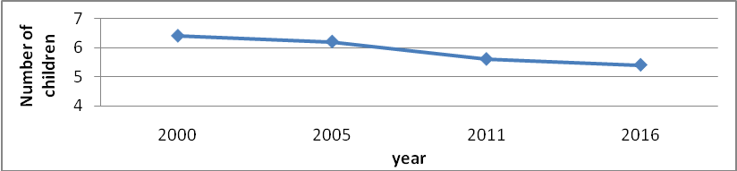
Source: EDHS 2000-2016
Despite the fact that the use of modern contraceptive by currently married Ethiopian and Oromia Region women has increased steadily between EDHS 2000 and EDHS 2019, jumping from 6% to 41% and 4.6 to 38.9 % respectively, the target of reaching 4.0 children per woman by the year 2015 could not be achieved both at National and Oromia Region. Unmet need for family planning among married women aged 15-49 has declined over time from 41% in 2000 to 28.9% in 2016, though it still very high. Hence, many women in Oromia, particularly, in the rural parts of the Region have been left exposed to high fertility that could endanger both the women’s economic and health status.

Mortality is the death of an individual or the number of deaths that occur in a population. Mortality in population is measured in number of ways. (WHO,2004)

CRUDE DEATH RATE (CDR) is estimate of the rate at which members of a population die during a specified period. The numerator is the number of people dying during the period; the denominator is the size of the population, usually at the middle of the period (mid-year population). It is the simplest and most common mortality measure often presented in statistical reports by countries or international agencies. The Crude Death rate (CDR) of the Region has decreased from 12.9 in 2000 to 9.4 in 2012 and was estimated to be 7.9 per 1000 peoples in 2019.
Maternal Mortality Ratio/MMR/: It is one of the indicators is mortality measure. Maternal Mortality Ratio/MMR/ is annual number of maternal deaths per 100,000 live births from any causes related to or aggravated by pregnancy or its management(excluding accidental or incidental causes) (WHO, 2004). The Maternal Mortality Ratio of Oromia also reduced from 871 to 420 deaths per 100,000 live births in the period 2000 to 2016. It has remained as an area of concern to reduce that all stakeholders need to give attention and collaborate in all manners.
Infant and child mortality Rates: In the last twenty years, the infant and child mortality rates of the Region , though not sufficient, has decreased from 116 and 193 per 1000 children in 2000 to 43 and 55 in 2019, repectively.

Figure 2. Trends in Neonatal, infant and Child mortality in Oromia
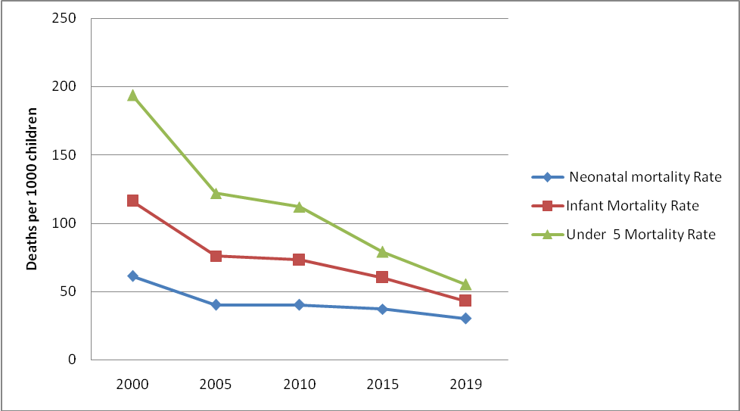
The maternal mortality ratio of Oromia reduced from 871 to 420 deaths per 100,000 live births in the period 2000 to 2016 though it is remained high

Figure 3: Trends in Maternal Mortality Ratio in Oromia

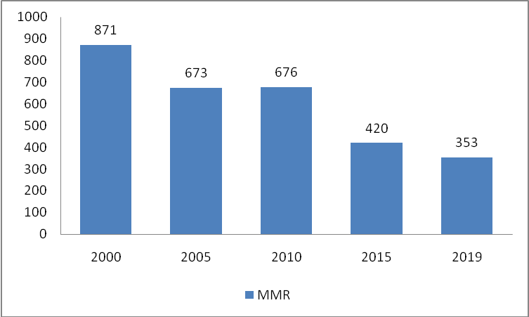
Source: EDHS 2000,2005,2010,2016 and mini EDHS -2019
Migration is the movement of people into or out of a specific geographic area. Migration, as one of the factors of demographic changes can affect substantially the structure of populations. Internal migration within a country; from rural areas to urban areas, urban to urban and rural to rural significantly alter the demographic characteristics of people: numbers, sex and age structures of the population living in an area. In rural areas, this number will decrease as young people move out of them to cities to find work. Conversely, in cities the number will increase as the people from the rural areas enter the city and make the shortage of infrastructure, social services, and finally became source conflict and insecurity. Migration into a country will also alter the country’s population structure. The majority of people who migrate will be young and this will result in an increase in the number of young in the host country. This will also result in a decrease in the number of young in the country of origin.

4.1.6. Population Growth
All populations change in size with time in three scenarios. If births exceed deaths, the population grows; if deaths exceed births, the population shrinks and only when births equal deaths do the populations stay the same. Population growth is the difference between crude birth Rate (CBR) and crude death rates. Both are measured by the rate of births or deaths respectively among a population of 1,000. The CBR and CDR are determined by taking the total number of births or deaths in a population and dividing both values by total population to obtain the rate per 1,000. The crude birth rate is called "crude" because it does not take into account age or sex differences among the population.
The total population of the Region is expected to grow at 2.6% in 2019 while urban population Growth rate was 4.5% per annum in 2013 and projected to grow by 3.7 % in 2019. Rural population growth rate was estimated to grow at 2.9% per annum in 2013 and 2.7% in 2019. In relations to population growth rate, a very important population indicator is the doubling time of the current population in size. The doubling time of population is the amount of time it takes for a given quantity to double in size or value at a constant growth rate. Accordingly, depending on the current 2.6 per annual growth rate in 2019, the doubling time of the population would be in 26 years and the population of the region is expected to reach 76 million and the population of the region is estimated to be about 51.68 million in 2030, of which 17.4% would be urban residents. Hence, this implicates that the more populations increase, the more productions, expansion and maintenance of infrastructures, delivery of social and economic services, shelters, employment…etc, are required from all concerned bodies. Of course, if it is well managed, additional numbers of the population are source of labor for economic development and consumptions of market goods. Otherwise, it incurs additional burdens on the precarious resources, economy and security of the Region.

Implication of Population on Development

Population Implication on Economic Development

As Coale and Hoover(1958) stated in situations where the supply of capital is inelastic, rapid population growth resulting from high fertility forces the diversion of investment to duplicate existing facilities, prevents increase in capital per worker, and leads to a decline in productivity. In the short term, high fertility increases the dependency burden and reduces savings and investment required to increase the productive capacity of the economy. This is mainly due to the increased consumption needs of a large population. The pattern of investment shifts towards welfare types like on health, education, housing… than on directly productive types.
It is also believed that in the intermediate term, high fertility will increase the size of and the rate of growth of the labour force which requires a given level of investment to provide them with productive employment and capital per worker but high dependency burden will erode the possibility for savings and investment, making it difficult to provide employment for the growing labor force (Coale and Hoover,1958).

Oromia is an area where high fertility prevails, though shown a declining trend in the last two decades. The population of the Region was rapidly growing and, particularly, young population constituted large share. In the last five years (2016-2019) from the total Regional public investment, about 40% of Oromia budget was allotted for education and health sectors.

Economic Growth: Regarding economic growth of the Region, the GDP has grown on average by 7.3 per annum while population grew at 2.7 % in the last four years. The high population growth may put pressure on per capita income growth as it only grown from 566.2 in 2016 to702.6 USA dollars in 2019. High population growth rate directly affect the per capita GDP growth of economy in the Region ( See table 4.3)

Table 4.3: Comparisons of population and Real Per capita GDP Growth rate

Items | Year
Items | 2016 | 2017 | 2018 | 2019
Population Growth Rate(%) | 2.7 | 2.7 | 2.7 | 2.7
GDP Growth(%)
Real GDP per capita growth Rate(%) | 4.1 | 9.9 | 1.8 | 3.8
Net GDP per capita growth Rate* | 1.4 | 6.2 | -0.9 | 1.1

Note (*) :Difference between rates of Real GDPper growth rate and growth and population growth

Poverty: Poverty is in simple terms is not having enough money or access to resources to enjoy a decent standard of living; but also lack of access to healthcare, education or water and sanitation facilities etc. One of the indicators of poverty level is regional poverty headcount. Poverty headcount ratio is the percentage of the population living below the national poverty lines. The percentage of Oromia population living below the national poverty line has decreased on average by 1.07 per annum from 39.9 in 2000 to 23.9 in 2015/16. However, in absolute figure, the number of people in poverty has decreased on average only in 0.62 percent per annum, which is, it decreased from 9.8 million to 8.06 million during this period. Generally, about 23.9 percent of the total population of the region was still found under poverty in 2015/16.
From the figure 4 it can be seen that the absolute poverty indices slightly declining as the economy of the Region was growing. It seems that high population growth had its own effect on both growth of economy and reducing poverty.

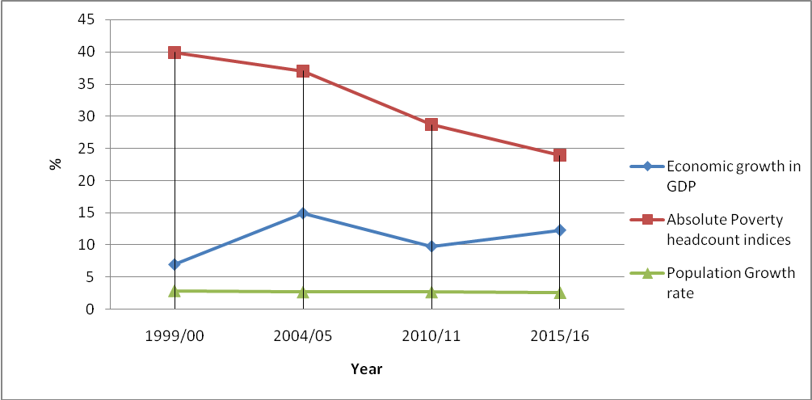
Source: own computation base on the available data.
Figure 4: Trends of Poverty Reduction, economic Growth and population growth.

Employment: Employment is one of the economic indicators that are used to measure the level of economic development is participation of the people in the economy. Most of the time it is measured in economically active and inactiveness of the population. The participation of the people in the economy implicates high employment and low dependent numbers on economic active of population for survival/subsistence.

The economically active populations are those people in employment plus the unemployed. The economic activity rate is an indication of the actual and potential labour supply within an area. It measures the number of people who are in employment or unemployed expressed as a percentage of the working age population. The economically inactive population is those people who are in neither employment nor unemployed. This includes those looking after a home and family, long- or short-term sick, injured or disabled people, or those who are retired.
Economic inactivity rate expresses the number of people who are economically inactive as a percentage of the working age population. Percentages given for those who are economically inactive and do/not want a job show the proportion of all economically inactive people.
The denominator includes all people aged 15-64, which is also sourced from the annual population Survey.

Table 4.4: Economic Status of Urban Population of Oromia
Year | Total population (age 10+) | Economically active population | Employed population | Economically not active | Activity rate
2012 | 3,131,966 | 1,979,212 | 1,643,077 | 1,158,165 | 63.0
2014 | 3,795,509 | 2,365,737 | 1,983,701 | 1,429,772 | 62.3
2015 | 3,898,166 | 2,489,386 | 2,102,417 | 1,408,777 | 63.9
2016 | 4,106,702 | 2,567,646 | 2,177,073 | 1,539,056 | 62.5
2018 | 4,247,857 | 2,536,652 | 2,080,506 | 1,711,205 | 59.7
Source: CSA, Urban Unemployment Surveys 2012-2018
In Oromia total urban population age 10 years and above has increased by (35.63%) 1.12 million in between 2012 and 2018, which is, a growth rate of 6% per annum. The total urban economically active population of the Region has increased from 1,979,212 persons in 2012 to 2,536,652 in 2018. It can be observed that economic active urban population has increased by 28.6% percent in between 2012-2018. However, the activity rate of urban population has declined from 63% to 59.7 % in the same period. A rapid urban population of the region is also resulted high economically inactive urban population. The Region’s economically inactive population has increased by 48.5% from1.12 million to 1.71 million in between 2012-2018. It has grown by 8.6% average annual growth rate. Economically inactive urban population is an indication of high burdens on economy and others services of the region. Therefore, both economic active and inactive urban population of the region are expected to increase with rapid urban population growth in the Region.
Unemployment: Another indicator of development, especially at macroeconomic level is unemployment rate in population. Unemployment is to be without a job, that is, when a capable person cannot find work, they are considered unemployed. An unemployed worker is actively seeking employment but is unable to find a job at any level. According to ILO, an unemployment rate of about 4% - 6% is considered "healthy". (CSA,2018)

In this regard urban unemployment rate of Oromia Region has increased from 16.7% in 2012 to 18% in 2018 (CAS, 2012-2018). This might be due to two main causes. One of this cause is high number of young people’s entering job markets from through migartion. For instance, in between 2015-2020 urban population of the Region were grown on average in 3.8 percent, that is, nearly one million peoples were added to the population of the Region during the same period mainly through migration and natural growths. On the other hand, the economy of the Region has been growing on average by 7.3 percent in the last four years (2016-2019), though urban employment rate was remained on average at 16.3 percent (2014-2018) and even increased to 18% on 2018.

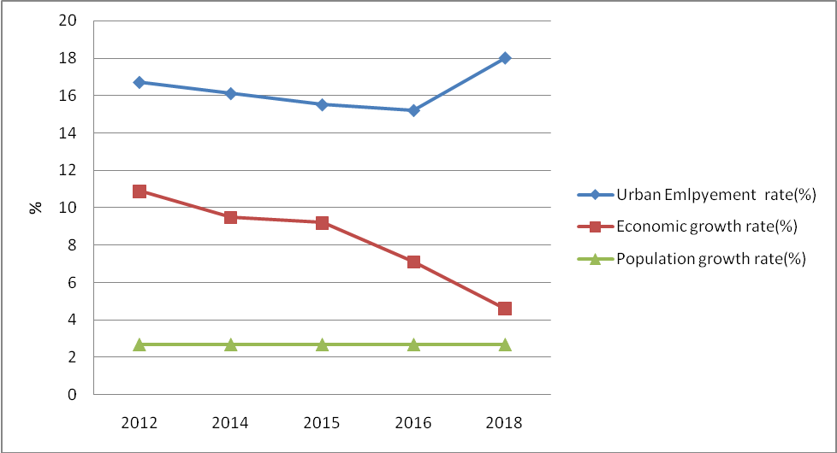

Figure 5: Regional Urban Unemployment and Eeconomic growth rate

On the other hand, despite the fact that the economy of the Region is substantially growing, it could not have produced sufficient jobs for the influx of young people entering labour market; and the availed jobs are mostly temporary jobs. Absence of skills and lack of entrepreneurship were other contributing factors to urban unemployment. In general, there is mismatch between demand and supply of labors in the Region as the economy could not produce enough jobs. It is exacerbated by high urban population growth rate in the Region.

Population Implication on Social Services
Most of the social service sectors have direct relationship with many population parameters in given areas, particularly; education, health, cultural and other social services are highly affected by the population. Considering the characteristic of the population at policy and planning stages would have paramount importance in determining the quality and quantity of the services. Therefore, in this sub section we will briefly see education and health services and population.

4.2.2.1. Education

Education is the process of facilitating learning, or the acquisition of knowledge, skills, values, beliefs, and habits. Education is a major catalyst in the process of economic development. It plays a cardinal role in fertility reduction and control programs by providing new visions and skills to families and couples on all aspects of life.
In 2019 out of the total population of the Region, about 14.34 million children were found in school age population, which is, 38 percent of the total population. It has been increasing from years to years. School age population has increased by 1.12 million (8.6 %) in between 2015 and 2019.

Table4. 5: School Age population of Oromia Region/2015-2019/
Year | Total Population | Preschool (4-6 years) | Primary school (7-14 years) | Secondary School  (15-18 years) | Total school population | % of school age population from total population
2015 | 33,999,815 | 2,899,387 | 7,217,797 | 3,108,099 | 13,225,283 | 38.90
2016 | 34,895,497 | 2,975,768 | 7,407,941 | 3,189,978 | 13,573,687 | 38.90
2017 | 35,856,743 | 3,047,439 | 7,553,286 | 3,310,515 | 13,911,240 | 38.80
2018 | 36,830,815 | 3,092,595 | 7,640,886 | 3,404,579 | 14,138,060 | 38.39
2019 | 37,831,576 | 3,134,568 | 7,697,613 | 3,523,939 | 14,356,120 | 37.95
Source: Oromia Region GTP-II Evaluation Report, 2020

It is observed that with the increase of the population, more children and adolescents today have been enrolled in pre-primary, primary and secondary education than ever before. Many education facilities were expanded by public, privates and others to serve the upcoming young population. Despite all these efforts, any young populations are still waiting for education. Comparably, girls are still left behind the boys in enrolments at all educational levels. Education data showed access to education services was expanding at the expense of quality in the Region. It can be seen from the table below that many of education sector indicators are still below the expected targets and standards and calls for further investments and attentions of all concerned bodies of the Region. The pressure that comes from high school age population of the Region may continue for sometimes in the future as the population of the Region is left to grow at alarming rate

Table 4.6: Oromia Region Education sector performances

Performance of Education indicators | 2015 | 2016 | 2017 | 2018 | 2019
Primary level(1-8)
Gross Enrolment Ratio | 95 | 149 | 104 | 105 | 106
Net enrolment rate | 86.8 | 98.2 | 97.5 | 97.7 | 98.3
Gender parity index | 0.91 | 0.89 | 0.88 | 0.88 | 0.87
Pupils section ratio | 57 | 60 | 60 | 60 | 58
Pupils teacher ratio | 53 | 56 | 53 | 53 | 49
Secondary level/9-10/
Gross Enrolment Ratio | 36.2 | 37.5 | 38.1 | 41 | 42.4
Net enrolment rate | 17.5 | 17.9 | 17.5 | 18.9 | 19.6
Primary Gender parity index | 1 | 0.98 | 0.9 |  | 0.9
Pupils section ratio | 59 | 62 | 62 | 64 | 66
Pupils teacher ratio | 27 | 27 | 26 | 27 | 28
Secondary level/11-12/
Gross Enrolment Ratio | 8.1 | 9.2 | 29.8 | 10 | 14.5
Net Enrolment rate | 4.5 | 5.2 | 18.1 | 5.2 | 8
Gender Parity index | 0.96 | 0.9 | 1.3 |  | 0.9
Pupils -section ratio | 51 | 53 | 53 | 55 | 62
Pupils- teacher ratio | 21 | 22 | 23 | 21 | 28
Source: Oromia Region GTP-II Evaluation Report,2020

High number of school age populations of the Region has diverse impacts on the economy as well as access and quality of education services. For instance, about 24 % of the total budget of the Region apportioned to finance education services in the region in 2019. Despite the fact that education sector budget of the region was growing on average by 24.5% per annum, and education sector expenditure per capita increased from birr 225 to birr 401 in between 2015-2019. The available data showed there are wider gaps that remained unfulfilled both access to and quality of education services, as school age populations of the region remained large for accommodation.
Table 4.7: Share of Education Budget from total budget in birr
Public investment on Education | 2015 | 2016 | 2017 | 2018 | 2019
Region Total budget (birr) | 32,623,270,270 | 42,951,112,179 | 46,440,163,820 | 55,809,286,530 | 63,440,979,599
Education Total Budget(birr) | 7,635,902,549 | 9,430,806,591 | 13,310,985,214 | 13,952,961,005 | 15,179,969,757
Share of Education budget from the Region by % | 23.4 | 22.0 | 28.7 | 25.0 | 23.9
Total Population | 33,999,815 | 34,895,497 | 35,856,743 | 36,830,815 | 37,831,576
Per capita of Education budget( birr) | 225 | 270 | 371 | 379 | 401
Per capita of total budget of the Region(birr) | 959.5 | 1230.8 | 1295.2 | 1515.3 | 1676.9

Source: Oromia Bureau of Finance and Economic Cooperation, 2012

4.2.2.2. Health

Health: As officially defined by the World Health Organization, a state of complete physical, mental, and social well-being, not merely the absence of disease or infirmity. As defined by World Health Organization (WHO), it is a "State of complete physical, mental, and social wellbeing, and not merely the absence of disease or infirmity." Therefore, health is an important part of the well-being of a population. Improving health and providing health for all depend on the capacity of the economy to save and invest in health care as well as in policies and programs which increase access to health services it also depends to a large extent on population dynamics. Demographic factors affect the attainment of goals in the health sectors in at least two ways. First, high rates of morbidity and mortality among mothers and children tend to be byproducts of high fertility. Second, the need for facilities, personnel and funds is affected by increasing population.

Populations of the different age groups do need different health services. In this regard, girls in pre-reproductive age (<14 years) has increased by 1.3 million (20.3%) from 6.3million in 2007 to 7.6 million in 2019. These are ages at which most girls are pre-pubescent and unlikely to have the ability to bear children, but their fertile years are still in the future, that is, they have high potential to keep momentum of population growth.
Women in reproductive age (15 years to age 49 years) are commonly referred to as the childbearing years. It is the ages when females are most fertile and most likely to bear children. Hence, the number of women in this age group has increased in 3.2 million (56.2%) and reached 9.6 million in between 2007- 2019. This is population group who contributed to high fertility rates in this period and continued to contribute to high population growth in the future. Post-Reproductive age women are those who found in age 50 years to end of life. These are the years during which females’ bearing children again becomes unlikely and their fertility will not increase again in the future except health services as population. (Look at table 8)

Table 4.8: Women’s in different population age groups (Millions)

Women’s Age group | 2,007 | % | 2,017 | % | 2,019 | %
Pre reproductive age (0-14years) | 6.3 | 46.8 | 7.4 | 41.6 | 7.6 | 40.4
Reproductive age (15-49 years) | 6.02 | 44.8 | 8.8 | 49.4 | 9.5 | 50.5
Post reproductive age (50+years) | 1.13 | 8.4 | 1.6 | 9.0 | 1.7 | 9.1
Total | 13.453 | 100 | 17.8 | 100 | 18.8 | 100
Source: Computed based on CSA Medium Variant projection for Oromia
Similarly, rapid population growth would have high burden on health facilities. Accordingly, in the last five years’ numbers of health institutions of all types have increased by 683(8.65%) while populations have increased by 4.9 million (14.6%). As per the minimum standards set for population to each health institutions ratios, additional 1,179 of all health facilities are required in 2020; particularly, it means that additional 4 specialized hospitals, 340 district hopspitals,151 health centers and 684 health posts are needed for the existing people of the Region

Table4. 9: Health institution to population

Year | Population Number | Hospitals of all types | Health centers | Health Posts | Ratio of pop to Hospitals | Ratio of Population to Health centers | Ratio of Population to Health posts
2015 | 33,914,866 | 57 | 1,320 | 6,519 | 594,998 | 25,693 | 5,202
2016 | 34,880,772 | 65 | 1,326 | 6,523 | 536,627 | 26,305 | 5,347
2017 | 35,855,163 | 66 | 1,366 | 6,797 | 543,260 | 26,248 | 5,275
2018 | 36,839,051 | 79 | 1404 | 7090 | 466,317 | 26,239 | 5,196
2019 | 37,827,593 | 83 | 1404 | 7090 | 450,328 | 26,943 | 5,335
2020 | 38,865,436 | 85 | 1404 | 7090 | 457,240 | 27,682 | 5,482

Source: Health Bureau report, 2020
Regarding the health personnel and population of the Region, regardless of their professional background, number of health personnel have increased by 30,586(70.56%)from 43,227 in 2015 to 73,813 in 2020, which is, an average annual rising by 6117 (14.2%)during this period. During the same period, the ratio of doctor to population has improved by 41%, which is, from 1: 47,367 to 1: 27,940. A significant change was observed in nurse to population in between in the Region though numbers of have increased in 4.9 million in between 2015-2020.
[

Regarding other health and population related variables, there are wider gaps in delivering of health services in the Region. Regarding contraceptive methods, the percentage of distribution of currently married women age 15-49 by contraceptive methods currently used has increased from 6.6% to 40.7 % in between 2000-2019 while unmet need for family planning services remained high.

Table 4.10 : Percentage of Major Health and population Related Indicators

S.No | Types of health Services | 2000 | 2005 | 2011 | 2016 | 2019
1 | Any family planning methods (%) | 6.6 | 13.6 | 26.2 | 28.6 | 40.7
2 | Modern family planning methods (%) | 4.3 | 12.9 | 24.9 | 28.1 | 38.9
3 | Unmet need for contraceptive (%) | 36.4 | 41.4 | 29.9 | 28.9 | -
4 | ANC visit with a skilled provider (%) | 27 | 24.8 | 31.3 | 50.7 | 70.8
5 | Birth Assisted by a skilled provider (%) | 4.9 | 4.8 | 8.1 | 19.7 | 43.7
6 | Birth delivered in health facility (%) | 4.3 | 4.1 | 8 | 18.8 | 40.7

Source: EDHS, 2000-2016 and 2019mini EDHS

Health services coverage of the Region was expanding in the Region though existing services are poor in quality. They suffer from shortages of trained men power, diagnostic and therapeutic equipments and supplies and finances.

Regarding budget allotted for health sectors in the Region, it was grown up on average by 6.3 per annum in between 2015-2019 ;and its share from the total budget of the Region was declined from 7.24 % to 5.5% though the amount of budget increased from 2.3 billion to 3.47 billion. Regarding individual’s share from the health expenditure, the per capita of health expenditure increased from birr 69.4 to 91.7 in between 2015-2019. Compared to the national report on per capita health expenditure of 25 USD in 2017, it is very insignificant and needs the attention of all.

Table 4.11: Share of Health Budgets from total budget in birr (2015-2019)
Public Investment on Health | Year
Public Investment on Health | 2015 | 2016 | 2017 | 2018 | 2019
Total Region Budget | 32,623,270,270 | 42,951,112,179 | 46,440,163,820 | 55,809,286,530 | 63,440,979,599
Total Health Budget | 2,360,606,090 | 3,421,075,602 | 3,155,271,930 | 2,545,834,113 | 3,467,395,173
Share of Health Budget of the total Region by % | 7.24 | 7.97 | 6.79 | 4.56 | 5.47
Population of the Region | 33,999,815 | 34,895,497 | 35,856,743 | 36,830,815 | 37,831,576
Per capita of health budget of the Region | 69.4 | 98.0 | 88.0 | 69.1 | 91.7
Per capita of total budget of the Region | 959.5 | 1230.8 | 1295.2 | 1515.3 | 1676.9
Source: Bureau of Finance and Economic Cooperation and OPED,2020.

Regarding the Levels of Child Malnutrition Under age 5 in Oromia Region though there were improvements they are still high that need attention .The three indices (height-for-age, weight-for-height, and weight-for-age) are expressed as standard deviation units from the median for the reference group.

Table 4.12: Trends of degree of malnutrition in Oromia
Source: EDHS, 2000-2016
Malnutrition Indicators | Year
Malnutrition Indicators | 2000 | 2005 | 2011 | 2016
Stunted /height-for-age/ -2 SD | 47.2 | 41 | 41.4 | 37
Underweight /weight-for-height/ -2 SD | 10.4 | 9.6 | 9.7 | 10.6
Wasted /weight-for-age / '-2 SD | 42.4 | 34.4 | 26 | 22.5

5. Conclusion and the way forwards

5.1. Conclusion

Population, the aggregate of human beings, is basic to the production and distribution of material wealth. Population size, composition, its spatial distribution and some other demographic and socio- economic data are very important for planning and evaluation of various developmental programs. Population is determined by three demographic processes, namely, fertility, mortality and migration.

Oromia region has been implementing the National Population Policy enacted in 1993 in the last twenty-five years. Though changes in population dynamics are not much remarkable, both fertility and mortality have been declining in the last two decades. Change in fertility rate was sluggish compared to changes in mortality rates in Oromia. As a result of these demographic factors, the region has been experiencing fast population growth and declining but high dependency ratio. The structure of population was dominated by young people. A rapidly growing population impacted on economic development, poverty alleviation and reduction of unemployment though the government was striving to boast the economy and expand economic and social services in the region.
In general, the more population size increases, the more productions, expansion and maintenance of infrastructures, delivery of social and economic services, shelters, employment…etc are expected from all concerned bodies. If it is well managed, additional numbers of population are source of labor supply and markets for production and consumptions goods. Otherwise, it incurs additional burdens on the precarious resources, economy and security of the region.

5.2. The way forward

A population policy is designed to bring population and economic growth rates in equilibrium. It is also designed to efficiently and effectively manage all resources to man’s socioeconomic advantages. Coordination and collaboration among all concerned bodies are needed to implement the policy properly in the region. Therefore, Oromia regional government and all stakeholders should give due attention for population issues as top agenda in development endeavors and boasting economic development in the Region.

References

Coale A. J and E,M.Hoover(1958): Population Growth and economic Development in low income Countries, Princeton Town.
_______ (2000): Ethiopian Demographic and Health Survey (EDHS), Addis Ababa
_______ (2005), Ethiopian Demographic and Health Survey (EDHS), Addis Ababa
______ (2016), Ethiopian Demographic and Health Survey (EDHS), Addis Ababa
______ (2013), Statistical Report on the 2016 Urban Employment Unemployment Survey, Finfine/Addis Ababa,Ethiopia
______ (2011), Statistical Report on the Urban Employment Unemployment Survey, Addis Ababa.
MOFED (1994); Integrating Population and Development Planning, Workshop proceedings, Addis Ababa
OPEDC (2017): Projected Population of Oromia by Zones from (2017-2020), Finfinne

Annexes

Annex 1: Population of Oromia Region by Sex and age structure
Years | Urban + Rural | Urban Population |  |  |  |  |  | Rural Population
Years | Total | Total Urban |  | Male | % | Female | % | Total Rural |  | Male | % | Female | %
Years | Total | Size | % |  |  |  |  | Size | %
2007 | 27,062,002 | 3,349,793 | 12.4 | 1,695,696 | 6.3 | 1,654,097 | 6.1 | 23,712,208 | 87.6 | 11,933,603 | 44.1 | 11,778,605 | 43.5
2015 | 33,999,815 | 4,989,826 | 14.7 | 2,524,856 | 7.4 | 2,464,970 | 7.2 | 29,009,989 | 85.3 | 14,597,129 | 42.9 | 14,412,860 | 42.4
2016 | 34,895,497 | 5,164,085 | 14.8 | 2,623,764 | 7.5 | 2,540,321 | 7.3 | 29,736,077 | 85.2 | 14,975,915 | 42.9 | 14,760,162 | 42.3
2017 | 35,856,743 | 5,321,672 | 14.8 | 2,707,411 | 7.6 | 2,614,261 | 7.3 | 30,535,071 | 85.2 | 15,382,750 | 42.9 | 15,152,321 | 42.3
2018 | 36,830,815 | 5,525,705 | 15.0 | 2,812,827 | 7.6 | 2,712,878 | 7.4 | 31,305,111 | 85.0 | 15,774,420 | 42.8 | 15,530,692 | 42.2
2019 | 37,831,576 | 5,739,521 | 15.2 | 2,921,963 | 7.7 | 2,817,559 | 7.4 | 32,092,054 | 84.8 | 16,182,087 | 42.8 | 15,909,966 | 42.1
2020 | 38,884,904 | 5,960,535 | 15.3 | 3,034,743 | 7.8 | 2,925,793 | 7.5 | 32,924,373 | 84.7 | 16,602,134 | 42.7 | 16,322,236 | 42.0
Source: OPEDC and CSA Population Projection, 2019

Annex 2: Population Projection of Oromia
Region and Zone | 2015/2007 |  |  | 2016/2008 |  |  | 2017/2009 |  |  | 2018/2010 |  |  | 2019/2011 |  |  | 2020/2012
Region and Zone | Total | Male | Female | Total | Male | Female | Total | Male | Female | Total | Male | Female | Total | Male | Female | Total | Male | Female
OROMIYA-REGION | 33,999,815 | 17,121,986 | 16,877,829 | 34,895,497 | 17,599,416 | 17,296,081 | 35,856,743 | 18,090,160 | 17,766,583 | 36,830,815 | 18,587,246 | 18,243,570 | 37,827,593 | 19,102,055 | 18,725,538 | 38,868,592 | 19,632,398 | 19,236,194
WEST WELLEGA-ZONE | 1,680,226 | 835,433 | 844,793 | 1,726,700 | 858,579 | 868,122 | 1,791,098 | 890,568 | 900,530 | 1,823,270 | 906,679 | 916,591 | 1,872,601 | 931,234 | 941,367 | 1,924,560 | 957,213 | 967,347
EAST WELLEGA-ZONE | 1,526,004 | 762,272 | 763,733 | 1,569,166 | 783,860 | 785,305 | 1,613,478 | 806,029 | 807,449 | 1,660,639 | 829,628 | 831,011 | 1,707,422 | 853,033 | 854,389 | 1,755,442 | 877,058 | 878,384
ILU ABA BORA-ZONE | 1,591,688 | 797,641 | 794,047 | 1,635,959 | 819,832 | 816,127 | 909,579 | 454,876 | 454,703 | 934,783 | 467,490 | 467,293 | 960,648 | 480,439 | 480,209 | 987,191 | 493,734 | 493,458
BUNOBEDELE ZONE |  |  |  |  |  |  | 771,848 | 387,752 | 384,096 | 793,335 | 398,548 | 394,788 | 815,437 | 409,652 | 405,785 | 838,172 | 421,075 | 417,097
JIMMA -ZONE | 3,257,257 | 1,637,570 | 1,619,686 | 3,321,673 | 1,683,423 | 1,638,250 | 3,411,303 | 1,730,544 | 1,680,759 | 3,503,512 | 1,778,983 | 1,724,529 | 3,598,359 | 1,828,757 | 1,769,602 | 3,695,919 | 1,879,905 | 1,816,014
WEST SHEWA-ZONE | 2,451,636 | 1,225,607 | 1,226,030 | 2,519,498 | 1,259,586 | 1,259,912 | 2,589,095 | 1,294,439 | 1,294,657 | 2,678,424 | 1,339,461 | 1,338,963 | 2,737,463 | 1,376,483 | 1,360,979 | 2,811,257 | 1,414,419 | 1,396,838
NORTH SHEWA-ZONE | 1,467,555 | 734,637 | 732,918 | 1,508,741 | 755,218 | 753,523 | 1,551,117 | 776,393 | 774,724 | 1,594,720 | 798,179 | 796,541 | 1,639,587 | 820,595 | 818,992 | 1,685,755 | 843,660 | 842,095
EAST SHEWA-ZONE | 2,009,894 | 1,024,509 | 985,385 | 2,069,556 | 1,055,155 | 1,014,401 | 2,130,371 | 1,086,422 | 1,043,950 | 2,192,459 | 1,118,378 | 1,074,082 | 2,255,939 | 1,151,074 | 1,104,865 | 2,320,875 | 1,184,532 | 1,136,343
ARSI-ZONE | 3,285,311 | 1,648,395 | 1,636,916 | 3,378,107 | 1,695,153 | 1,682,954 | 3,473,665 | 1,743,281 | 1,730,383 | 3,572,336 | 1,792,824 | 1,779,512 | 3,673,906 | 1,843,823 | 1,830,083 | 3,778,465 | 1,896,323 | 1,882,142
WEST HARARGE-ZONE | 2,318,898 | 1,184,252 | 1,134,646 | 2,382,234 | 1,216,649 | 1,165,585 | 2,447,244 | 1,249,903 | 1,197,341 | 2,513,930 | 1,284,017 | 1,229,913 | 2,582,209 | 1,318,928 | 1,263,281 | 2,652,044 | 1,354,627 | 1,297,418
EAST HARARGE-ZONE | 3,377,832 | 1,706,866 | 1,670,966 | 3,468,873 | 1,752,942 | 1,715,931 | 3,562,146 | 1,800,131 | 1,762,015 | 3,657,844 | 1,848,549 | 1,809,295 | 3,755,493 | 1,897,928 | 1,857,565 | 3,855,181 | 1,948,313 | 1,906,869
BALE-ZONE | 1,709,185 | 892,840 | 816,344 | 1,753,145 | 917,911 | 835,234 | 1,798,435 | 943,665 | 854,771 | 1,848,101 | 971,680 | 876,422 | 1,893,152 | 997,288 | 895,863 | 1,942,658 | 1,025,196 | 917,462
BORENA ZONE | 1,189,633 | 598,347 | 591,286 | 1,220,387 | 613,835 | 606,553 | 519,735 | 261,765 | 257,970 | 534,257 | 269,096 | 265,161 | 539,872 | 271,457 | 268,415 | 554,843 | 278,946 | 275,897
WEST GUJI ZONE |  |  |  |  |  |  | 1,166,486 | 585,070 | 581,417 | 1,198,631 | 601,210 | 597,421 | 1,239,946 | 622,746 | 617,199 | 1,274,640 | 640,192 | 634,448
SOUTH WEST SHEWA ZONE | 1,141,287 | 575,464 | 565,823 | 1,173,363 | 591,633 | 581,730 | 1,206,369 | 608,271 | 598,099 | 1,222,323 | 616,077 | 606,247 | 1,256,796 | 633,447 | 623,349 | 1,292,272 | 651,322 | 640,950
GUJI-ZONE | 1,738,124 | 874,520 | 863,604 | 1,784,530 | 897,941 | 886,589 | 1,397,633 | 704,732 | 692,901 | 1,434,110 | 723,189 | 710,922 | 1,471,386 | 742,047 | 729,339 | 1,509,081 | 761,113 | 747,968
WEST ARSI-ZONE | 2,601,329 | 1,285,531 | 1,315,798 | 2,673,591 | 1,321,232 | 1,352,360 | 2,731,154 | 1,349,679 | 1,381,475 | 2,807,429 | 1,387,368 | 1,420,061 | 2,885,708 | 1,426,046 | 1,459,662 | 2,965,682 | 1,465,570 | 1,500,112
KELEMWELLEGA ZONE | 978,721 | 492,483 | 486,238 | 1,005,597 | 506,045 | 499,552 | 1,033,245 | 520,050 | 513,195 | 1,061,361 | 534,192 | 527,169 | 1,090,255 | 548,783 | 541,472 | 1,119,772 | 563,690 | 556,082
HOROGUDRUWELLEGA | 715,222 | 358,324 | 356,898 | 735,461 | 368,477 | 366,984 | 756,291 | 378,927 | 377,364 | 777,731 | 389,683 | 388,048 | 799,800 | 400,756 | 399,044 | 822,516 | 412,153 | 410,363
FINFINNE SPECIAL ZONE | 960,014 | 487,294 | 472,720 | 968,915 | 501,945 | 466,970 | 994,867 | 516,865 | 478,003 | 1,021,618 | 532,016 | 489,601 | 1,051,614 | 547,538 | 504,076 | 1,082,267 | 563,358 | 518,909
Source: OPEDC and CSA Population Projection, 2019
Annex 3: Population of Oromia Region by Sex and age structure
Year | Population Aged 0-80+ - (Total) (Males)
Year | 0-4 | 5-9 | 10-14 | 15-19 | 20-24 | 25-29 | 30-34 | 35-39 | 40-44 | 45-49 | 50-54 | 55-59 | 60-64 | 65-69 | 70-74 | 75-79 | 80+
2007 | 2,491,083 | 2,145,884 | 1,808,187 | 1,507,389 | 1,199,090 | 972,293 | 765,394 | 617,595 | 493,396 | 396,897 | 309,098 | 248,698 | 203,199 | 158,899 | 116,798 | 77,099 | 118,299
2015 | 2,706,265 | 2,445,513 | 2,320,378 | 1,993,260 | 1,664,101 | 1,352,705 | 1,075,204 | 861,091 | 676,291 | 539,495 | 424,389 | 328,505 | 247,081 | 187,433 | 134,981 | 85,881 | 79,412
2016 | 2,739,867 | 2,476,780 | 2,362,813 | 2,059,218 | 1,723,288 | 1,414,156 | 1,118,863 | 901,370 | 704,376 | 562,377 | 440,832 | 343,031 | 255,853 | 192,201 | 138,228 | 87,498 | 78,666
2017 | 2,772,608 | 2,514,928 | 2,396,719 | 2,124,660 | 1,785,576 | 1,475,231 | 1,167,423 | 941,925 | 735,588 | 586,048 | 458,724 | 357,795 | 265,912 | 197,633 | 141,616 | 89,497 | 78,276
2018 | 2,801,697 | 2,564,380 | 2,403,041 | 2,202,234 | 1,850,568 | 1,534,931 | 1,221,255 | 981,954 | 770,168 | 610,172 | 478,144 | 372,562 | 277,320 | 203,648 | 145,126 | 91,821 | 78,226
2019 | 2,829,139 | 2,613,025 | 2,421,260 | 2,269,890 | 1,918,889 | 1,594,948 | 1,280,659 | 1,022,646 | 808,420 | 635,433 | 499,376 | 387,767 | 290,205 | 210,400 | 148,937 | 94,416 | 78,638
Year | Population Aged 0-80+ - (Total) (Females)
Year | 0-4 | 5-9 | 10-14 | 15-19 | 20-24 | 25-29 | 30-34 | 35-39 | 40-49 | 45-49 | 50-54 | 55-59 | 60-64 | 65-69 | 70-74 | 75-79 | 80+
2007 | 2,419,347 | 2,089,254 | 1,768,460 | 1,494,267 | 1,231,373 | 1,009,477 | 790,282 | 630,086 | 485,090 | 384,691 | 302,192 | 240,596 | 191,396 | 145,296 | 102,099 | 61,500 | 87,298
2015 | 2,604,461 | 2,371,963 | 2,254,031 | 1,936,155 | 1,634,204 | 1,362,731 | 1,114,220 | 893,813 | 696,855 | 545,718 | 417,862 | 325,282 | 248,073 | 186,634 | 132,095 | 82,791 | 70,941
2016 | 2,626,705 | 2,392,721 | 2,288,976 | 1,992,868 | 1,683,735 | 1,410,857 | 1,153,185 | 933,878 | 725,072 | 571,519 | 434,857 | 338,615 | 257,084 | 192,498 | 136,340 | 85,323 | 71,847
2017 | 2,654,052 | 2,425,522 | 2,321,095 | 2,054,071 | 1,740,326 | 1,462,809 | 1,197,685 | 975,848 | 758,367 | 598,826 | 455,084 | 353,269 | 267,612 | 199,372 | 141,096 | 88,379 | 73,169
2018 | 2,677,973 | 2,470,264 | 2,324,288 | 2,128,639 | 1,799,873 | 1,514,752 | 1,245,157 | 1,016,979 | 795,352 | 625,855 | 477,765 | 368,256 | 279,132 | 206,782 | 146,037 | 91,728 | 74,737
2019 | 2,698,864 | 2,512,462 | 2,337,328 | 2,192,333 | 1,861,893 | 1,567,064 | 1,295,276 | 1,057,746 | 835,585 | 652,974 | 502,727 | 383,737 | 291,662 | 214,739 | 151,219 | 95,283 | 76,634

Source: OPEDC and CSA population Projection (2015-2019)

