Table of Contents

[INTRODUCTORY 1](#_Toc75505144)

[Physical Background 2](#_Toc75505145)

[Climate of KelemWollega Zone 3](#_Toc75505146)

[Soil 5](#_Toc75505147)

[Wild life 5](#_Toc75505148)

[Population Growth: - 6](#_Toc75505149)

[Population Distribution : - 6](#_Toc75505150)

[Ethnic composition in the Zone 7](#_Toc75505151)

[Religion 7](#_Toc75505152)

[Agriculture 7](#_Toc75505153)

[Land Use /Land Cover 8](#_Toc75505154)

[Numbers of farmer Households by land holding sizes in year 2011 and 2012 8](#_Toc75505155)

[Land cultivated and crop harvested in the year 2011 & 2012 E.C. 9](#_Toc75505158)

[Coffee production 11](#_Toc75505159)

[Irrigation: - 12](#_Toc75505160)

[Livestock:- 13](#_Toc75505161)

[Honey Production 17](#_Toc75505162)

[Cooperative 18](#_Toc75505163)

[Mining:- 21](#_Toc75505164)

[Revenue 21](#_Toc75505165)

[Revenue 21](#_Toc75505166)

[Financial Institutions found in the zone 23](#_Toc75505167)

[Trade: 24](#_Toc75505212)

[*Tourism* 26](#_Toc75505213)

[Education*:-* 28](#_Toc75505239)

[Health 37](#_Toc75505300)

[Energy supply? 42](#_Toc75505517)

[Transport Authority 42](#_Toc75505518)

[Communication 44](#_Toc75505519)

[Road 44](#_Toc75505522)

[Sports: - 45](#_Toc75505564)

[Justice 45](#_Toc75505586)

[77 45](#_Toc75505617)

[Social Security 46](#_Toc75505619)

[Unemployment 46](#_Toc75505621)

[Micro and small scale enterprises 48](#_Toc75505673)

[Qellem Wollega Zone NGO Profile 50](#_Toc75505674)

[Development Activities 51](#_Toc75505675)

[Problems & Potentialities 52](#_Toc75505680)

[Problems 52](#_Toc75505681)

[Potentialities 53](#_Toc75505682)

# FOREWORD

Preparation of short, medium and long term regional development plans is one of the major activities of Zonal Planning and economic development office. Collecting ,analyzing ,compiling ,and disseminating zonal as well as its districts data pertaining to natural resources ,population and socio-economic situations that are crucial for development planning and other activities being carried on the zone are also inseparable parts of the activities of the office. The mandate of the office can be meaningfully and effectively attained when reliable; detail and up-to -date data on various aspects of the zone are accurately and systematically collected, compiled, analyzed and properly used for zonal development planning.

Kelem Wollega plan and economic development has published socio-economic development of the zone for the first time .It is intended to provide detail information on environment ,natural resources, population and socio-economic situations of the zone and districts that are vital for planners to perform proper development plans and researchers to conduct different development oriented research activities .

Finally, on behalf of Kelem Wollega plan and economic development office, I would like to thank all those who have participated in the preparation of this important and timely publication. Besides, our office wishes to express its redness to welcome all constructive suggestion and comments that may contribute to the improvement of our future activities.

# Acknowledgment

The preparation of this physical and socio-economic profile that presents a comprehensive analytical appraisal of the natural resource potential and existing socio-economic and infrastructural features of Kelem Wollega zone have not been materialized had it been for the good will and support of the zonal sector and districts plan and economic development office and other sectorial offices.

The office acknowledgement also goes to Kelem Wollega zonal and its districts plan and economic development offices and their respective experts for their contributions towards the efforts made to prepare and materialize this profile. Similarly, the office would like also to thank regional directorate of data and information who gave us different training, comments and has published several documents that became a base for us. Furthermore, the office would like to extend its special acknowledgements for the unreserved effort and hard work they put into the realization of this socio-economic profile.

Directorate of data and information plan and economic development commission for their editing and comments they contributed for the improvement of our activities.

1. Obbo Balaxe Makuriya, head of the zonal planning and economic Development office, has been responsible for coordinating the activities of the preparation of the profile.
2. Obbo Tujuba Nagasa, coordinator of plan and statics, has been responsible for coordinating the activities of the preparation of the profile and for his editing socio-economic profile.
3. Obbo Chala Yadata, team leader of GIS and statistics, for the preparation of zonal socio-economic profile.
4. Obbo Yihun Birhane, expert of the socio-economic profile for the collecting different data that helped us for the preparation of our profile.

# INTRODUCTORY REMARK

Today, information is a decisive factor for all development oriented activities .Proper development planning needs reliable and up to date data. So, there is nothing ,which can be properly planned and accurately done without accurate and reliable information and data .However, in developing countries like Ethiopia ,availabilities of reliable and up to date data on varies aspects (physical, population ,socio-economic ,infrastructures etc.) are low .Therefore ,some of the major problems of developing planning could be largely attributed to the lack of reliable and up to date of both qualitative and quantitative data. The underutilization of available data and poor management of data are also other problems of developing countries.

Based on the need to purposefully intervene in the zonal development efforts, the national regional government of Oromiya has established the plan and economic development commission and provided among others the responsibility of collecting and compiling development information on various aspects of the region. Accordingly, our office in collaboration with its districts plan and economic office, has prepared this detailed document with the main objective of providing the necessary data and information that will enable the preparation of zonal development plan. It is also believed that the data presented in this profile could be valuable reference for decision makers and for those who wish to carry out development activities, studies and other related tasks at micro, and macro levels of the zone or district.

I would like to inform our readers that unless it is specified, all data embodied in this document refer to 2011 and 2012 Ethiopian budget year.

Finally, it is my sincere wish that all those who refer this document would signal their prompt reactions so that further improvements would have been made before the next edition.

# Physical Background:-

KelemWollega zone, with an area of **10,487km2** accounts for about 2.9 % of the total area of Oromiya and, it is the 13th larger zone of Oromiya. It is located between 8010’58”N-9021’53”N latitude and and 34007’37”E-35026’53”E longitude .It is bordered by west Wollega on North and East, Beni-shengul Gumuz in North-west, Ilubabor zone in South and South-East, Gambella in West and South-West, and Sudan in the West. Dembi Dolo which was emerged at rather high urbanization rates during the Italian occupation is zonal capital .Dembi Dolo is located at about 652 km. from Addis Abeba .KelemWollega classified into 11rural districts and 1 administrative town considered as districts, 256 rural kebeles and 20 urban kebeles.

According to sub-regional atlas of West Oromiy,the three main Tectonics which has major role in the land formation of this zone are Precambrian, Mesozoic-Tertiary cover of the plateaus and Upper tertiary-Quaternary complexes of Rifts.

Precambrian tectonics is mostly found in western part of the zone in the upper Baro valley, which is estimated to have 255 million years. It’s known as rocks of lower complex (granite-gneiss). The upper complex rocks (approximately 10000-450 million years) that is found in small portion of Gidami.

The second type is Mesozoic-Cenozoic tectonics. This type of Tectonic consists of basement complex rocks and sedimentary rocks. The upper Paleozoic sediments occur in large areas of KelemWollega occurring in almost all districts.

The central part of the zone has the altitudinal range of 1500 meters to 2500 meters which extends to the north and eastern part of the zone. Most part of the KelemWollega zone ranges between 500 meters to 1500 meters. The lowest part is located towards the Sudan Border in Gidami district below 500 meter in area called Warokoyan.

The zone have relatively low plateau of undulating landscape as a result of erosion. This elevation of this low plateau ranges between 1500 and 2000 meters. The major lowlands of the zone is Baro lowland which rises in elevation between 1000 and 1500 meters, separates KelemWollega plateau from that of Ilubabor. Lowland in the zone is found along the Sudan border, which is estimated to be below 500 meters above sea level.

And, at last a Major Miocene shield volcano in KelemWollega is used to be found in the borders of Jimma Horo, Yemalogi Welel and Anfilo woredas.

# Climate of Kelem Wollega Zone

From this data one can understand that, the zone is highly characterized with woyinadega climatic classification which is highly suitable for agriculture. The zone has four seasons; namely summer season of big rainfall {extending from June to August); Autumn season (extending from September to November); Winter season (extending from December to February) and spring season of small belg rains (extending from March to May).The annual rainfall pattern in the zone generally decreases from east to west following the physiographic nature of the zone. The mean annual rainfall of the eastern high lands range from 1800-2000mm, while in the central plateaus range between 1600-1800mm and in the remaining parts of the zone it becomes between 1200-1600mm and becomes less than 1200mm in the southwestern parts of the zone.

Gidami

Anfilo

Sayo

Gawo Kebe

Hawa Gelan

Dale Sedi

Lalo Kile

Dale Wabera

Jimma Horo

Yema Logi Welel

Sedi Chenqa

Dembi Dolo Town

Kelem Wollega Adminisrative map

**Legend**

**Export\_Output\_60**

<all other values>

**DIS\_NAME**

Anfilo

Dale Sedi

Dale Wabera

Dembi Dolo Town

Gawo Kebe

Gidami

Hawa Gelan

Jimma Horo

Lalo Kile

Sayo

Sedi Chenqa

Yema Logi Welel

0

10

20

30

40

5

Kilometers

µ

Author:Chala Yadata

Date: 7/11/2019

**Benishangul gumuz national regional state**

**Gambela national regional state**

**Elubabora zone**

**West Wellega zone**

**Sudan country**

A

A

B

B

C

C

D

D

E

E

5

5

4

4

3

3

2

2

1

1

# **Soil**

# The major soil types of KelemWollega zone are acrisols, Nitosols, Eutric, Fluvisols, Histosols, and Verti-soils. These soil types are found in different parts of the zone. Mineral resources of the zone are not well identified and surveyed.

# **Wild life**

As the zone is rich by natural vegetation which are home for different species of wild animal, Kelem Wollega zone has a number of wild lives of all type. According to Oromia Forest and Wild life Enterprise, having the total area of 103,500 hatar Dhati Welel Park is the newly established park in the Zone by proclamation no. 87/2005, article 49(1), regulation no. 122/2009, which holds more than 20 species of mammals and more than 150 species of birdlife. It is Gazetted by the Regional Government of Oromia and has been announced on May, 25, 2012 by the Reg. no. 149/2012.This park provided the last home for the larger mammal species listed as vulnerable by IUCN (the world conservation Union), such as Hippopotamus (Hippopotamus amphibious*)*, African Buffalo (syncerus coffer) and Lions(panther Leo). These species once has been frequent in Western Ethiopia, but nowadays considerably diminished as the result of excessive hunting. Herds of African Buffalo, and groupings of Hippopotamus swim in the river and their occurring mass looks like a floating huge black rocks, are the largest amazing groupings one cannot experience elsewhere. Even if, there is no extensive study regarding this, the multitude of birds and the variety of their plumage is one of the remarkable things in the area. The largest wetland existing in the park is the habitat for a wide and diverse range of vertebrates and invertebrates animals and water birds, frogs, and fish species. Species of wetland birds found in the area are, standard winged night jar, hammer kob, hemprich’s hornbill, white winged cliff chat breasted wood peaker, speckled mouse bird, Nubian wood peaker, long crested eagle, black crowned crane, enlarger’s lark*,* which are remarkable bird species of the area. However, there is no study carried out regarding the species of fish, amphibians, and reptiles found in this area.

### Soil

The major soil types of Kelem Wollega zone are acrisols, Nitosols, Eutric Fluvisols, District Histosols, and Vertisols. These soil types are found in different parts of the zone. Mineral resources of the zone are not well identified and surveyed.

### Wild life

As the zone is rich by natural vegetation which are home for different species of wild animals, KelemWollega zone has a number of wild lives of all types. According to Oromia Forest and Wild life Enterprise, having the total area of 103,500 hector Dhati Walal Park is the newly established park in the Zone by proclamation no. 87/2005, article 49(1), regulation no. 122/2009, which holds more than 20 species of mammals and more than 150 species of birdlife. It is Gazetted by the Regional Government of Oromia and has been announced on May, 25, 2012 by the Reg. no. 149/2012.This park provided the last home for the larger mammal species listed as vulnerable by IUCN (the world conservation Union), such as Hippopotamus (Hippopotamus amphibious*)*, African Buffalo (synceruscoffer) and Lions(panther Leo). These species once has been frequent in Western Ethiopia, but nowadays considerably diminished as the result of excessive hunting. Herds of African Buffalo, and groupings of Hippopotamus swim in the river and their occurring mass looks like a floating huge black rocks, are the largest amazing groupings one cannot experience elsewhere. Even if, there is no extensive study regarding this, the multitude of birds and the variety of their plumage is one of the remarkable things in the area. The largest wetland existing in the park is the habitat for a wide and diverse range of vertebrates and invertebrates animals and water birds, frogs, and fish species. Species of wetland birds found in the area are, standard winged night jar, hammer kob, hemp rich’s hornbill, white winged cliff chat breasted wood peaker, speckled mouse bird, Nubian wood peaker, long crested eagle, black crowned crane, enlarger’s lark*,* which are remarkable bird species of the area.

However, there is no study carried out regarding the species of fish, amphibians, and reptiles found in this area.

**Population projection of Kelem Wollega zone Urban and Rural as of 2012 E.C**

|  |  |  |  |  |  |  |  |  |  |
| --- | --- | --- | --- | --- | --- | --- | --- | --- | --- |
| Year | Urban +Rural | | | Urban | | | Rural | | |
| Both Sex | Male | Female | Both Sex | Male | Female | Both Sex | Male | Female |
| 2011 | 1,085,211 | 546,264 | 538,948 | 124,591 | 64,429 | 60,161 | 960,621 | 481,834 | 478,787 |
| 2012 | 1,119,772 | 563,690 | 556,462 | 130,462 | 67,465 | 62,996 | 989,311 | 496,225 | 493,086 |

Source:

## **Population Growth**: -

According to population projection made based on 2007 (1999 E.C) Population and Housing Census Result, the total population of Kelem Wollega zone is about1, 1,085(546,264 male and 538,948 females) in 2011 E.C. This was increased to 119, 772(563,690 male and 556,082females) in (2012 E.C) with an annual growth rate of (3) %. Of the total population of the zone, male population accounted for 50.3 %, while the remaining 49.7% were females. Rural population was 960,621 (481,834males and 478,787females), while urban population 124,591 (64,429males and 60,161females) in (2011 E.C).Similarly, rural population was increased to 989,311 (496,225 males and 493,086 females) with an annual growth rate of (2.9) %, while urban population was increased to 130,462 (67,465 males and 62,996) females in (2012 E.C) with an annual growth rate of (4.5) %.

According to zonal agricultural office there **were 127,776** households in Kelem Wollega zone. Crude population density of the zone in 2011 and 2012 was about/ 103.5 and 106.8 persons per km**2** respectively. Sex ratio of the zone is about 1to 1 ratio in 2011 and also 1to 1 ratio in 2012.

### **Population Distribution**: -

As the projection of 1999 housing and population census, 1,119,772 people were distributed over an area of about **10,487km2** of Kelem Wollega zone in 2012. This gives an average crude density of about 106.8 persons per km2. However, there is great variation from district to district. It ranges from 281 persons per square kilometer in Hawa Galan to 58.17 persons per square kilometer in Gidami. In general, about 88.5% of the total population of the zone resides in rural areas while the remaining 11.5% of the total population lives in urban areas.

## Ethnic composition in the Zone

Based on the 1999 housing and population Census conducted by the [Central Statistical Agency](https://en.wikipedia.org/wiki/Central_Statistical_Agency_(Ethiopia)) of Ethiopia (CSA), the two largest ethnic groups reported in Kelem Welega zone were (94.8%)[Oromo](https://en.wikipedia.org/wiki/Oromo_people) and (4.01%) [Amhara](https://en.wikipedia.org/wiki/Amhara_people); all other ethnic groups occupied 1.19% of the population. [Afan Oromo](https://en.wikipedia.org/wiki/Oromo_language) was spoken as a first language by 96.31% and 3.13% spoke [Amharic](https://en.wikipedia.org/wiki/Amharic_language) ; the remaining 0.56% spoke all other primary languages reported.

## Religion

According to 1999 Population and Housing Census result, around 42.5% of the zone's total populations were Protestant, followed by Orthodox Christians 34%, Muslims 21%, Catholic 1.45% and others1.5 %.

## Agriculture

Agriculture is one of the economic sector on which our country’s / region’s economy is depend on. About 89% of our region’s population depend on this sector. Since our zone is one of the zones in our region agriculture is well practiced in it, especially mixed farming (i.e. crop growing& cattle rearing). To practice these farming different activists have been done in the past two years as indicated below.

According to the data of Kelem Wollega zone agricultural office, in the year 2011 there were 256 peasant associations in the zone, having 245,812 farmers household members (224,501 males and 21,273females) and 226 farmers training centers; and in the same year **356,732** farmers households (277,459 males and 79,273 females) had received agricultural extension services. In the year 2012 there were 226 farmers training centers. On the other hand, there were also 866 (634 males and 232 females) and 888 (651 males and 237 females) development agents in the zone in 2011 and 2012 E.C respectively. Agricultural system of the zone is characterized by small scale peasant holding.

### Land Use /Land Cover

According to the data obtained from KelemWollega zone Agricultural office, of the total land area of the zone ,about 24.84% was under cultivation, about 13.5% was pasture or grass land about 9.99% was under natural and manmade forests while the remaining 51.67% was under different uses like residential ,roads ,hills ,gorges etc. in 2011 and in 2012 E.C of total land area of the zone, about 32.71 was under cultivation, about 3.21% was pasture or grass land about 14.41% was under natural and manmade forests while the remaining 49.67% was under different uses like residential ,roads ,hills ,gorges ,etc.

Numbers of farmer Households by land holding sizes in year 2011

Source:-Kelem Wollega Zone Agricultural office.

The above graph shows that about 19,000 households have<1ha farm land, 26,555 have 1-2ha farm land, 33,111 households have 2-3ha farm land, 26,555 households have 3-4ha farm land and 16,166 households have 4-5ha farm land and 6389 households have>5ha farm land in the year 2011. This shows that majority of the KelemWollega zone households have 1-3ha farm land size in the year 2011.

|  |  |  |  |  |
| --- | --- | --- | --- | --- |
| Year | Crops | Land Cover in hector | Production | Productivity |
| 2011 | **Cereals Crops** | *151,123.95* | *5,328,266.46* | 42.87 |
| **Pulses** | 18,749.87 | 363,549.17 | 19.39 |
| **Oil seeds** | 6,276.2 | 74,007.4 | 11.79 |
| **Total** | **176,150.02** | **5,765,868** | **32.73** |
| 2012 | **Cereals Crops** | *153,523.2* | *5,661,090* | 45.8 |
| **Pulses** | 18,209.7 | 380,908.944 | 20.98 |
| **Oilseeds** | 5,529.1 | 75,964.42 | 13.739 |
| **Total** | **177,262** | **6,317,963.2** | **35.6** |
|  |  |  |  |  |
|  |  |  |  |  |

Land cultivated and crop harvested in the year 2011 & 2012 E.C.

**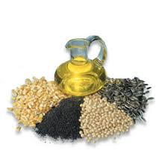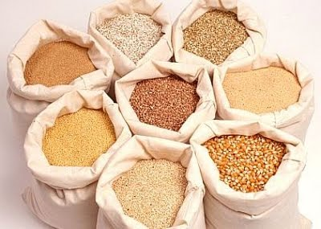**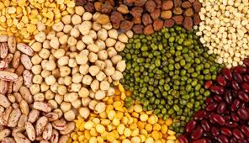

As it is indicated in the above table in 2011 E.C., about 176,150.02 hectares of land were cultivated under different types of crops during meher season, from which about 5,765,868 quintals of production were produced .About *151,123.95* hectares of land were under cereals, while 18,749.87 and **6,276.2** hectares of land were cultivated respectively under pulses and oilseeds. From the indicated cultivated areas of land, about *5 328,266.46* quintals of cereals, 363,549.17quintals of pulses and **74,007.4** quintals of oil seeds were produced**.**

Similarly, in 2012E.C hectares 177262 of land were cultivated under different crops during meher season, from which about 6,317,963.2 quintals production was produced. Among which 153,523.2; 18209.7 and 5,529.1 hectares of land were cultivated under cereals, pulses and oil seeds in the year 2012 E.C respectively. From the indicated crop type *5,661,090;* 380,908.944 and 75,964.42 quintals production of cereals, pulses and oilseeds were harvested in the year 2012E.C respectively. The main cereal crops grown teff, barley, wheat, maize, sorghum, millet, oats and rice; the major crops grown under Pulse crops were soybeans, field peas, haricot beans, chick peas, lentils, grass peas/vetch, peas & fenugreek. Similarly, Nueg, linseed, ground nuts, sun flower, sesame and rapeseed were the major oilseed crops grown.

**Crop Calendar of the zones**

|  |  |  |  |  |  |
| --- | --- | --- | --- | --- | --- |
| S/N | Type of crop | Calendar | | | |
| Land Preparation | Planting (sowing) | Weeding | Harvesting |
| 1 | Maize | Mar-April | May | June-Aug | Nov-Dec |
| 2 | Sorghum | April-May | May-June | June-Sep | Dec-Jan. |
| 3 | Teff | April -July | Jul15-Aug | Aug-Oct. | Nov-Dec |
| 4 | Wheat | May-June | June-July | Aug-Sept | Dec.-Jan |
| 5 | Barley | Mar-April | April | June | Jul15-Aug20 |
| 6 | Millet | April-May | June | July-Aug | Oct-Nov |
| 7 | Rice | May | June | June-July | Nov |
| 8 | Bean | May | June | July-Aug | Nov-Dec |
| 9 | Pea | June | July | Aug. | Nov-Dec |
| 10 | Haricot bean | April-May | May-June | June-July | Aug |
| 11 | Lentil | June-July | Aug | Sept. | Nov-Dec |
| 12 | Chickpea | June-July | Aug | Sept. | Oct.-Nov |
| 13 | Soya bean | May-June | June | Aug-Sept | Nov-Dec |
| 14 | Niger seed | May-June15 | June-July15 | Aug. | Nov-Dec |
| 15 | Seas am | June | July | Aug-Sep. | Nov-Dec |
| 16 | Rape seed | April | May | May 15 | Sep-Oct. |
| 17 | Ground nut | May | June | July | Nov-Dec |

## 

## Coffee production

|  |  |  |  |
| --- | --- | --- | --- |
| Coffee production and Coffee supplied for the central market (tons) | | Year | |
| 2011 | 2012 |
| Coffee production potential land and its coverage | Coffee production potential land (ha) | 481,785 | 515,735 |
| Land covered with coffee plant(ha) | 402,369 | 452,101 |
| Total Coffee produced | Production (tone) | 43,395 | 114,450 |
| Coffee supplied  for the central market (tons) | Washed | 1,038 | 656.7 |
| Unwashed | 23,586 | 22,549 |
| Total coffee supplied for the Central market (tons) | 24,624 | 23,205.7 |

Sources: Zonal Agriculture office

**Coffee production: -** As it is indicated in the above table coffee production potential area was 481,785 ha. And land covered with coffee plantation was about 402,369 ha that indicate that 79,416 ha were yet covered by coffee plantation, and coffee produced was 43,395tons in the year 2011. Similarly in the year 2012, land covered with coffee plantation was about 452,101ha while coffee production was 114,450 tones.

**Coffee supplied to the central market: -**As it was revealed in the above table Coffee supplied to the central market was 24,624 tones (1038 washed & 23,586 unwashed) in the year 2011 and 23,205.7 tones (656.7 washed & 22,549 unwashed) in the year 2012 was supplied to the central market.

Generally, out of **43,395** tones coffee production in the zone in the year 2011, **24,624** tones (56.74%) was supplied to the central market. In the year 2012 23,205.7 tones was supplied to the central market which is 20.28% of the total production.

## Irrigation: -

Irrigation can be done by harvesting surface water and ground water during winter season. It is a type of agriculture that can be cultivated 2-3 times a year. It has high production & productivity rather than cultivation during rainy season. Even though Kelem Wollaga has an abundant surface and ground water resources, its irrigation system does not fully practiced, the usage of irrigation technologies, still are not well practiced yet.

**Production and land cultivated by type of irrigation:**

|  |  |  |  |  |  |  |
| --- | --- | --- | --- | --- | --- | --- |
| Year | Type of irrigation | Cultivated land in hectares | Production in quintal | No of participated farmers | | |
| male | Female | Total |
| 2011 | Traditional | 17,314.00 | 2,783,911.00 | 60,360 | 1,252 | 61,612 |
| Modern | 114.00 | 13,231.00 |
| Pump | 2,802.00 | 345,469.00 |
| Hand dug | 974.00 | 96,922.00 |
| **Total** | 21,204.6 | 3,239,533 |
| 2012 | Traditional | 34,895.9 | 4,638,341.5 | 72,233 | 4,314 | 76,547 |
| Modern | 187.5 | 27,821 |
| Pump | 4306.5 | 619,626 |
| Hand Well | 1422 | 192,608.00 |
| **Total** | 40,811.6 | 5,478,396.5 |

Source: KelemWollega zone irrigation authority

According to the data obtained from Kelem Wollega zone Agricultural office, in the year 2011 about 21,204.6 hectares of land was covered with irrigation from which about 3,239,533 quintals of production were harvested 61,612 farmers (60,360males & 1,252 female’s households) were participated on the activity. Similarly, in 2012 about 40, 811.6 hectares of land was covered with different types of crops from which about 5,478,396.5 quintals of production were harvested by 76,547farmers (72,233 males & 4314 females’ households).

**Irrigation development activities in Kelem Wollega zone from 2011-2012 E.C**

|  |  |  |  |  |
| --- | --- | --- | --- | --- |
| Years | Land cultivated under irrigation (hectares) | Total production  (quintals) | Productivity per hectare | Number of farmers participated |
| 2011 | 21,204.6 | 3,239,533 | 152.8 | 61,612 |
| 2012 | 40,811.6 | 5,478,396.5 | 134 | 76,547 |

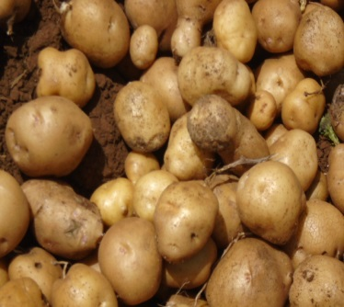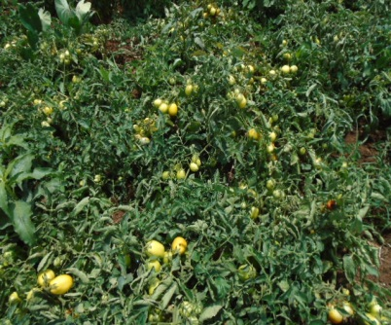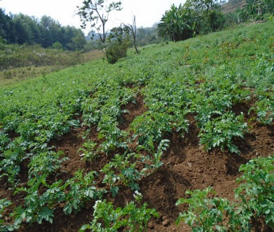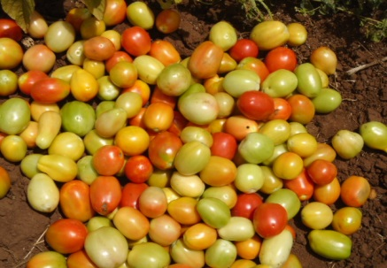Source:-KelemWollega zone Agricultural Office

## **Livestock**:-

There were 99,023 cattle, 530,931 sheep, 406,843 goats 21,639horses, 20,619 mules, 65,301 donkeys, 1,775,475 poultry in the zone in 2011 E.C and 1,045,696 cattle, 571,512 sheep, 427,784goats, 19,997 horses, 28,568 mules’ 84,244 donkeys, 1,590,464 poultry in the zone in the year 2012 E.C.

Types of Live stocks

|  |  |  |  |  |  |  |  |  |  |
| --- | --- | --- | --- | --- | --- | --- | --- | --- | --- |
| Year | Cattle | Goats | Sheep | Horses | Mules | Donkeys | Camels | Poultry | Total |
| 2011 | 992,023 | 406,843 | 530,931 | 21,639 | 20,619 | 65,301 | 0 | 1,775,475 | 3,812,831 |
| 2012 | 1,045,696 | 427,784 | 571,512 | 19,997 | 28,568 | 84,244 | 0 | 1,590,464 | 3,768,265 |

**[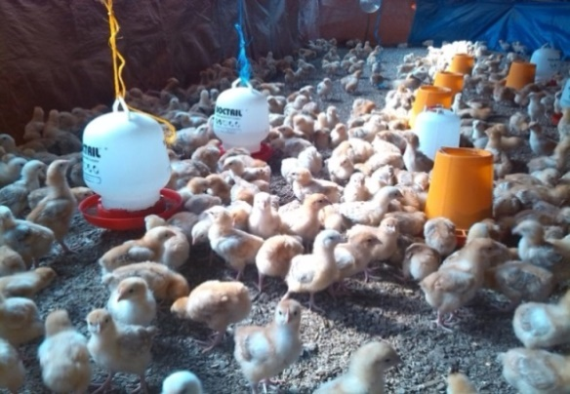](file:///G:\karoora2009.ppt)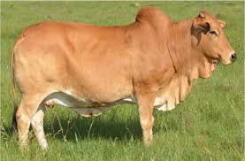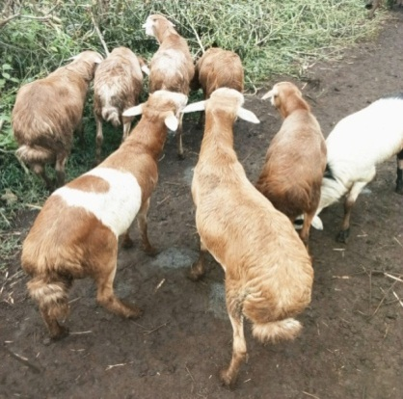**Photo of Livestock practices

**Source:-field visit**

**Common Livestock Diseases in the Zone**

Mostly the common livestock diseases of the zone in the past two years

|  |  |  |  |  |
| --- | --- | --- | --- | --- |
| S/N | Type of Disease | 2011 | 2012 | Remark |
| 1 | Trypanosomiasis | All of them were active in this year | All of them were active in this year |  |
| 2 | Internal parasites |
| 3 | Ecto parasites |
| 4 | Lumpy skin disease |
| 5 | New castle disease |
| 6 | Pasteurellosis |
| 7 | Black leg |
| 8 | Anthrax |
| 9 | Rabies |
| 10 | Babesiosis |
| 11 | Brucellosis |
| 12 | Fowl Thyphoid |
| 13 | Foot and Mouth Disease |

Source: Zonal Livestock Agency

Livestock Treated:

|  |  |  |  |  |  |  |
| --- | --- | --- | --- | --- | --- | --- |
| Year | Type of diseases from which livestock were Treated in the last two years | | | | | |
| Trypanosomiasis | Internal parasites | External parasites | Operation | Others | Total |
| 2011 | 104,386 | 130,424 | 138,082 | 16,347 | 211,484 | 486,258 |
| 2012 | 85,347 | 155,961 | 125,422 | 16,757 | 212,785 |  |

Source: Zonal Livestock Agency

Livestock Vaccinated:

|  |  |  |  |  |  |  |  |
| --- | --- | --- | --- | --- | --- | --- | --- |
| Year | Type diseases from which livestock’s were vaccinated | | | | | | |
| Render pest | C.B.P.P | Black leg | Haemorhagic | Anthrax | Others | Total |
| 2011 | 0 | 152,656 | 115,537 | 108,036 | 161,265 | 349,259 | 886,753 |
| 2012 | 0 | 168,810 | 128,365 | 116,005 | 208,143 | 473,018 | 473,018 |

Source: Zonal Livestock Agency

**Clinics and Health Posts of the Zone & Live stocks Vaccinated in the two years**

In the year 2011 there were 167veterinary clinics by type (B-Type 2, C-Type 9 D-Type 157), with36 veterinary doctors, 256 health assistants and 30 health technicians. Similarly, in 2012 There were 167 veterinary clinics (B-Type 2, & C-Type 9 & 157 Type D), with 27 veterinary Doctors, 190 health assistants and 31 health technicians in the zone. Moreover, in the year 2011 and 2012 about 486,258 and 459,486 livestock were respectively treated against different type of diseases in the zone.

Similarly, 886,753 and 473,018 livestock were respectively vaccinated in the year 2011 and 2012.

**Total Egg Production in 2011 and 2012**

|  |  |  |  |
| --- | --- | --- | --- |
| Year | Types of breed | Total laying hens | Total egg production in the year / million |
| 2011 | Endogenous Breeds | 49,347 | 3.95 |
| Hybrids Breeds | 116,290 | 25.6 |
| Exotic Breeds | 0 | 0 |
| **Total** | **165,637** | **29.55** |
| 2012 | Endogenous Breeds | 105,470 | 6.01 |
| Hybrids Breeds | 117,596 | 23.13 |
| Exotic Breeds | 0 | 0 |
| **Total** | **223,066** | **29.14** |

**Source: Zonal Livestock Development Office**

**Numbers of hybrid breeds, livestock and poultry in year 2011 and 2012**

|  |  |  |  |  |  |
| --- | --- | --- | --- | --- | --- |
| Year | Heifer | Calf | Sheep | Poultry | Others |
| 2011 | 82 | 32 | - | 312,649 | - |
| 2012 | 150 | 98 | - | 220,569 | - |

**Source: zonal Livestock agency**

**Number of Veterinary personnel in the zone in the year 2011 & 2012**

|  |  |  |  |  |
| --- | --- | --- | --- | --- |
| Year | Doctor | Health Assistant | Health Technicians | Total |
| 2011 | 36 | 256 | 30 | 322 |
| 2012 | 27 | 190 | 31 | 248 |

Source: zonal Livestock agency

As indicated on the above table, the number of Veterinary personals in the year 2012 was decreasing except on health technicians. For detail see the above table. As a result these have caused the decrease in livestock treated and vaccinated.

## 

## Honey Production

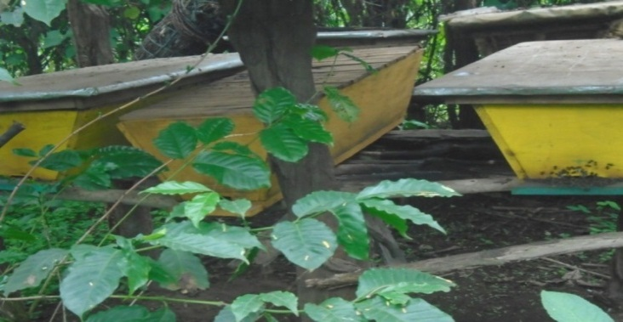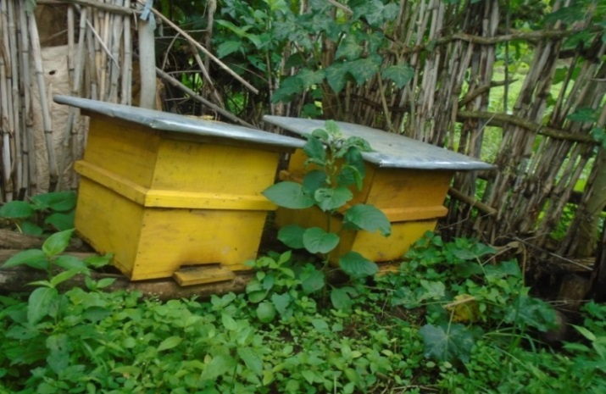

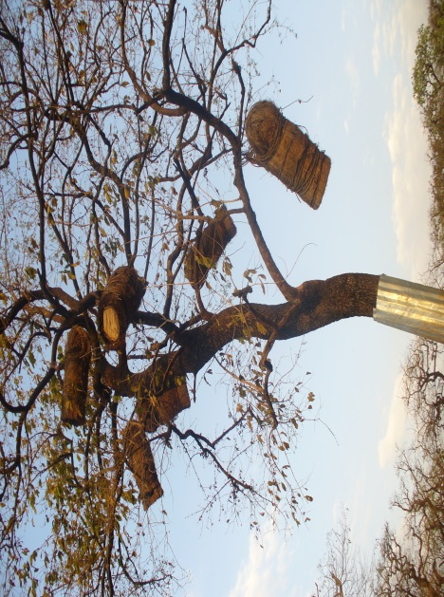

**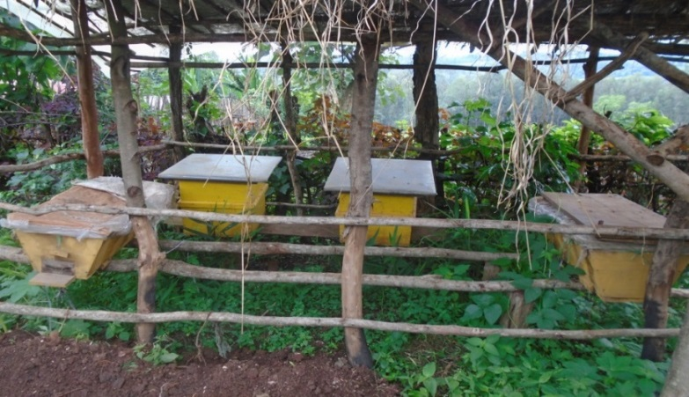**

Source:-Field visit

**Beehives inventory and production of honey by type in 2011 and 2012**

|  |  |  |  |  |  |  |  |  |  |  |  |  |
| --- | --- | --- | --- | --- | --- | --- | --- | --- | --- | --- | --- | --- |
| Year | Traditional beehives | | | Transitional beehives | | | Modern beehives | | | All Beehives | | |
|  | Number of hives | Total honey Produced (Kg) | Productivity | Number of hives | Total Produced (Kg) | productivity | Number of hives | Total Produced (Kg) | Productivity | Number of hives | Total honey Produced (Kg) | Productivity |
| 2011 | 672,523 | 1,942,546 | 2.88 | 89,699 | 532,846 | 5.9 | 8,212 | 148,942 | 18 | 770,434 | 2,624,334 | 3.4 |
| 2012 | 620,072 | 1,695,259 | 2.7 | 96,083 | 376,916 | 3.9 | 8911 | 158,279 | 17.8 | 725,066 | 2,230,454 | 3.1 |

Source: Zonal Livestock Agency

According to the above table Kelem Wollega zone has the potential to produce high amount of honey per year. But currently the production is limited to 2,624,334 Kg of honey in the year 2011 E.C. and to 2,230,454 kg of honey in 2012. Of which the greater portion was produced from traditional hives. This production is harvested from the three types of hives. The total number of hives was 770,434 in the year 2011 and 725,066 in the year 2012. Generally honey productivity per hive was very low. The productivity of honey per bee hive is shown in the above table; see the detail.

**Major Factors affecting Bee keeping activities**

Among the major factors which have contributed to low production and productivity of beekeeping are:

1. Using different chemical (herbicides and insecticides),
2. Poor beekeeping system,
3. Lack of awareness,
4. Lack of knowledge about the habit and management of bees**,**
5. The resistance to use modern beehives because of cost of hives,
6. In availability of modern beehives sufficiently and
7. others.

## Cooperative

Cooperatives are organization which can be established/organized depend on the interest of their members’ to fulfill their needs which can be not be fulfilled individually. They play a great role in the development/ growth of economy of ones country by changing individual’s living standards. Based on these ideas many proclamations were proclaimed to organize modern cooperative societies in our country Ethiopia in last 20-30 years. For example, proclamation no. 85/86 of the provisional government of Ethiopia, proclamation no. 147/91 E.C and the newly proclaimed one as of Oromia Region, proclamation no. 985/2009 was proclaimed.

*Type of cooperatives and their members Organized Kelem Wollega Zone*

|  |  |  |  |  |  |  |  |  |  |
| --- | --- | --- | --- | --- | --- | --- | --- | --- | --- |
| *S/N* | *Type of*  *Cooperative* | *Number of cooperativess* | *2011* | | | *2012* | | | |
| *Members of members* | | | *No. of coop* | *Members of members* | | |
| *Male* | *Female* | *Total* | *Male* | *Female* | *Total* |
|  | *Union* | *7* | *59,049* | *9,286* | *68,335* | *7* | *59,841* | *9626* | *69467* |
|  | **Primary Cooperatives** |  |  |  |  |  |  |  |  |
| *2.1* | *Multi-purpose coop* | *265* | *69,897* | *9,351* | *79,248* | *265* | *70,733* | *9433* | *80,166* |
| *2.2* | *Forestry* | *21* | *3,921* | *480* | *4,401* | *21* | *4338* | *493* | *4831* |
| *2.3* | *Fattening* | *0* | *0* | *0* | *0* | *2* | *47* | *12* | *59* |
| *2.4* | *Irrigation* | *7* | *379* | *100* | *479* | *7* | *379* | *100* | *479* |
| *2.5* | *Vegetables & Fruits* | *3* | *41* | *34* | *75* | *3* | *41* | *34* | *75* |
| *2.6* | *Consumers Coop.* | *74* | *5,690* | *2302* | *7992* | *72* | *5,877* | *2,440* | *8317* |
| *2.7* | *Saving & Credit* | *312* | *11,058* | *18,354* | *29,412* | *285* | *9376* | *17423* | *26,799* |
| *2.8* | *Others* | *6* | *130* | *13* | *143* | *7* | *152* | *13* | *165* |
| Total | | **695** | **150,165** | **39,920** | **190,085** | **669** | **150,784** | **39,574** | **190,358** |

Source: Kelem Wollega Zone Coop. Promotion Office

The Assets’ of The Above Cooperative societies

|  |  |  |  |  |  |  |  |  |  |  |  |  |
| --- | --- | --- | --- | --- | --- | --- | --- | --- | --- | --- | --- | --- |
| *S/N* | *Type of Cooperative* | *No. of coop.* | *Their Assets* | | | | | | | | | |
| *2011* | | | | | *2012* | | | | |
| *Fixed* | *Current* | *Total* | *Liability* | *Capital* | *Fixed* | *Current* | *Total* | *Liability* | *Capital* |
| 1 | Union | 7 | 69,500,846 | 56,964,320 | 126,465,166 | 95,147,867 | 31,317,745 | 341,413,415 | 70,677,459 | 412,090,874 | 382,735,844 | 29,355,475 |
| 2 | Primary Coop.: |  |  |  |  |  |  |  |  |  |  |  |
| 2.1 | Multy purpose coop | 265 | 82,644,874 | 22,024,244 | 104,568,826 | 70,040,121 | 36,896,191 | 84,307,082 | 30,444,171 | 114,751,253 | 84,551,019 | 30,200,534 |
| 2.2 | Forestry | 21 | 1,073,101 | 992,562 | 2,325,001 | 0 | 2,325,001 | 1,007,355 | 1,185,682 | 2,193,037 | 190,810 | 2,002,227 |
| 2.3 | Fatening | 0 | 0 | 0 | 0 | 0 | 0 | 0 | 0 | 0 | 0 | 0 |
| 2.4 | Irrigation | 7 | 5,152 | 0 | 5,152 | 0 | 5,152 | 5,152 | 0 | 5,152 | 0 | 5,152 |
| 2.5 | Vegetables & Fruits | 3 | 0 | 0 | 0 | 0 | 0 | 0 | 0 | 0 | 0 | 0 |
| 2.6 | Consumers Coop. | 74 | 55,364 | 48,855 | 104,220 | 41,800 | 62,419 | 55,364 | 48,855 | 104,220 | 41,800 | 62,419 |
| 2.7 | Saving & Credit | 312 | 181,592 | 104,803 | 286,395 | 5,227 | 281,169 | 181,592 | 104,803 | 286,395 | 5,227 | 281,169 |
| 2.8 | Others | 6 | 0 | 0 | 0 | 0 | 0 | 0 | 0 | 0 | 0 | 0 |
|  | Total | 695 | 8,445,077 | 939,685 | 9,384,762 | 2,308,458 | 7,076,305 | 10,439,769 | 1,335,089 | 11,774,858 | 3,961,176 | 7,813,682 |

Source: Kelem Wollega Zone Coop. Promotion Office

## Mining:-

As far as mining activity and mineral resource is concerned Kelem Wollega zone, detail survey and study was not extensively conducted yet. But, there is some information about the mining in the zone from different publications**.** Any naturally occurring mineral mass in the Earth crust have definite chemical and physical composition. These occurrences may be of any commercial value for exploitation but they are present in the crust naturally. According to Ethiopian Mapping Authority of 1988 publications, Known mineral occurrences in the Kelem Wollega zone are Gold, Platinum, Titanium, Uranium, basalt and sand. Of which, gold is found in Lalo Kile, Seyo, Hawa Gelan and Dale Wabera woredas, Platinum in Lalo Kile, Titanium in Seyo, and Uranium in Anfilo and Seyo woredas. Besides these, some information at present indicates that the extraction of Platinum is being started in Lalo Kile woreda. Most of the minerals especially gold are extracted locally by people who live in the nearby areas.

**FINANCE**

**REVENUE AND EXPENDITURE OF THE TOWN (2011/ 2012)**

Government revenue is money received by a [government](https://en.wikipedia.org/wiki/Government) from [taxes](https://en.wikipedia.org/wiki/Tax_revenue) and [non-tax](https://en.wikipedia.org/wiki/Non-tax_revenue) sources to enable it to undertake expenditures. Government revenue as well as [government expenditure](https://en.wikipedia.org/wiki/Government_spending) are components of the [government budget](https://en.wikipedia.org/wiki/Government_budget) and are important tools of the government's [fiscal policy](https://en.wikipedia.org/wiki/Fiscal_policy). Government revenue is the income available to fund the activities of a government. Running a country can be very expensive, and governments have a wide range of responsibilities, such as operating the various departments, maintaining an armed force, investing in development, and the alleviation of poverty. Every country has its method of revenue generation that varies from control of a country’s physical resources to taxation of the country's citizenry.

The revenue of Kelem Wollega zone is collected from different sources .The largest tax revenue of the town is collected from direct tax followed by indirect tax and non-tax. As indicated in table below, in 2011 fiscal year the direct tax collected was 171,686,667.34birr. The indirect tax collected was 16,987,360.86 birr and other taxes amounted to 10,893,139.14 birr. In 2012 fiscal year, on the other hand, about 197,592,450.45; 17,997,379.32and 11,037,390.91was collected from direct and indirect and nan-tax source respectively. Generally, 199,567,167.34 birr in 2011 and 226,627,220.68 birr was collected.

**Table \_\_\_\_\_Revenue collected by type**

|  |  |  |  |  |  |
| --- | --- | --- | --- | --- | --- |
| S/N | Type Revenue | Amount collected (ETH. Birr) | |  |  |
| 2011 | 2012 | Total | Remark |
| 1 | Direct Tax | 171,686,667.34 | 197,592,450.45 | 369,279,117.78 |  |
| 2 | Indirect Tax | 16,987,360.86 | 17,997,379.32 | 34,984,740.18 |  |
| 3 | Non- Tax | 10,893,139.14 | 11,037,390.91 | 21,930,530.05 |  |
|  | Total | 199,567,167.34 | 226,627,220.68 | 426,194,388.02 |  |

Source: Kelem Wollega Revenue’s Authority

As indicated in the table above the total direct income collected in the two years was 369,279,117.78 ETH Birr (171,686,667.34 in 2011 & 197,592,450.45 in 2012).The total direct revenue collected in the year 2012 exceeded that of 2011 by 25,905,783.10ETH.Birror which is 15.1%. And the indirect tax collected in 2011 was 16,987,360.86 and 17,997,379.32 ETH birr in 2012 which exceeded from that of 2011 by 1,010,018.46 ETH Birr or by 6%. The non- tax collected in 2011 was 10,893,139.14 ETH Birr and 11,037,390.91 ETH Birr in 2012. Generally the above different taxes collected in the above two years were increasing by 1-15.1%.

Graph\_\_\_Total revenue collected in the year 2011 and 2012

Source: Zonal Revenue Authority

The above graph shows that tax collected in the year 2012 has increased by 27,060,053.60 birr when it is compared with that of 2011.

Table\_\_\_Number of Tax payers in the zone by types

|  |  |  |  |  |  |  |
| --- | --- | --- | --- | --- | --- | --- |
| Year | Number of Traders | Number of Farmers | Number of Gov’t Employees | Number of Non-Gov’t Employees | Others | Total |
| 2011 | 8743 | 110,725 | 18,557 | 3012 | 0 | 141,037 |
| 2012 | 8760 | 110,725 | 19,703 | 3012 | 0 | 142,200 |

Source: - Kelem Wollega Zone Revenues Authority

As it could be seen from the above table the total numbers of tax payers in 2011 E.C were 141,037 and 142, 200 in the year 2012. This showed that the added tax payers in 2012 were only from Government employees.

**Total budget and expenditure of Kelem Wollega at zonal level**

|  |  |  |  |  |
| --- | --- | --- | --- | --- |
| Type of budget | Annual budget of 2011 | Expenditure of 2011 | Annual budget of 2012 | Expenditure of 2012 |
| Recurrent | 347,725,465.99 | 320,822,815.93 | 368,245,473.05 | 348,245,473.05 |
| Capital | 150,037,598.65 | 82,871,737.13 | 201,929,950.77 | 179,059,936.21 |
| All | 497,763,064.64 | 403,694,553.06 | 570,175,423.82 | 527,305,409.26 |

Source: Kelem Wollega Finance & Economic Office

Table\_\_Total budget and expenditure of Kelem Wollaga zone at woredas level

|  |  |  |  |  |
| --- | --- | --- | --- | --- |
| Type of budget | Annual budget of 2011 | Expenditure of 2011 | Annual budget of 2012 | Expenditure of 2012 |
| Recurrent | 1,223,419,659 | 1,200,965,124.62 | 1,335,270,741.79 | 1,324,554,053.73 |
| Capital | 79,495,835.00 | 61,294,810.75 | 102,471,062.92 | 99,887,388.96 |
| All | 1,302,915,494.00 | 1,262,259,935.37 | 1,437,741,804.71 | 1,424,441,442.69 |

Source: Kelem Wollega Finance & Economic Office 2012

As it can be seen from the table above, annual total budget and expenditure of at zonal level were 497,763,064.64and 403,694,553.06 in 2011 E.C. respectively in the year 2012 the annual total budget and expenditure was grown to570,175,423.82 and 527,305,409.26 respectively. Similarly, the annual total budget and expenditure of woredas’ were 1,302,915,494.00and 1,262,259,935.37 ETB respectively in the year 2011. The total annual budget and expenditure of the woredas’ were 1,437,741,804.71and 1,424,441,442.69 ETB in 2012 E.C. In the same manner, the capital Budget and its expenditure at zonal level in the year 2011 were 150,037,598.65&82,871,737.13 ETB respectively. On the other hand, the capital budget of the zone in 2012 they were 201,929,950.77 and 179,059,936.21 respectively. The capital Budget of Wereda’s and its expenditure in 2011 were 279,495,835.00 & 61,294,810.75 ETB respectively. Similarily,the capital budget and expenditure were 102,471,062.92 and 99,887,388.96 respectively. Generally the amount of the recurrent budget and capital budget in both years were increased at the zonal and weredas’ level.

Financial Institutions found in the zone

Financial institutions (FIs) are companies engaged in the business of dealing with financial and monetary transactions such as deposits, loans, investments, and currency exchange. Virtually everyone living in a developed economy has an ongoing or at least periodic need for the services of financial institutions. Data obtained from Burayu town municipality revealed that there are governments as well as private financial institutions operating in the town.

The commercial Banks and development bank of Ethiopia are the government owned banks operating in the zone. The private banks, include Awash Bank, Oromia International Bank, Cooperative Bank of Oromia, Hibrat Bank, , Absinya Bank, Dashen Bank, Berhan Bank. The number of banks are listed as follow in the below table.

**Table\_\_\_\_Number of bank by type**

|  |  |  |  |
| --- | --- | --- | --- |
| **S/N** | **Banks** | **2011** | **2012** |
| **1** | Awash Bank | 4 | 4 |
| **2** | Oromia International bank | 4 | 4 |
| **3** | Oromia Cooperative bank | 5 | 8 |
| **4** | Ethiopia Commercial bank | 12 | 13 |
| **5** | Dashen bank | 1 | 1 |
| **6** | Development bank | 1 | 1 |
| **7** | Birhan Bank | 0 | 1 |
| **8** | Hibret bank | 0 | 1 |
| **9** | Absinya bank | 0 | 1 |
| **Total** | | 27 | 34 |

Sources: statistical Abstracts of PEDO of KelemWollega Zone

As indicated in the above table in the year 2011 there were total of 27 different types of banks in kelem Wollega zone; i.e. 12 commercial banks 5 cooperative bank, 4 Oromia international bank ,1 development bank ,4 Awash bank , 1 Dashen bank.On the other hand in the year 2012 there were 34 banks in the year 2012 i.e 13 commercial banks 8 cooperative bank, 4 Oromia international bank ,1 development bank ,4 Awash bank , 1 Dashen bank, 1 Birhan Bank, 1 Hibret bank and 1 Absinya Bank.

## Trade:

Exportable items by type and amount supplied to the central market in the year 2011 and 2012 E.C.

|  |  |  |  |  |
| --- | --- | --- | --- | --- |
| No | Major cash crops &exportable items | Measurement | Amount supplied to the central market | |
| 2011 | 2012 |
| 1 | Sesame | Tons | 273 | 450 |
| 2 | Cattle | No. | 21,188 | 24,661 |
| 3 | Sheep | No. | 8,186 | 12,130 |
| 4 | Goat | No. | 7,057 | 8541 |
| 5 | Skin | No. | 97,516 | 81,229 |
| 6 | Hide | No. | 12,425 | 15,987 |

Source:- Kelem Wollega zone Market Development Office

According to ,zonal Market Development office 273 tons of sesame, 21,188 cattle, 8,186 sheep 7,057 goat , 97,516 skins(number) and 12,425 hides (number) were supplied to the central market in 2011. Similarly, in 2012 450 tons of sesame, 24,661 cattle, 12,130 sheep, 8,541 goats, 81,229 skins (number) and 15,987 hide (number) were supplied to central market.

As it is revealed in the above table number of products supplied to the central market had fluctuated because of market problem.

*Tourism*

*KelemWollega zone has several cultural and natural tourist attraction centers of which cultural and historical sites, parks, games and different natural and manmade are the major one. The following table presents tourist attraction sites.*

|  |  |  |  |  |  |
| --- | --- | --- | --- | --- | --- |
| No | Tourism attraction center | Wereda | Distance from Zone center Kilo meters | Distance from Finfinne | Special Feature of the Area |
| 1 | Kuni water Fall | Sedi-Chenka | 75 | 595 | Water Fall |
| 2 | Kuni Cave | Sedi Chenka | 75 | 595 | Cave |
| 3 | Kara Kawe cave |  | 153 | 673 | Cave |
| 4 | Gumguma cave |  | 45 | 638 | Cave |
| 5 | Dagawalbata | Gawo Qebe | 89 | 588 | Natural stone one on other |
| 6 | Keto water fall | Hawa Galan | 48 | 604 | Water Fall |
| 7 | Gargeda natural forest | Anfilo | 42 | 794 | Different Birds and Wild Life |
| 8 | Hine natural forest |  | 89 | 593 | Different Birds and Wild Life |
| 9 | Midaga birbir |  | 96 | 595 |  |
| 10 | Walal mountain and Surrounding landscape |  | 42 | 638 | Physical Features, The third Highest Mountain in Ethiopia |
| 11 | Kirite mountain |  | 113 | 628 | Physical Features |
| 12 | Borta lake |  | 2 | 652 |  |
| 13 | Gambiyo Cave |  | 54 | - | Cave |
| 14 | Dati park |  | 128 | 648 | Different Birds and Wild Life |
| 15 | Jajo Akakil Stone cave |  | 132 | 652 | Cave |
| 16 | Shebel / Manmade forest and land escapes |  | 48 | 700 | Different Birds and Wild Life |

Table\_Tourist attraction centers in Kelem Wollaga zone with their distance from Dembi Dollo and Finfinne *Source; Kelem Wollega Zone Culture and Tourism Office*

Picture\_ some tourist attraction center

**Kara Kawe Cave** 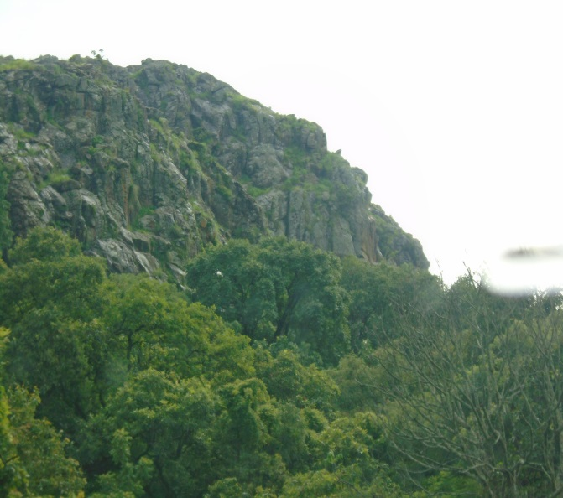**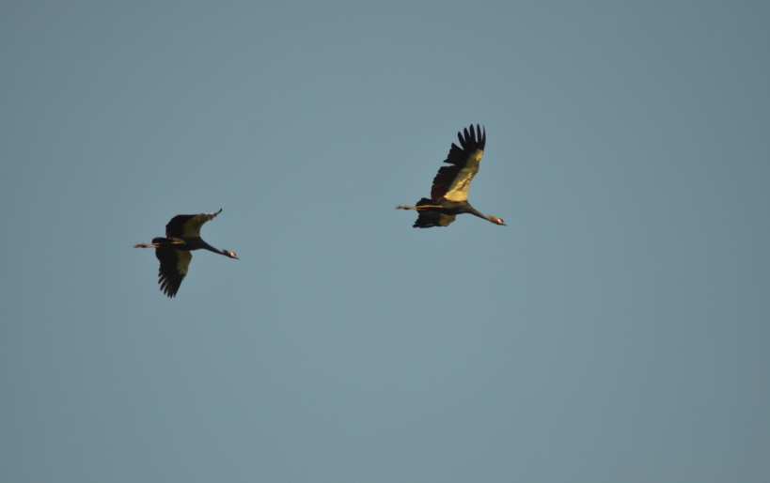**

***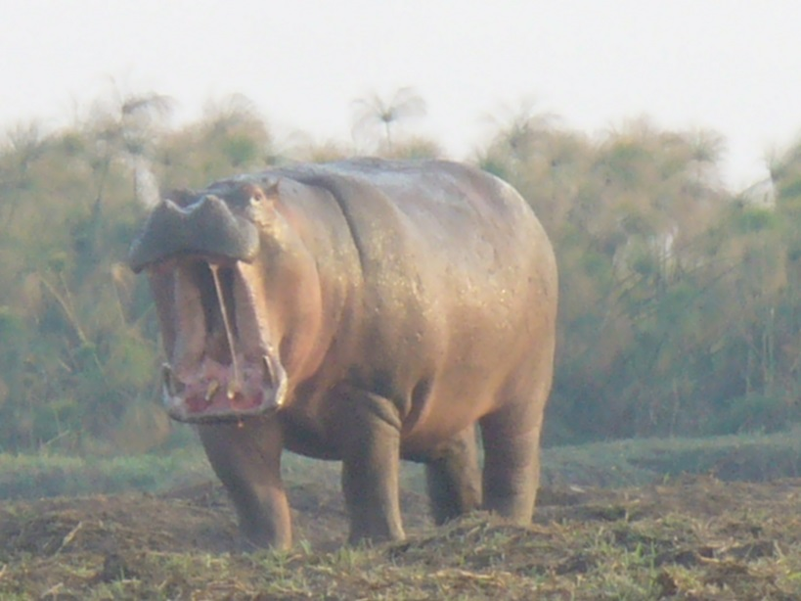***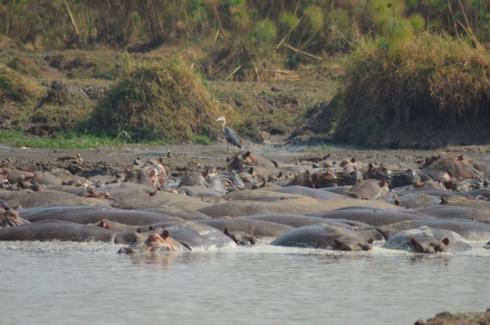

###### Datiwalel Source; Kelem Wollega Zone Culture and Tourism Office

###### **Library and its ownership**

# 

|  |  |  |  |  |  |  |
| --- | --- | --- | --- | --- | --- | --- |
| *Year* | *Public Library* | | *Gov’t library* | | *Total* | |
|  | ***No*** | ***Sitting capacity*** | ***No*** | ***Sitting capacity*** | ***No*** | ***Sitting capacity*** |
| *2011* | ***0*** | ***0*** | ***0*** | ***0*** | ***0*** | ***0*** |
| *2012* | ***0*** | ***0*** | ***5*** | ***125*** | ***5*** | ***125*** |

******

## 

## **Education***:-*

Education plays a major role in enhancing the development of society at large and to be of use educational system should be oriented towards solving socio-economic constraints. Different educationalists, philosophers and psychologists had given different opinions regarding education in different ways. However, the universally accepted definition of education is that education is the process of facilitating learning or the acquisition of knowledge, skills, values, beliefs, and habits. One of the basic aims of education is to strengthen the individual’s and societies’ problem-solving capacity, ability and culture starting from basic education at all levels. Education helps to improve, change, as well as develop and conserve his environment for the purpose of an all-rounded development by diffusing science and technology into the society. In line with this, the main objective of the education part of this publication is to analyze the situation of the development of education in Kelem Wollega zone by considering the years 2011 and 2012. The document provides pertinent information regarding number of schools, number of enrolments, number of sections, number of teachers for all levels of education (KG-Grade 12) and also deals with key education indicators and their analysis.

**Kindergarten**

**Number of schools*: -*** Non-governmental organizations, private institutions, and religious based organizations are the operator of kindergarten program where government is involved in developing curriculum, training teachers and providing supervisory supports for kindergarten program.

There were 54 kindergarten of which 7 were government and 47 non –government kindergartens in the year 2011 .There were 76 government 11 non-government primary first cycle (1-4) schools. Regarding primary second cycle (5-8); there were 361 government and 10 non-government schools. Similarly, 36 senior secondary (9-10) governments, 13 government and 1 non-government preparatory schools serving in the zone in the year 2011 E.C.

Similarly in the year 2012 E.C. there were 6 government and 47 non –government kindergartens. There were 82 government 7 non-government totally 89 primary first cycle (1-4) schools and 362 gov’t & 10 non-gov’t second cycle (5-8) schools. Regarding full primary second cycle (1-8) there are 437 government and 10 non-government schools. Similarly, 37 senior secondary (9-10) governments &1 non-gov’t senior secondary schools 13 government and 1 non-government preparatory schools and 1 teachers training college and 1 university were serving in the zone in the year 2012 E.C.

**Student participation rate: -** Regarding participation rate (gross enrollment ratio), there is a wide gap between sex and levels of school in Kelem Wollega zone. In the year 2011

There were totally **327,583** students (male 176,532& female 151, 051) in both government & non Gov’t schools i.e. from Kindergarten to preparatory in 2012 E.C. The data indicate the difference between male students and female students. The number of male students exceeded the number of female students by 14,547 students or 9.2% (especially from grade 5-8, 9-10 & 11-12) which need additional work upon them to minimize the gap.

**Table: 1. Student participation rate /gross enrollment by level of school**

|  |  |  |  |  |  |  |  |  |  |  |  |  |  |
| --- | --- | --- | --- | --- | --- | --- | --- | --- | --- | --- | --- | --- | --- |
| Year | level of Education | Government | | | | Non-Gov't& Others | | | | Total | | | |
| **No.** | **Male** | **Female** | **Total** | **No.** | **Male** | **female** | **Total** | **NO** | **Male** | **female** | **Total** |
| 2011 | **Kindergarten** | **7** | **324** | **346** | **670** | **47** | **2203** | **2117** | **4320** | **54** | **2527** | **2463** | **4990** |
| **1st-4th** | **76** | **77449** | **68945** | **146,394** | **11** | **1509** | **1477** | **2986** | **87** | **78,958** | **70,422** | **149,380** |
| **5th-8th** | **361** | **50,913** | **42750** | **93663** | **10** | **939** | **866** | **1805** | **371** | **51,852** | **43,616** | **95,468** |
| **9th-10th** | **36** | **21086** | **15966** | **37,052** | **1** | **140** | **103** | **243** | **37** | **21,226** | **16,069** | **37,295** |
| **11th-12th** | **13** | **9166** | **7842** | **17,008** | **1** | **179** | **111** | **290** | **14** | **9345** | **7953** | **17,298** |
| Total | 493 | 158,938 | 135,849 | 294,787 | 70 | 4970 | 4674 | 9144 | 77 | 163908 | 140523 | 304431 |
| 2012 | **Kindergarten** | **6** | **398** | **405** | **803** | **47** | **2601** | **2350** | **4951** | **53** | **2999** | **2755** | **5754** |
| **1st-4th** | **82** | **77096** | **68253** | **145349** | **7** | **1802** | **1638** | **3440** | **89** | **78898** | **69891** | **148789** |
| **5th-8th** | **362** | **53542** | **46240** | **99782** | **10** | **1810** | **1641** | **3451** | **372** | **55352** | **47881** | **103233** |
| **9th-10th** | **37** | **23204** | **17649** | **40853** | **1** | **1295** | **1100** | **2395** | **38** | **24499** | **18749** | **43248** |
| **11th-12th** | **13** | **14,430** | **11,583** | **26,013** | **1** | **354** | **192** | **546** | **14** | **14,784** | **11775** | **26,559** |
| Total | 500 | 168,272 | 143725 | 311,997 | 66 | 7862 | 6921 | 14783 | 566 | 176,532 | 151051 | 327,583 |

**Source:-\_\_**

**Number of student sat for & promoted the national examinations (Grade 8)**

|  |  |  |  |  |  |  |  |  |  |  |  |  |  |  |  |  |  |  |
| --- | --- | --- | --- | --- | --- | --- | --- | --- | --- | --- | --- | --- | --- | --- | --- | --- | --- | --- |
| Year | Government | | | | | | Non-Gov’t | | | | | | Total | | | | | |
| Sat for Exam | | | Promoted | | | Sat for Exam | | | Promoted | | | Sat for Exam | | | Promoted | | |
| M | F | T | M | F | T | M | F | T | M | F | T | M | F | T | M | F | T |
| 2011 | **8241** | **6298** | **14539** | **7756** | **6297** | **14053** | **5995** | **4495** | **10490** | **5403** | **4115** | **9515** | **14236** | **10793** | **25029** | **13159** | **10413** | **23571** |
| 2012 |  |  |  |  |  |  |  |  |  |  |  |  |  |  |  |  |  |  |

**Source:-**

In 2011 E.C. 25,029 (14,236 male & 10,793 female) students sat for grade 8 National examinations and about 23,571(13,159 male & 10,413 female) 94.2 % of students were promoted to grade 9. Similarly , 7697(4308 male & 3389 female) students sat for the grade 10 National examination and 6406( 5370 male &2836 females ) were promoted to preparatory .On the other hand, 2034( 1119 male 915 females) students sat for grade 12 national examination in 2011 and only 1619( 915 males & 698 females were promoted to join university.

|  |  |  |  |  |  |  |  |  |  |
| --- | --- | --- | --- | --- | --- | --- | --- | --- | --- |
| Year | Type of examinations | Number of student sat for examination | | | Number of student promoted examination | | | | Promotion rate |
| **Male** | **Female** | **Total** | **Male** | | **female** | **Total** |
| **2011** | Grade 8 | 14236 | 10793 | 25029 | 13159 | 10413 | | 23571 | 94.2 |
| EGSCE/10th | 4308 | 3389 | 7697 | 3570 | 2836 | | 6406 | 83.23 |
| EHIEE/12th | 1119 | 915 | 2034 | 921 | 698 | | 1619 | 79.6 |
| **2012** | Grade 8 |  |  |  |  |  | |  |  |
| EGSCE/10th |  |  |  |  |  | |  |  |
| EHIEE/12th |  |  |  |  |  | |  |  |

|  |  |  |  |  |  |  |  |  |  |  |  |  |  |  |
| --- | --- | --- | --- | --- | --- | --- | --- | --- | --- | --- | --- | --- | --- | --- |
| Year | Type of ownership | Qualification | 1-4 | | | 5-8 | | | 9-10 | | | (11-12) | | |
|
| **M** | **F** | **T** | **M** | **F** | **T** | **M** | **F** | **T** | **M** | **F** | **T** |
| 2011 | **Government** | Grade 12 & Below | 49 | 21 | 70 | 10 | 2 | 12 | 0 | 0 | 0 | 0 | 0 | 0 |
| **LB** | 59 | 36 | 95 | 17 | 3 | 20 | 9 | 15 | 24 |  | 0 | 0 |
| **Diploma** | 942 | 1390 | 2332 | 1401 | 446 | 1847 | 89 | 11 | 100 | 19 | 3 | 22 |
| **MA/BSc** | 90 | 120 | 210 | 303 | 112 | 415 | 861 | 197 | 1058 | 373 | 26 | 399 |
| **MA/BSc/MED** | 0 | 0 | 0 | 0 | 0 | 0 | 22 | 1 | 23 | 58 | 1 | 59 |
| **Others** | 0 | 0 | 0 | 0 | 0 | 0 | 1 | 2 | 3 | 0 | 0 | 0 |
| **Expert** |  |  |  |  |  |  |  |  |  |  |  |  |
| **Total** | 1140 | 1567 | 2707 | 1731 | 563 | 2294 | 982 | 226 | 1208 | 450 | 30 | 480 |
| 2012 | **Non Gov’t** | **Grade 12 & Below** | **33** | **16** | **49** | **33** | **5** | **38** | **-** | **-** | **--** | **-** | **-** | **-** |
| **LB** | 63 | 46 | 109 | 21 | - | **21-** | **-** | **-** | **-** | - | - | **-** |
| **Diploma** | 1220 | 1717 | 2937 | 1437 | 484 | **1921** | **71** | **17** | **88** | 20 | 3 | **23** |
| **MA/BSc** | 91 | 79 | 170 | 301 | 170 | 471 | **940** | **216** | **1156** | **445** | **34** | **479** |
| **MA/MSc** | 0 | 0 | 0 | 3 | 0 | 3 | **33** | **3** | **36** | **78** | **5** | **83** |
| **Others** | - | - | - | - | - | - | **-** | **-** | **-** | **-** | **-** | **-** |
| **Expert** |  |  |  |  |  |  |  |  |  |  |  |  |
| **Total** | 1407 | 1858 | 6265 | 1795 | 659 | 2454 | 1044 | 236 | 1280 | 543 | 42 | 585 |

**Numbers of teachers by type of ownership and qualification**

# **TVET**

Number TVET Colleges/Institutions in the Zone

|  |  |  |  |  |
| --- | --- | --- | --- | --- |
| Year | Government | Non-Government | Total | Remark |
| 2011 | 16 | 2 | 18 |  |
| 2012 | 16 | 2 | 18 |  |

Source: Zone TVET Office

As indicated in the above table in 2011 & 2012 there were 18(16 government & 2 non-government) TVET institutions in Kelem Wollega zone which were built for the purpose of training TVET trainees.

Number of TVET Trainees by level and sex (Government)

|  |  |  |  |  |  |  |  |  |  |
| --- | --- | --- | --- | --- | --- | --- | --- | --- | --- |
| Level of Training | 2011 | | | 2012 | | | Total | | |
| Male | Female | Total | Male | Female | Total | Male | Female | Total |
| Level 1 | 0 | 0 | 0 | 1030 | 512 | 1542 | 1030 | 512 | 1542 |
| Level 2 | 0 | 0 | 0 | 511 | 349 | 860 | 511 | 349 | 860 |
| Level 3 | 0 | 0 | 0 | 500 | 349 | 849 | 500 | 349 | 849 |
| Level 4 | 0 | 0 | 0 | 1729 | 712 | 2441 | 1729 | 712 | 2441 |
| Level 5 | 0 | 0 | 0 | 59 | 325 | 384 | 59 | 325 | 384 |
| Total | 0 | 0 | 0 | 3029 | 2247 | 5276 | 3029 | 2247 | 5276 |

Source: Zone TVET Office

Number of TVET Trainees Employed by Level & sex

|  |  |  |  |  |  |  |  |  |  |
| --- | --- | --- | --- | --- | --- | --- | --- | --- | --- |
| Level of Training | 2011 | | | 2012 | | | Total | | |
| Male | Female | Total | Male | Female | Total | Male | Female | Total |
| Level 1 | 0 | 0 | 0 | 149 | 68 | 217 | 149 | 68 | 217 |
| Level 2 | 0 | 0 | 0 | 0 | 0 | 0 | 0 | 0 | 0 |
| Level 3 | 0 | 0 | 0 | 100 | 51 | 151 | 100 | 51 | 151 |
| Level 4 | - | - | - | - | - | - | - | - | - |
| Level 5 | - | - | - | - | - | - | - | - | - |
| Total | - | - | - | 249 | 73 | 322 | 249 | 73 | 322 |

# Source: zone TVET Office

As it can be seen from the above table, the total numbers of TVET trainees were not employed in each year. In the year 2012 there were only 322(249 male & 73 females) trainees were employed, which was about 6.1 % of the trainees in 2012 E.C.

## **Health**

In Kelem Wollega zone, there were 4 hospitals, 51 health centers, 266 health posts which were built by Government. In other word there were also 135 clinics, 6 pharmacies, 18 drug vendors. Government hospitals have 247 beds. In health institutions there were 22 doctors, 115 health officers, 15sanitarians, 569 community health extents, 610 nurses, 13 laboratory technicians, 5 x-ray technicians and 55 pharmacists’ health personals up to the end of the year 2011 E.C. Similarly, there were 4 hospitals, 51 health centers, 266 health posts which were owned by gov’t and 135 clinics 6 pharmacies, 15 rural drug vendors were owned by non-governments. And also these gov’t hospitals have 247 hospital beds. Totally these Gov’t institutions have 17 doctors ,111 health officers ,18 sanitarians ,584 community health extent ,630 nurses ,19 laboratory technicians ,4 x-ray technicians and 75 pharmacist health personnel in the year 2012.About 19.2 % of health institution in the zone has access to improved water supply. From this one can understand that about 81.8% of the health institutions did not accessed to improved water supply in the year 2011 and 2012.

|  |  |  |  |  |  |  |  |  |  |
| --- | --- | --- | --- | --- | --- | --- | --- | --- | --- |
| Population of zone | Type of professional | Doctors | Health officer | Nurses | sanitarians | Pharmacist | Technicians | | Health Extension worker |
| **Lab** | **X-ray** |
| 2011/  2012 | No of professionals | 22/17 | 115/111 | 610/630 | 15/18 | 55/75 | 13/19 | 5/4 | 569/584 |

**Health institutions accessed with improved water**

|  |  |  |  |  |  |  |  |  |  |  |  |  |
| --- | --- | --- | --- | --- | --- | --- | --- | --- | --- | --- | --- | --- |
|  | 2011 | | | | | | 2012 | | | | | |
|  | Hospital | Health Centers | Health Post | Clinics | Pharmacies | Drug Vendors | Hospital | Health Centers | Health Post | Clinics | Pharmacies | Drug Vendors |
| No of Health Facilities in the zone | 4 | 51 | 266 | 135 | 6 | 18 | 4 | 51 | 266 | 120 | 6 | 15 |
| No. of Health institutions accessed to improved water supply | 4 | 38 | 0 | 37 | 1 | 8 | 4 | 38 | 0 | 45 | 1 | 9 |

Source: Zonal Health office

**Pregnancy related deaths per 100,000 live births) in kelem Wollega zone in 2011 and 2012**

|  |  |  |  |
| --- | --- | --- | --- |
| No | Woreda | Pregnancy related deaths per 100,000 live births | |
| 2011 | 2012 |
|  | Anfilo | 0 | 0 |
|  | Seyo | 1 | 2 |
|  | Dembi Dollo | 0 | 0 |
|  | Hawa Galan | 0 | 0 |
|  | Yamalogi Welel | 0 | 0 |
|  | Lalo Kile | 0 | 0 |
|  | Dale Sedi | 1 | 0 |
|  | Sedi Chanka | 0 | 0 |
|  | Dale Wabera | 0 | 0 |
|  | Gawo Kebe | 0 | 0 |
|  | Jima Horo | 0 | 0 |
|  | Gidama | 0 | 0 |
|  | Total | 2 | 2 |

Source: Kelem Wollega Health Office

As it was indicated in the above data taken from the zonal health office, pregnancy related death per 100,000 live births in kelemWollega zone in 2011 and 2012 was only 2 in number.

**Health professionals to population ratio in kelemWollega zone in 2012**

|  |  |  |  |  |  |  |  |  |  |  |
| --- | --- | --- | --- | --- | --- | --- | --- | --- | --- | --- |
| Year | Population of zone | Type of professional | Doctors | Health officer | Nurses | sanitarians | Pharmacist | Technicians | | Health Extension worker |
| **Lab** | **X-ray** |
| 2011 | 2011/  2012 | No of professionals | 22/17 | 115/111 | 610/630 | 15/18 | 55/75 | 13/19 | 5/4 | 569/584 |
| 1,085,211 | Professionals to population ratio | 49,328 | 9,437 | 1,779 | 72,347 | 19,331 | 83,478 | 217,042 | 1,907 |
| 2012 | 1,119,772 | Professionals to population ratio | 65,869 | 10,088 | 1,777 | 62,210 | 14,930 | 58,935 | 279,943 | 1,917 |

Source: Zonal Health office

In kelem wollaga zone ,there were 17 doctors ,111 health officers, 630 nurses,19 laboratory technicians,4 x-ray technicians and 75 pharmacists in the year 2012. Health Professionals to population ratio was 1:65,869 doctors, 1:10,088 health officers, 1: 1,777 nurses’ 1:14,930 pharmacist, 1: 86,130 lab. Technicians and 1: 373,257 x-ray in the 2012.

**Top Ten Diseases in 2011**

|  |  |  |  |
| --- | --- | --- | --- |
| No | Top ten diseases | No. People affected | % |
|  | Acute febrile illness | 45424 | 18.17% |
|  | Pneumonia | 38540 | 15.42 |
|  | Infection of the skin and subcutaneous tissue | 26682 | 10.68% |
|  | Other or un specified diseases of eye and adnexa | 23207 | 9.28% |
|  | Dyspepsia | 21986 | 8.8% |
|  | Diseases of the mususclo skeleton system and connective tissue | 21758 | 8.72% |
|  | Typhoid fever | 18741 | 7.5% |
|  | Acute upper respiratory infections | 18630 | 7.45% |
|  | Helminthiasis | 17679 | 7.07 |
|  | Diarrhea (non- bloody) | 17294 | 6.92 |

**Top Ten Diseases in 2012**

|  |  |  |  |
| --- | --- | --- | --- |
| No. | TOP ten diseases | | |
| **Top ten diseases** | **No. of People affected** | **%** |
|  | Acute febrile illness | 38296 | 19.13% |
|  | Pneumonia | 31538 | 15.75% |
|  | Diseases of the mususclo skeleton system and connective tissue | 19633 | 9.81% |
|  | Dyspepsia | 18376 | 9.18% |
|  | Infection of the skin and subcutaneous tissue | 17453 | 8.72% |
|  | Helminthiasis | 16041 | 8.01% |
|  | Acute upper respiratory infections | 15837 | 7.91% |
|  | Typhoid fever | 15126 | 7.56% |
|  | Trauma (injury, fracture) | 14152 | 7.07% |
|  | Urinary tract infection | 13758 | 6.87% |

**HIV/AIDS Diseases**:

|  |  |  |  |  |  |  |  |
| --- | --- | --- | --- | --- | --- | --- | --- |
| SN | Woreda | 2011 | | | 2012 | | |
| HIV carrier | | | HIV carrier | | |
| Male | Female | Total | Male | Female | Total |
| 1 | HawaGelan | 31 | 45 | 76 | 31 | 53 | 84 |
| 2 | Seyo | 41 | 51 | 92 | 31 | 53 | 84 |
| 3 | Anfilo | 87 | 97 | 184 | 89 | 88 | 177 |
| 4 | Dale Wabera | 40 | 60 | 100 | 0 | 0 | 0 |
| 5 | Gawokebe | 11 | 7 | 18 | 17 | 0 | 17 |
| 6 | Gidami | 28 | 40 | 68 | 27 | 42 | 69 |
| 7 | Dale Sadi | 24 | 40 | 64 | 16 | 40 | 56 |
| 8 | YamalogiWelel | 4 | 3 | 7 | 2 | 2 | 4 |
| 9 | LaloKile | 20 | 16 | 36 | 7 | 6 | 13 |
| 10 | DembiDollo | 0 | 0 | 0 | 57 | 109 | 166 |
| 11 | Jima Horo | 8 | 20 | 28 | 8 | 19 | 27 |
| 12 | SediChanka | 85 | 134 | 219 | 1 | 2 | 3 |
|  | Total | 379 | 513 | 892 | 286 | 414 | 700 |

Source: Zone plan& Economic Development Office statistical abstract

As it was indicated in the above table, the total population living with HIV/ADIS decreases by 21.5%; i.e. 892 people in 2011 to 700 people in the year of 2012. It differs from district to district which ranges from 219 people in Sedi Chanka to 0 in Dembi-Dollo town and Yamalogi Welel 7 and 3 in the year 2011 and 2012 respectively.

## C:\Users\user\Desktop\NGO forum\Mulatus Photo\Water\IMG_6343.JPGPotable water and Energy

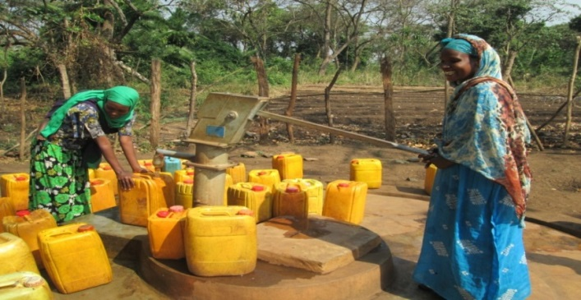

|  |  |  |  |  |  |  |  |
| --- | --- | --- | --- | --- | --- | --- | --- |
| No | Woreda | 2011 | | | 2012 | | |
| **urban** | **Rural** | **total** | **urban** | **rural** | **Total** |
| 1 | Anfilo | 36 | 59.84 | 52.16 | 13 | 62 | 49 |
| 2 | Dale Sadi | 18 | 83.95 | 72.14 | 0 | 79 | 71 |
| 3 | Dale Wabera | 24 | 81.6 | 69.85 | 25 | 65 | 55 |
| 4 | DambiDolo | 33 | 0 | 32.51 | 41 | 0 | 41 |
| 5 | GawoKebe | 21 | 83.10 | 62.21 | 20 | 83 | 75 |
| 6 | Gidami | 36 | 77.16 | 83.19 | 59 | 77 | 74 |
| 7 | Hawa Galan | 16.9 | 64.06 | 48.22 | 23 | 58 | 50 |
| 8 | Jima Horo | 0 | 74.18 | 73.58 | 0 | 77 | 72 |
| 9 | LaloKile | 0 | 95.13 | 71.07 | 0 | 76 | 76 |
| 10 | SadiCanka | 22 | 71.5 | 69.37 | 35 | 55 | 50 |
| 11 | Sayo | 94.17 | 70.52 | 64.6 | 45 | 76 | 75 |
| 12 | Y/Walal | 14 | 75.07 | 71.47 | 39 | 77 | 74 |
| Total | | **31** | **75.3** | **63.77** | **29.54** | **72.62** | **64.02** |

Source: Field visit

**Table\_\_\_ potable water coverage by woreda**s

Source:-Zonal water office

In general, rivers, springs, hand dug wells, shallow and deep wells are major sources of drinking water in the zone .As the data obtained from zonal water office indicate, potable water coverage of the zone in the year 2011 was 63.77% (75.30rural &31 town), while in 2012 the total potable water coverage of the zone had increased to 64.02%(72.62 rural &29.54urban).

**Urban and Rural potable water coverage in 2011 and 2012**

Source:-adopted from the above table

**Functional, non-functional and maintainable water scheme in kelem Wollega zone in 2011 and 2012**

|  |  |  |  |  |
| --- | --- | --- | --- | --- |
| Year | Water scheme | | | |
| **Total** | **Functional** | **Non functional** | **Maintainable** |
| 2011 | 4095 | 3927 | 168 | 168 |
| 2012 | 4410 | 4123 | 287 | 287 |

Source: Zonal water & Energy Office

The above data reveal that the number of water schemes has increased in the zone from 4095 in 2011 E.C.to 4410 in 2012 E.C. Of the total water schemes found in the zone in 2011 E.C, 3927 (95 %) were functional, 168 (4.1 %) non- functional and maintainable while the remaining 176. Similarly, in the year 2012 E.C. 4123 (93.5%) were functional, 287 schemes were non-functional and maintainable.

## Transport

|  |  |  |  |  |  |  |  |  |  |
| --- | --- | --- | --- | --- | --- | --- | --- | --- | --- |
| **Year** | **Number of vehicles by ownership** | | | | **Number of Vechiles by type of service** | | | | |
| Gov’t | Private | Non Gov’t | Total | Freight | Passengers | Motor -cycles | Bajaj | Others |
| **2011** | 392 | 917 | 28 | 1337 | 201 | 126 | 725 | 98 | 187 |
| **2012** | 270 | 1426 | 86 | 1729 | 197 | 269 | 820 | 350 | 93 |

Source: K/W/zone Transport Authority

From the above table the total number of Vehicles in 2011 were 1,337 (Gov’t, 392 Private 917and Non-Gov’t 28) and in 2012 there were 1,729 vehicles (Gov’t 270, Private 1, 426 and Non-Gov’t86) which were increased by 22.6 %. From the 2011 year.

**Driving License Renewed by Type of License**

|  |  |  |  |  |  |  |  |
| --- | --- | --- | --- | --- | --- | --- | --- |
| Year | 1st | 2nd | 3rd | 4th | 5th | 6th | Total |
| 2011 | 106 | 21 | 136 | 33 | 7 | 0 | 303 |
| 2012 | 252 | 1 | 783 | 74 | 7 | 44 | 1161 |

Source: zonal transport Authority

As it can be seen from the above table the total number of license renewed in 2011 E.C was 303. In the year 2012 it has increased to 1,161 which are still less than the total number of vehicles.

**Number of Traffic accident Victims by Type of injury and property damaged**

|  |  |  |  |  |  |  |  |  |
| --- | --- | --- | --- | --- | --- | --- | --- | --- |
| Year | Property damaged | | People died | | | Seriously demanded | | |
| Number | ETH. Birr | Male | Female | Total | Male | Female | Total |
| 2011 | 10 | 405,500 | 6 | 3 | 9 | 7 | 7 | 14 |
| 2012 | 17 | 442,400 | 11 | 6 | 17 | 2 | 4 | 6 |

Source: Kelem Wollega Transport Authority

## Communication

In the year 2012 E.C in Kelem Wollega was no sufficient branches of media transmission center.But there is only one branch media transmission center called OBN having only 3 workers( male ) and 10 mini-medias in 10 districts of the zone which were functioned by the workers of Government communication affairs of those districts.

**Table: 14 Types of Road and Their Length in (Km)**

|  |  |  |
| --- | --- | --- |
| **Type of road** | **2011** | **2012** |
|
|
| **Asphalt** | 104.5 | 124.5 |
| **Gravel** | 1005.719 | 1,122.17 |
| **Coble stone** | 69.81 | 67.3 |
| **Dry weather road** | 436.508 | 664.14 |
| **All weather road** | 1180.029 | 1,313.97 |
| **Total** | 1,616.54 | 1,978.11 |

Source: Statistical Abstract of Kelem Wollega Zone Development Plan Office

According to zonal road authority of Kelem Wollega, in 2011 E.C, there were 104.5km asphalt, 1005.72Km gravel, 69.81Km cobblestone and 436.51km dry weather road. In the year 2012 E.C, there were 124.5 km asphalt, 1,122.17 Km gravel, 67.3 Km cobblestone and 664.14km dry weather road. The total length of the road was 1,978.11km up to the end of 2012 E.C

## **Sports**: -

In the year 2012 E.C, the zone has one medium stadium at Dembi Dollo town. The capacity of the stadium was not identified. According to the information gathered from Youth and Sport Office, there were different kinds of fields with different kinds of sports. The sport activities that exist in Kelem Wollega zone are youth project under age 15 and age 17. The widely practiced sports in the zone were football, Volleyball, Basketball, Athletics, Table Tennis and some other modern and cultural sports.

**Number of stadium and sport clubs by type in the year 2012.E.C**.

|  |  |  |  |  |  |  |
| --- | --- | --- | --- | --- | --- | --- |
| Number of stadium | | Number of sports clubs/ teams | | Number of Registered | Number  Coaches | Number of sports |
| Mini- stadium | Standardized  Stadium | Name | Number |
| 7 | - | Different | 317 | 4,757 | 252 | 155 |

Source: Zonal Statistical Abstract of Planning & Economic Development Office 2012

## Justice

Justices is generally understood to mean right, fair, and appropriate. Justice is achieved when unjust act is readdressed and the victim feels gain. Justice also means the offender is held accountable for his behavior. In general the following table indicates both civil and criminal cases recorded and got decision in year 2011 and 2012 EC

|  |  |  |  |  |  |  |  |  |
| --- | --- | --- | --- | --- | --- | --- | --- | --- |
| year | Civil Cases | | | | Criminal Cases | | | |
| Lodged | Decided | % | Pending | Lodged | Decided | % | Pending |
| 2011 | 1,106 | 916 | 82.8 | 190 | 425 | 374 | 88 | 51 |
| 2012 | 1,222 | 1,111 | 90.9 | 111 | 624 | 547 | 87.7 | 77 |

Source:- zonal Court offices

As the data obtained from zonal court office indicate 2011 E.C **425 criminals** were recorded and **1,106 civil cases** were recorded. Out of the total criminal cases lodged in 2011E.C374were decided, while **51** were pended. In 2012 Out of the total civil cases 1,222 lodged civil cases1,111were decided, while 111 were pended, and from the total criminals lodged 624 cases 547 were decided and 77 were pended.

## Social Security

Social security primarily refers to a social insurance program providing social protection, or protection against socially recognized conditions, including poverty, old age, disability, unemployment and others. Unemployment as one form of social security, refers to the condition and extent of joblessness within an economy, and is measured in terms of unemployment rate. It is computed as the proportion of the unemployed persons to the total economically active population. Hence, unemployment is the condition of not having a job, often referred to as being "out of work", or unemployed. It is measured using three criteria, namely those without work, available for work and seeking work. It is known that, an official estimate of unemployment is based on the International Labor Organization (ILO) definition. According to ILO, people aged 16 and over are unemployed if they are out of work, want a job, have actively sought work in the last four weeks and are available to start work in the next two weeks; or are out of work, have found a job and are waiting to start work in the next two weeks.

## Unemployment

Unemployment is a condition when the people are willing and able to work and actively seek jobs at the condition where there is no job opportunity. Unemployment can be occurred when an economy cannot operate at its full capacity. The main causes of unemployment are migration of people from rural to urban, Educational structure, technological advancement, Natural disasters (Accident), population growth, attitude toward work, culture of vacancy announcement. The consequence of unemployment can be Addiction, dependency, psychological problems, poverty, prostitution, Begging ,etc..

Table: Total Number of unemployed persons in last two years (2011 & 2012) in Rural & Urban

|  |  |  |  |  |  |  |  |  |  |
| --- | --- | --- | --- | --- | --- | --- | --- | --- | --- |
| Year | Rural | | | Urban | | | Total | | |
| Male | Female | Total | Male | Female | Total | Male | Female | Total |
| 2011 | 7,257 | 3,930 | 11,187 | 5,535 | 2,999 | 8,534 | 12,792 | 6,929 | 19,721 |
| 2012 | 7,228 | 4,914 | 12,142 | 11,880 | 9,697 | 21,585 | 19,108 | 14,611 | 33,719 |

**Source :**

|  |  |  |  |
| --- | --- | --- | --- |
| Year | Educated Unemployed persons | | |
| **Male** | **Female** | **Total** |
| 2011 | **1,319** | **596** | **1,915** |
| 2012 | **2,992** | **2,300** | **5,292** |

Source; Statistical Abstract of Kelem Wollega Zone Plan and Development

As it can be seen from the above table the total numbers of unemployed persons in 2011 E.C were 19,721( 12,792 male & 6,929 female)from which educated people( certificate to 3rd Degree) who were unemployed were totally 1,915(1,319 male &596 female). In the year 2012 the total unemployed persons were 33,719 ( 19,108male &14,611 female) among which educated people who were unemployed were 5,292( 2,999 male &2,300 female)

## Micro and small scale enterprises

Micro and small scale enterprises and service given to them

|  |  |  |  |  |  |  |
| --- | --- | --- | --- | --- | --- | --- |
| Year | Number of MSEs | Land allotted to MSEs in (ha) | Loan dispersed to them | Members Received Training | Total Capital they have | Job Opportunity created |
| 2011 | 1,670 | 1,707.22 | 46,126,707.00 | 10,434 | 25,126,144 | 6,098 |
| 2012 | 2,574 | 2,069 | 15,954,500 | 13,421 | 19,085,018 | 7,906 |

Source:

|  |  |  |  |  |  |  |  |  |
| --- | --- | --- | --- | --- | --- | --- | --- | --- |
| **Si No** | **Name of NGO** | **Project** | **Beneficiaries** | | | **Duration** | **Location** | **Total budget** |
|
| **Male** | **Female** | **Total** |
| 1 | Menschen fur menschen | Dale wabera integrated rural  development project | 60,200 | 62,617 | 122,817 | 2013- 2019 | Dale wabera | 171,585,973.00 |
| Gawo Kebe Sustainable Development Project | 14,550 | 16,450 | 31,000 | Dec. 2015-2019 | G/Qebe | 25,351,518 |
| Sedi Chenka Sustainable Development Project |  |  | 61,148 | June 2018-2019 | SediChenka | 37,834,509.00 |
| 2 | STAND by me Ethiopia | Comprehensive care and support services to OVC and poor families | 1144 | 1239 | 2383 | Sep.2016-Aug.2020 | D/Dollo town | 21,427,466 |
| 3 | Ethiopian orthodox church development and inter church Aid commission | Cor- group polio eradication project | 3897 | 110 | 4007 | Jan 2013-Dec.2020 | Anfillo, Gidami, Y/welel, J/Horo, sayo | 6,022,191.00 |
| Collective Effort to Enhance Immunization Service | 163,470 (infants & pregnant women) | 0 | 163,470 | July 2015-Dec. 2020 | Anfillo, Gidami, Y/welel , J/Horo, Seyo, D/Wabera& H/Gelan | 6,820,460 |
| 4 | Ethiopian catholic church social and development coordination of Nekemte | Dembi Food Security Project | 1,200 | 890 | 2090 | Feb. 2017-Jan.2020 | Seyo | 9,435339.84 |
| Strengthening Education Development Project Phase 1 | 4,000 | 3350 | 7350 | June 2017-July 2020 | Sayo | 13,299,827 |
|
| 5 | ManaGammachuu | OVC& At-Risk Single | 30 | 150 | 180 | June 2017- May 2021 | D/Dollo Town | 4,996,260 |
| 6 | Ethiopian Evangelical church mekaneYesus Development and social services | Dale sadi food security and climate change adaption project | 6,789 | 6,128 | 12,917 | March 12015-Febr.28,2018 | D/Sedi | 9,0659,58.00 |
| Green Livelihood & Natural Resources Development | 26,389 | 25,736 | 52,125 | April 2016-March 2019 | Gidami, J/Horo, G/Qebe& H/Gelan | 21,,495,293 |
| Treatment of women with Gynecological Complication of child birth | 0 | 150 | 150 | June 2017-Dec.2017 | Gidami, J/Horo, G/Qebe, & H/Gelan | 757,232 |
| 7 | Nehemia child sponsorship | Childe Sponsorship project | 100 | 100 | 200 | Jan.2015-Dec. 2017 | D/Sedi | 2,620,368 |
| D/Dollo childe sponsor Ship | 100 | 100 | 200 | Jan. 2015-Dec.2017 | D/Dollo | 3,103,857 |
| 8 | WendimuBejo& His Family Charity Organization | OVC Support Project | 10 | 10 | 20 | Feb.2018-Jan.2021 | D/Dollo | 3,210,000 |
| 9 | Welel Development Association(WALDA) | Education | 410 | 410 | 820 | 2019 | Seyo&HawaGelan | 454,262.00 |
| 10 | Rift Valley Children& Women Development Organization | Creating sustainable Business Projects for the Youth and Small Holders Farmers | 626 | 547 | 1173 | June 2019-2021 | Dale Wabera&SediChenka | 16,800,079 |

## Qellem Wollega Zone NGO Profile

## Development Activities

Major on-going governmental and Non-governmental projects and programs in the zone and their major objectives

## Dembi Dollo University

Dembi Dollo University was established as per the higher education proclamation 351/2008 and it is a new University currently under construction which would have made fully operational in 2010 E.C academic year and currently available on teaching learning process in different programs .

## Dembi Dollo Local Airport

The construction of Dembi Dollo local airport is one of the on-going governmental project which is considered as the golden opportunity for Kelem Wollega and the surrounding community for it is expected to support the accelerating development of tourism activities in the zone.

Dembi Dollo airport has started serving the community after its termination for about a decade and half. Ethiopian airlines has opened a new flight program and rendering local passengers flight service as frequent as twice in a week. The airport is under construction in order to improve its operational and technical standard to the required level. Construction of its runway is one of the activities it is undertaking. Therefore it is very convenient to arrive at Dembi Dolloo and access it from any corner of the country

## Dembi Dollo Town Asphalt road

Due emphasis has been given to the development of road authority in the GTP. The government has recognized the importance of road in the development of national economic and social activities and hence attaches a high priority to improve the road infrastructure.

Construction of the asphalt road inside the capital town of the zone, DembiDollo, by Oromia Region Road Authority is accelerating the development of Kelem Wollega zone.

## DambiDollo Bus station

The construction of DambiDollo bus station which maintained its standard have been accomplished and currently available to provide serves for the society.

# Problems & Potentialities

## Problems

* Population and Environment is inseparable phenomena that people cannot exist without environment. Human being has been created to live on this earth by utilizing the recourses in harmonious or in the manner that the resources on the environment sustain the existence of all living things on the earth in general and the coming generation in particular.
* Because of the population growth from year to year; the land holding capacity of individual farmers have been decreasing from time to time which implies, the individual farmer land holding descended from father to son was very minimal with family size that increase from time to time and the land holding remain the same that the newly coming young generation couldn’t get land to live in the rural areas so that they were forced to migrate to urban areas to search for employment opportunity.
* Depletion of the natural environment because of over grazing and fire wood utilization which human beings keep after large heads of cattle to sustain his life and use forest resources as energy option.
* The provision of clean water, quality education, proportional health facilities and health professional for the community will be questionable unless the government give due considerations.
* Youth unemployment remains a major political and socioeconomic challenge in the zone despite the recent strong growth performance of the country. So, one of the most pressing problems particularly in Kelem Wollega today is youth unemployment.

## 

## Potentialities

* The huge investment made so far in infrastructure development will result in greater return in increasing the productivity of the economy and by encouraging more productive investment
* The zone has potential irrigable land for vegetable production
* Vast farm land in lowland areas for the production of cereal crops that could be supplied as a raw material for factories like flour factories.
* Baboon trees that could be supplied as a raw material
* A lot of rivers that drain the zone from different directions can accelerate irrigation development
* High potential cultivable land, natural resources and tourism attraction areas such as Dhati Wolel National park, rich mineral resource endowment for further investment opportunities.
* High availability of productive labor force.